ISSUES

When new schedule task is created (clicking + button, by putting data and clicking save). Following exception is thrown

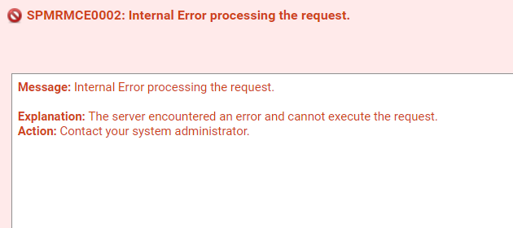

Reason: nullPointer exception in code

INFO | jvm 1 | 2019/06/04 19:26:34 | 2019/06/04 19:26:34 WARN #351 ExceptionHandlerTools Error: (id: 1559656594806) Internal Error processing the request. caused by:

INFO | jvm 1 | 2019/06/04 19:26:34 | java.lang.NullPointerException

INFO | jvm 1 | 2019/06/04 19:26:34 | at com.softwareag.platform.management.is.configuration.impl.ISScheduledTasksConfigurationManager.commonConfiguration(ISScheduledTasksConfigurationManager.java:769)

How did I got : by looking into SPM log SAG_105\profiles\SPM\logs\**wrapper.log**

Solution : Check for null