Cloning existing dir of github into backup location:

-This is one-time setup or

-Need to be done when new repo is created in github and backedup in personel system

Use git-gui, and select “clone existing repository”

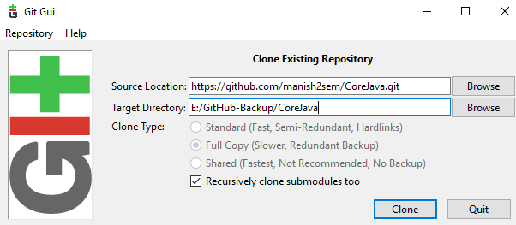

Source Location:

Login to the github account, go to the desire repo

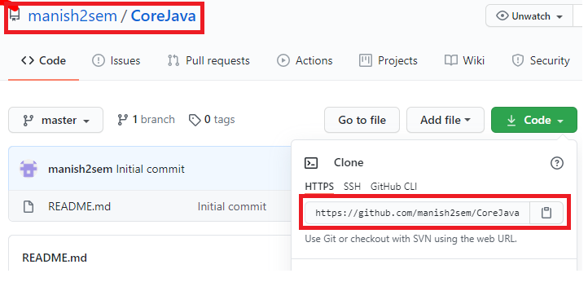

Make sure in Target Directory :

E:/GitHub-Backup is existing

CoreJava is not present. This will be created while cloning.

Synching :

Case1:

Update to github

Update local backup: