Manish Jain (+91-8010632949)
rajmanishjain@yahoo.co.in

 | 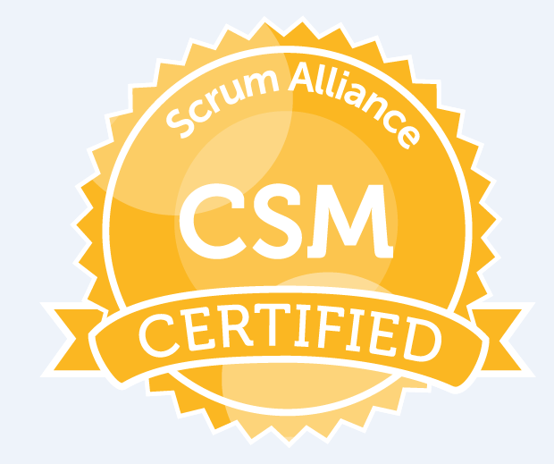 | 

A pragmatic who is passionate about technology, innovation & team collaboration
with significant expertise and a proven record of success in of broad-based
management in Software Application Design and Development.

Comprehensive background in architecting and managing complex and full-lifecycle
IT solutions using iterative and agile methodologies. Expert in design, implement,
test and deploy the collection of Enterprise Systems using global delivery models.

A certified AWS Cloud Architect and Certified Scrum Master from Scrum-Alliance.

Summary

- Over 14 years experience in the field of Software Development in Java profile.
- Currently working in SDG Software India Pvt Ltd, Noida for last 9 years for Fortune 50, USA client, serving as a capacity of Application Architect role.
- Experienced in Software development and customization, product implementation and maintenance using Java and related technologies. Expertise in designing J2EE architecture, environment setup and applying patterns and best practicing.
- Hands-on full stack developer, Technical evangelist, Distributed Systems, Web
Applications, Enterprise Integration (SOA), RESTful Architectures, System Analysis,
reverse engineering, Object-Oriented programming, Java/EE, Spring Framework,
Hibernate, EJB, MVC Frameworks.
- Good hands-on of Microservices design, architecture and patterns using spring boot and spring cloud.
- Having exposure in CI/CD environments, DevOps, Docker, Docker File, Jenkins, Jenkinsfile, Git, GitHub,TeamCity. Good understanding Swarm and Kubernetes.
- Good knowledge of OOAD, UML, and Design Patterns, Good exposure to various phase of lifecycle of project including requirement analysis, design and testing, experience to work with custom java frameworks and design patterns.
- Good understanding of OAuth 2.0 protocol and workflows.

Professional Certificates

AWS certified Solution Architect – Associate 2018 | Validation Number K1YV0FK22F1Q13GQ  https://aw.certmetrics.com/amazon/public/verification.aspx
Certified Scrum Master 2018 | https://certification.scrumalliance.org/accounts/831815-manish-jain/certifications/943490-csm
Sun Certified Java Professional | Expired.
Professional Qualifications:

MCA (2003)-B-level (3-year full time classroom program) From Cistem Institute Of Information Technology (Jaipur), recognized by DOEACC Society, Ministry of IT & C, Govt. of India, New Delhi. | 2003 with C grade (55%-65%)
B.Sc. (Mathematics–1998) From Rajasthan University | 1998 with 61%
Senior Secondary (Rajasthan Board) - PCM | 1995 With 55%
Secondary – Rajasthan Board | 1993 with 70%

Professional Experience:

SDG Software India Pvt Ltd (CMMI3), Noida  www.sdgc.com | Mar 2010 – Till Date
Global Logic, Nagpur  (payroll of Magna InfoTech)  http://www.globallogic.com | Oct 2009 – Jan 2010
Keane India Ltd, Noida, (CMMI5)  www.keane.com | Sept 2005 – May 2009
Saigun Technology, Noida (PCMMI3)  www.saigun.com | Dec 2004 – Sept 2005

Professional Experience details:

Company | SDG Software Pvt Ltd, Noida
Project-Customer | Fortune-15 USA Clients
Duration | March 2010 – Till Date
Designation | Project Lead
Team size | 7

Projects: Identity and Access Management

This J2EE application comes under the umbrella of enterprise Identity and access management vertical.
This application provides access and management of resource for more than 3.5 lacs employees which include employee and contractor on boarding and password change and recovery management. Following are the high level use case of the application.

- Implementing validation for reset of password of Single Sign On User with following Authentication options
- Registered Mobile Number
- Registered personal email id
- Registered RSA token
- Registered Active Challenge Questions and Answers
- Password Reset by Manager

- Implementing Change of Password Recovery Settings of Single Sign On Users for following options
- Active Challenge Questions and Answers
- Personal Email Id
- Mobile Number
- Implementing Help Desk Ticket Creation functionality.
- Implementing in JSF 2 and Restful Web Services environment.
- All the web services protected by Authorization Server (Akana).
- Contractor on boarding workflow
- New hire employee workflow

My responsibilities include
- Designing and architecting the application using best J2EE practices and tools.
- Translating the business use cases into technical design and code implementation.
- Client communication on daily basis with latest updates on project health and status.
- Task distribution amongst team members, code review.
- Support and training (technical and functional) to team members.
- Overall 90% contribution on technical activities and rest 10% on project lead activities.

Technology Stack

JSF 2.2,Quartz 2.2.1 Scheduler, Jersey Rest API 1.18 ,Spring 3.0.5 (IOC), Apache Maven 3.2, jboss-eap-6.3.0, Oracle 11.2

Company | Global Logic  Nagpur,(http://www.globallogic.com)
Project/Engagement | SPRINT(www.sprint.com)  A Leader in Mobile device and communication in US and UK.
Duration | Oct 2009 – Jan 2010
Designation | Sr. Software Engineer
Team size | 15

Projects: PRIM

PRIM makes one’s most personal communication device, the mobile phone, a manageable communication portal. It forms a nucleus around contacts as the starting point for any communication as well as management of one’s personal, work and social data. This is achieved through a dynamic address book that contains custom and personalized entries along with synchronization with multiple endpoints. The address book works in conjunction with various personal communication activities and events to form an ecosystem for comprehensive communication services.

Technology Stack
JDK 1.5, EJB 3.0, Struts 2.0, JbossAS (Version 4.0.2 GA) BossMQ Oracle 10g

Company | Keane India Ltd. Noida,(www.keane.com)
Project/Engagement | Best Western International(www.bestwestern.com)
Duration | September 2005 to May 2009
Designation | Sr. Software Engineer
Team size | 12

Projects: WebBookingEngine

Web Booking Engine (WBE) is an application for Consumer looking to reserve a room at a Best Western hotel. This is a reservation application for destination resorts, as well as global leisure travel and hospitality industries. Product search and reservation/booking capabilities are handled by a series of interdependent software modules that encapsulate business logic. Together, these system components provide an Internet Booking Engine for the leisure travel industry.

Technology Stack
JDK 1.5, EJB 3.0, Struts 1.3.5, jsp 2.0, servlet 2.4, Standard-1.1 (JSTL 1.1) , JDBC 3.0, JNDI, , Log4j, PL/SQL, JbossAS (Version 4.0.2 GA),

Personal Details:

DOB: Aug 1977
Permanent Address: House No 744 Sector 19, Faridabad.
PAN No: A*************P
Passport No: F*************6
LinkedIn : www.linkedin.com/in/manish-jain-csm-5495028

