Ques. Create two HTML pages using all formatting tags, Table tags, Image etc. Link both the pages also.

<html>

<head><title>This page is showing usage of multiple tags</title></head>

<body bgcolor="Green"><h1><b><p align="center">This is a Table Tag</p></b></h1>

<table style="width:100%" border="1">

<tr>

<th><h1><b>Tag Name</b></h1></th>

<th><h1><b>Description</b></h1></th>

</tr>

<tr>

<td>p tag</td>

<td><p>It is used to write a Paragraph</p></td>

</tr>

<tr>

<td>i tag</td>

<td><i>It is used to display text in Italics</i></td>

</tr>

<tr>

<td>h tag</td>

<td><h2>It is used to display text in Headings</i></td>

</tr>

<tr>

<td>b tag</td>

<td><b>It is used to display text in bold</b></td>

</tr>

<tr>

<td>img tag</td>

<td>It is used to display text in bold<img src="download.jpg"height="142" width="342"></td>

</tr>

<tr>

<td>a tag</td>

<td>It is used to display link<a href="C:\Users\shivam\Desktop\nehaaspp\download.jpg">this is apple image</a></td>

</tr>

</table>

</body>

</html>

**OUTPUT**

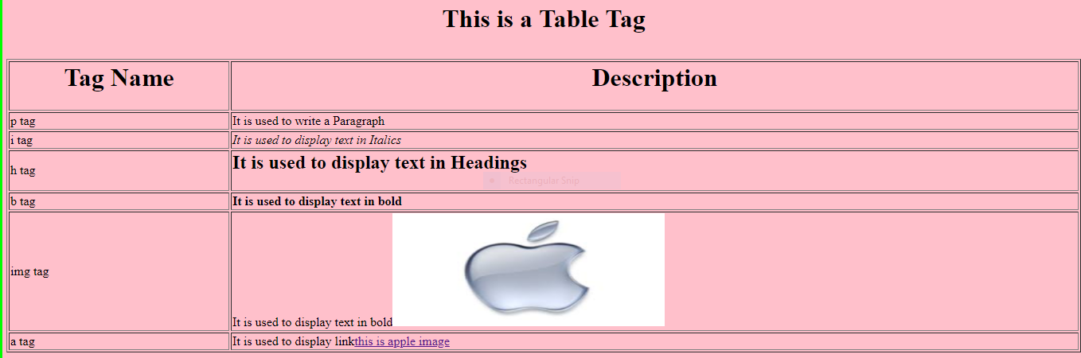

Ques. Make a web site home page using Frame and frameset.

<html>

<head>

<frameset cols="50%,50%">

<frame src="q1.html"> hello</frame>

<frame src="q5.html" name="hello"> go</frame>

</frameset>

</head>

</html>

**OUTPUT**

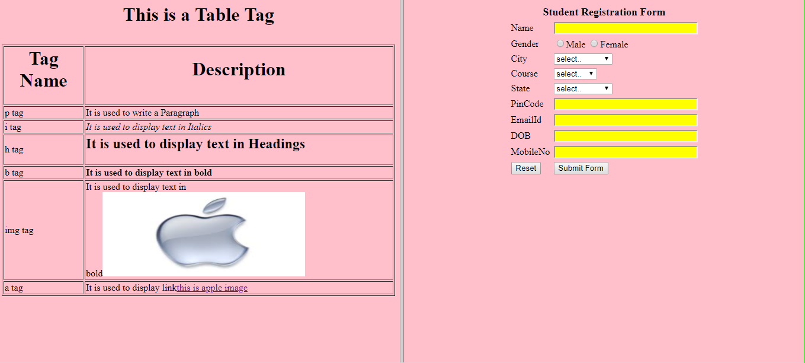

Ques. Registration form using HTML 5.0 input type also.

<html>

<head>

<style>

td {

width: 200px;

}

input {

width: 190px;

}

select {

width: 190px;

}

</style>

</head>

<h2 align="left">REGISTRATION FORM</h2>

<body>

<table>

<tr>

<td>

First Name:

</td>

<td>

<input type="text" name="firstname" placeholder="" />

</td>

</tr>

<tr>

<td>

Last Name:

</td>

<td>

<input type="text" name="lastname" placeholder="" />

</td>

</tr>

<tr>

<td>

Email:

</td>

<td>

<input type="email" name="email" placeholder=" " />

</td>

</tr>

<tr>

<td>

Date of Birth:

</td>

<td>

<input type="date" name="birthday" />

</td>

</tr>

<tr>

<td>

Gender:

</td>

<td>

<select name="gender">

<option value="male">Male</option>

<option value="female">Female</option>

</select>

</td>

</tr>

<tr>

<td>

<input type="submit" />

</td>

</tr>

</table>

</body>

</html>

**OUTPUT**

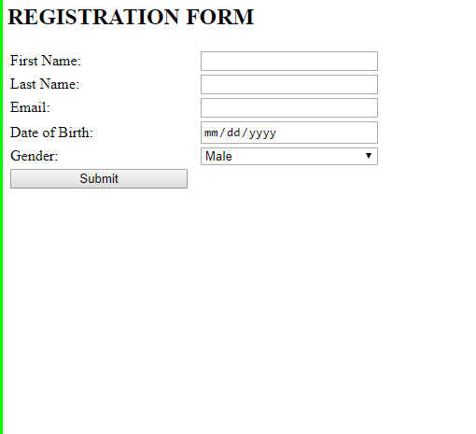

Ques. Create a registration form and implement CSS file with HTML.

<html>

<head>

<title>this is registration form</title>

<link rel="stylesheet" href="styles.css">

</head>

<body>

<table cellpadding="2" width="20%" align="center"

cellspacing="2">

<tr>

<td colspan=2>

<center><font size=4><b>Student Registration Form</b></font></center></td></tr>

<tr>

<td>Name</td>

<td><input type=text name=textnames id="textname" size="30"></td></tr>

<tr>

<td>Gender</td>

<td><input type="radio" name="sex" value="male" size="10">Male

<input type="radio" name="sex" value="Female" size="10">Female</td></tr>

<tr>

<td>City</td>

<td><select name="City">

<option value="-1" selected>select..</option>

<option value="New Delhi">NEW DELHI</option>

<option value="Mumbai">MUMBAI</option>

<option value="Goa">GOA</option>

<option value="Patna">PATNA</option>

</select></td></tr>

<tr>

<td>Course</td>

<td><select name="Course">

<option value="-1" selected>select..</option>

<option value="B.Tech">B.TECH</option>

<option value="MCA">MCA</option>

<option value="MBA">MBA</option>

<option value="BCA">BCA</option>

</select></td></tr>

<tr>

<td>State</td>

<td><select Name="State">

<option value="-1" selected>select..</option>

<option value="New Delhi">NEW DELHI</option>

<option value="Mumbai">MUMBAI</option>

<option value="Goa">GOA</option>

<option value="Bihar">BIHAR</option>

</select></td></tr>

<tr>

<td>PinCode</td>

<td><input type="text" name="pincode" id="pincode" size="30"></td></tr>

<tr>

<td>EmailId</td>

<td><input type="text" name="emailid" id="emailid" size="30"></td></tr>

<tr>

<td>DOB</td>

<td><input type="text" name="dob" id="dob" size="30"></td>

</tr>

<tr>

<td>MobileNo</td>

<td><input type="text" name="mobileno" id="mobileno" size="30"></td>

</tr>

<tr>

<td><input type="reset"></td>

<td colspan="2"><input type="submit" value="Submit Form" /></td>

</tr>

</table></form>

</body>

</html>

**Styles.css**

input[type=text]

{

background-color: yellow;

color: purple;}

body{

background-color: pink;}

form{

background-color: green;}

**OUTPUT**

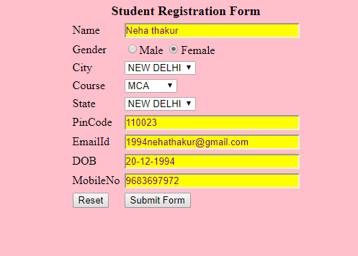

Ques. Create a HTML form which has:  
    textbox for name(should not be blank), Contact No. (max length is 10 digits),   
7)Write a Javascript code to change the background color at a frequent intervals.

<html>

<head>

<script>

var x=1;

functionq7()

{

setInterval("q7()",2000);

}

function q7()

{

if(x==1)

{

document.body.style.background = "red";

x=2;

}

else if(x==2)

{

document.body.style.background = "blue";

x=3;

}

Else

{

document.body.style.background = "green";

x=1;

}

}

</script>

</head>

<body onload= "q7()">

</html>

**OUTPUT**



8) Write a Javascript code to open the new document after a particular interval.

<html>

<head>

<script>

var x=1;

functionq8(){

window.open("q5.html");

setTimeout("q8()",5000);

}

function q8()

{

setTimeout("q8()",1000);

}

</script>

</head>

<body onload= "q8()">

</body>

</html>

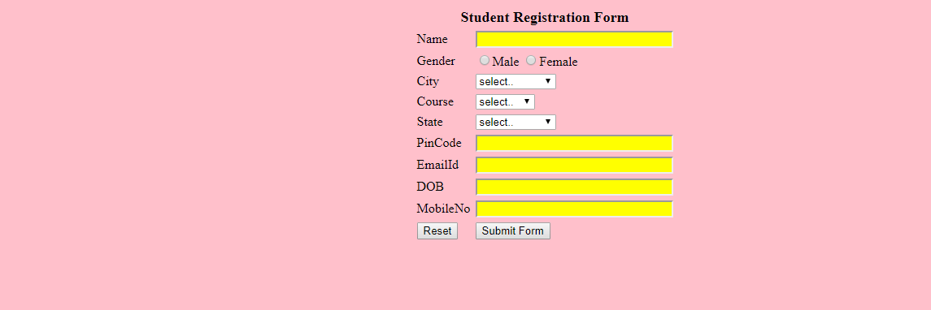  
  
  
ASP .NET  
9) Create a web page with server controls which is having connection with server.  
10) Create an Asp.net application to show the various use of HTML controls.  
    a) Enter two numbers and display the result in a text box(Operations: Add, Subtract, Multiply, Division)

**Aspx design:**

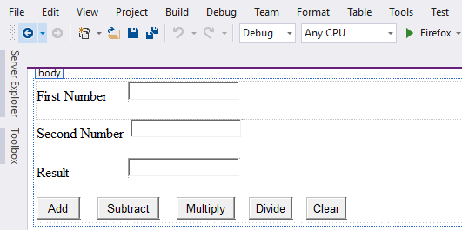

**Aspx code:**

<%@PageLanguage="C#"AutoEventWireup="true"CodeBehind="WebForm1.aspx.cs"Inherits="calc.WebForm1"%>

<!DOCTYPEhtml>

<htmlxmlns="http://www.w3.org/1999/xhtml">

<headrunat="server">

<title></title>

</head>

<body>

<formid="form1"runat="server">

<divstyle="height: 43px">

<asp:LabelID="Label1"runat="server"Text="First Number"></asp:Label>

&nbsp;&nbsp;&nbsp;&nbsp;

<asp:TextBoxID="TextBox1"runat="server"style="margin-top: 0px"></asp:TextBox>

<br/>

</div>

<asp:LabelID="Label2"runat="server"Text="Second Number"></asp:Label>

&nbsp;

<asp:TextBoxID="TextBox2"runat="server"></asp:TextBox>

<p>

<asp:LabelID="Label3"runat="server"Text="Result"></asp:Label>

&nbsp;&nbsp;&nbsp;&nbsp;&nbsp;&nbsp;&nbsp;&nbsp;&nbsp;&nbsp;&nbsp;&nbsp;&nbsp;&nbsp;&nbsp;&nbsp;

<asp:TextBoxID="TextBox3"runat="server"></asp:TextBox>

</p>

<p>

<asp:ButtonID="Button1"runat="server"OnClick="Button1_Click"Text="Add"Width="50px"/>

&nbsp;&nbsp;&nbsp;&nbsp;

<asp:ButtonID="Button3"runat="server"OnClick="Button3_Click"Text="Subtract"/>

&nbsp;&nbsp;&nbsp;&nbsp;<asp:ButtonID="Button4"runat="server"OnClick="Button4_Click"Text="Multiply"/>

&nbsp;&nbsp;&nbsp;

<asp:ButtonID="Button5"runat="server"OnClick="Button5_Click"Text="Divide"/>

&nbsp;&nbsp;&nbsp;

<asp:ButtonID="Button2"runat="server"OnClick="Button2_Click"Text="Clear"/>

</p></form></body></html>

**Aspx.cs code:**

using System;

usingSystem.Collections.Generic;

usingSystem.Linq;

usingSystem.Web;

usingSystem.Web.UI;

usingSystem.Web.UI.WebControls;

namespace calc{

publicpartialclassWebForm1 : System.Web.UI.Page {

protectedvoid Button1_Click(object sender, EventArgs e) {

int num1 =Convert .ToInt32 ( TextBox1.Text);

int num2 = Convert.ToInt32(TextBox2.Text);

int res = num1 + num2;

TextBox3.Text = res.ToString(); }

protectedvoid Button2_Click(object sender, EventArgs e) {

TextBox1.Text = " ";

TextBox2.Text = " ";

TextBox3.Text = ""; }

protectedvoid Button3_Click(object sender, EventArgs e) {

int num1 = Convert.ToInt32(TextBox1.Text);

int num2 = Convert.ToInt32(TextBox2.Text);

int res = num1 - num2;

TextBox3.Text = res.ToString(); }

protectedvoid Button4_Click(object sender, EventArgs e) {

int num1 = Convert.ToInt32(TextBox1.Text);

int num2 = Convert.ToInt32(TextBox2.Text);

int res = num1 * num2;

TextBox3.Text = res.ToString(); }

protectedvoid Button5_Click(object sender, EventArgs e) {

int num1 = Convert.ToInt32(TextBox1.Text);

int num2 = Convert.ToInt32(TextBox2.Text);

int res = num1 / num2;

TextBox3.Text = res.ToString(); } }}

**Output:**

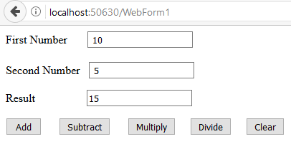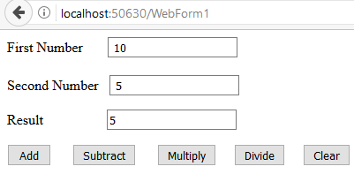

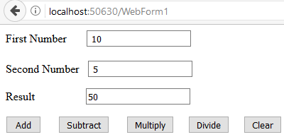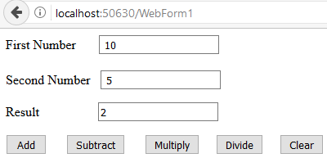

    b) Select a color of your choice(make checkbox) and change the background color.  
    c) Open the link as you select the name of the college from the dropdown list.  
    d) Display the name of courses according to the name of the college from the dropdown list.  
11) Create a web application and show all validations on the forms.

**Aspx design:**

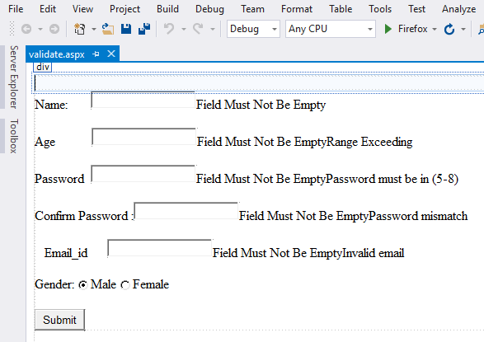

**Aspx code:**

<%@PageLanguage="C#"AutoEventWireup="true"CodeBehind="validate.aspx.cs"Inherits="validationcontrol.validate"%>

<!DOCTYPEhtml>

<htmlxmlns="http://www.w3.org/1999/xhtml">

<headrunat="server">

<title></title>

</head>

<bodystyle="height: 336px">

<formid="form1"runat="server">

<div>

</div>

<asp:LabelID="Label1"runat="server"Text="Name"></asp:Label>

:&nbsp;&nbsp;&nbsp;&nbsp;&nbsp;&nbsp;

<asp:TextBoxID="TextBox1"runat="server"></asp:TextBox>

<asp:RequiredFieldValidatorID="RequiredFieldValidator1"runat="server"ControlToValidate="TextBox1"ErrorMessage="Field Must Not Be Empty"></asp:RequiredFieldValidator>

<p>

Age&nbsp;&nbsp;&nbsp;&nbsp;&nbsp;&nbsp;&nbsp;&nbsp;&nbsp;&nbsp;

<asp:TextBoxID="TextBox2"runat="server"></asp:TextBox>

<asp:RequiredFieldValidatorID="RequiredFieldValidator2"runat="server"ControlToValidate="TextBox2"Display="Dynamic"ErrorMessage="Field Must Not Be Empty"></asp:RequiredFieldValidator>

<asp:RangeValidatorID="RangeValidator1"runat="server"ControlToValidate="TextBox2"ErrorMessage="Range Exceeding"MaximumValue="99"MinimumValue="1"Type="Integer"></asp:RangeValidator>

</p>

<p>

<asp:LabelID="Label3"runat="server"Text="Password"></asp:Label>

&nbsp;

<asp:TextBoxID="TextBox3"runat="server"TextMode="Password"></asp:TextBox>

<asp:RequiredFieldValidatorID="RequiredFieldValidator3"runat="server"ControlToValidate="TextBox3"Display="Dynamic"ErrorMessage="Field Must Not Be Empty"></asp:RequiredFieldValidator>

<asp:RangeValidatorID="RangeValidator2"runat="server"ControlToValidate="TextBox3"ErrorMessage="Password must be in (5-8)"MaximumValue="8"></asp:RangeValidator>

</p>

<p>

Confirm Password :<asp:TextBoxID="TextBox5"runat="server"TextMode="Password"></asp:TextBox>

<asp:RequiredFieldValidatorID="RequiredFieldValidator5"runat="server"ControlToValidate="TextBox5"Display="Dynamic"ErrorMessage="Field Must Not Be Empty"></asp:RequiredFieldValidator>

<asp:CompareValidatorID="CompareValidator1"runat="server"ControlToCompare="TextBox3"ControlToValidate="TextBox5"Display="Dynamic"ErrorMessage="Password mismatch"></asp:CompareValidator>

</p>

<p>

&nbsp;&nbsp;&nbsp;

<asp:LabelID="Label6"runat="server"Text="Email_id"></asp:Label>

&nbsp;&nbsp;&nbsp;&nbsp;&nbsp;

<asp:TextBoxID="TextBox4"runat="server"></asp:TextBox>

<asp:RequiredFieldValidatorID="RequiredFieldValidator4"runat="server"ControlToValidate="TextBox4"Display="Dynamic"ErrorMessage="Field Must Not Be Empty"></asp:RequiredFieldValidator>

<asp:RegularExpressionValidatorID="RegularExpressionValidator1"runat="server"ControlToValidate="TextBox4"ErrorMessage="Invalid email"ValidationExpression="@&quot;^(?(&quot;&quot;)(&quot;&quot;.+?(?&lt;!\\)&quot;&quot;@)|(([0-9a-z]((\.(?!\.))|[-!#\$%&amp;'\*\+/=\?\^`\{\}\|~\w])*)(?&lt;=[0-9a-z])@))&quot; +"></asp:RegularExpressionValidator>

</p>

<p>

Gender:<asp:RadioButtonID="RadioButton1"runat="server"Checked="True"GroupName="sex"Text="Male"/>

<asp:RadioButtonID="RadioButton2"runat="server"GroupName="sex"Text="Female"/>

</p>

<p>

<asp:ButtonID="Button1"runat="server"Text="Submit"/>

</p>

</form></body></html>

**Output:**

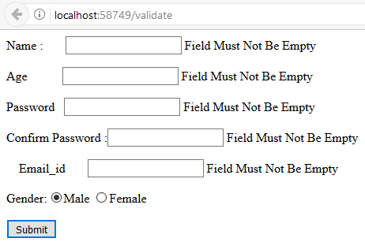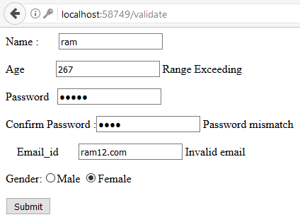

12) Create a website for a college which accept a feed back form.  All the fields should be connected through ADO.Net.

**Aspx design:**



**Aspx code:**

<%@PageLanguage="C#"AutoEventWireup="true"CodeBehind="WebForm1.aspx.cs"Inherits="calc.WebForm1"%>

<!DOCTYPEhtml>

<htmlxmlns="http://www.w3.org/1999/xhtml">

<headrunat="server">

<title></title>

</head>

<body>

<formid="form1"runat="server">

<divstyle="height: 43px">

<asp:LabelID="Label1"runat="server"Text="First Number"></asp:Label>

&nbsp;&nbsp;&nbsp;&nbsp;

<asp:TextBoxID="TextBox1"runat="server"style="margin-top: 0px"></asp:TextBox>

<br/>

</div>

<asp:LabelID="Label2"runat="server"Text="Second Number"></asp:Label>

&nbsp;

<asp:TextBoxID="TextBox2"runat="server"></asp:TextBox>

<p>

<asp:LabelID="Label3"runat="server"Text="Result"></asp:Label>

&nbsp;&nbsp;&nbsp;&nbsp;&nbsp;&nbsp;&nbsp;&nbsp;&nbsp;&nbsp;&nbsp;&nbsp;&nbsp;&nbsp;&nbsp;&nbsp;

<asp:TextBoxID="TextBox3"runat="server"></asp:TextBox>

</p>

<p>

<asp:ButtonID="Button1"runat="server"OnClick="Button1_Click"Text="Add"Width="50px"/>

&nbsp;&nbsp;&nbsp;&nbsp;

<asp:ButtonID="Button3"runat="server"OnClick="Button3_Click"Text="Subtract"/>

&nbsp;&nbsp;&nbsp;&nbsp;<asp:ButtonID="Button4"runat="server"OnClick="Button4_Click"Text="Multiply"/>

&nbsp;&nbsp;&nbsp;

<asp:ButtonID="Button5"runat="server"OnClick="Button5_Click"Text="Divide"/>

&nbsp;&nbsp;&nbsp;

<asp:ButtonID="Button2"runat="server"OnClick="Button2_Click"Text="Clear"/>

</p></form></body></html>

**Aspx.cs code:**

using System;

usingSystem.Collections.Generic;

usingSystem.Linq;

usingSystem.Web;

usingSystem.Web.UI;

usingSystem.Web.UI.WebControls;

namespace calc{

publicpartialclassWebForm1 : System.Web.UI.Page {

protectedvoid Button1_Click(object sender, EventArgs e) {

int num1 =Convert .ToInt32 ( TextBox1.Text);

int num2 = Convert.ToInt32(TextBox2.Text);

int res = num1 + num2;

TextBox3.Text = res.ToString(); }

protectedvoid Button2_Click(object sender, EventArgs e) {

TextBox1.Text = " ";

TextBox2.Text = " ";

TextBox3.Text = ""; }

protectedvoid Button3_Click(object sender, EventArgs e) {

int num1 = Convert.ToInt32(TextBox1.Text);

int num2 = Convert.ToInt32(TextBox2.Text);

int res = num1 - num2;

TextBox3.Text = res.ToString(); }

protectedvoid Button4_Click(object sender, EventArgs e) {

int num1 = Convert.ToInt32(TextBox1.Text);

int num2 = Convert.ToInt32(TextBox2.Text);

int res = num1 * num2;

TextBox3.Text = res.ToString(); }

protectedvoid Button5_Click(object sender, EventArgs e) {

int num1 = Convert.ToInt32(TextBox1.Text);

int num2 = Convert.ToInt32(TextBox2.Text);

int res = num1 / num2;

TextBox3.Text = res.ToString(); } }}

**Output:**





**Aspx design:**



**Aspx code:**

<%@PageLanguage="C#"AutoEventWireup="true"CodeBehind="WebForm1.aspx.cs"Inherits="calc.WebForm1"%>

<!DOCTYPEhtml>

<htmlxmlns="http://www.w3.org/1999/xhtml">

<headrunat="server">

<title></title>

</head>

<body>

<formid="form1"runat="server">

<divstyle="height: 43px">

<asp:LabelID="Label1"runat="server"Text="First Number"></asp:Label>

&nbsp;&nbsp;&nbsp;&nbsp;

<asp:TextBoxID="TextBox1"runat="server"style="margin-top: 0px"></asp:TextBox>

<br/>

</div>

<asp:LabelID="Label2"runat="server"Text="Second Number"></asp:Label>

&nbsp;

<asp:TextBoxID="TextBox2"runat="server"></asp:TextBox>

<p>

<asp:LabelID="Label3"runat="server"Text="Result"></asp:Label>

&nbsp;&nbsp;&nbsp;&nbsp;&nbsp;&nbsp;&nbsp;&nbsp;&nbsp;&nbsp;&nbsp;&nbsp;&nbsp;&nbsp;&nbsp;&nbsp;

<asp:TextBoxID="TextBox3"runat="server"></asp:TextBox>

</p>

<p>

<asp:ButtonID="Button1"runat="server"OnClick="Button1_Click"Text="Add"Width="50px"/>

&nbsp;&nbsp;&nbsp;&nbsp;

<asp:ButtonID="Button3"runat="server"OnClick="Button3_Click"Text="Subtract"/>

&nbsp;&nbsp;&nbsp;&nbsp;<asp:ButtonID="Button4"runat="server"OnClick="Button4_Click"Text="Multiply"/>

&nbsp;&nbsp;&nbsp;

<asp:ButtonID="Button5"runat="server"OnClick="Button5_Click"Text="Divide"/>

&nbsp;&nbsp;&nbsp;

<asp:ButtonID="Button2"runat="server"OnClick="Button2_Click"Text="Clear"/>

</p></form></body></html>

**Aspx.cs code:**

using System;

usingSystem.Collections.Generic;

usingSystem.Linq;

usingSystem.Web;

usingSystem.Web.UI;

usingSystem.Web.UI.WebControls;

namespace calc{

publicpartialclassWebForm1 : System.Web.UI.Page {

protectedvoid Button1_Click(object sender, EventArgs e) {

int num1 =Convert .ToInt32 ( TextBox1.Text);

int num2 = Convert.ToInt32(TextBox2.Text);

int res = num1 + num2;

TextBox3.Text = res.ToString(); }

protectedvoid Button2_Click(object sender, EventArgs e) {

TextBox1.Text = " ";

TextBox2.Text = " ";

TextBox3.Text = ""; }

protectedvoid Button3_Click(object sender, EventArgs e) {

int num1 = Convert.ToInt32(TextBox1.Text);

int num2 = Convert.ToInt32(TextBox2.Text);

int res = num1 - num2;

TextBox3.Text = res.ToString(); }

protectedvoid Button4_Click(object sender, EventArgs e) {

int num1 = Convert.ToInt32(TextBox1.Text);

int num2 = Convert.ToInt32(TextBox2.Text);

int res = num1 * num2;

TextBox3.Text = res.ToString(); }

protectedvoid Button5_Click(object sender, EventArgs e) {

int num1 = Convert.ToInt32(TextBox1.Text);

int num2 = Convert.ToInt32(TextBox2.Text);

int res = num1 / num2;

TextBox3.Text = res.ToString(); } }}

**Output:**





13) Create a webpage to display data in the data grid linked with database.

14.) Write the Program to insert the Order Form details into SQL table using connected architecture of [ADO.NET](http://ado.net/).

15.) Create a web page using [ASP.NET](http://asp.net/) and show the use of session in it.