**PART-3**

**What is GitHub? When was it created? Why? By who? What similar platforms exist? Why would you use such a platform?**

-GitHub is a web-based Git repository hosting service where we can collaborate with other developer and work on project. It has all the features of Git as well as it’s other feathers which makes it easy to understand and use.

-Development of the GitHub platform began on 1 October 2007 and was launched on 10 April 2008.

-It was hard to use Git unless you’re a Linux kernel coder which was developed by Linus Torvalds. So in 2007, development of GitHub came along, and set up an easy-to-use website where programmers host as well as manage their software projects using Git.

-It was developed by Tom Preston-Werner, Chris Wanstrath, and PJ Hyett.

-Other Similar Platforms are Bitbucket, SourceForge, GitLab, Kiln, CodePlane, CodePlex, BeansTalk.

-GitHub platform is mostly used for source code. It is also used for Documentation, Issue tracking, Wikis, Commits history, Bug tracking, task management etc. for every project.

**PART-4**

**Go through the Git tutorial here: https://try.github.io. While doing the tutorial, save your work the LastnameFirstnameGitTutorial-mm-dd-yyyy.docx file.**

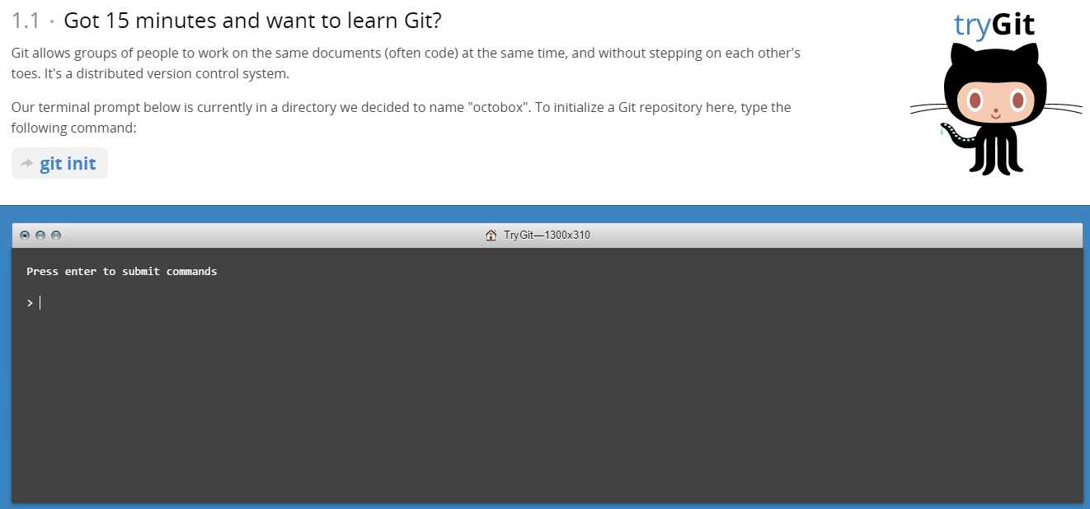

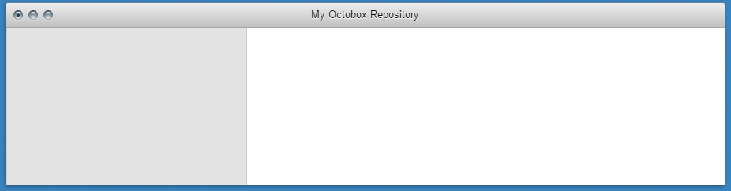

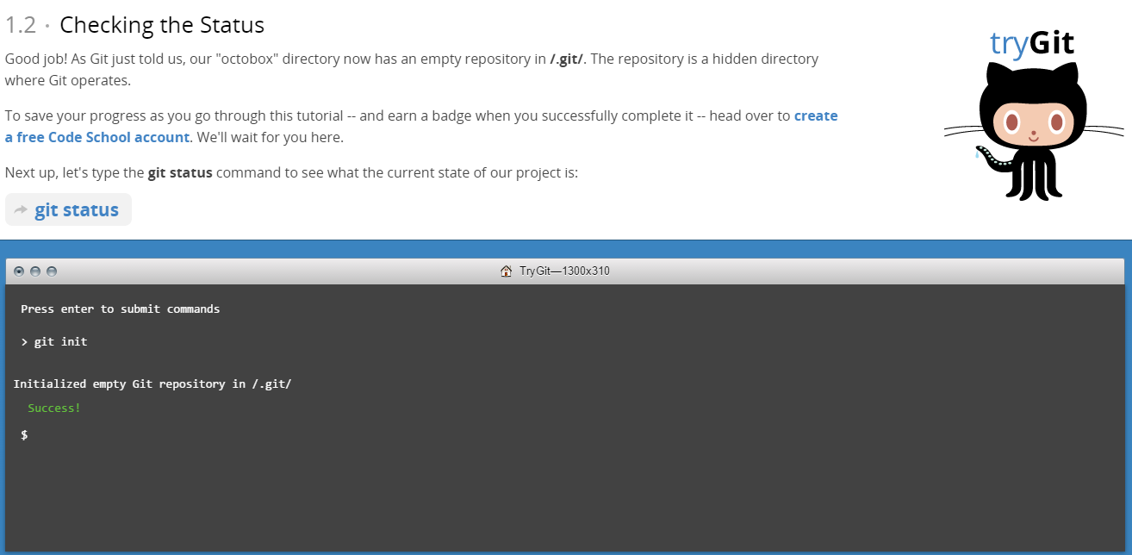

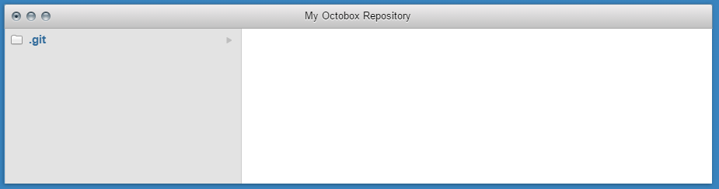

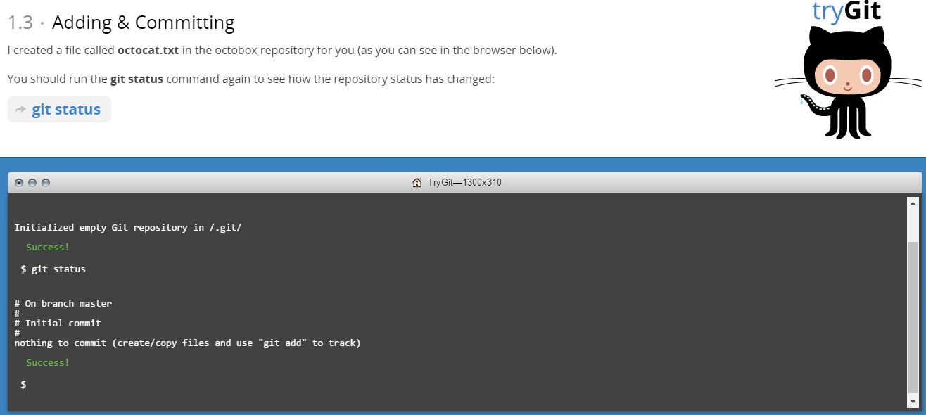

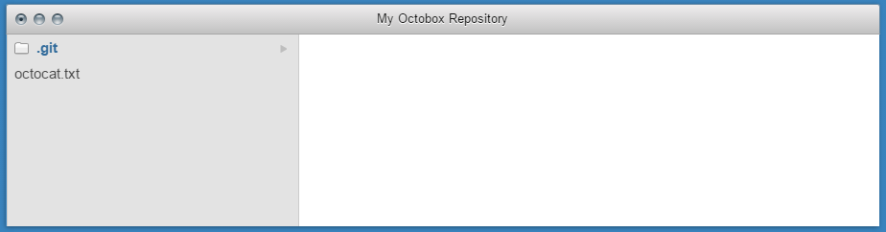

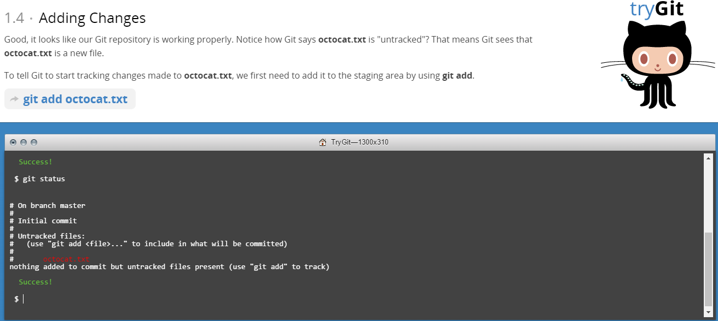

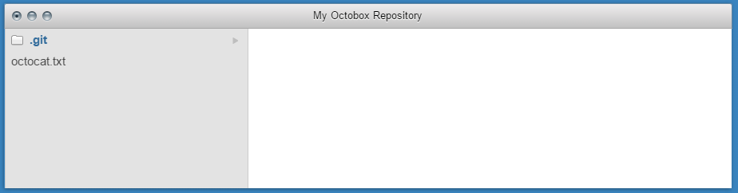

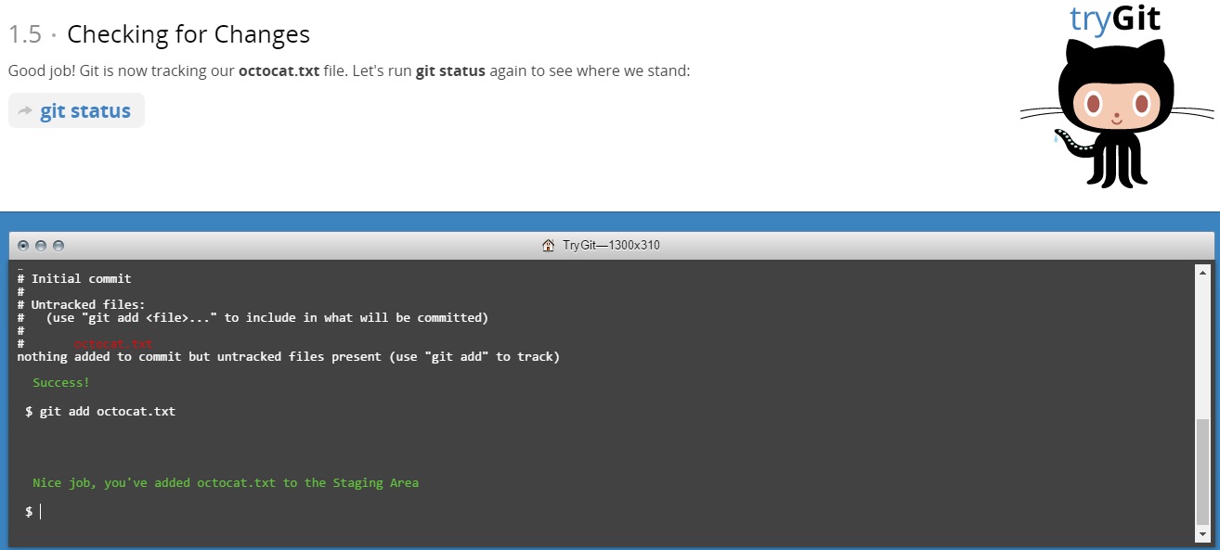

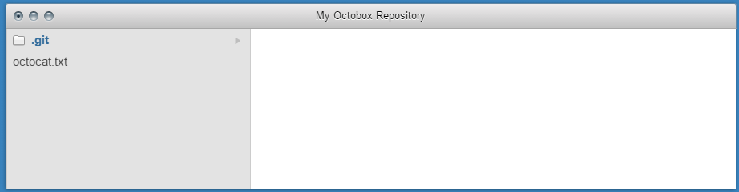

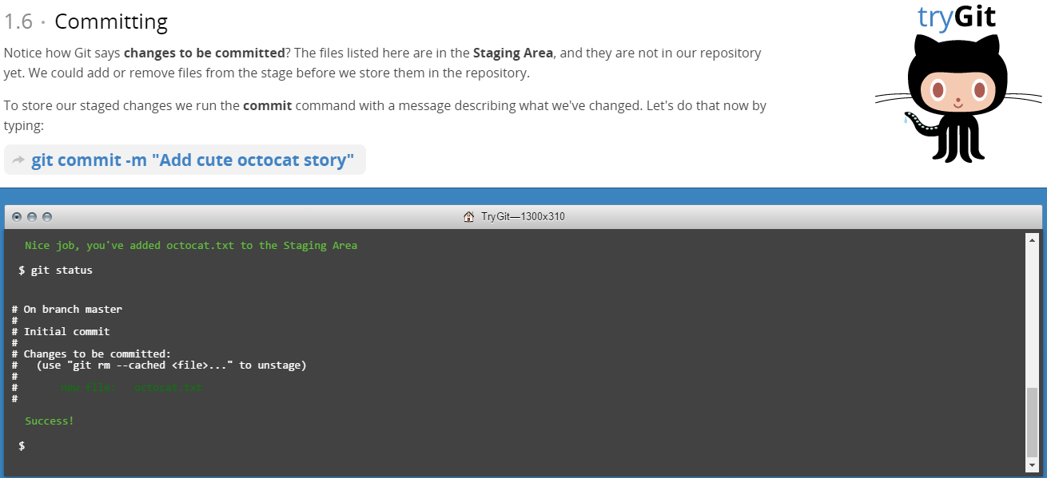

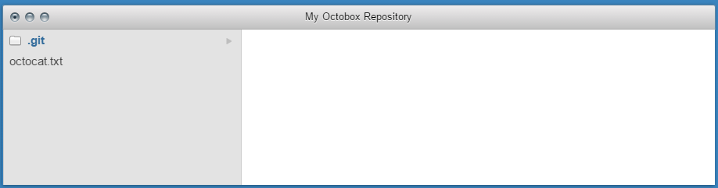

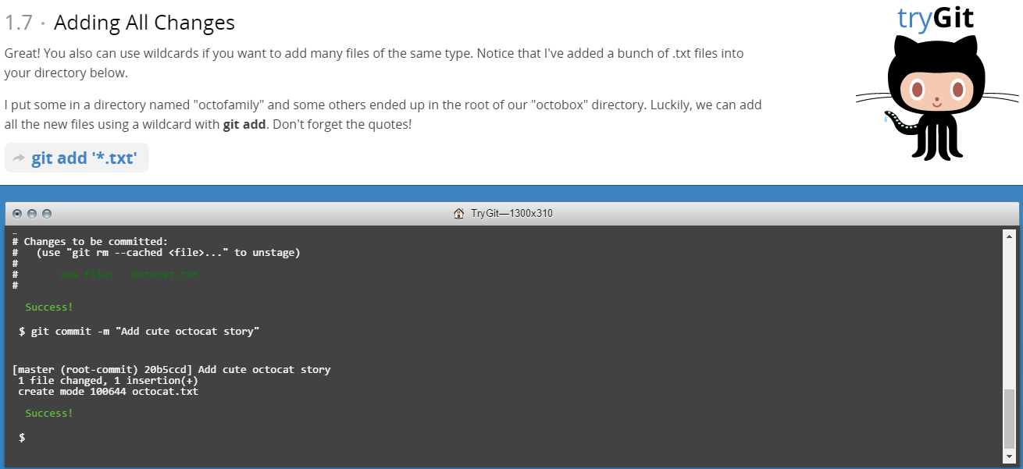

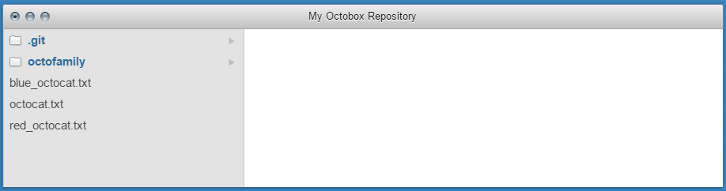

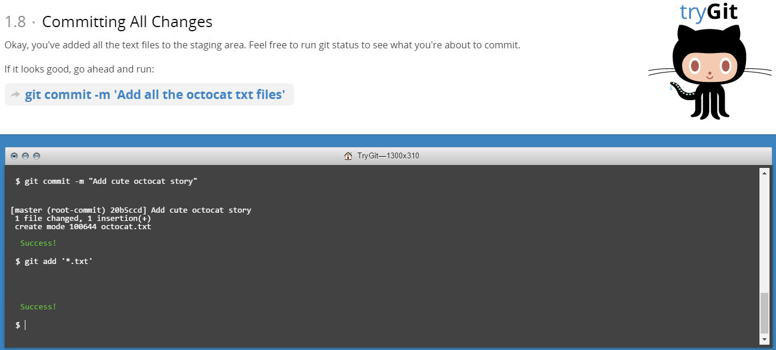

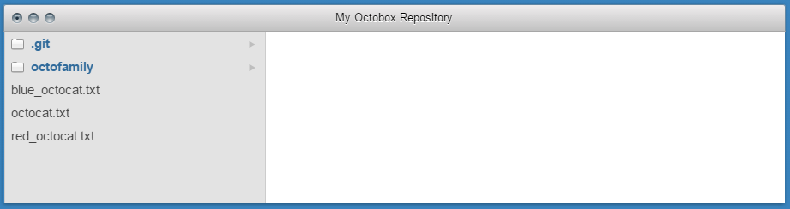

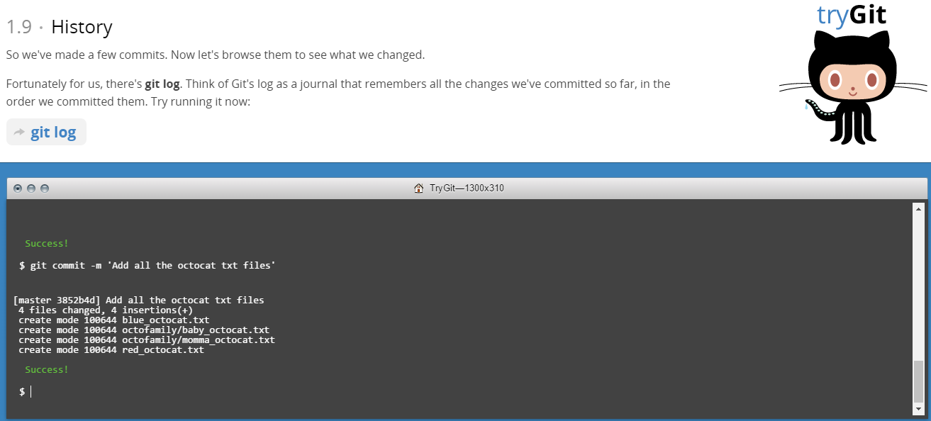

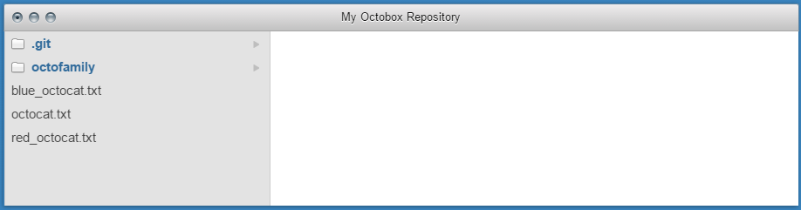

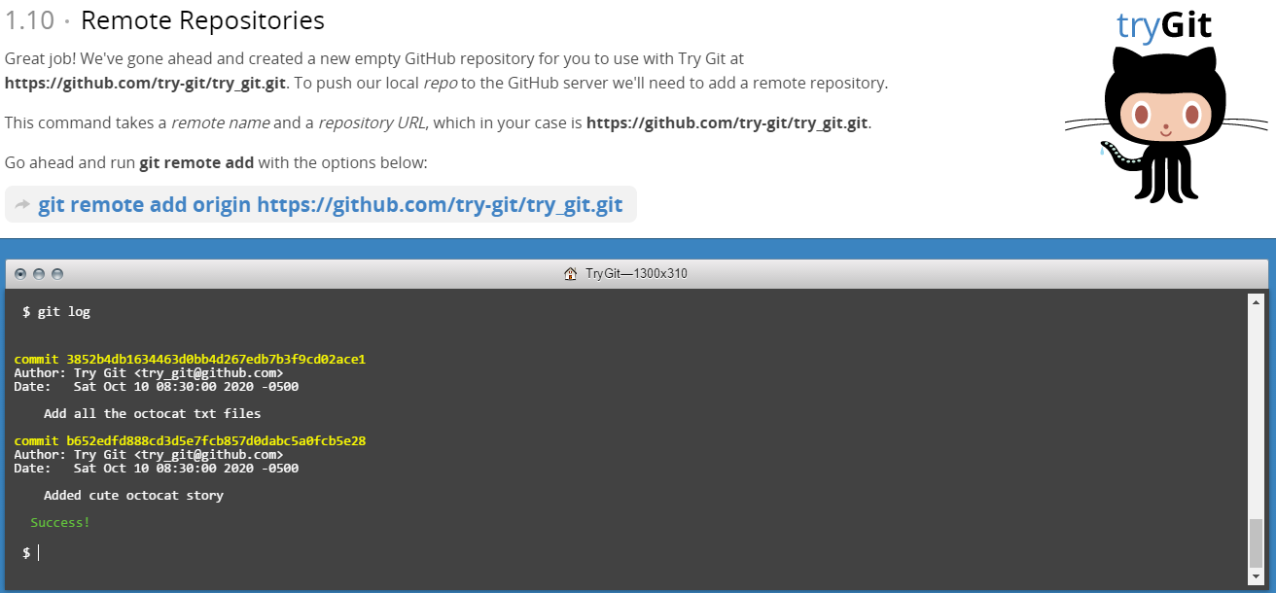

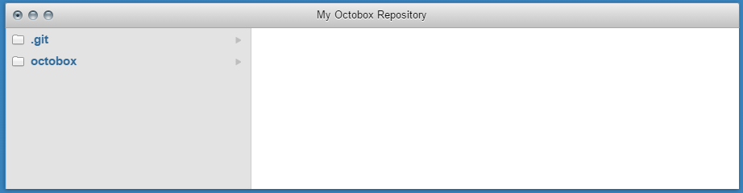

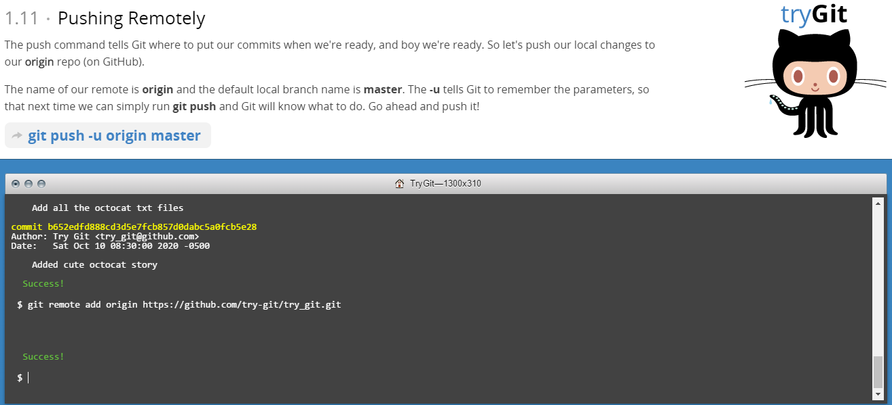

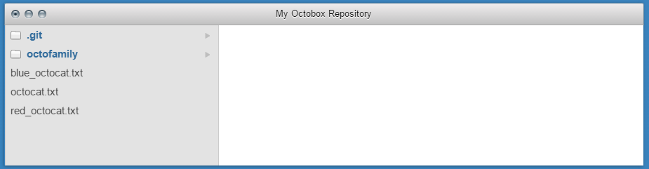

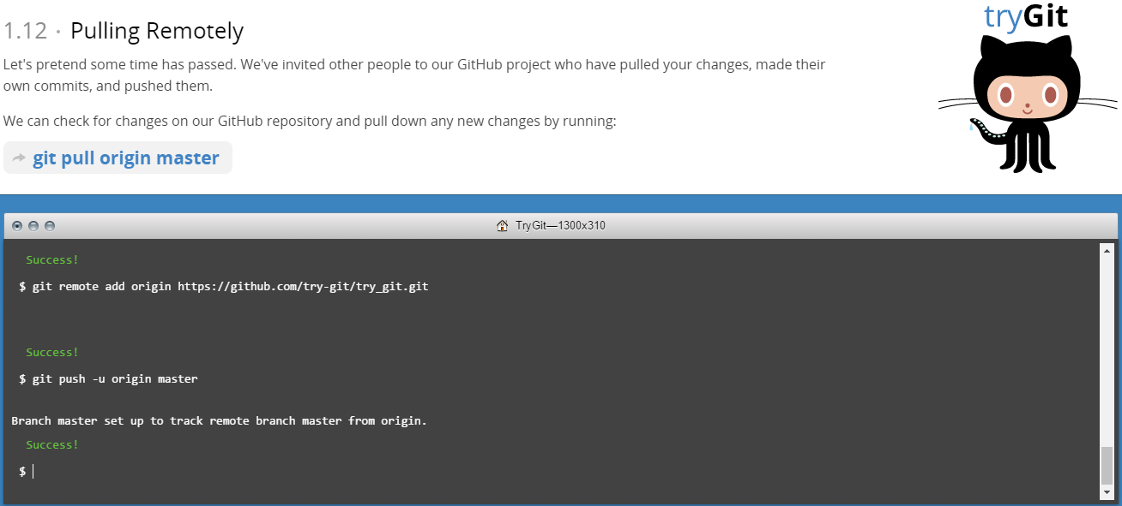

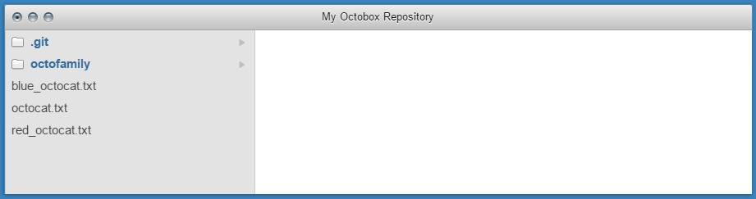

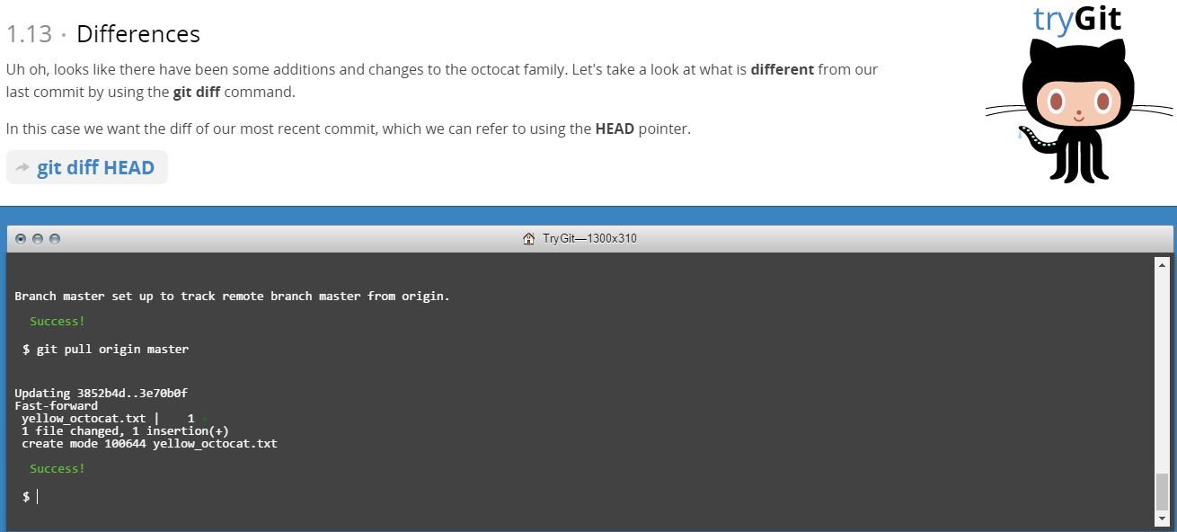

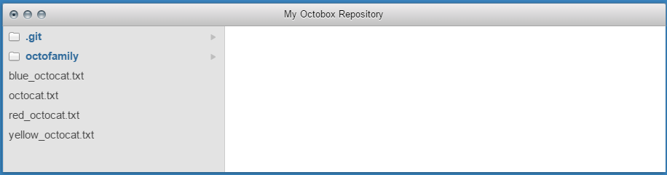

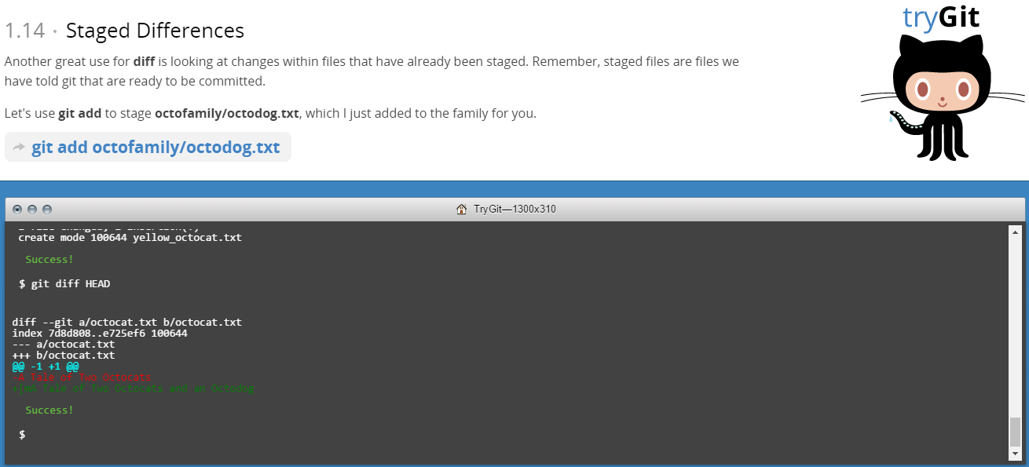

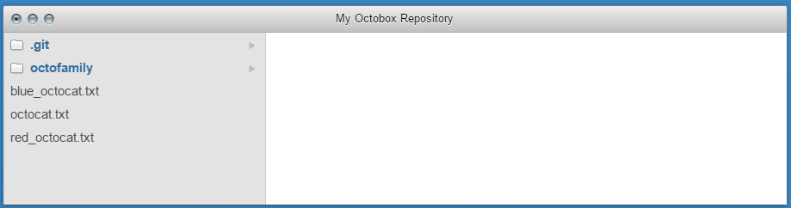

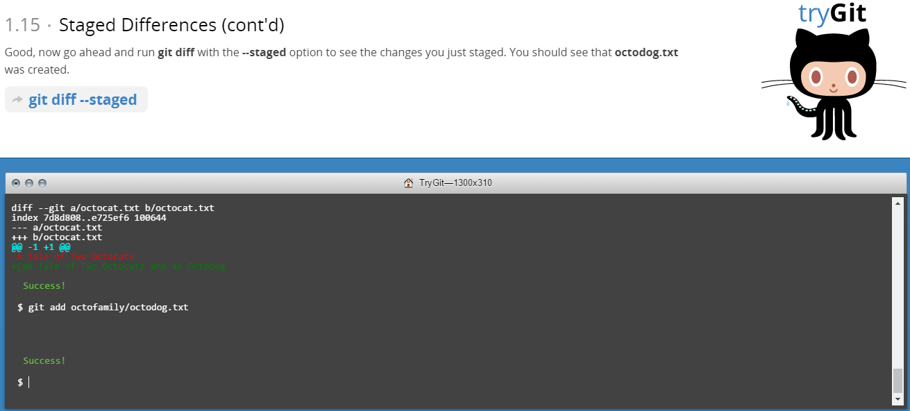

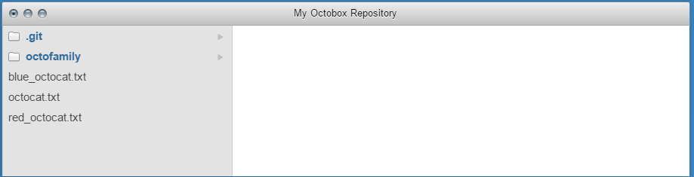

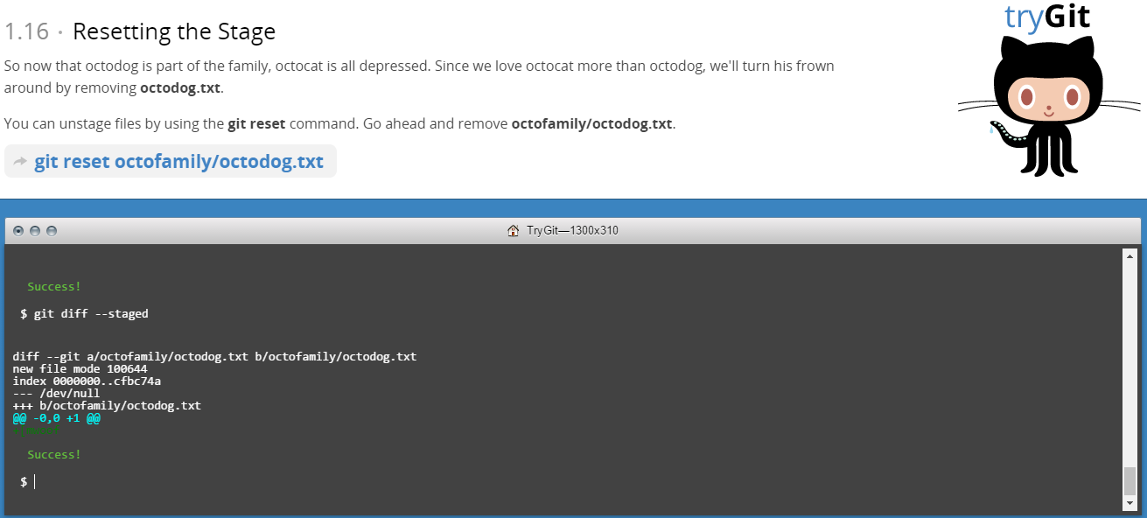

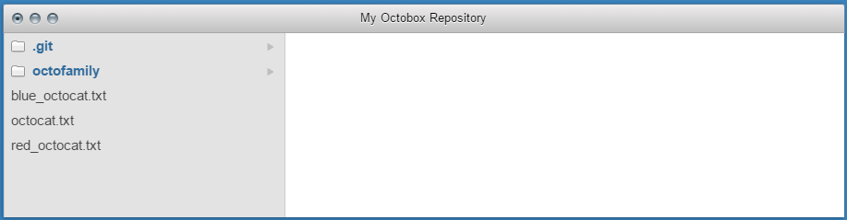

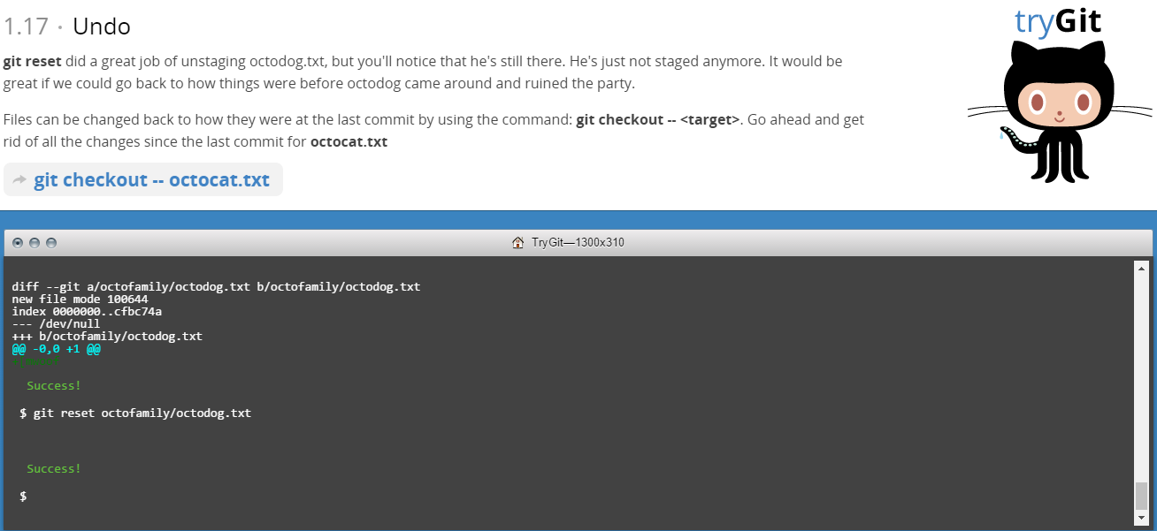

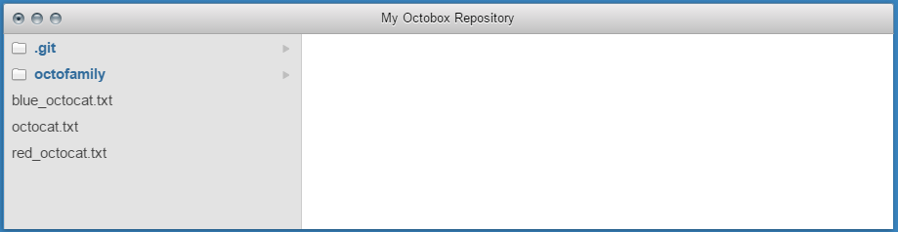

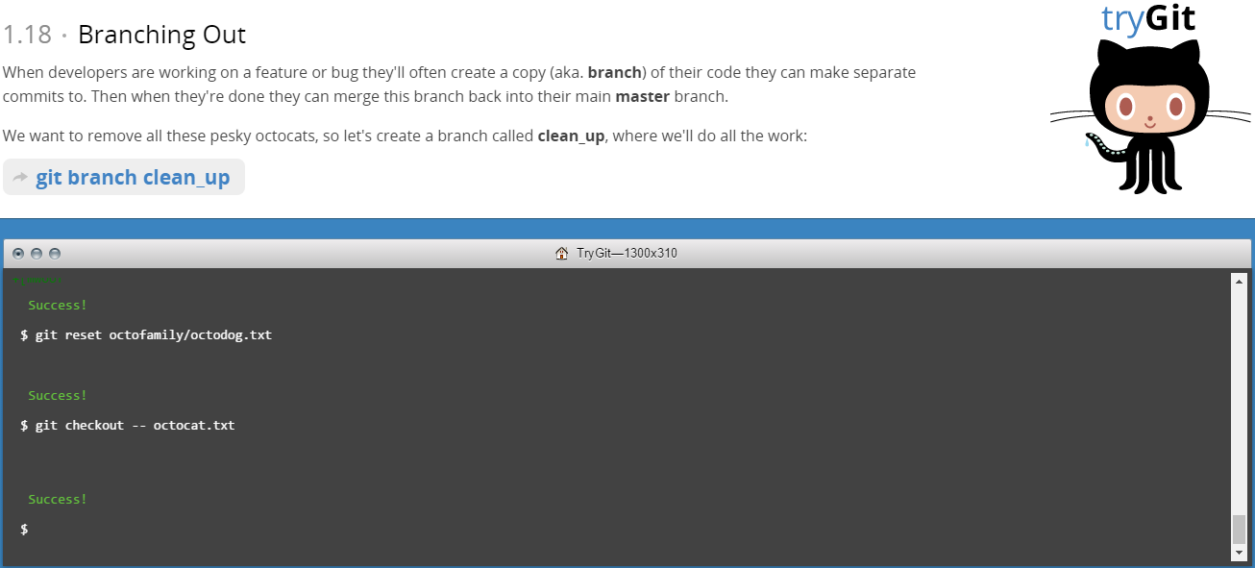

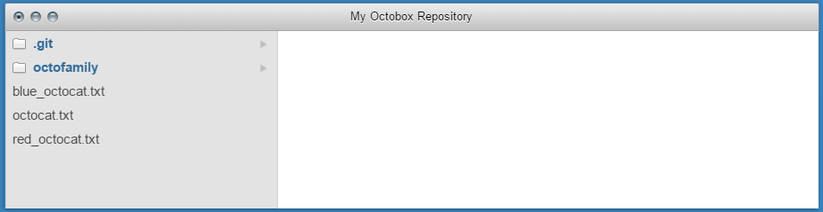

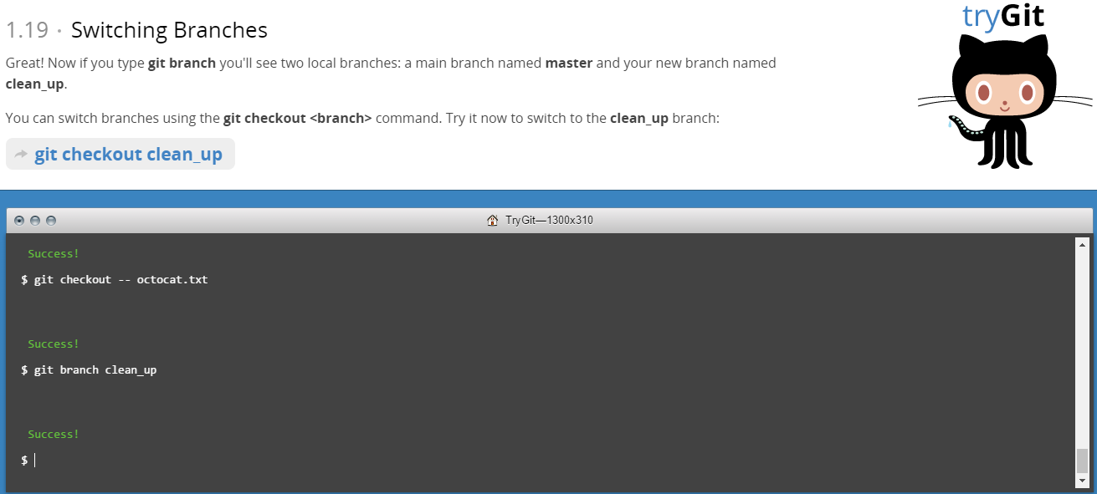

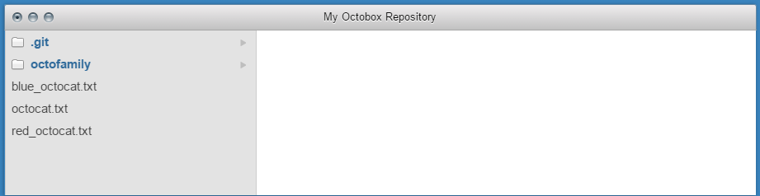

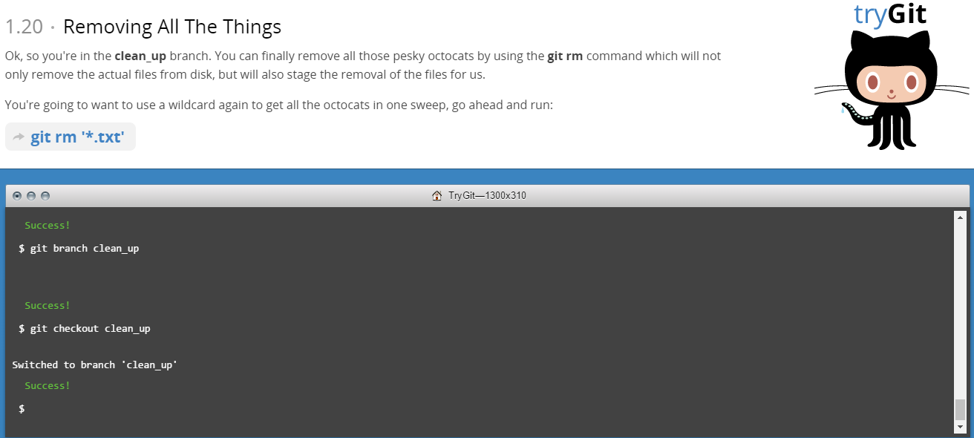

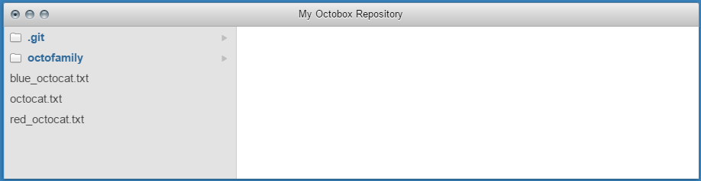

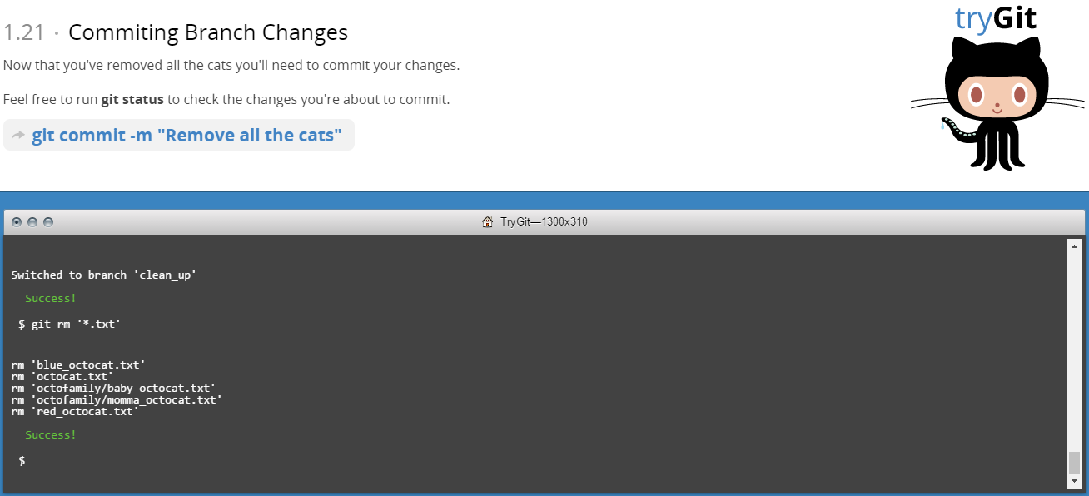

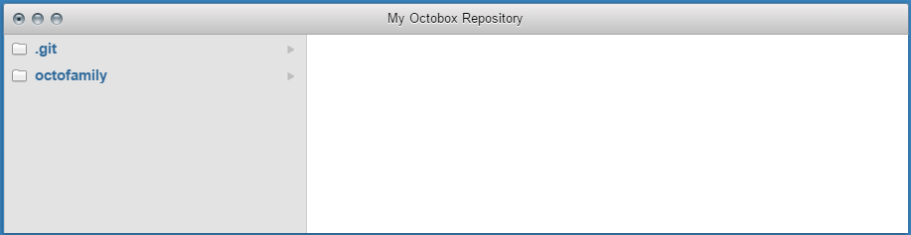

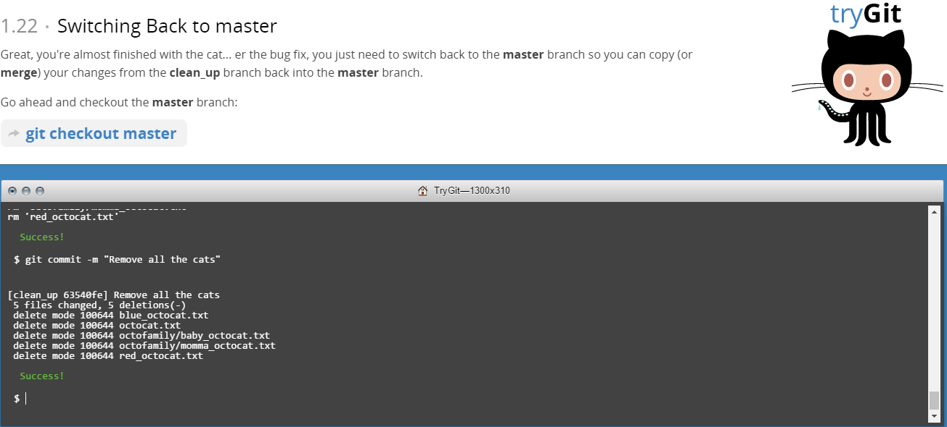

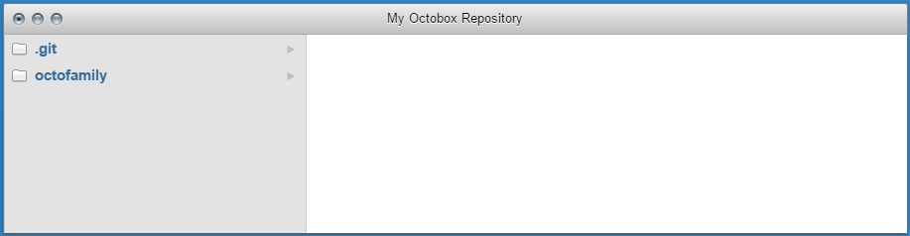

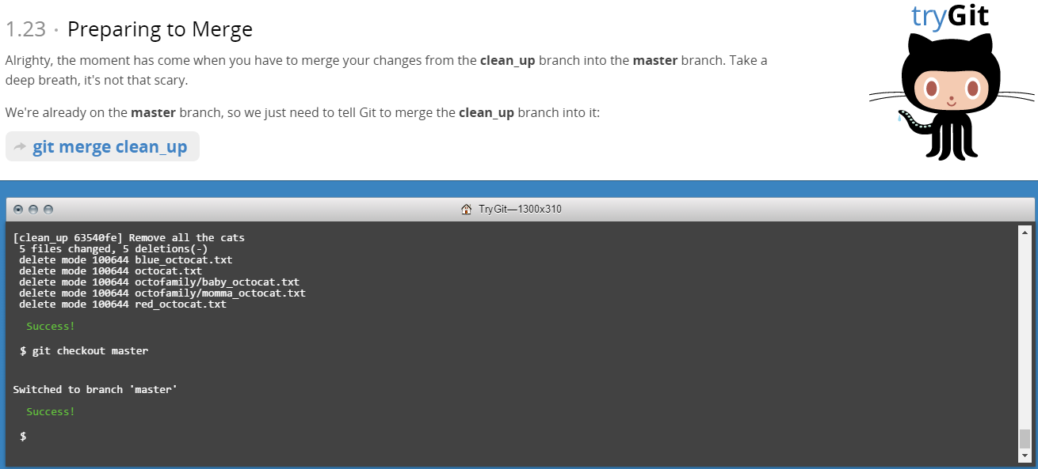

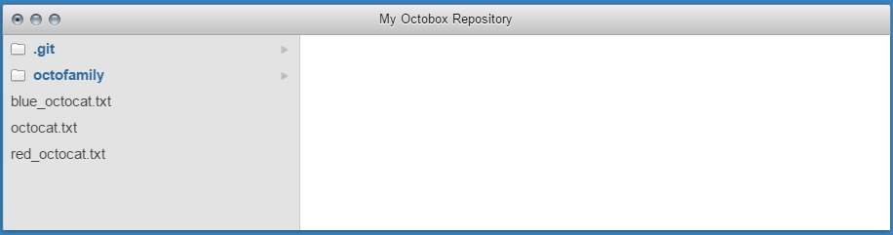

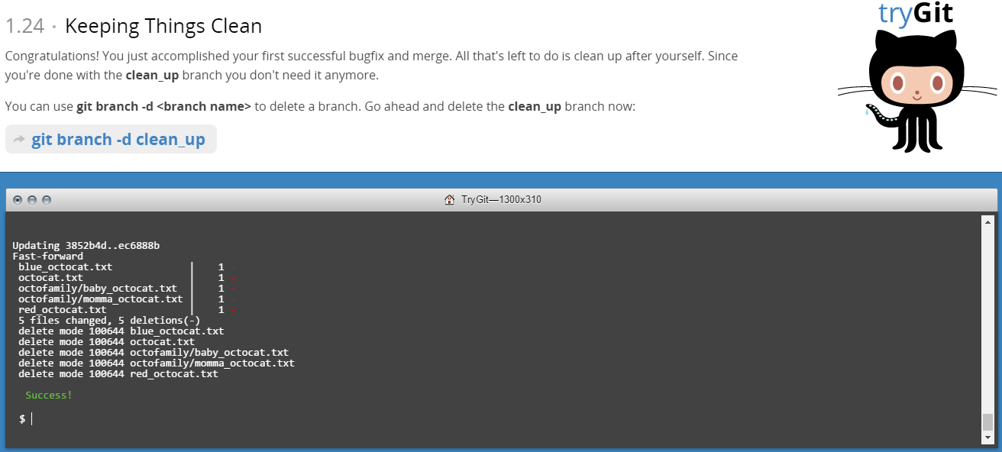

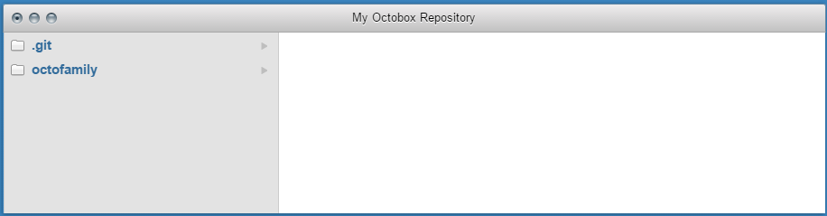

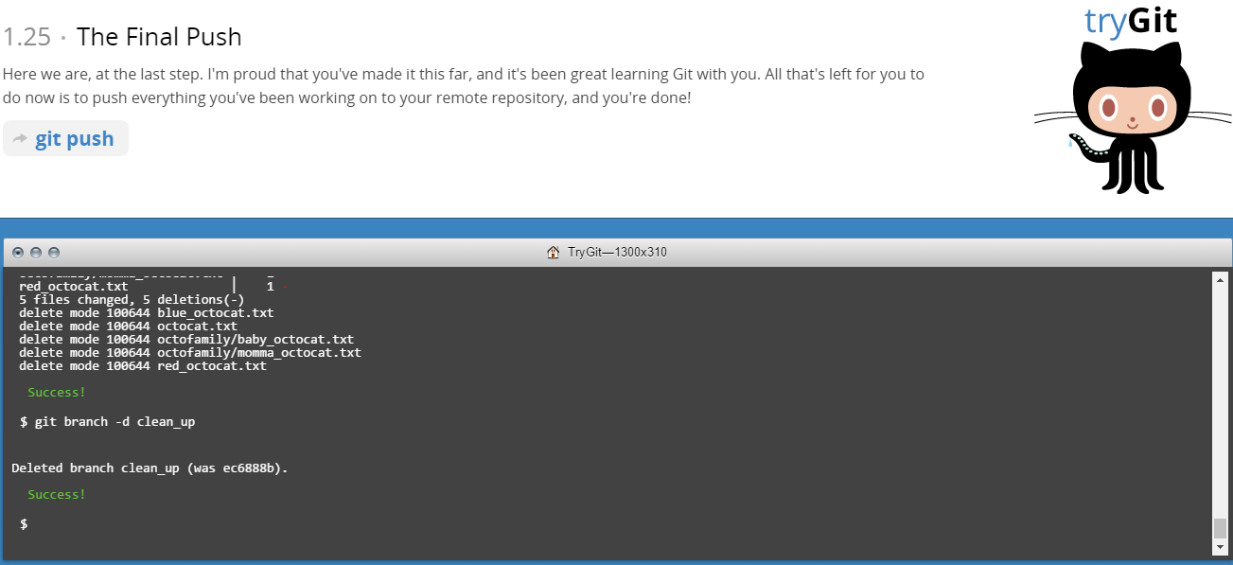

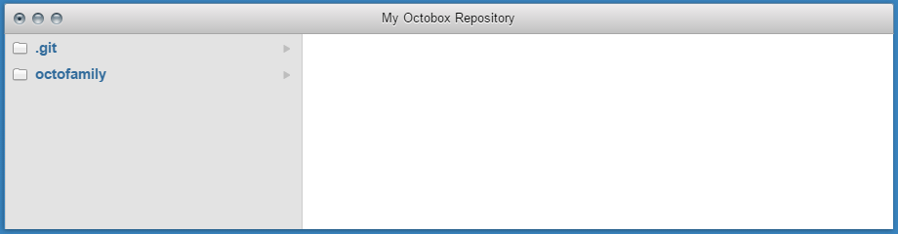

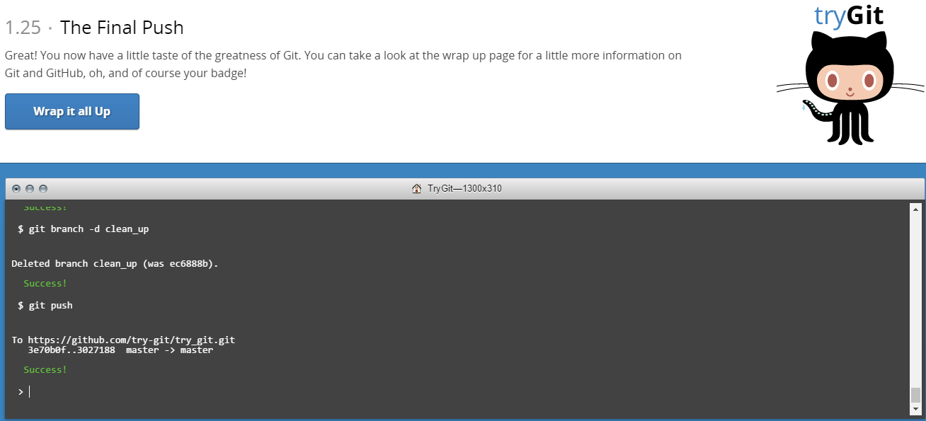

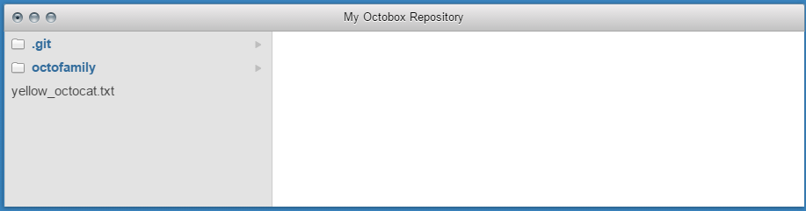

**PART-5**

**Define the following terms in the context of Git (2 lines maximum):**

1. **Repository**

Repository in Git is utilized for project management as well as files which are present in project. Management is important due to collaboration of many people working together on single project which changes data in the file time and again. Git stores history of our work in a data structure called as repository.

1. **Commit**

Git commit "records changes to the repository" which is used in connection with your local repository.

1. **Push**

Git push "updates remote refs along with associated objects" which is used to interact with a remote repository.

1. **Branch**

Branch is a lightweight movable pointer which points to one of the many commits in Git. By default, branch name is called master. And this master branch points to the last commit.

1. **Fork**

Fork in Git is used to create a copy of a repository which allows coder to freely experiment on copy of project without affecting original project.

1. **Merge**

Merge in Git is used to link two or more development histories together. While git pull request, merge command is used to combine the changes from another repository.

1. **Clone**

Clone in Git is used to Clone a repository into a new directory and also creates remote-tracking branches for each branch in the cloned repository in the newly created directory.

1. **Pull**

Git pull is used to fetch the file with git fetch command along with given parameters and integrate with another repository with git merge command.

1. **Pull request**

Pull request in Git let other coders know about the changes you have made to GitHub repository by push command. Once a pull request is sent, interested coder can review, edit, modify and even push by following commits.

**PART 7**

**List the commands and strategy you use to do this part of the exercise in the LastnameFirstnameGitTutorial-mm-dd-yyyy.docx file and push it to:** [**https://github.com/yourpseudo/CS6412016**](https://github.com/yourpseudo/CS6412016)**.**

**A) Add your name (last name, first name) in the file, add a comment (date and time) (REQUIRED), and update the README.md file at: https://github.com/paceuniversity/courses.**

-First, I retrieve the README.md file from <https://github.com/paceuniversity/courses>

-I click on Edit the file from project option.

-Then I added my Name with Date and Time in README.md file.

-Next, I click on Propose File Change option.

-Then I Pull request for Update in README.md file.

-Lastly, the request was accepted by Professor and update was visible in File.

**B) Push the Word file in YOUR GitHub account in a repository called CS6432016.**

-Open Git Bash and initialize git

$ git init

-Created a new remote repository

$ git remote add githubmanish <https://github.com/manish57/CS6432016.git>

-Adds all the file to your local repository

$ git add –all

-Commits the changes

$ git commit –m “initial commit”

-Push the changes in your local repository

$ git push –u githubmanish master --force