**Page Details**

**Purpose:**

The purpose of this page (refer to **eADR_dashboard** screenshot) is user to select a dropdown values based on certain values like DRB/DRA. Based on DRB/DRA below list of dropdown values will get updated.

**Description:**

In this page, user selects a DRB members from each dropdown i.e., DRB Members, Caltrans, Contractor and out of these three, one will be selected as Chair using checkbox. The reason for the radio button is not used, because of each row would need to have two fields one dropdown and one radio button like table, but in the out-of-the-box AEM forms, the size of the selection area is small due to which user cannot visualize properly. So, single checkbox is used every row of DRB Members section.

For the DRB Nominees, user will select a four dropdowns for each Caltrans and Contractor. Here, we customized the dropdown, when user selects a dropdown, search area and dropdown values will be visible and user can type the required name to select the value from the dropdown. This makes easy to user when there is lot of values present inside dropdown.

Once the data is sent to the backend process, the fields data will get bind to the XDP document and PDF document is generated. Once it is done, View PDF button is shown to the user and views the PDF document by using the button.

**Libraries used:** select2.js

**Sample Image of select2.js dropdown:**

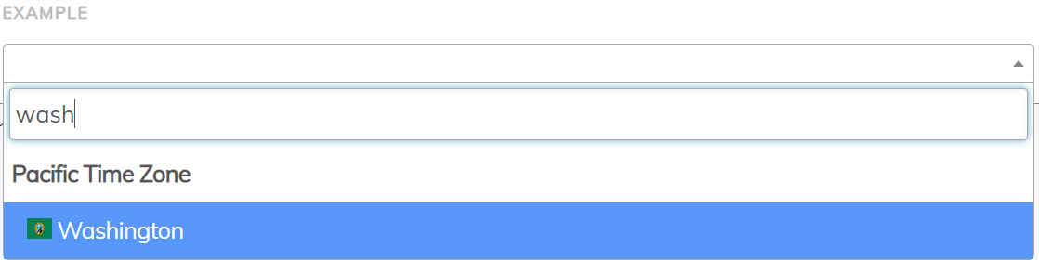

**Frontend Code Reference:** Refer the **Frontend_code** folder.