**Project Details**

**Project Summary**

**Project Objective:** The objective of this project is to address disputes between two entities, namely, contractors and government-based organizations. This will be achieved through the use of a system portal where contractors can access the claims on behalf of affected individuals.

**Technology Solution:** Adobe Experience Manager (AEM) is a content management system (CMS) technology is utilized throughout the application.

**Project Idea:** Users can engage with the website through the Adobe Experience Manager (AEM) content management system. The website is designed to be portable, allowing users to interact seamlessly across various devices such as mobile phones, tablets, and desktop computers.

**Technology Implementation**

To streamline the claim process, the Adobe Experience Manager (AEM) content management system is employed. This enables contractors to file bids for individuals affected by damage through a smooth interface, efficient workflows, user interactions, and a responsive application design.

For building the website, various AEM functionalities were employed throughout the entire application. These include:

**Themes:**

Themes in Adobe Experience Manager (AEM) are predefined styles, layouts, and design elements that ensure a consistent visual appearance across a website or application. Users can define and manage themes to maintain a unified look, including aspects like color schemes, typography, and spacing for a cohesive user experience.

For this project, you can find the folder named “etc”.

**Clientlibs:**

In AEM, "clientlibs" refer to client libraries, which are collections of client-side resources such as CSS stylesheets, JavaScript files, and images. These resources are grouped together to facilitate the efficient management and delivery of assets to the client-side (browser) of an AEM application.

To customize both the functionality and design of the pages, I have centralized common code within client libraries (clientlibs). This approach allows for efficient management and maintenance of shared code elements across multiple pages on the website.

For this project, you can find the folder named “apps”.

**Template:**

Throughout the entire application, I utilized a generic template to construct a page that incorporates both header and footer components.

For this project, you can find the folder named “template”.

**PDF Generation:**

Each form button action involves the integration of form data with PDF through XDP to PDF conversion. This ensures that users can access the submitted information in the form of a PDF after logging in to the webpage.

**External Services Used:**

This project is integrated with Adobe Sign to capture the esignature from the end user.

**Approaches to Development**

**Frontend Development Approach:**

In the frontend development, we used web pages to design the website and implemented the fragment approach to enhance reusability by incorporating the same functionality throughout the entire website. This method allows for the efficient reuse of specific code segments across multiple sections of the site.

On a high level, if you need to know how website pages are created, please refer **content** folder.

**Backend Development Approach:**

In the backend development process, I employed the AEM Workbench to establish communication with the frontend application. This was achieved through the workbench process, utilizing REST APIs. The Oracle database was utilized to store data, including prefill information and submit action data.

**Design Approach:**

Following design example illustrates how the signature is captured from the user using Adobe Sign by clicking on “View PDF” button inside the application.

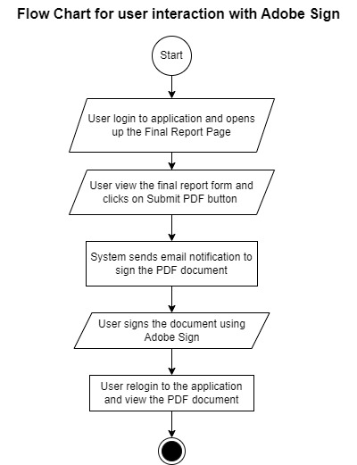

In this process, the user logs into the application, views the final report, and receives an email notification to sign the PDF document using the Adobe Sign API. After the user completes the signature process, they can see the submitted document within the application on the same page.