**[Assignment]**

**Technical Specification**

Submitted By

[Manish Yadav]

**Technology Used:**

1. Spring boot

2. Derby database

3. Spring rest-api

4. Java 1.8

**Environment setup:**

Go to eclipse file->Import->Existing Maven project

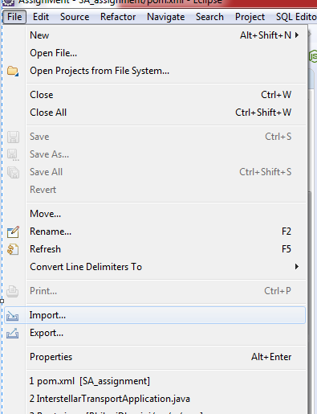

Perform maven operation ->Maven clean->maven update->maven install

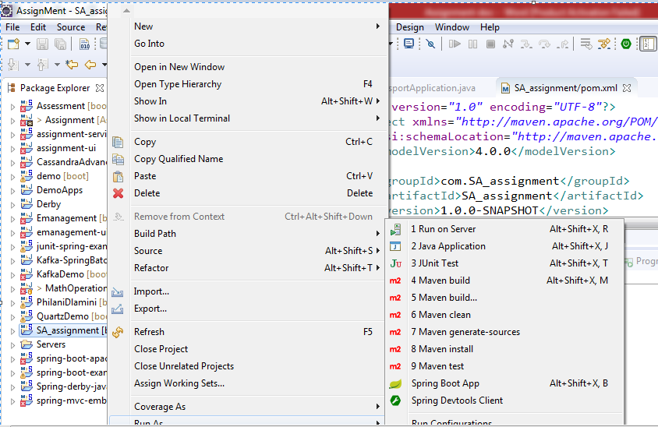

Go to->package->com.sa.assignment->**InterstellarTransportApplication**

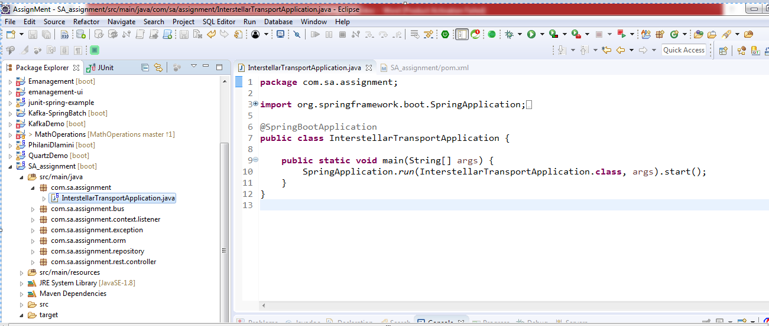

Run as->Spring boot application.

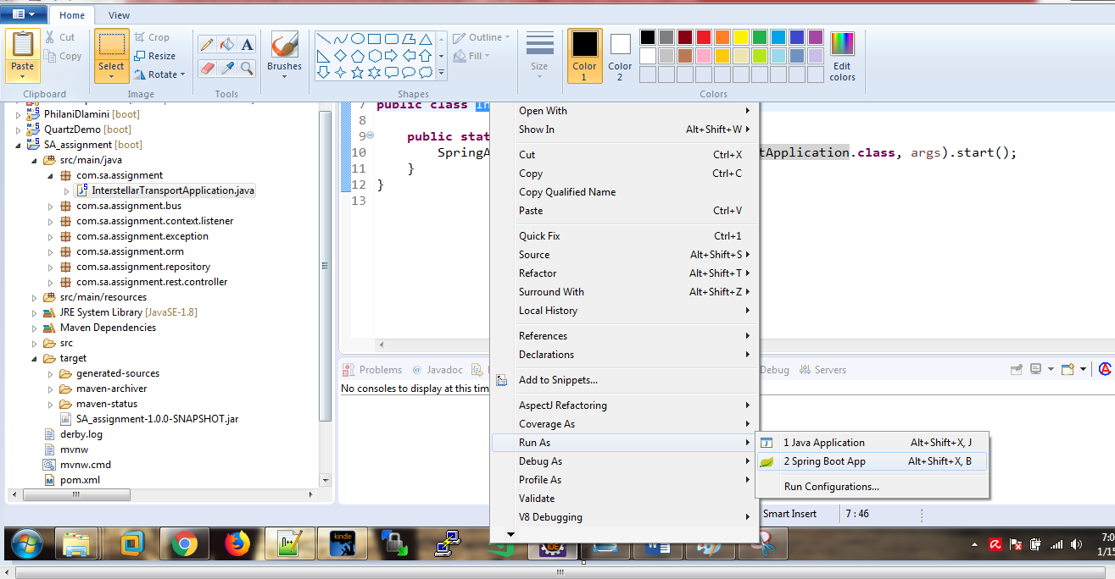

Note :Front end not available to insert planet in to db instead of that using Excel file to insert data into derby data base please check log’s

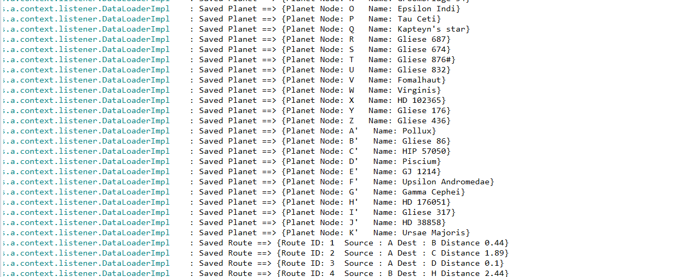

* Finds the shortest path given the source and destinaiton

* **@param** source source node

* **@param** destinaiton destinaiton node

* **@Usage** http://localhost:8080/shortestpath/A/Z