**Project Setup**

**1. Import maven project form eclipse.**

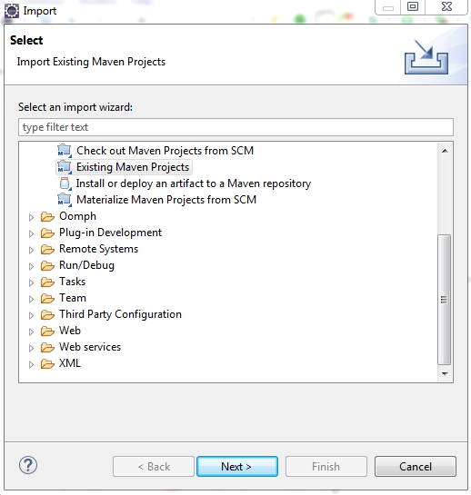

**2. After import perform maven update /Install**

**Please update project**

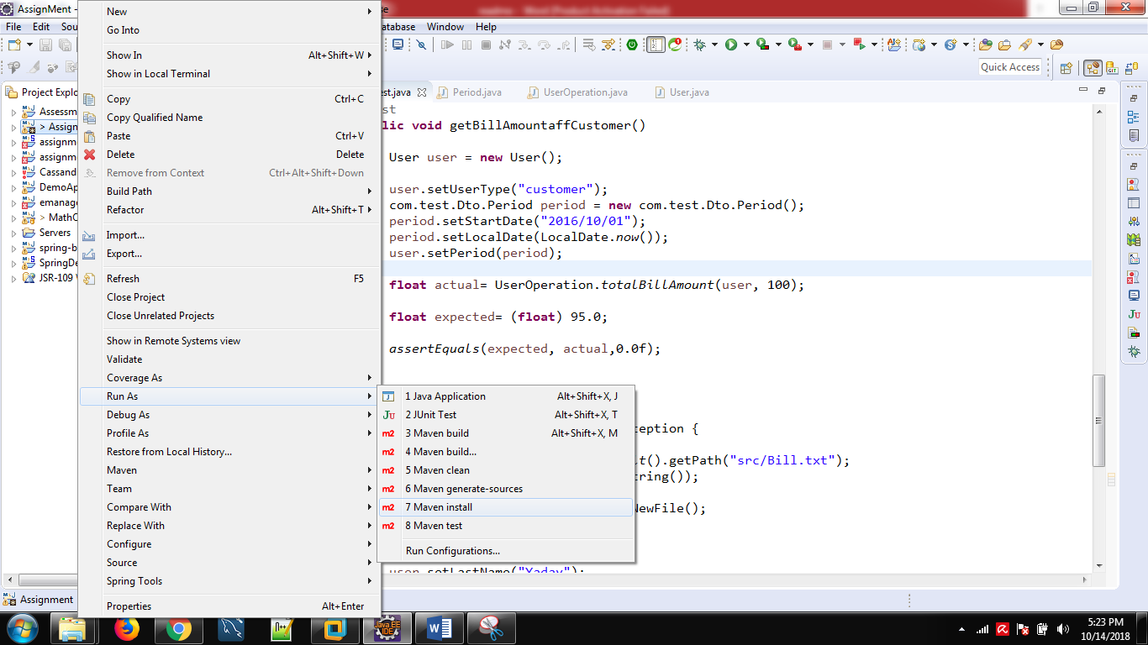

**3. Go to src>test>java folder run as junit test**

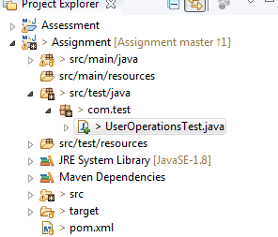

**4. Find the output under Bill.text**

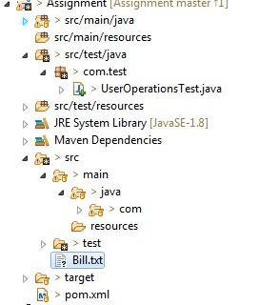



**5. for code Coverage report**

**A. perform maven install**

**Go to ->target folder ->jacoco-ut->com.test.Dto->run index.html**

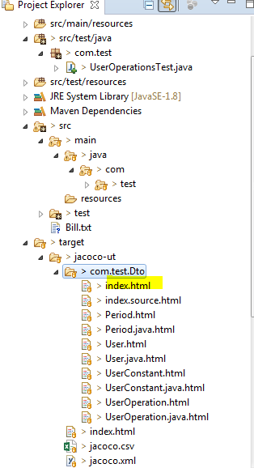

**You will get the coverage report :jcacao report**

