**[Assignment]**

**Application (Web) Technical Specification**

Submitted By

[Manish Yadav]

**Configuration and Technology**

1. Junit

2. Spring Web

3. Database using for running for junit . Delete database table’s data for full coverage.

* Run Test Case Using Juint

Under the assignment-service

Go to-> testsrc->com.assignment.TDDTest->FileUploadTestRunner.java

Right Click->Run as junit

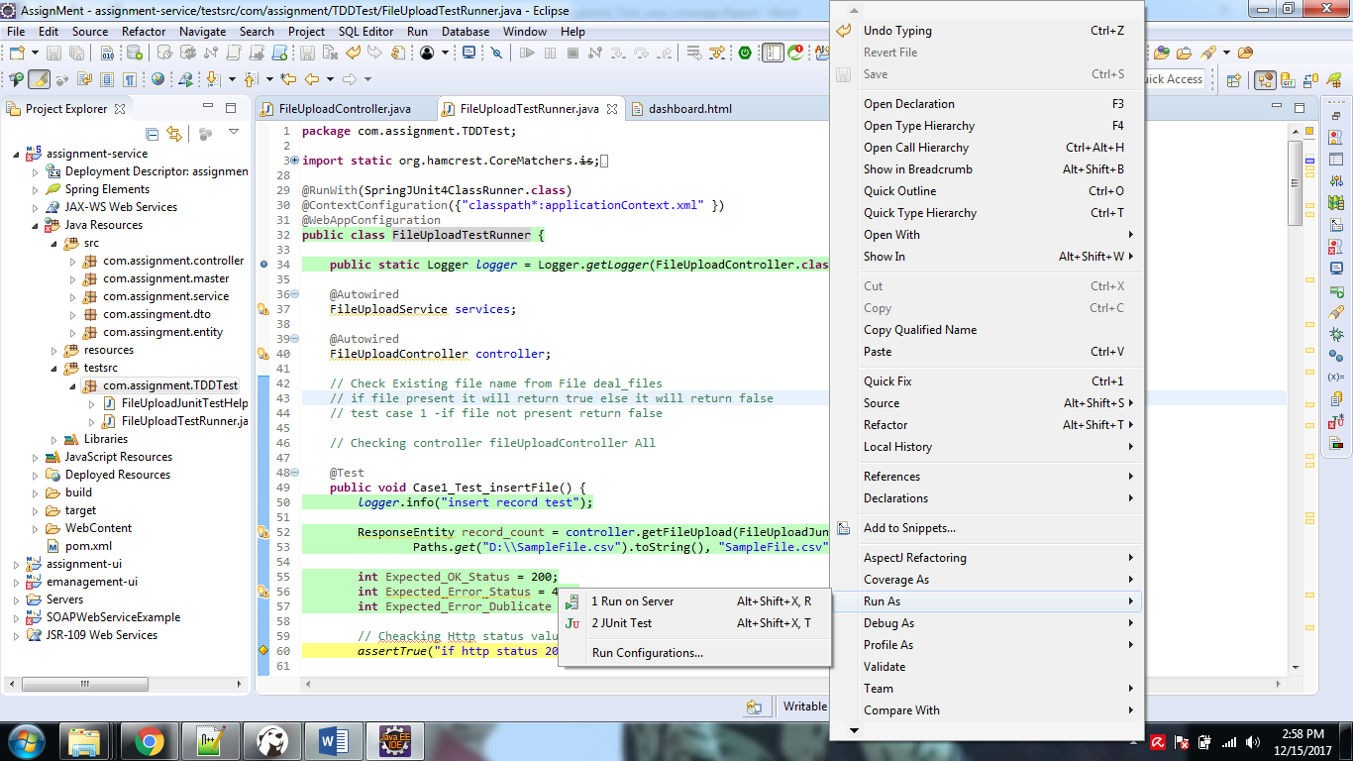

It will give below Result:

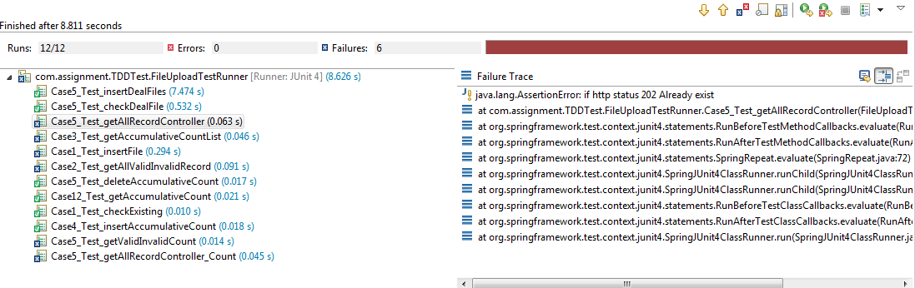

**Code Coverage Percentage**

* Code coverage

Under the assignment-service

Go to-> testsrc->com.assignment.TDDTest->FileUploadTestRunner.java

Right Click->coverage as ->junit

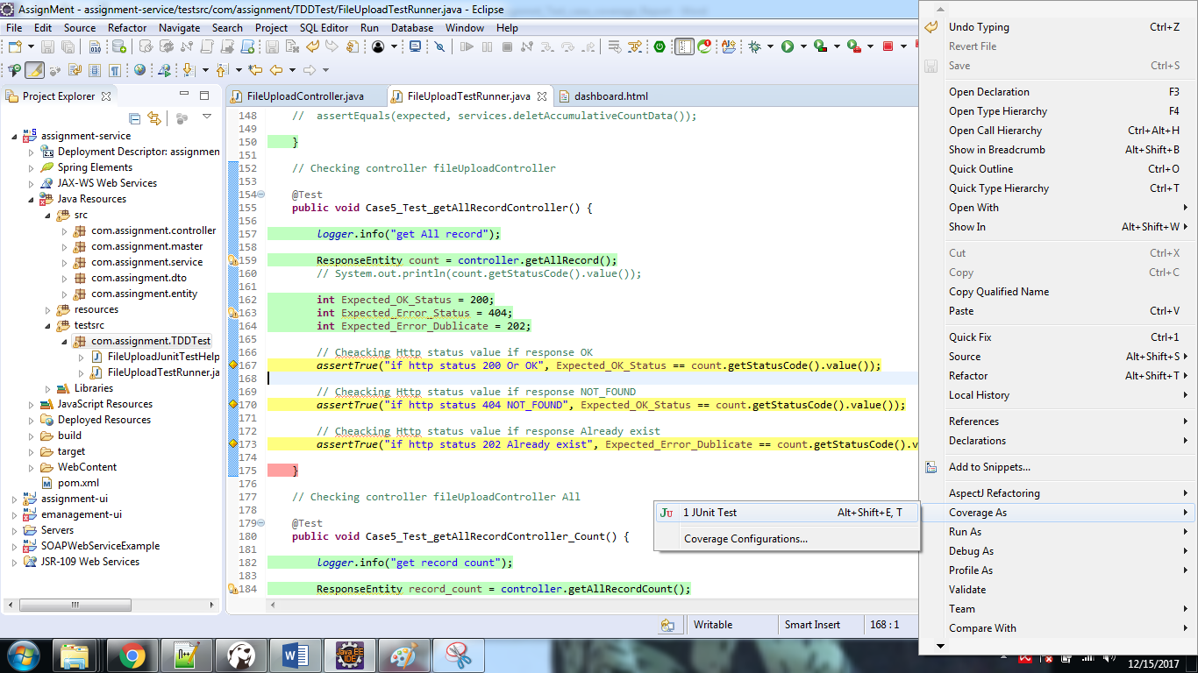

It will give below result

