HTTP methods:-1 POST
2GET
3.DELETE
4.PUT

Difference between Router and Switch
Both Router and Switch are the connecting devices in networking. A router is employed to settle on the littlest path for a packet to achieve its destination.
The main objective of router is to connect various networks simultaneously and it works in network layer, whereas the main objective of switch is to connect various devices simultaneously and it works in data link layer.
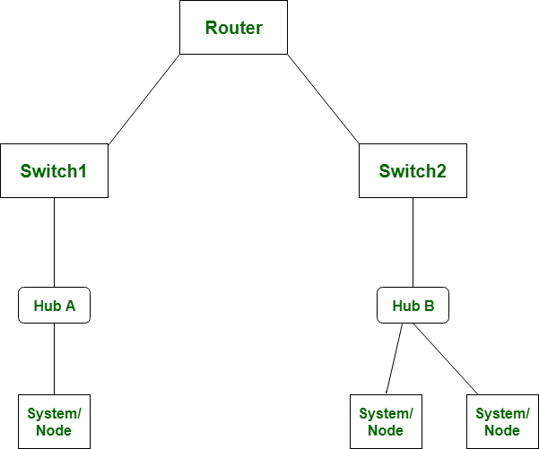
Let’s see that the difference between router and switch:
S.NO | Router | Switch
1. | The main objective of router is to connect various networks simultaneously. | While the main objective of switch is to connect various devices simultaneously.
2. | It works in network layer. | While it works in data link layer.
3. | Router is used by LAN as well as MAN. | While switch is used by only LAN.
4. | Through router data is sent in the form of packet. | While through switch data is sent in the form of packet and frame.
5. | It is a full duplex mode transmission. | It is also a full duplex mode transmission.
6. | There is less collision take place in router. | While there is no collision take place in full duplex switch.
7. | Router is compatible with NAT. | While it is not compatible with NAT.
8. | The types of routing are: Adaptive and Non-adaptive routing. | The types of switching are: Circuit, Packet and Message Switching.

ed Black Tree vs AVL Tree
- Difficulty Level : Easy
- Last Updated : 09 Jan, 2019
In this post we will compare Red Black Tree and AVL Tree.
Red Black Tree:
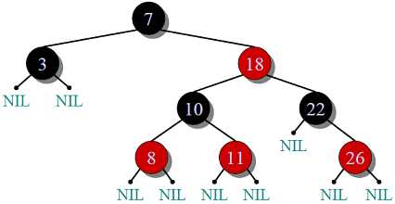
Properties:
- Self-Balancing is provided by painting each node with one two colors(Red or Black).
- When Tree is modified, new tree is subsequently rearranged and repainted.
- It requires 1 bit of color information for each node in tree.
Constraints maintained by Red Black Tree:
- Root is always black.
- All NULL leaves are black, both children of red node are black.
- Every simple path from a given node to any of its descendant leaves contains the same number of black
nodes.
- Path form root to farthest leaf is no more than twice as long as path from root to nearest leaf.
AVL(Adelson-Velskii and Landis) Tree
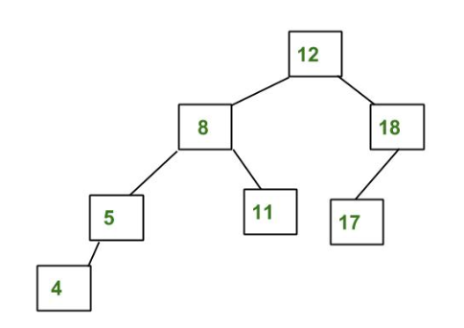
Properties:
- Height difference of left and right subtree of node should be less than 2.
- Re-balancing is done when heights of two child subtrees of a node differ by more than one.
- Faster retrievals as strictly balanced.
Difference:
- AVL trees provide faster lookups than Red Black Trees because they are more strictly balanced.
- Red Black Trees provide faster insertion and removal operations than AVL trees as fewer rotations are done due to relatively relaxed balancing.
- AVL trees store balance factors or heights with each node, thus requires storage for an integer per node whereas Red Black Tree requires only 1 bit of information per node.
- Red Black Trees are used in most of the language libraries like map, multimap, multiset in C++ whereas AVL trees are used in databases where faster retrievals are required.

- The AVL trees are more balanced compared to Red Black Trees, but they may cause more rotations during insertion and deletion.

- The path from the root to the furthest leaf is no more than twice as long as the path from the root to the nearest leaf.
- What is the worst case possible height of Red-Black tree? Assume base of Log as 2 in all options

2Log(n+1)

Difference between Process and Thread:
S.NO | Process | Thread
1. | Process means any program is in execution. | Thread means segment of a process.
2. | Process takes more time to terminate. | Thread takes less time to terminate.
3. | It takes more time for creation. | It takes less time for creation.
4. | It also takes more time for context switching. | It takes less time for context switching.
5. | Process is less efficient in term of communication. | Thread is more efficient in term of communication.
6. | Process consume more resources. | Thread consume less resources.
7. | Process is isolated. | Threads share memory.
8. | Process is called heavy weight process. | Thread is called light weight process.
9. | Process switching uses interface in operating system. | Thread switching does not require to call a operating system and cause an interrupt to the kernel.
10. | If one process is blocked then it will not effect the execution of other process | Second thread in the same task couldnot run, while one server thread is blocked.
11. | Process has its own Process Control Block, Stack and Address Space. | Thread has Parents’ PCB, its own Thread Control Block and Stack and common Address space.

Difference between binary semaphore and mutex :
 | Binary Semaphore | Mutex
1. | Its functions based up on signalling mechanism | Its functions based up on locking mechanism
2. | The thread which is having higher priority than current thread can also release binary semaphore and take lock. | The thread which has acquired mutex can only release Mutex when it exits from critical section.
3. | Semaphore value is changed according to wait () and signal () operations. | Mutex values can be modified just as locked or unlocked.
4. | Multiple number of threads can acquire binary semaphore at a time concurrently. | Only one thread can acquire mutex at a time
5. | Binary semaphore have no ownership. | There is ownership associated with mutex because only owner can release the lock.
6. | They are faster than mutex because any other thread/process can unlock binary semaphore. | They are slower than binary semaphores because only thread which has acquired must release the lock.
7. | If you have number of instances for resource it is better to use Binary semaphore. | If you have single instance for resource it is better to use mutex.

