Puzzle 1 | (How to Measure 45 minutes using two identical wires?)

How do we measure forty-five minutes using two identical wires, each of which takes an hour to burn? We have matchsticks with us. The wires burn non-uniformly. So, for example, the two halves of wire might burn in 10 minutes and 50 minutes respectively
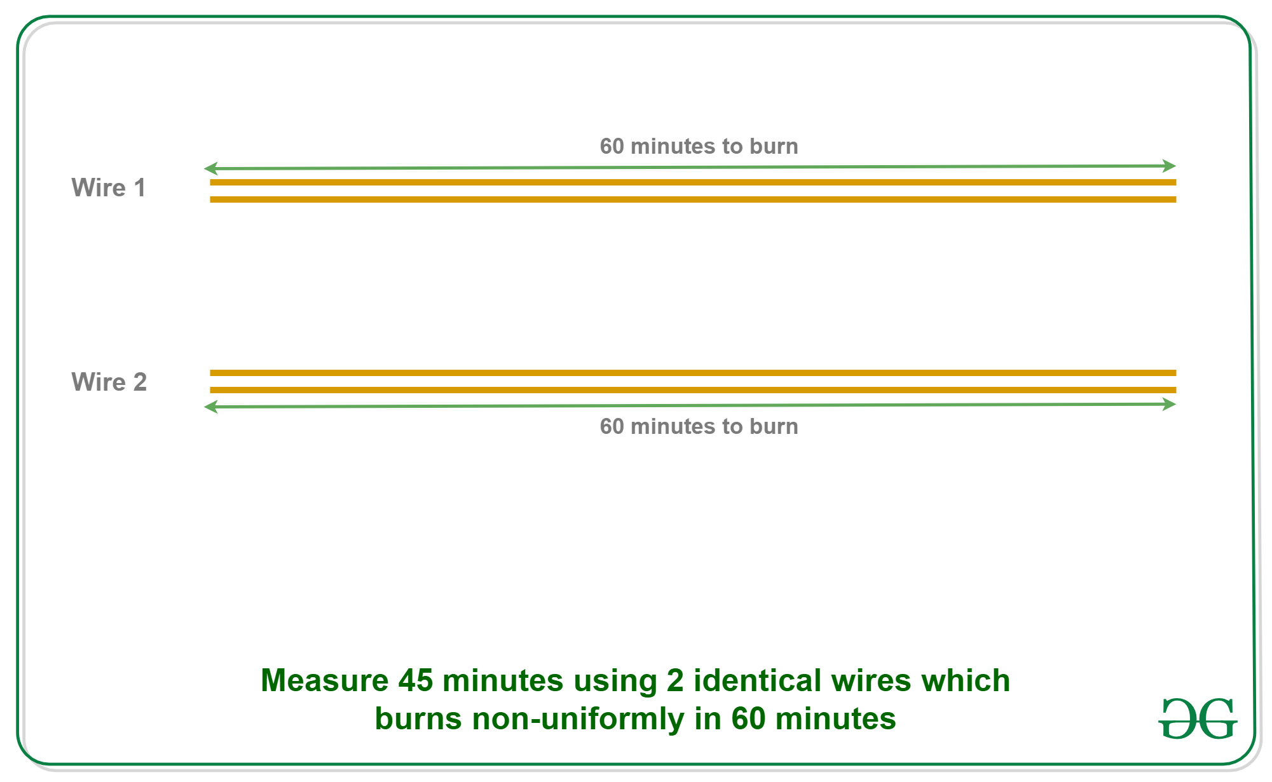Answer:
If we light a stick, it takes 60 minutes to burn completely. What if we light the stick from both sides? It will take exactly half the original time, i.e. 30 minutes to burn completely.
0 minutes – Light stick 1 on both sides and stick 2 on one side.
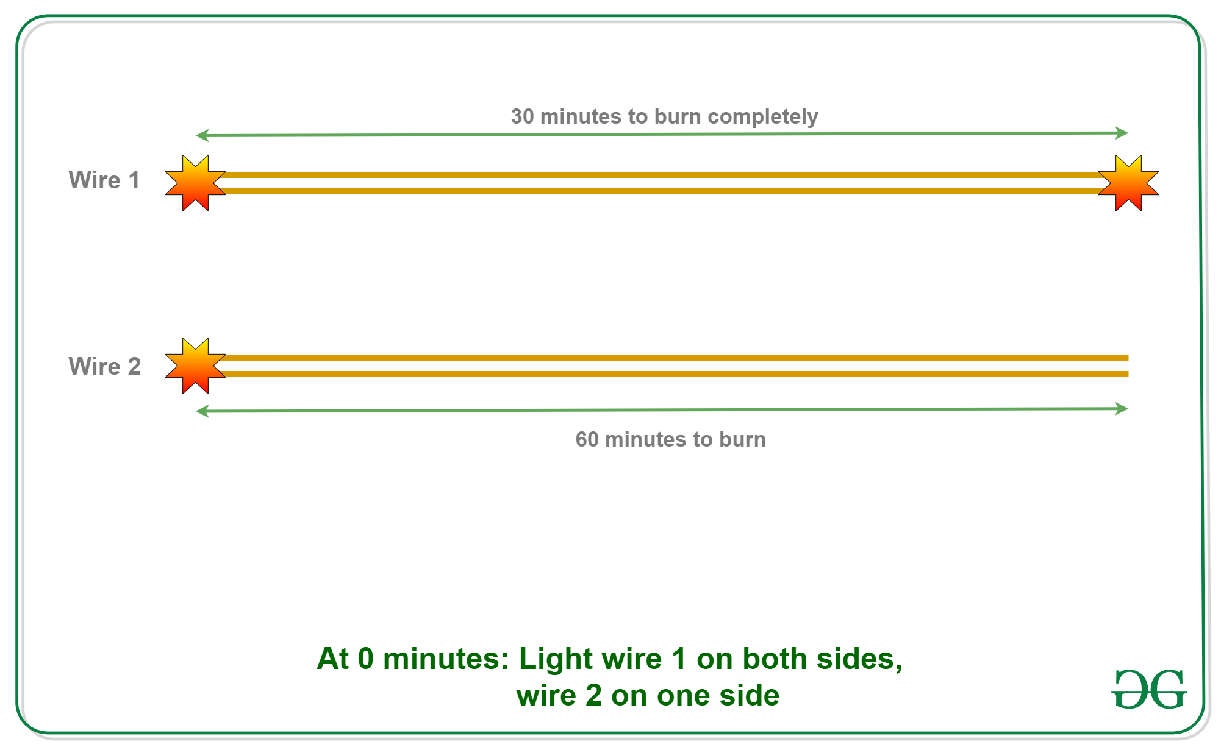
- 30 minutes – Stick 1 will be burnt out. Light the other end of stick 2.
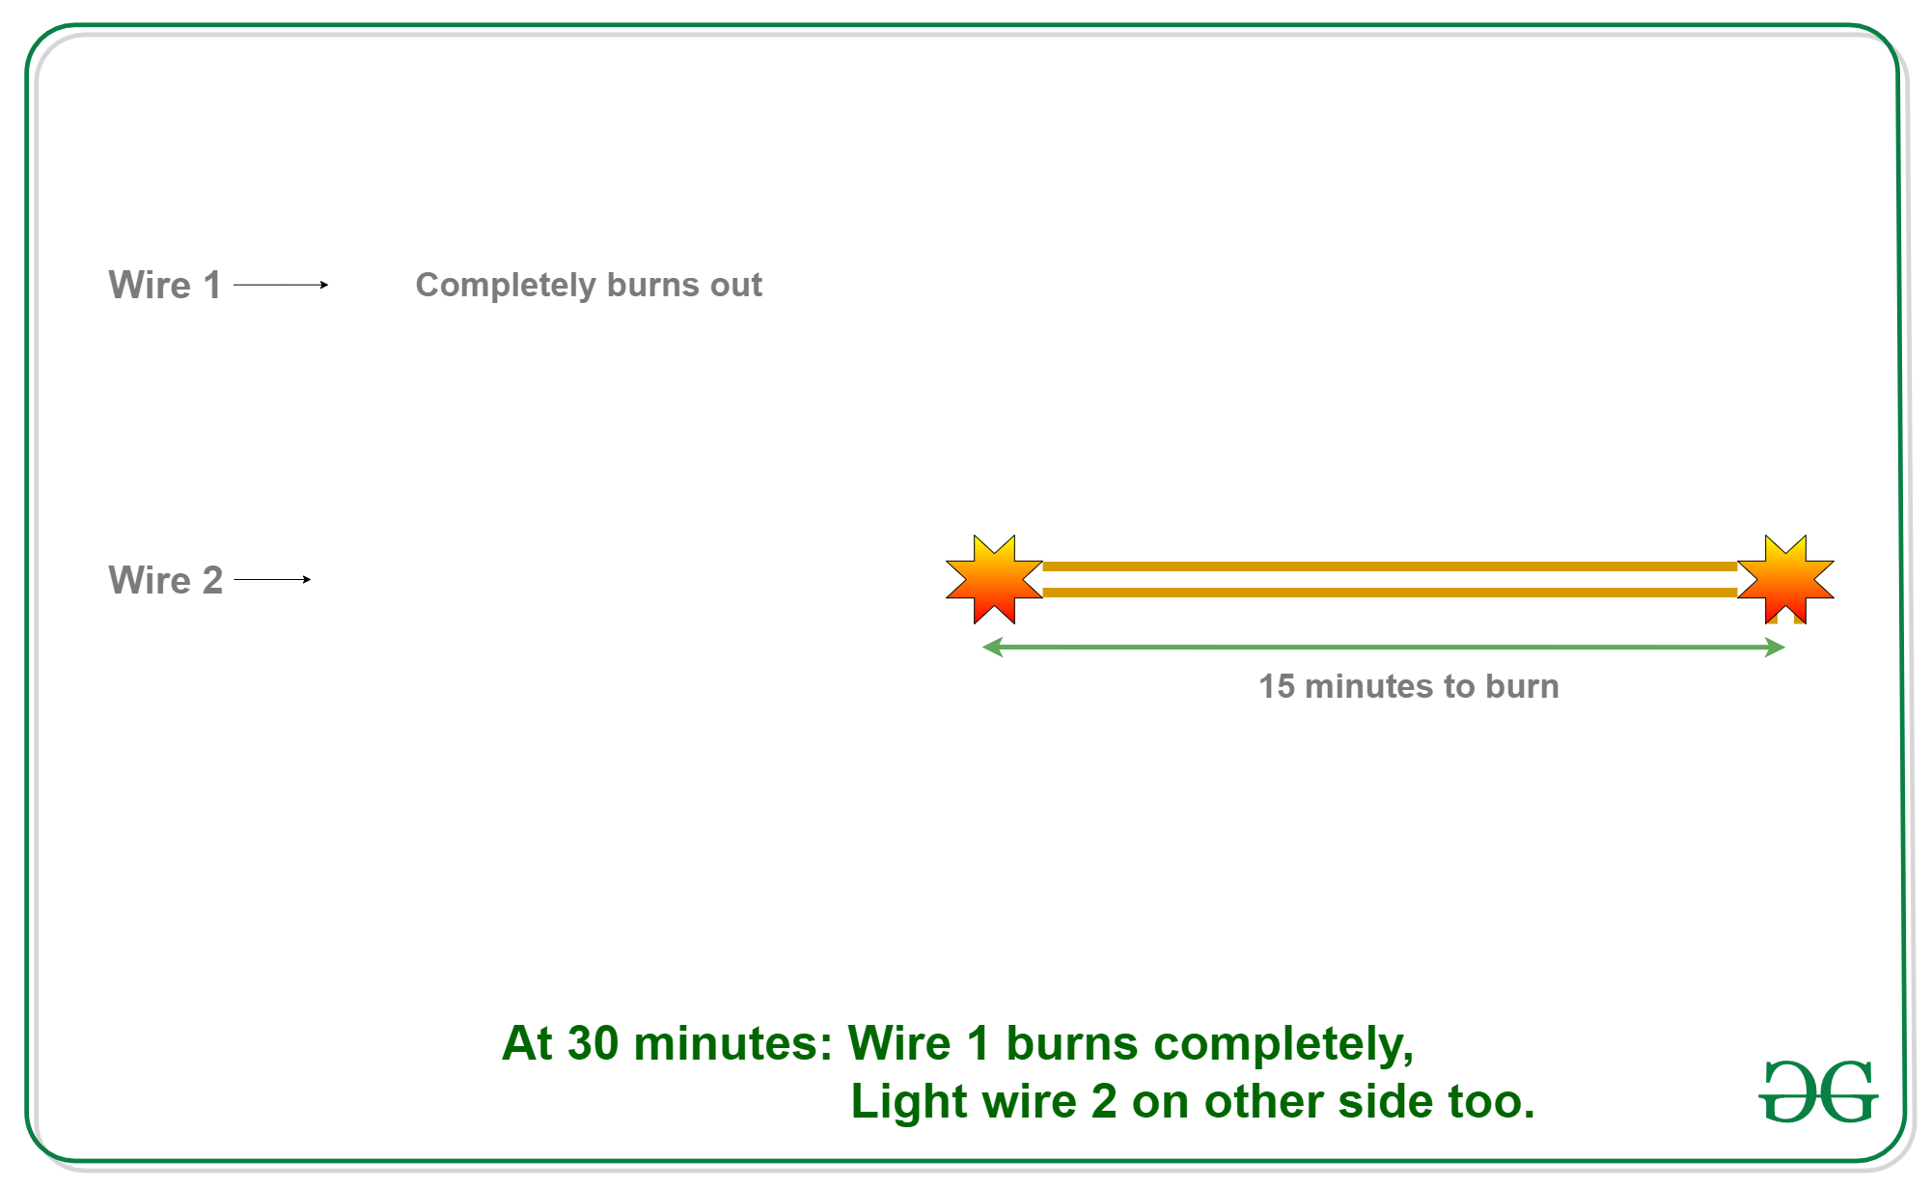
- 45 minutes – Stick 2 will be burnt out. Thus 45 minutes is completely measured.

Puzzle 2 | (Find ages of daughters)

Alok has three daughters. His friend Shyam wants to know the ages of his daughters. Alok gives him first hint.
1) The product of their ages is 72.
Shyam says this is not enough information Alok gives him a second hint.
2) The sum of their ages is equal to my house number.
Shyam goes out and look at the house number and tells “I still do not have enough information to determine the ages”.
Alok admits that Shyam can not guess and gives him the third hint
3) The oldest of the girls likes strawberry ice-cream.
Shyam is able to guess after the third hint. Can you guess what are the ages of three daughters?
Answer:
1) Product of ages is 72
Below are all possibilities to get 72 from product of three different ages:
1 * 1 * 72 = 72
1 * 2 * 36 = 72
1 * 3 * 24 = 72
1 * 4 * 18 = 72
1 * 6 * 12 = 72
1 * 8 * 9 = 72
2 * 2 * 18 = 72
2 * 3 * 12 = 72
2 * 4 * 9 = 72
2 * 6 * 6 = 72
3 * 3 * 8 = 72
3 * 4 * 6 = 72
2) Sum of the ages is given
1 + 1 + 72 = 74
1 + 2 + 36 = 39
1 + 3 + 24 = 28
1 + 4 + 18 = 23
1 + 6 + 12 = 19
1 + 8 + 9 = 18
2 + 2 + 18 = 22
2 + 3 + 12 = 17
2 + 4 + 9 = 15
2 + 6 + 6 = 14
3 + 3 + 8 = 14
3 + 4 + 6 = 13
All sums are unique except 14. So the age sum must have been 14, otherwise Shyam would have guessed the ages from hint 2 only.
So we have two possible combination to get sum 14
2 + 6 + 6 = 14
3 + 3 + 8 = 14
3) Alok has an oldest girl (not two!!). So the ages must be 3, 3 and 8.

Puzzle 3 | (Calculate total distance travelled by bee)

Puzzle: Two trains are on same track and they are coming toward each other. The speed of the first train is 50 km/h and the speed of the second train is 70 km/h. A bee starts flying between the trains when the distance between two trains is 100 km. The bee first flies from first train to second train. Once it reaches the second train, it immediately flies back to the first train … and so on until trains collide. Calculate the total distance travelled by the bee. Speed of bee is 80 km/h.
Answer: 66.67 km approx.
Solution:
- Let the first train A move at u km/h.
- Let the second train B move at v km/h.
- Let the distance between two trains be d km
- Let the speed of bee be b km/h
- Therefore, the time taken by trains to collide = d/(u+v)
Now putting all the known values into the above equation, we get,
u = 50 km/hr
v = 70 km/hr
d = 100 km
b = 80 km/hr

Therfore, the total distance travelled by bee
= b*d/(u+v)
= 80 * 100/(50+70)
= 66.67 km (approx)
Puzzle 4 | (Pay an employee using a gold rod of 7 units ?)

An employee works for an employer for 7 days. The employer has a gold rod of 7 units. How does the employer pay to the employee, so that the number of employee’s rod units increases by one at the end of each day? The employer can make at most 2 cuts in the rod.
(Hint- after the end of the day employee’s can’t spend any part of rod)
Solution:
The employer can pay for seven days by making 2 cuts in a way that he has 3 rods of size 1, 2 and 4.
1st Day: Employer gives 1 unit cut.
2nd day: Takes back 1 unit cut from employee given on the first day and gives 2 unit cut.
3rd Day: Gives 1 unit and then the employer is left with 4 unit rod lengths.
4th Day: Takes back cuts of 1 and 2 units. Gives the cut of 4 units.
5th Day: Gives cut of 1 unit to the employee.
6th Day: Takes back cut of 1 unit and gives a cut of 2 units.
7th Day: Gives cut of 1 unit to the employee.

Puzzle 7 | (3 Bulbs and 3 Switches)
- Difficulty Level : Easy
- Last Updated : 30 Jan, 2021
There is a room with a door (closed) and three light bulbs. Outside the room, there are three switches, connected to the bulbs. You may manipulate the switches as you wish, but once you open the door you can’t change them. Identify each switch with its bulb. All bulbs are in working condition.
Let the bulbs be X, Y, and Z
Turn on switch X for 5 to 10 minutes. Turn it off and turn on switch Y. Open the door and touch the light bulb.
1. if the light is on, it is Y
2. if the light is off and hot, it is X
3. if the light is off and cold, it is Z
Puzzle 8 | (Find the Jar with contaminated pills)
- Difficulty Level : Medium
- Last Updated : 11 May, 2021
Puzzle: You have 5 jars of pills. Each pill weighs 10 grams, except for contaminated pills contained in one jar, where each pill weighs 9 grams. Given a scale, how could you tell which jar had the contaminated pills in just one measurement?
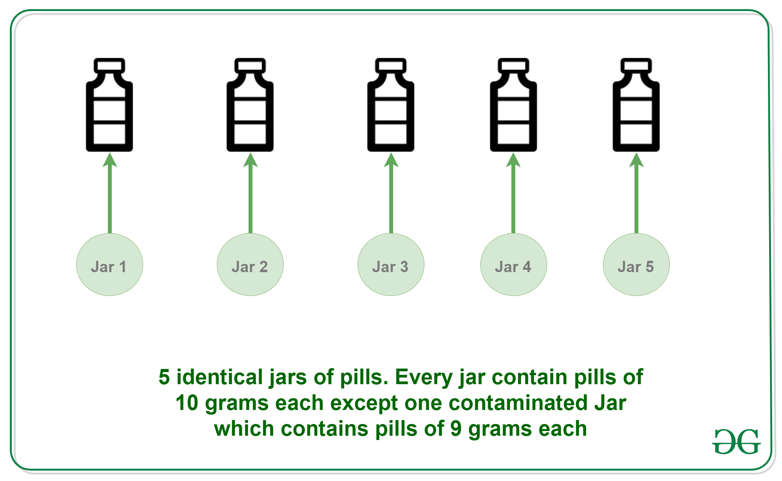

Solution: To find the contaminated Jar, follow this step-wise approach.
- Step 1: Take out 1 pill from jar 1, 2 pills from jar 2, 3 pills from jar 3, 4 pills from jar 4 and 5 pills from jar 5.
- Step 2: Put all these 15 pills on the scale. The correct weight is 150 (15*10). But one of the jars has contaminated pills. So the weight will definitely be less than 150.
- Step 3: If the weight is 149 then jar 1 has contaminated pills because there is only one contaminated pill. If the weight is 148 then jar 2, if the weight is 147 then jar 3, if 146 then jar 4, if 145 then jar 5.

