HTTP Non-Persistent & Persistent Connection

- The Hypertext Transfer Protocol (HTTP) is an application-level protocol that uses TCP as an underlying transport and typically runs on port 80.
- HTTP is a stateless protocol i.e. server maintains no information about past client requests.
HTTP Connections
- Non-Persistent
- Persistent
Before starting with persistent and non-persistent HTTP connection lets know what is a RTT.
RTT-> Time for a small packet to travel from client to server and back.
RTT= 2*propagation time
1. For an connection Persistent or Non-persistent it is sure that to initiate TCP connection one RTT is used.
2. One RTT is used for HTTP request and first few bytes to HTTP response to return.
So in order to know total file transmission time->
total = 2RTT+transmit time
Difference between Persistent & Non-Persistent connection.
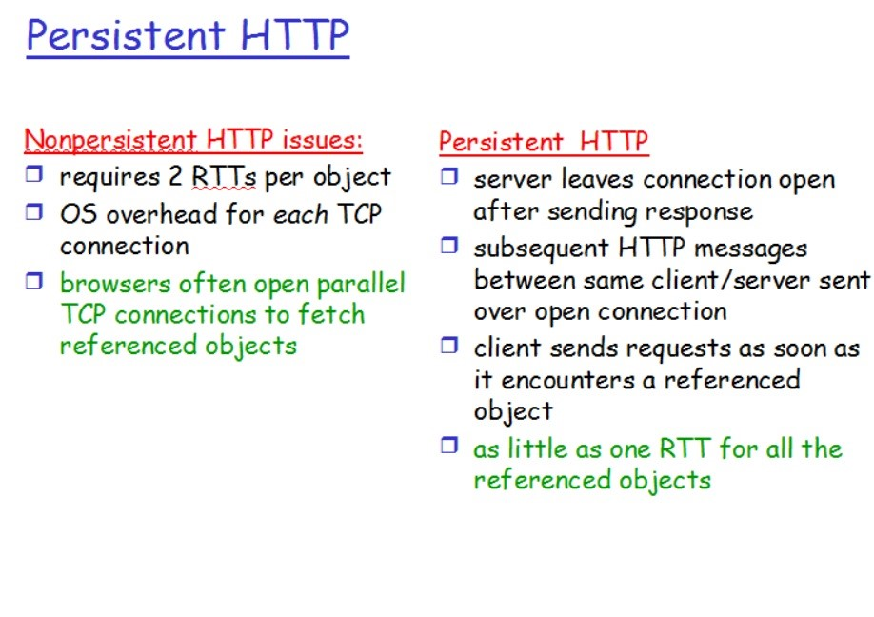
Non-Persistent Connection
- Without parallel connection
- With parallel connection
Without parallel connection Non-Persistent
Each objection takes two RTT (assuming no window limit) one for TCP connection and other for HTTP image/text file.
With parallel connection Non-Persistent
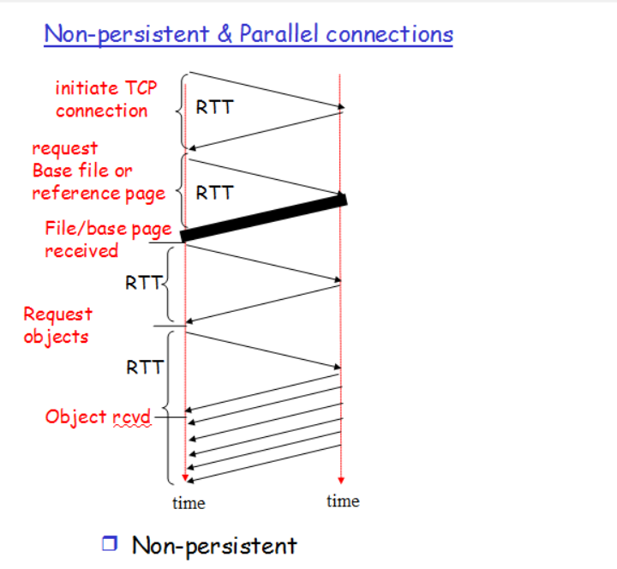
Persistent connection
- Non-Pipelined
- Pipelined
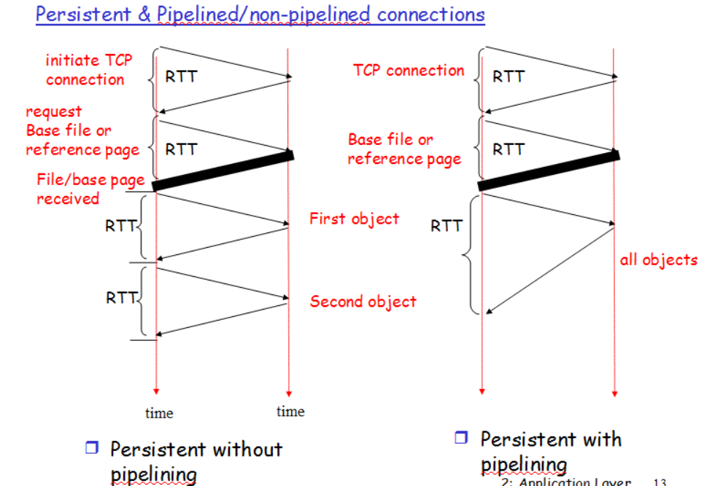
In Non-pipeline connection we first establish connection which takes two RTT then we send all the objects images/text files which takes 1 RTT each (TCP for each object is not required).

In Pipelined connection 2RTT for connection establishment and then 1RTT(assuming no window limit) for all the objects i.e. images/text.
Advantages of persistent connections :
1) Lower CPU and memory usage because there are less number of connections.
2) Allows HTTP pipelining of requests and responses.
3) Reduced network congestion (fewer TCP connections).
4) Reduced latency in subsequent requests (no handshaking).
5) Errors can be reported without the penalty of closing the TCP connection.
Disadvantages of persistent connections :
Resources may be be kept occupied even when not needed and may not be available to others.
Most of the modern browsers like Chrome, Firefox and Internet Explorer use persistent connections.

Difference between http:// and https://

In short, both of these are protocols using which the information of a particular website is exchanged between Web Server and Web Browser. But what’s difference between these two? Well, extra s is present in https and that makes it secure! What a difference A very short and concise difference between http and https is that https is much more secure compared to http.

- HyperText Transfer Protocol (HTTP is a protocol using which hypertext is transferred over the Web.
- Due to its simplicity, http has been the most widely used protocol for data transfer over the Web but the data (i.e. hypertext) exchanged using http isn’t as secure as we would like it to be.
- In fact, hyper-text exchanged using http goes as plain text i.e. anyone between the browser and server can read it relatively easy if one intercepts this exchange of data.
- But why do we need this security over the Web? Think of ‘Online shopping’ at Amazon or Flipkart. You might have noticed that as soon as we click on the Check-out on these online shopping portals, the address bar gets changed to use https. This is done so that the subsequent data transfer (i.e. financial transaction etc.) is made secure. And that’s why https was introduced so that a secure session is setup first between Server and Browser.
- In fact, cryptographic protocols such as SSL and/or TLS turn http into https i.e. https=http+cryptographic protocols.
- Also, to achieve this security in https, Public Key Infrastructure (PKI) is used because public keys can be used by several Web Browsers while private key can be used by the Web Server of that particular website.
- The distribution of these public keys is done via Certificates which are maintained by the Browser. You can check these certificates in your Browser settings.
- another syntactic difference between http and https is that
- http uses default port 80 while https uses default port 443.
- But it should be noted that this security in https is achieved at the cost of processing time because Web Server and Web Browser needs to exchange encryption keys using Certificates before actual data can be transferred. Basically, setting up of a secure session is done before the actual hypertext exchange between server and browser.
Differences between HTTP and HTTPS
- In HTTP, URL begins with “http://” whereas URL starts with “https://”
- HTTP uses port number 80 for communication and HTTPS uses 443
- HTTP is considered to be unsecure and HTTPS is secure
- HTTP Works at Application Layer and HTTPS works at Transport Layer
- In HTTP, Encryption is absent and Encryption is present in HTTPS as discussed above
- HTTP does not require any certificates and HTTPS needs SSL Certificates

Difference between HTML and HTTP

Many folks get confused between these two terms which are associated with the Web. Are they really same?
First thing first. HTML is a Language while HTTP is a Protocol.
HTML(Hypertext Markup Language)
- HTML (Hypertext Markup Language) is a language for marking the normal text so that it gets converted into hypertext. Again, not so clear.
- Basically, HTML tags (e.g. “<head>”, “<body>” etc.) are used to tag or mark normal text so that it becomes hypertext and several hypertext pages can be interlinked with each other resulting in the Web.
- Please note that the HTML tags are used to help render web pages as well in the Browser.
- HTTP (Hypertext Transfer Protocol)
- On the contrary, HTTP (Hypertext Transfer Protocol) is a protocol for transferring the hypertext pages from Web Server to Web Browser.
- For exchanging web pages between Server and Browser, an HTTP session is setup using protocol methods (e.g. GET, POST etc.).
- EXPLANATION
To understand this difference between HTML and HTTP, we can think of an analogy. Think of HTML as C language and HTTP as FTP. Now one can write C programs in C language and then one can transfer these C programs from Server to Clients using FTP (i.e. File transfer protocol). Same way, web pages (which are mostly HTML pages) are written in HTML and these web pages are exchanged between Server and Clients using HTTP. Since HTML is a language and HTTP is a protocol, they are two different things though related. In fact, it’s possible to exchange HTML web pages without HTTP (e.g. using FTP to transfer HTML pages). Even, it’s possible to transfer non HTML pages using HTTP (e.g. using HTTP to transfer XML pages). More details on XML in some other post. We hope that the above clarifies the difference between HTML and HTTP.

What are the differences between HTTP, FTP, and SMTP?
- HTTP stands for Hyper Text Transfer Protocol,
- FTP for File Transfer Protocol,
- while SMTP stands for Simple Mail Transfer Protocol.
- All the three are used to transfer information over a computer network, and are an integral part of today’s internet.
Why do we need three Protocols for transferring files?
We need the three protocols as they all serve different purposes. These are HTTP, FTP, and SMTP.
- HTTP is the backbone of World Wide Web (WWW). It defines the format of messages through which Web Browsers (like Firefox, Chrome) and Web Servers communicate, whilst also defining how a web browser should respond to a particular web browser request.
- FTP is the underlying protocol that is used to, as the name suggests, transfer files over a communication network. It establishes two TCP connections: Control Connection to authenticate the user, and Data Connection to transfer the files.
- SMTP is what is used by Email servers all over the globe to communicate with each other, so that the assignment you submitted at 11:59 pm reaches your professor’s inbox within the deadline.
How do their implementations differ?
All the three are Application Layer Protocols, using TCP as the underlying Transport layer protocol. But the way they use it, and are implemented in general, is vastly different. The below table briefly differentiates between them.
HTTP FTP SMTP
Parameter | HTTHHTTpP | FTP | SMTP
Port number | 80 | 20 and 21 | 25
Type of band transfer | In-band | Out-of-band | In-band
State | Stateless | Maintains state | –
Number of TCP connections | 1 | 2 (Data Connection and Control Connection) | 1
Type of TCP connection | Can use both Persistent and Non-persistent | Persistent for  Control connection.  Non-persistent for  Data Connection | Persistent
Type of Protocol | Pull Protocol (Mainly) | – | Push Protocol (Primarily)
Type of Transfer | Transfer files between Web server and Web client | Transfer directly between computers | Transfers mails via Mail Servers

- HTTP is stateless. A Stateless protocol implies that the HTTP Web Server does not maintains which request had originated from which user. Hence, to give a customized service to the user, HTTP uses Cookies.
- FTP is Out-of-band, as it uses a separate channel to send data (Data connection), as to send control information (Control connection).
- As SMTP is much older that HTTP, it restricts all its messages to be in 7-bit ASCII format. Whereas HTTP has no such restriction.
- HTTP encapsulates each file in a different HTTP message. Whereas, SMTP places all the contents of a mail in a single message.

