TCP Connection Termination

In TCP 3-way Handshake Process we studied that how connection establish between client and server in Transmission Control Protocol (TCP) using SYN bit segments. In this article we will study about how TCP close connection between Client and Server. Here we will also need to send bit segments to server which FIN bit is set to 1.
TCP supports two types of connection releases like most connection-oriented transport protocols:
- Graceful connection release –
In Graceful connection release, the connection is open until both parties have closed their sides of the connection.
- Abrupt connection release –
In Abrupt connection release, either one TCP entity is forced to close the connection or one user closes both directions of data transfer.
Abrupt connection release :
An abrupt connection release is carried out when a RST segment is sent. A RST segment can be sent for the below reasons:
- When a non-SYN segment was received for a non-existing TCP connection.
- In an open connection, some TCP implementations send a RST segment when a segment with an invalid header is received. This will prevent attacks by closing the corresponding connection.
- When some implementations need to close an existing TCP connection, they send a RST segment. They will close an existing TCP connection for the following reasons:
  - Lack of resources to support the connection
  - The remote host is now unreachable and has stopped responding.
When a TCP entity sends a RST segment, it should contain 00 if it does not belong to any existing connection else it should contain the current value of the sequence number for the connection and the acknowledgment number should be set to the next expected in-sequence sequence number on this connection.

Graceful Connection Release :
The common way of terminating a TCP connection is by using the TCP header’s FIN flag. This mechanism allows each host to release its own side of the connection individually.
How mechanism works In TCP :
- Step 1 (FIN From Client) –
Suppose that the client application decides it wants to close the connection. (Note that the server could also choose to close the connection). This causes the client send a TCP segment with the FIN bit set to 1 to server and to enter the FIN_WAIT_1 state. While in the FIN_WAIT_1 state, the client waits for a TCP segment from the server with an acknowledgment (ACK).
- Step 2 (ACK From Server) –
When Server received FIN bit segment from Sender (Client), Server Immediately send acknowledgement (ACK) segment to the Sender (Client).
- Step 3 (Client waiting) –
While in the FIN_WAIT_1 state, the client waits for a TCP segment from the server with an acknowledgment. When it receives this segment, the client enters the FIN_WAIT_2 state. While in the FIN_WAIT_2 state, the client waits for another segment from the server with the FIN bit set to 1.
- Step 4 (FIN from Server) –
Server sends FIN bit segment to the Sender(Client) after some time when Server send the ACK segment (because of some closing process in the Server).
- Step 5 (ACK from Client) –
When Client receive FIN bit segment from the Server, the client acknowledges the server’s segment and enters the TIME_WAIT state. The TIME_WAIT state lets the client resend the final acknowledgment in case the ACK is lost.The time spent by client in the TIME_WAIT state is depend on their implementation, but their typical values are 30 seconds, 1 minute, and 2 minutes. After the wait, the connection formally closes and all resources on the client side (including port numbers and buffer data) are released.
In the below Figures illustrates the series of states visited by the server-side and also Client-side, assuming the client begins connection tear-down.In these two state-transition figures, we have only shown how a TCP connection is normally established and shut-down.
TCP states visited by ClientSide –
TCP states visited by ServerSide –
Here we have not described what happens in certain scenarios like when both sides of a connection want to initiate or shut down at the same time. If you are interested in learning about more this and other advanced issues concerning TCP, you are encouraged to see Stevens’comprehensive book.
GATE Question –
Consider a TCP client and a TCP server running on two different machines. After completing data transfer, the TCP client calls close to terminate the connection and a FIN segment is sent to the TCP server. Server-side TCP responds by sending an ACK which is received by the client-side TCP. As per the TCP connection state diagram(RFC 793), in which state does the client side TCP connection wait for the FIN from the server-side TCP?
(A) LAST-ACK
(B) TIME-WAIT
(C) FIN-WAIT-1
(D) FIN-WAIT-2
TCP TIMERS
TCP uses several timers to ensure that excessive delays are not encountered during communications. Several of these timers are elegant, handling problems that are not immediately obvious at first analysis. Each of the timers used by TCP is examined in the following sections, which reveal its role in ensuring data is properly sent from one connection to another.
TCP implementation uses four timers –
- Retransmission Timer –
- To retransmit lost segments, TCP uses retransmission timeout (RTO). When TCP sends a segment the timer starts and stops when the acknowledgment is received.
- If the timer expires timeout occurs and the segment is retransmitted.
- RTO (retransmission timeout is for 1 RTT) to calculate retransmission timeout we first need to calculate the RTT(round trip time).
RTT three types –
  - Measured RTT(RTTm) –
  - The measured round-trip time for a segment is the time required for the segment to reach the destination and be acknowledged, although the acknowledgment may include other segments.
  - Smoothed RTT(RTTs) – It is the weighted average of RTTm. RTTm is likely to change and its fluctuation is so high that a single measurement cannot be used to calculate RTO.
Initially -> No value
After the first measurement -> RTTs=RTTm
After each measurement -> RTTs= (1-t)*RTTs + t*RTTm
Note: t=1/8 (default if not given)
  - Deviated RTT(RTTd) –
  - Most implementation do not use RTTs alone so RTT deviated is also calculated to find out RTO.
Initially -> No value
After the first measurement -> RTTd=RTTm/2
After each measurement -> RTTd= (1-k)*RTTd + k*(RTTm-RTTs)
Note: k=1/4 (default if not given)
Retransmission Timeout :
- RTO calculation – The value of RTO is based on the smoothed round-trip time and its deviation.
Initial value -> Original (given in question)
After any measurement -> RTO=RTTs + 4*RTTd
#NOTE: At every retransmission the value of RTO doubles. ( RTO(new) = RTO(before retransmission) *2 ) this is explained in Karn’s Algorithm
- Persistent Timer –
To deal with a zero-window-size deadlock situation, TCP uses a persistence timer.When the sending TCP receives an acknowledgment with a window size of zero, it starts a persistence timer.
. When the persistence timer goes off, the sending TCP sends a special segment called a probe. This segment contains only 1 byte of new data. It has a sequence number, but its sequence number is never acknowledged; it is even ignored in calculating the sequence number for the rest of the data. The probe causes the receiving TCP to resend the acknowledgment which was lost.
- Keep Alive Timer –
- A keepalive timer is used to prevent a long idle connection between two TCPs. If a client opens a TCP connection to a server transfers some data and becomes silent the client will crash. In this case, the connection remains open forever. So a keepalive timer is used. Each time the server hears from a client, it resets this timer. The time-out is usually 2 hours. If the server does not hear from the client after 2 hours, it sends a probe segment. If there is no response after 10 probes, each of which is 75 s apart, it assumes that the client is down and terminates the connection.
- Time Wait Timer – This timer is used during tcp connection termination. The timer starts after sending the last Ack for 2nd FIN and closing the connection.
After a TCP connection is closed, it is possible for datagrams that are still making their way through the network to attempt to access the closed port. The quiet timer is intended to prevent the just-closed port from reopening again quickly and receiving these last datagrams.
The quiet timer is usually set to twice the maximum segment lifetime (the same value as the Time-To-Live field in an IP header), ensuring that all segments still heading for the port have been discarded.

Multiplexing and Demultiplexing in Transport Layer
Multiplexing and Demultiplexing services are provided in almost every protocol architecture ever designed. UDP and TCP perform the demultiplexing and multiplexing jobs by including two special fields in the segment headers: the source port number field and the destination port number field.
Multiplexing –
Gathering data from multiple application processes of sender, enveloping that data with header and sending them as a whole to the intended receiver is called as multiplexing.
Demultiplexing –
Delivering received segments at receiver side to the correct app layer processes is called as demultiplexing.
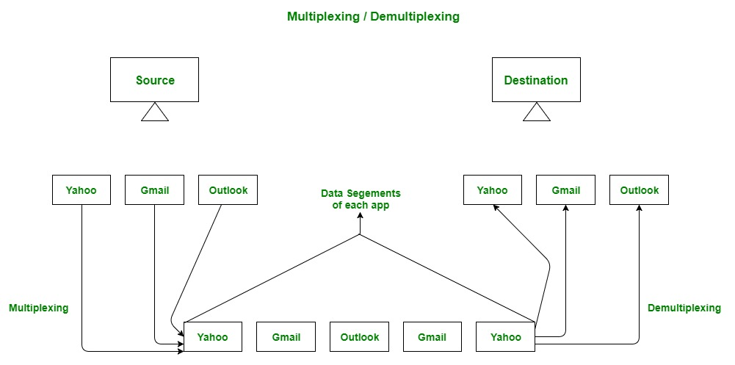
Figure – Abstract view of multiplexing and demultiplexing

Multiplexing and demultiplexing are the services facilitated by the transport layer of OSI model.
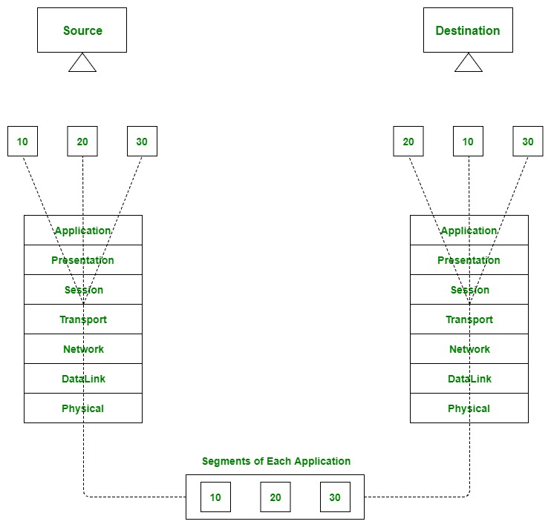
Figure – Transport layer- junction for multiplexing and demultiplexing
There are two types of multiplexing and Demultiplexing :
- Connectionless Multiplexing and Demultiplexing
- Connection-Oriented Multiplexing and Demultiplexing
How Multiplexing and Demultiplexing is done –
For sending data from an application at sender side to an application at the destination side, sender must know the IP address of destination and port number of the application (at the destination side) to which he want to transfer the data. Block diagram is shown below :
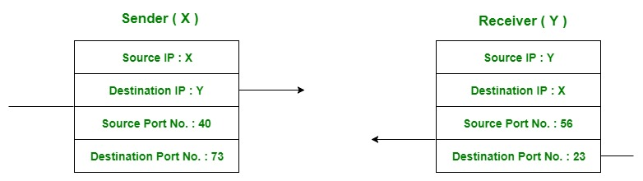
Figure – Transfer of packet between applications of sender and receiver
- Let us consider two messaging apps that are widely used now a days viz. Hike and whatsapp.
- Suppose A is the sender and B is the receiver. Both sender and receiver have these applications installed in their system (say smartphone).
- Suppose A want to send messages to B in whatsapp and hike both. In order to do so, A must mention the IP address of B and destination port number of the whatsapp while sending the message through whatsapp application.
- Similarly, for the later case, A must mention the IP address of B and destination port number of the hike while sending the message.
Now the messages from both the apps will be wrapped up along with appropriate headers(viz. source IP address, destination IP address, source port no,destination port number) and sent as a single message to the receiver. This process is called multiplexing. At the destination, received message is unwrapped and constituent messages (viz messages from hike and whatsapp application) are sent to appropriate application by looking to the destination the port number. This process is called demultiplexing. Similarly, B can also transfer the messages to A.
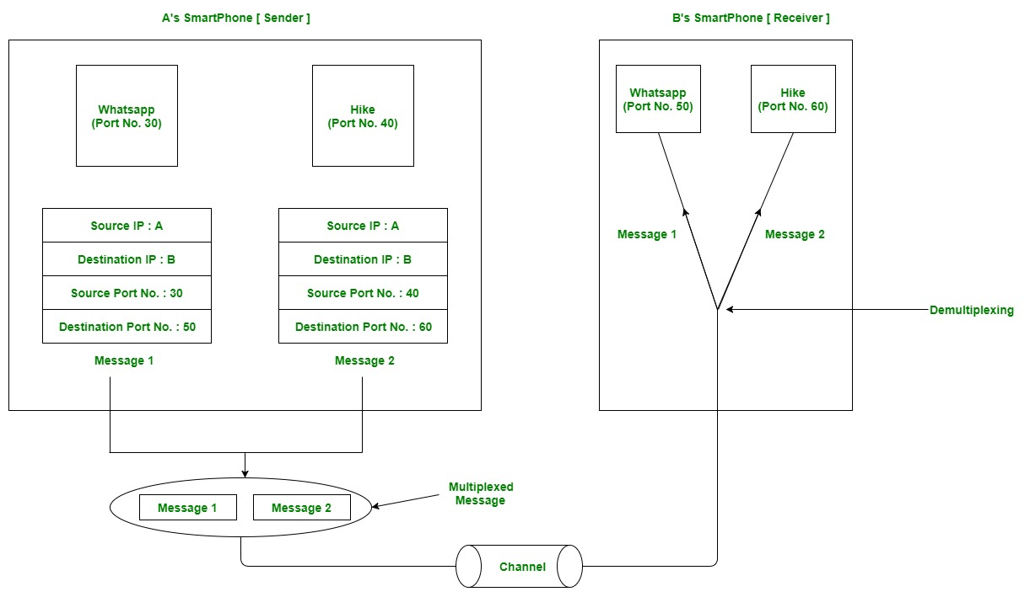
Figure – Message transfer using whatsapp and hike messaging application

TCP flags

In TCP connection, flags are used to indicate a particular state of connection or to provide some additional useful information like troubleshooting purposes or to handle a control of a particular connection. Most commonly used flags are “SYN”, “ACK” and “FIN”. Each flag corresponds to 1 bit information.
Types of Flags:
- Synchronization (SYN) – It is used in first step of connection establishment phase or 3-way handshake process between the two hosts.
- Only the first packet from sender as well as receiver should have this flag set. This is used for synchronizing sequence number i.e. to tell the other end which sequence number they should except.
- Acknowledgement (ACK) – It is used to acknowledge packets which are successful received by the host. The flag is set if the acknowledgement number field contains a valid acknowledgement number.
In given below diagram, the receiver sends an ACK = 1 as well as SYN = 1 in the second step of connection establishment to tell sender that it received its initial packet.
- Finish (FIN) – It is used to request for connection termination i.e. when there is no more data from the sender, it requests for connection termination. This is the last packet sent by sender. It frees the reserved resources and gracefully terminate the connection.

- Reset (RST) – It is used to terminate the connection if the RST sender feels something is wrong with the TCP connection or that the conversation should not exist.
- It can get send from receiver side when packet is send to particular host that was not expecting it.
Finish (FIN) v/s Reset (RST) –
- Push (PSH) – Transport layer by default waits for some time for application layer to send enough data equal to maximum segment size so that the number of packets transmitted on network minimizes which is not desirable by some application like interactive applications(chatting). Similarly transport layer at receiver end buffers packets and transmit to application layer if it meets certain criteria.
This problem is solved by using PSH. Transport layer sets PSH = 1 and immediately sends the segment to network layer as soon as it receives signal from application layer. Receiver transport layer, on seeing PSH = 1 immediately forwards the data to application layer.
In general, it tells the receiver to process these packets as they are received instead of buffering them.

- Urgent (URG) –Data inside a segment with URG = 1 flag is forwarded to application layer immediately even if there are more data to be given to application layer. It is used to notify the receiver to process the urgent packets before processing all other packets. The receiver will be notified when all known urgent data has been received.
Push (PSH) v/s Urgent (URG) –

Error Control in TCP
TCP protocol has methods for finding out corrupted segments, missing segments, out-of-order segments and duplicated segments.
Error control in TCP is mainly done through use of three simple techniques :
- Checksum – Every segment contains a checksum field which is used to find corrupted segment. If the segment is corrupted, then that segment is discarded by the destination TCP and is considered as lost.
- Acknowledgement – TCP has another mechanism called acknowledgement to affirm that the data segments have been delivered. Control segments that contain no data but has sequence number will be acknowledged as well but ACK segments are not acknowledged.
- Retransmission – When a segment is missing, delayed to deliver to receiver, corrupted when it is checked by receiver then that segment is retransmitted again. Segments are retransmitted only during two events: when the sender receives three duplicate acknowledgements (ACK) or when a retransmission timer expires.
  - Retransmission after RTO : TCP always preserve one retransmission time-out (RTO) timer for all sent but not acknowledged segments. When the timer runs out of time, the earliest segment is retransmitted. Here no timer is set for acknowledgement. In TCP, RTO value is dynamic in nature and it is updated using round trip time (RTT) of segments. RTT is the time duration needed for a segment to reach receiver and an acknowledgement to be received to the sender.
  - Retransmission after Three duplicate ACK segments : RTO method works well when the value of RTO is small. If it is large, more time is needed to get confirmation about whether a segment has delivered or not. Sometimes one segment is lost and the receiver receives so many out-of-order segments that they cannot be saved. In order to solve this situation, three duplicate acknowledgement method is used and missing segment is retransmitted immediately instead of retransmitting already delivered segment. This is a fast retransmission because it makes it possible to quickly retransmit lost segments instead of waiting for timer to end.

