Congestion Control in Computer Networks

What is congestion?
A state occurring in network layer when the message traffic is so heavy that it slows down network response time.

Effects of Congestion
- As delay increases, performance decreases.
- If delay increases, retransmission occurs, making situation worse.
Congestion control algorithms
- Leaky Bucket Algorithm
Let us consider an example to understand
Imagine a bucket with a small hole in the bottom.No matter at what rate water enters the bucket, the outflow is at constant rate.When the bucket is full with water additional water entering spills over the sides and is lost.
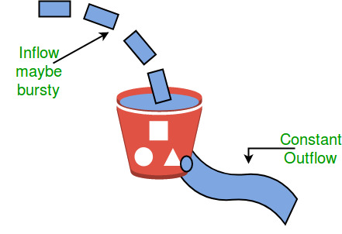
Similarly, each network interface contains a leaky bucket and the following steps are involved in leaky bucket algorithm:
- When host wants to send packet, packet is thrown into the bucket.
- The bucket leaks at a constant rate, meaning the network interface transmits packets at a constant rate.
- Bursty traffic is converted to a uniform traffic by the leaky bucket.
- In practice the bucket is a finite queue that outputs at a finite rate.
- Token bucket Algorithm
Need of token bucket Algorithm:-
The leaky bucket algorithm enforces output pattern at the average rate, no matter how bursty the traffic is. So in order to deal with the bursty traffic we need a flexible algorithm so that the data is not lost. One such algorithm is token bucket algorithm.
Steps of this algorithm can be described as follows:
- In regular intervals tokens are thrown into the bucket. ƒ
- The bucket has a maximum capacity. ƒ
- If there is a ready packet, a token is removed from the bucket, and the packet is sent.
- If there is no token in the bucket, the packet cannot be sent.
Let’s understand with an example,
In figure (A) we see a bucket holding three tokens, with five packets waiting to be transmitted. For a packet to be transmitted, it must capture and destroy one token. In figure (B) We see that three of the five packets have gotten through, but the other two are stuck waiting for more tokens to be generated.
- Ways in which token bucket is superior to leaky bucket:
The leaky bucket algorithm controls the rate at which the packets are introduced in the network, but it is very conservative in nature. Some flexibility is introduced in the token bucket algorithm.
- In the token bucket, algorithm tokens are generated at each tick (up to a certain limit).
- For an incoming packet to be transmitted, it must capture a token and the transmission takes place at the same rate. Hence some of the busty packets are transmitted at the same rate if tokens are available and thus introduces some amount of flexibility in the system.
Formula: M * s = C + ρ * s
where S – is time taken
M – Maximum output rate
ρ – Token arrival rate
C – Capacity of the token bucket in byte
Let’s understand with an example,
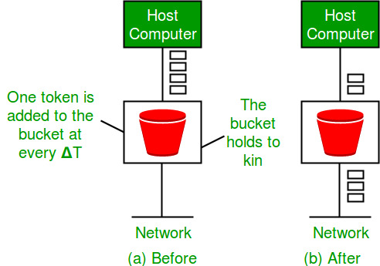

1) What is the maximum size of data that the application layer can pass on to the TCP layer below?
(A) Any size
(B) 2^16 bytes-size of TCP header
(C) 2^16 bytes
(D) 1500 bytes
Answer (A)
Application layer can send any size of data. There is no limit defined by standards. The lower layers divides the data if needed.

2) A client process P needs to make a TCP connection to a server process S. Consider the following situation: the server process S executes a socket(), a bind() and a listen() system call in that order, following which it is preempted. Subsequently, the client process P executes a socket() system call followed by connect() system call to connect to the server process S. The server process has not executed any accept() system call. Which one of the following events could take place?
(A) connect () system call returns successfully
(B) connect () system call blocks
(C) connect () system call returns an error
(D) connect () system call results in a core dump

Answer (C)
Since accept() call is not executed then connect () gets no response for a time stamp to wait & then return no response server error.
3) A computer on a 10Mbps network is regulated by a token bucket. The token bucket is filled at a rate of 2Mbps. It is initially filled to capacity with 16Megabits. What is the maximum duration for which the computer can transmit at the full 10Mbps?
(A) 1.6 seconds
(B) 2 seconds
(C) 5 seconds
(D) 8 seconds
Answer (B)
New tokens are added at the rate of r bytes/sec which is
2Mbps in the given question.
Formula :Formula: M * s = C + ρ * s
where M=10Mbps,
s=?
C=16mpbs
e=2;
applting the fromula we get ans=2;
Capacity of the token bucket (b) = 16 Mbits
Maximum possible transmission rate (M) = 10Mbps
So the maximum burst time = b/(M-r) = 16/(10-2) = 2 seconds
In the above formula, r is subtracted from M to calculate the maximum burst time. The reason for this subtraction is, new tokens are added at the rate of r while transmission happens at maximum transmission rate M.

