File Transfer Protocol (FTP) in Application Layer
- File Transfer Protocol(FTP) is an application layer protocol which moves files between local and remote file systems.
- It runs on the top of TCP, like HTTP.
- To transfer a file, 2 TCP connections are used by FTP in parallel: control connection and data connection.
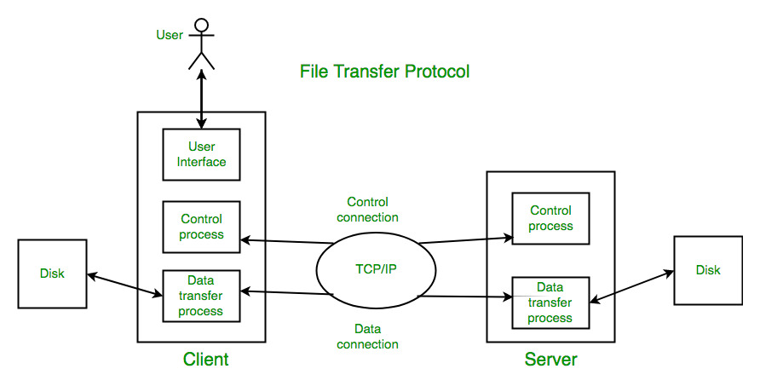What is control connection?
- For sending control information like user identification, password, commands to change the remote directory, commands to retrieve and store files, etc., FTP makes use of control connection.
- The control connection is initiated on port number 21.
What is data connection?
- For sending the actual file, FTP makes use of data connection. A data connection is initiated on port number 20.
- FTP sends the control information out-of-band as it uses a separate control connection.
- Some protocols send their request and response header lines and the data in the same TCP connection. For this reason, they are said to send their control information in-band. HTTP and SMTP are such examples.

FTP Session :
- When a FTP session is started between a client and a server, the client initiates a control TCP connection with the server side.
- The client sends control information over this.
- When the server receives this, it initiates a data connection to the client side.
- Only one file can be sent over one data connection. But the control connection remains active throughout the user session.
- As we know HTTP is stateless i.e. it does not have to keep track of any user state. But FTP needs to maintain a state about its user throughout the session.
Data Structures : FTP allows three types of data structures :
- File Structure – In file-structure there is no internal structure and the file is considered to be a continuous sequence of data bytes.
- Record Structure – In record-structure the file is made up of sequential records.
- Page Structure – In page-structure the file is made up of independent indexed pages.
FTP Commands –Some of the FTP commands are :
USER – This command sends the user identification to the server.
PASS – This command sends the user password to the server.
CWD – This command allows the user to work with a different directory or dataset for file storage or retrieval without altering his login or accounting information.
RMD – This command causes the directory specified in the path-name to be removed as a directory.
MKD– This command causes the directory specified in the pathname to be created as a directory.
PWD – This command causes the name of the current working directory to be returned in the reply.
RETR – This command causes the remote host to initiate a data connection and to send the requested file over the data connection.
STOR – This command causes to store a file into the current directory of the remote host.
LIST – Sends a request to display the list of all the files present in the directory.
ABOR – This command tells the server to abort the previous FTP service command and any associated transfer of data.
QUIT– This command terminates a USER and if file transfer is not in progress, the server closes the control connection.
FTP Replies –Some of the FTP replies are :
200 Command okay.
530 Not logged in.
331 User name okay, need a password.
225 Data connection open; no transfer in progress.
221 Service closing control connection.
551 Requested action aborted: page type unknown.
502 Command not implemented.
503 Bad sequence of commands.
504 Command not implemented for that parameter.
- Trivial File Transfer Protocol (TFTP):
- It is also file transfer protocol without sophisticated features of FTP.
- It is good for simple file transfers, such as during boot time.
- It uses UDP as transport layer protocols. Errors in the transmission (lost packets, checksum errors) must be handled by the TFTP server.
- It uses only one connection through well known port 69.
- TFTP uses a simple lock-step protocol (each data packet needs to be acknowledged). Thus the throughput is limited
Anonymous FTP :
- Anonymous FTP is enabled on some sites whose files are available for public access.
- A user can access these files without having any username or password.
- Instead, the username is set to anonymous and password to the guest by default.
- Here, user access is very limited. For example, the user can be allowed to copy the files but not to navigate through directories.

