Transaction
- The transaction is a set of logically related operation. It contains a group of tasks.
- A transaction is an action or series of actions. It is performed by a single user to perform operations for accessing the contents of the database.
Example: Suppose an employee of bank transfers Rs 800 from X's account to Y's account. This small transaction contains several low-level tasks:
X's Account
- Open_Account(X)
- Old_Balance = X.balance
- New_Balance = Old_Balance - 800
- X.balance = New_Balance
- Close_Account(X)
Y's Account
- Open_Account(Y)
- Old_Balance = Y.balance
- New_Balance = Old_Balance + 800
- Y.balance = New_Balance
- Close_Account(Y)

Operations of Transaction:
Following are the main operations of transaction:
Read(X): Read operation is used to read the value of X from the database and stores it in a buffer in main memory.
Write(X): Write operation is used to write the value back to the database from the buffer.
Let's take an example to debit transaction from an account which consists of following operations:
- 1. R(X);
- 2. X = X - 500;
- 3. W(X);
Let's assume the value of X before starting of the transaction is 4000.
- The first operation reads X's value from database and stores it in a buffer.
- The second operation will decrease the value of X by 500. So buffer will contain 3500.
- The third operation will write the buffer's value to the database. So X's final value will be 3500.
But it may be possible that because of the failure of hardware, software or power, etc. that transaction may fail before finished all the operations in the set.
For example: If in the above transaction, the debit transaction fails after executing operation 2 then X's value will remain 4000 in the database which is not acceptable by the bank.
To solve this problem, we have two important operations:
Commit: It is used to save the work done permanently.
Rollback: It is used to undo the work done.

Concurrency Control deals with interleaved execution of more than one transaction. In the next article, we will see what is serializability and how to find whether a schedule is serializable or not.
What is Transaction?
A set of logically related operations is known as transaction. The main operations of a transaction are:

Read(A): Read operations Read(A) or R(A) reads the value of A from the database and stores it in a buffer in main memory.

Write (A): Write operation Write(A) or W(A) writes the value back to the database from buffer.
(Note: It doesn’t always need to write it to database back it just writes the changes to buffer this is the reason where dirty read comes into picture)

Let us take a debit transaction from an account which consists of following operations:

- R(A);
- A=A-1000;
- W(A);

Assume A’s value before starting of transaction is 5000.

- The first operation reads the value of A from database and stores it in a buffer.
- Second operation will decrease its value by 1000. So buffer will contain 4000.
- Third operation will write the value from buffer to database. So A’s final value will be 4000.

But it may also be possible that transaction may fail after executing some of its operations. The failure can be because of hardware, software or power etc. For example, if debit transaction discussed above fails after executing operation 2, the value of A will remain 5000 in the database which is not acceptable by the bank. To avoid this, Database has two important operations:

Commit: After all instructions of a transaction are successfully executed, the changes made by transaction are made permanent in the database.

Rollback: If a transaction is not able to execute all operations successfully, all the changes made by transaction are undone.

Properties of a transaction

Atomicity: As a transaction is set of logically related operations, either all of them should be executed or none. A debit transaction discussed above should either execute all three operations or none.If debit transaction fails after executing operation 1 and 2 then its new value 4000 will not be updated in the database which leads to inconsistency.

Consistency: If operations of debit and credit transactions on same account are executed concurrently, it may leave database in an inconsistent state.

- For Example, T1 (debit of Rs. 1000 from A) and T2 (credit of 500 to A) executing concurrently, the database reaches inconsistent state.
- Let us assume Account balance of A is Rs. 5000. T1 reads A(5000) and stores the value in its local buffer space. Then T2 reads A(5000) and also stores the value in its local buffer space.
- T1 performs A=A-1000 (5000-1000=4000) and 4000 is stored in T1 buffer space. Then T2 performs A=A+500 (5000+500=5500) and 5500 is stored in T2 buffer space. T1 writes the value from its buffer back to database.
- A’s value is updated to 4000 in database and then T2 writes the value from its buffer back to database. A’s value is updated to 5500 which shows that the effect of debit transaction is lost and database has become inconsistent.
- To maintain consistency of database, we need concurrency control protocols which will be discussed in next article. The operations of T1 and T2 with their buffers and database have been shown in Table 1.

T1 | T1’s buffer space | T2 | T2’s Buffer Space | Database
 |  |  |  | A=5000
R(A); | A=5000 |  |  | A=5000
 | A=5000 | R(A); | A=5000 | A=5000
A=A-1000; | A=4000 |  | A=5000 | A=5000
 | A=4000 | A=A+500; | A=5500
W(A); |  |  | A=5500 | A=4000
 |  | W(A); |  | A=5500

Table 1

Isolation: Result of a transaction should not be visible to others before transaction is committed. For example, Let us assume that A’s balance is Rs. 5000 and T1 debits Rs. 1000 from A. A’s new balance will be 4000. If T2 credits Rs. 500 to A’s new balance, A will become 4500 and after this T1 fails. Then we have to rollback T2 as well because it is using value produced by T1. So a transaction results are not made visible to other transactions before it commits.

Durable: Once database has committed a transaction, the changes made by the transaction should be permanent. e.g.; If a person has credited $500000 to his account, bank can’t say that the update has been lost. To avoid this problem, multiple copies of database are stored at different locations.
What is a Schedule?
A schedule is a series of operations from one or more transactions. A schedule can be of two types:
- Serial Schedule:When one transaction completely executes before starting another transaction, the schedule is called serial schedule. A serial schedule is always consistent. e.g.; If a schedule S has debit transaction T1 and credit transaction T2, possible serial schedules are T1 followed by T2 (T1->T2) or T2 followed by T1 ((T2->T1). A serial schedule has low throughput and less resource utilization.
- Concurrent Schedule: When operations of a transaction are interleaved with operations of other transactions of a schedule, the schedule is called Concurrent schedule. e.g.; Schedule of debit and credit transaction shown in Table 1 is concurrent in nature. But concurrency can lead to inconsistency in the database. The above example of a concurrent schedule is also inconsistent.
Question: Consider the following transaction involving two bank accounts x and y:
- read(x);
- x := x – 50;
- write(x);
- read(y);
- y := y + 50;
- write(y);
The constraint that the sum of the accounts x and y should remain constant is that of?
- Atomicity
- Consistency
- Isolation
- Durability

[GATE 2015]
Solution:As discussed in properties of transactions, consistency properties says that sum of accounts x and y should remain constant before starting and after completion of transaction. So, the correct answer is B.

States of Transaction
In a database, the transaction can be in one of the following states -
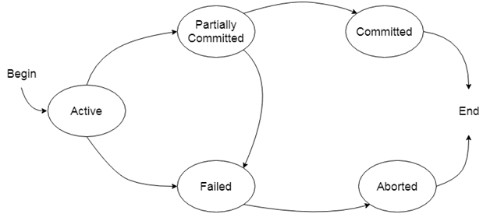

Active state
- The active state is the first state of every transaction. In this state, the transaction is being executed.
- For example: Insertion or deletion or updating a record is done here. But all the records are still not saved to the database.

Partially committed
- In the partially committed state, a transaction executes its final operation, but the data is still not saved to the database.
- In the total mark calculation example, a final display of the total marks step is executed in this state.

Committed
A transaction is said to be in a committed state if it executes all its operations successfully. In this state, all the effects are now permanently saved on the database system.

Failed state
- If any of the checks made by the database recovery system fails, then the transaction is said to be in the failed state.
- In the example of total mark calculation, if the database is not able to fire a query to fetch the marks, then the transaction will fail to execute.

Aborted
- If any of the checks fail and the transaction has reached a failed state then the database recovery system will make sure that the database is in its previous consistent state. If not then it will abort or roll back the transaction to bring the database into a consistent state.
- If the transaction fails in the middle of the transaction then before executing the transaction, all the executed transactions are rolled back to its consistent state.
- After aborting the transaction, the database recovery module will select one of the two operations:
  - Re-start the transaction
  - Kill the transaction

Schedule
A series of operation from one transaction to another transaction is known as schedule. It is used to preserve the order of the operation in each of the individual transaction.
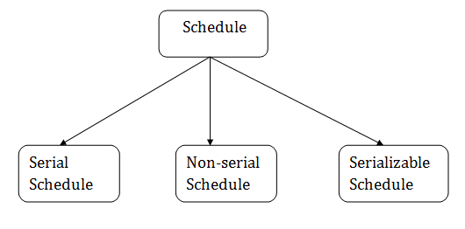

1. Serial Schedule
The serial schedule is a type of schedule where one transaction is executed completely before starting another transaction. In the serial schedule, when the first transaction completes its cycle, then the next transaction is executed.
For example: Suppose there are two transactions T1 and T2 which have some operations. If it has no interleaving of operations, then there are the following two possible outcomes:
- Execute all the operations of T1 which was followed by all the operations of T2.
- Execute all the operations of T1 which was followed by all the operations of T2.
- In the given (a) figure, Schedule A shows the serial schedule where T1 followed by T2.
- In the given (b) figure, Schedule B shows the serial schedule where T2 followed by T1.

2. Non-serial Schedule
- If interleaving of operations is allowed, then there will be non-serial schedule.
- It contains many possible orders in which the system can execute the individual operations of the transactions.
- In the given figure (c) and (d), Schedule C and Schedule D are the non-serial schedules. It has interleaving of operations.

3. Serializable schedule
- The serializability of schedules is used to find non-serial schedules that allow the transaction to execute concurrently without interfering with one another.
- It identifies which schedules are correct when executions of the transaction have interleaving of their operations.
- A non-serial schedule will be serializable if its result is equal to the result of its transactions executed serially.
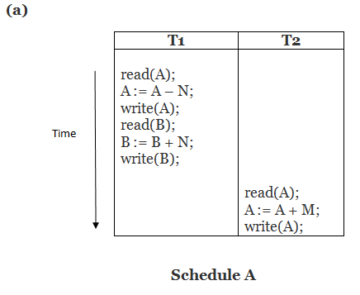
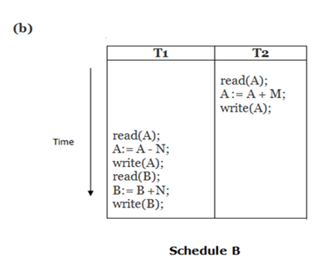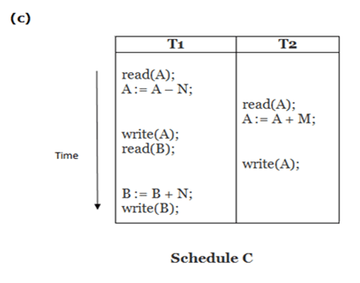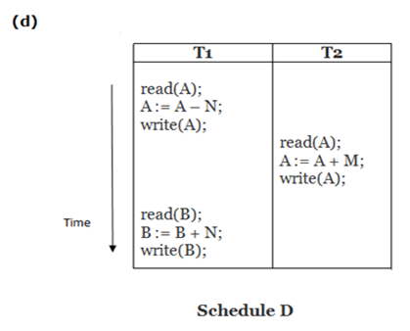
Here,
Schedule A and Schedule B are serial schedule.
Schedule C and Schedule D are Non-serial schedule.

Testing of Serializability
Serialization Graph is used to test the Serializability of a schedule.
Assume a schedule S. For S, we construct a graph known as precedence graph. This graph has a pair G = (V, E), where V consists a set of vertices, and E consists a set of edges. The set of vertices is used to contain all the transactions participating in the schedule. The set of edges is used to contain all edges Ti ->Tj for which one of the three conditions holds:
- Create a node Ti → Tj if Ti executes write (Q) before Tj executes read (Q).
- Create a node Ti → Tj if Ti executes read (Q) before Tj executes write (Q).
- Create a node Ti → Tj if Ti executes write (Q) before Tj executes write (Q).
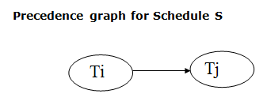
- If a precedence graph contains a single edge Ti → Tj, then all the instructions of Ti are executed before the first instruction of Tj is executed.
- If a precedence graph for schedule S contains a cycle, then S is non-serializable. If the precedence graph has no cycle, then S is known as serializable.
For example:

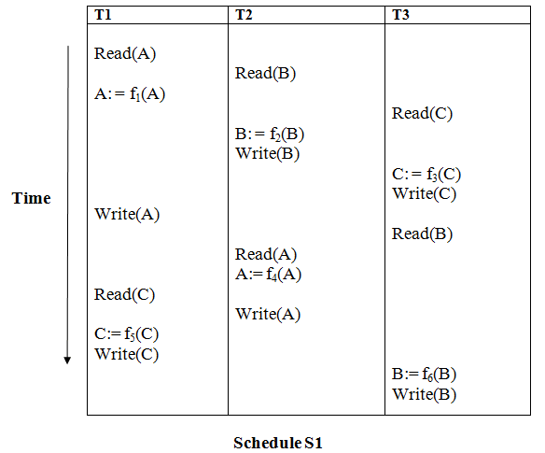
Explanation:
Read(A): In T1, no subsequent writes to A, so no new edges
Read(B): In T2, no subsequent writes to B, so no new edges
Read(C): In T3, no subsequent writes to C, so no new edges
Write(B): B is subsequently read by T3, so add edge T2 → T3
Write(C): C is subsequently read by T1, so add edge T3 → T1
Write(A): A is subsequently read by T2, so add edge T1 → T2
Write(A): In T2, no subsequent reads to A, so no new edges
Write(C): In T1, no subsequent reads to C, so no new edges
Write(B): In T3, no subsequent reads to B, so no new edges

Precedence graph for schedule S1:
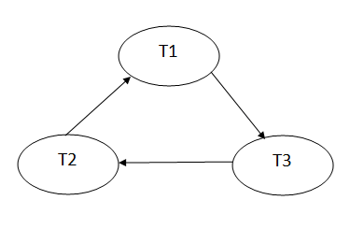
The precedence graph for schedule S1 contains a cycle that's why Schedule S1 is non-serializable.
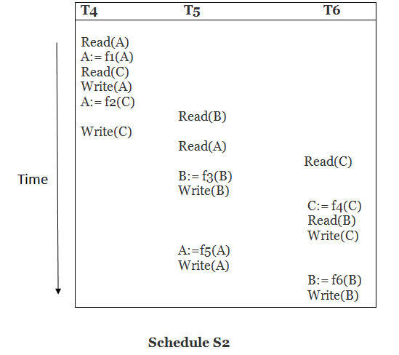
Explanation:
Read(A): In T4,no subsequent writes to A, so no new edges
Read(C): In T4, no subsequent writes to C, so no new edges
Write(A): A is subsequently read by T5, so add edge T4 → T5
Read(B): In T5,no subsequent writes to B, so no new edges
Write(C): C is subsequently read by T6, so add edge T4 → T6
Write(B): A is subsequently read by T6, so add edge T5 → T6
Write(C): In T6, no subsequent reads to C, so no new edges
Write(A): In T5, no subsequent reads to A, so no new edges
Write(B): In T6, no subsequent reads to B, so no new edges

Precedence graph for schedule S2:
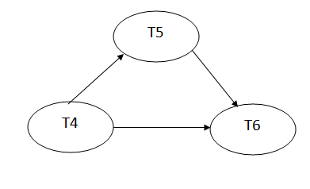
The precedence graph for schedule S2 contains no cycle that's why ScheduleS2 is serializable.

Conflict Serializable Schedule
- A schedule is called conflict serializability if after swapping of non-conflicting operations, it can transform into a serial schedule.
- The schedule will be a conflict serializable if it is conflict equivalent to a serial schedule.

Conflicting Operations
The two operations become conflicting if all conditions satisfy:
- Both belong to separate transactions.
- They have the same data item.
- They contain at least one write operation.

Example:
Swapping is possible only if S1 and S2 are logically equal.
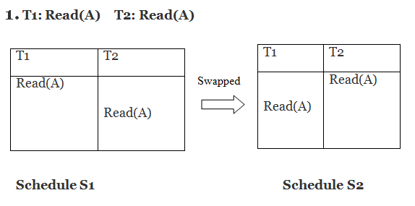
Here, S1 = S2. That means it is non-conflict.

Here, S1 ≠ S2. That means it is conflict.

Conflict Equivalent
In the conflict equivalent, one can be transformed to another by swapping non-conflicting operations. In the given example, S2 is conflict equivalent to S1 (S1 can be converted to S2 by swapping non-conflicting operations).
Two schedules are said to be conflict equivalent if and only if:
- They contain the same set of the transaction.
- If each pair of conflict operations are ordered in the same way.

Example:
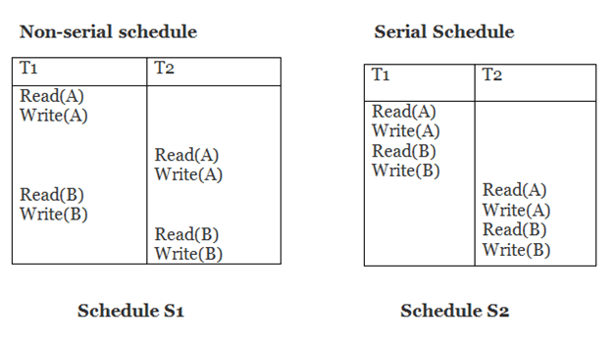
Schedule S2 is a serial schedule because, in this, all operations of T1 are performed before starting any operation of T2. Schedule S1 can be transformed into a serial schedule by swapping non-conflicting operations of S1.
After swapping of non-conflict operations, the schedule S1 becomes:
T1 | T2
Read(A)  Write(A)  Read(B)  Write(B) | Read(A)  Write(A)  Read(B)  Write(B)
Since, S1 is conflict serializable.

