

LAB EXPERIMENT

DATABASE MANAGEMENT SYSTEM

SUBMITTED BY MANISHA CHATURVEDI

07801012019

B.Tech CSE1(3rd semester)

FACULTY INCHARGE – PROF. ELA KUMAR

EXPERIMENT-1

Entity-Relationship Diagram

Takes

Received_from

Sell_to

Orders

Salesman

Customer

EXPERIMENT – 2

**Database Schema for a customer-sale scenario**

Customer(**Cust id : integer,** cust_name: string)

Item(**item_id: integer,** item_name: string, price: integer)

Sale(**bill_no: integer,** bill_data: date, **cust_id: integer, item_id: integer**, qty_sold: integer)

For the above schema, perform the following—

1. Create the tables with the appropriate integrity constraints.
2. Insert around 10 records in each of the tables.
3. List all the bills for the current date with the customer names and item numbers.
4. List the total Bill details with the quantity sold, price of the item and the final amount.
5. List the details of the customer who have bought a product which has a price>200.
6. Give a count of how many products have been bought by each customer
7. Give a list of products bought by a customer having cust_id as 5.
8. List the item details which are sold as of today.
9. Create a view which lists out the bill_no, bill_date, cust_id, item_id, price, qty_sold, amount. Create a view which lists the daily sales date wise for the last one week.

/*1.Creating tables*/

CREATE TABLE Customer(

cust_id int,

cust_name varchar(20)

PRIMARY KEY(cust_id)

);

CREATE TABLE Item(

item_id int,

item_name varchar(20),

price int

PRIMARY KEY(item_id)

);

CREATE TABLE Sale(

bill_no int,

bill_data date,

cust_id int references Customer(cust_id),

item_id int references Item(item_id),

qty_sold int

PRIMARY KEY(bill_no)

);

/*2.Instering values to respective tables*/

INSERT INTO Customer VALUES (1,'Aakash');

INSERT INTO Customer VALUES (2,'Nisha');

INSERT INTO Customer VALUES (3,'Vivek');

INSERT INTO Customer VALUES (4,'Shyam');

INSERT INTO Customer VALUES (5,'Anju');

INSERT INTO Customer VALUES (6,'Nitish');

INSERT INTO Customer VALUES (7,'Pragya');

INSERT INTO Customer VALUES (8,'Khyati');

INSERT INTO Customer VALUES (9,'Muskan');

INSERT INTO Customer VALUES (10,'Pooja');

INSERT INTO Item VALUES (1001,'lays chips',300);

INSERT INTO Item VALUES (1004,'Sugar',540);

INSERT INTO Item VALUES (1010,'Salt',290);

INSERT INTO Item VALUES (2223,'Biscuits',180);

INSERT INTO Item VALUES (1910,'Kurkure',340);

INSERT INTO Item VALUES (2450,'Corn Soup',210);

INSERT INTO Item VALUES (1003,'Soaps',500);

INSERT INTO Item VALUES (1008,'Detergent',170);

INSERT INTO Item VALUES (2133,'Vegetables',200);

INSERT INTO Item VALUES (2098,'Fruits',300);

INSERT INTO Sale VALUES (9001,'2001-08-10',8,1008,2);

INSERT INTO Sale VALUES (9110,'2011-10-19',3,1910,1);

INSERT INTO Sale VALUES (9670,'2020-09-19',1,1010,9);

INSERT INTO Sale VALUES (9232,'2020-09-19',9,2450,3);

INSERT INTO Sale VALUES (9871,'2020-08-10',5,1010,1);

INSERT INTO Sale VALUES (9021,'2020-09-20',7,1004,8);

INSERT INTO Sale VALUES (9222,'2020-09-19',6,1001,3);

INSERT INTO Sale VALUES (9910,'2001-09-20',4,2133,2);

INSERT INTO Sale VALUES (9233,'2020-09-20',10,1003,7);

INSERT INTO Sale VALUES (9564,'2020-09-19',2,2223,3);

UPDATE Sale SET cust_id=5 WHERE item_id=1010;

SELECT * FROM Customer;

SELECT * FROM Item;

SELECT * FROM Sale;

/*3.Bills for the current date*/

SELECT c.cust_name,i.item_id,s.bill_no

FROM Customer c,Item i,Sale s

WHERE c.cust_id=s.cust_id and i.item_id=s.item_id and s.bill_data='2020-09-19';

/*4.Total Bill details*/

SELECT s.qty_sold,i.price,(s.qty_sold*i.price)Total

FROM Sale s,Item i WHERE i.item_id=s.item_id;

/*5.Customers who have bought a product which has price>200*/

SELECT c.cust_id,c.cust_name

From Customer c,Item i,Sale s

WHERE i.price>200 and i.item_id=s.item_id and c.cust_id=s.cust_id;

/*6.Total product bought by each customer*/

SELECT s.cust_id,count(s.item_id)Total_Product

FROM Sale s GROUP BY s.cust_id;

/*7.List of products bought by customer having cust_id=5*/

SELECT s.bill_no,s.item_id,s.qty_sold

FROM Sale s WHERE s.cust_id=5;

/*8.List of items which are sold as of today*/

SELECT i.item_id,i.item_name,i.price

FROM Item i,Sale s

WHERE s.bill_data='2020-09-19' AND i.item_id=s.item_id;

/*9.View table*/

CREATE VIEW Sales1 AS

SELECT s.bill_no,s.bill_data,c.cust_id,i.item_id,

i.price,s.qty_sold,(i.price*s.qty_sold)Amount

FROM Customer c,Item i,Sale s

WHERE c.cust_id=s.cust_id and i.item_id=s.item_id;

SELECT * FROM Sales1;

SELECT count(s.qty_sold*i.price)Quantity_Sold,s.bill_data FROM Sale s,Item i WHERE s.bill_data>=DATEADD(day,-7,GETDATE()) GROUP BY s.bill_data;

OUTPUT

/*2.Tables with respective values*/

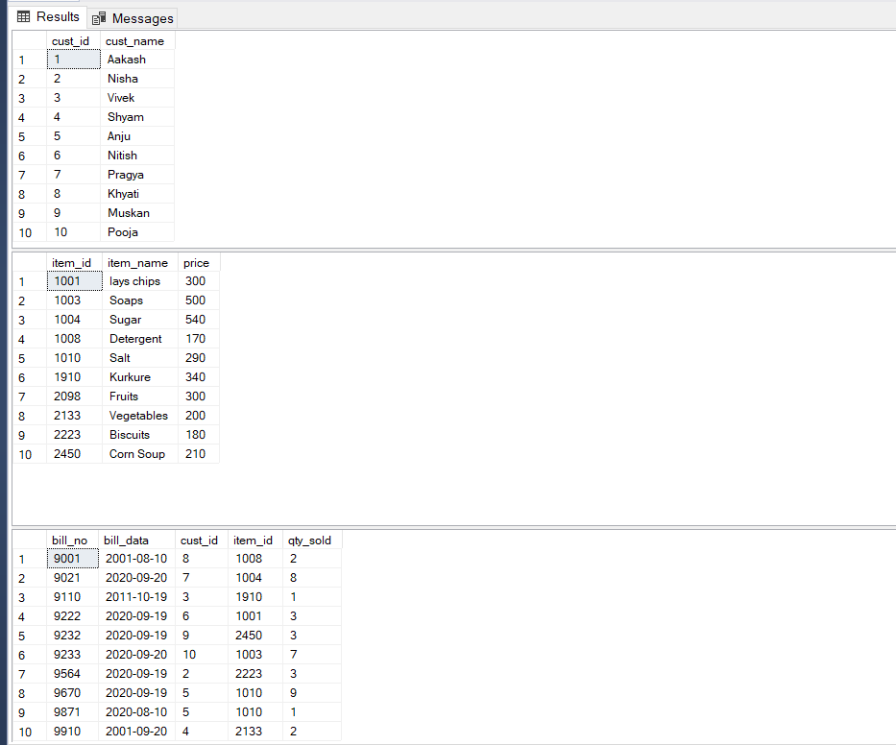

/*3*/

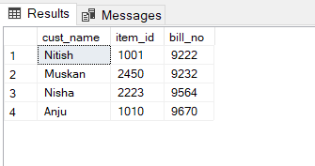

/*4*/

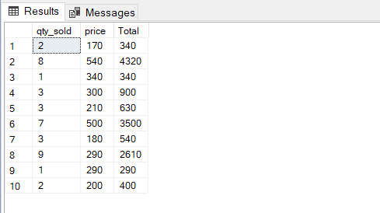

/*5*/

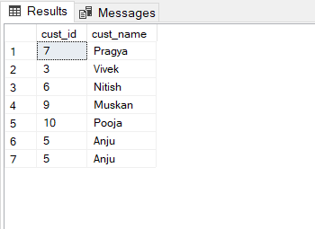

/*6*/

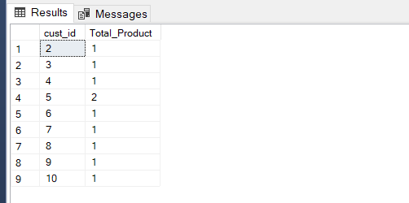

/*7*/

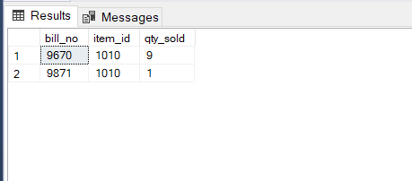

/*8*/

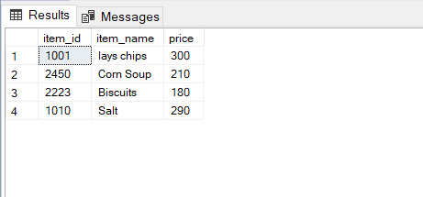

/*9*/

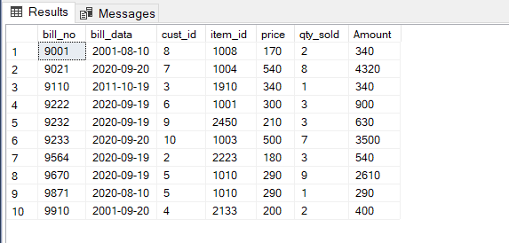

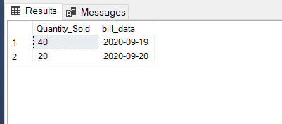

EXPERIMENT-3

**Database Schema for a Student Library scenario**

Student(**Stud_no : integer,** Stud_name: string)

Membership(**Mem_no: integer**, **Stud_no: integer**)

Book(**book_no: integer**, book_name:string, author: string)

Iss_rec**(iss_no:integer**, iss_date: date, **Mem_no: integer**, **book_no: integer**)

For the above schema, perform the following—

1. Create the tables with the appropriate integrity constraints
2. Insert around 10 records in each of the tables
3. List all the student names with their membership numbers
4. List all the issues for the current date with student and Book names
5. List the details of students who borrowed book whose author is CJDATE
6. Give a count of how many books have been bought by each student
7. Give a list of books taken by student with stud_no as 5
8. List the book details which are issued as of today
9. Create a view which lists out the iss_no, iss _date, stud_name, book name
10. Create a view which lists the daily issues-date wise for the last one week

CREATE DATABASE LAB4;

USE LAB4;

/*1.Creating tables*/

CREATE TABLE Student

(

Stud_no int,

Stud_name varchar(20)

PRIMARY KEY(Stud_no)

);

CREATE TABLE Membership

(

Mem_no int,

Stud_no int references Student(Stud_no)

PRIMARY KEY(Mem_no)

);

CREATE TABLE Book(

Book_no int,

Book_name varchar(20),

Author varchar(20)

PRIMARY KEY(Book_no)

);

CREATE TABLE Iss_rec(

Iss_no int,

Iss_date date,

Mem_no int references Membership(Mem_no),

Book_no int references Book(Book_no)

PRIMARY KEY(Iss_no)

);

/*2.Inserting values */

INSERT INTO Student VALUES (12,'Salman');

INSERT INTO Student VALUES (23,'Manisha');

INSERT INTO Student VALUES (34,'Nisha');

INSERT INTO Student VALUES (9,'Aakash');

INSERT INTO Student VALUES (10,'Kapil');

INSERT INTO Student VALUES (24,'Aaliya');

INSERT INTO Student VALUES (78,'Vivek');

INSERT INTO Student VALUES (17,'Simran');

INSERT INTO Student VALUES (45,'Nidhi');

INSERT INTO Student VALUES (56,'Rajat');

INSERT INTO Student VALUES (1,'Manish');

INSERT INTO Membership VALUES (1234,56);

INSERT INTO Membership VALUES (2321,78);

INSERT INTO Membership VALUES (8766,1);

INSERT INTO Membership VALUES (9321,10);

INSERT INTO Membership VALUES (4532,9);

INSERT INTO Membership VALUES (6754,45);

INSERT INTO Membership VALUES (1456,17);

INSERT INTO Membership VALUES (3421,34);

INSERT INTO Membership VALUES (6751,23);

INSERT INTO Membership VALUES (8956,12);

INSERT INTO Book VALUES (6571,'Young Girl','Anne Frank');

INSERT INTO Book VALUES (8534,'Seven Wonders','Steve');

INSERT INTO Book VALUES (9000,'Igniters','Vivek');

INSERT INTO Book VALUES (8999,'Descrete Maths','Aakash');

INSERT INTO Book VALUES (6555,'Biology','Rajan');

INSERT INTO Book VALUES (7655,'Chemistry','Anne Frank');

INSERT INTO Book VALUES (6011,'Panchtantra','Vivek');

INSERT INTO Book VALUES (7232,'Invisible Man','CJDATE');

INSERT INTO Book VALUES (9191,'Liefelong','Steve');

INSERT INTO Book VALUES (8001,'Reality','Anne Frank');

INSERT INTO Iss_rec VALUES (2331,'2020-09-20',2321,6011);

INSERT INTO Iss_rec VALUES (4545,'2020-09-17',8956,7232);

INSERT INTO Iss_rec VALUES (1212,'2020-09-20',4532,6571);

INSERT INTO Iss_rec VALUES (9088,'2020-08-11',6751,9000);

INSERT INTO Iss_rec VALUES (8011,'2020-08-20',9321,6011);

INSERT INTO Iss_rec VALUES (3222,'2020-09-19',8956,8999);

INSERT INTO Iss_rec VALUES (1444,'2020-07-30',8766,7232);

INSERT INTO Iss_rec VALUES (7688,'2020-09-20',2321,8534);

INSERT INTO Iss_rec VALUES (9453,'2020-08-10',3421,7655);

INSERT INTO Iss_rec VALUES (1010,'2020-09-15',8956,7232);

SELECT * FROM Student;

Select * from book;

select * from iss_rec;

select * from Membership;

/*3.Student names with their membership numbers*/

SELECT s.stud_name,m.mem_no FROM Student s,Membership m WHERE s.stud_no=m.stud_no;

/*4.Issues for the current date*/

SELECT i.Iss_no,i.Mem_no,i.Book_no,s.stud_name,b.book_name FROM Iss_rec i,Student s,Book b,Membership m

WHERE i.iss_date='2020-09-20' and m.mem_no=i.mem_no and b.book_no=i.book_no and m.stud_no=s.stud_no;

/*5.Students who borrowed book by CJDATE*/

SELECT m.Mem_no,m.Stud_no,s.Stud_name

FROM Membership m,Iss_rec i,Book b,Student s

WHERE b.Author='CJDATE' AND i.Book_no=b.Book_no AND m.Mem_no=i.Mem_no AND s.Stud_no=m.Stud_no;

/*6.Count of books bought by each student*/

SELECT m.Stud_no,count(s.stud_no)Count_books

FROM Book b,Student s,Iss_rec i,Membership m

WHERE i.Mem_no=m.Mem_no AND m.stud_no=s.stud_no AND b.book_no=i.book_no GROUP BY m.stud_no;

/*7.List of books taken by a student with stud_no=78*/

SELECT b.book_no,b.book_name,b.Author

FROM Book b,Student s,Iss_rec i,Membership m

WHERE s.stud_no=78 and s.Stud_no=m.Stud_no AND i.Mem_no=m.Mem_no and b.book_no=i.book_no;

/*8.Book details which are isssued today*/

SELECT * FROM Book b,Iss_rec i

WHERE i.Iss_date='2020-09-20' AND b.Book_no=i.Book_no;

/*9.View which lists out the iss_no,iss_date,stud_name,book_name*/

CREATE VIEW list AS SELECT i.Iss_no,i.Iss_date,s.Stud_name,b.book_name FROM Iss_rec i,Student s,Book b, Membership m WHERE s.stud_no=m.Stud_no and m.Mem_no=i.Mem_no and b.book_no=i.book_no;

SELECT * FROM list;

/*10.Issues date wise for the last one week*/

SELECT COUNT(i.iss_date)count_book,i.Iss_date FROM Iss_rec i WHERE i.Iss_date>=DATEADD(day,-7,GETDATE()) GROUP BY i.Iss_date;

**OUTPUT**

/*2*/

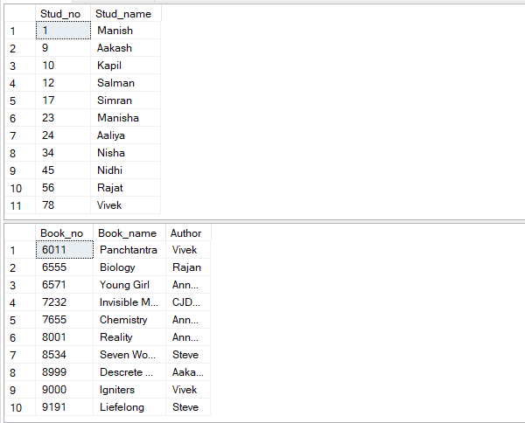

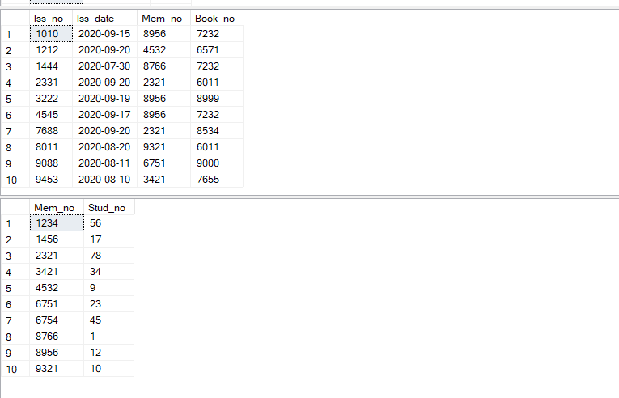

/*3*/

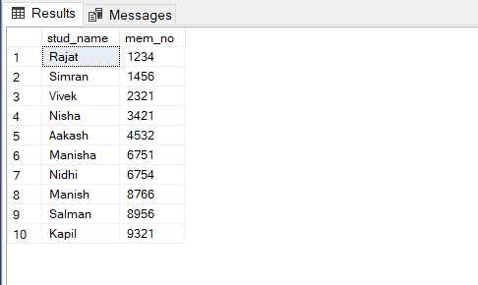

/*4*/

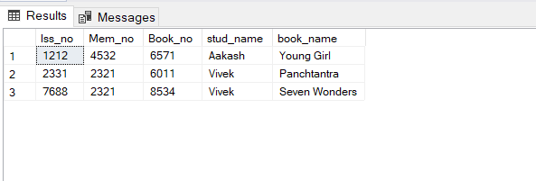

/*5*/

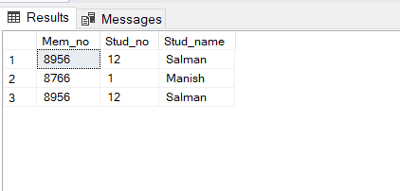

/*6*/

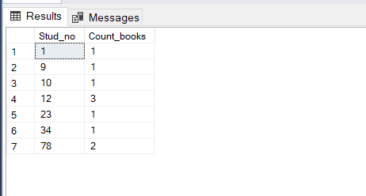

/*7*/

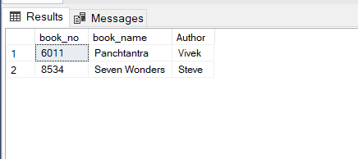

/*8*/

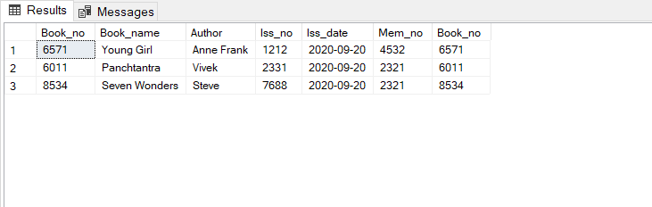

/*9*/

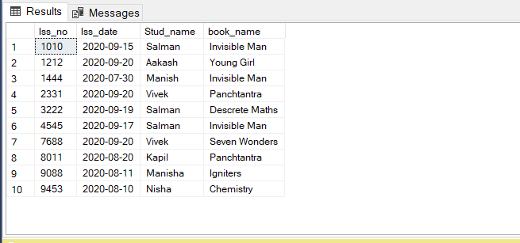

/*10*/

