**MANISHA SAWLANI**

**ICE**

**Dr. B R Ambedkar National Institute of Technology Jalandhar**

**What Is A Candlestick?**

A candlestick is a type of price chart used in technical analysis that displays a security's high, low, open, and closing prices for a specific period. It originated from Japanese rice merchants and traders to track market prices and daily momentum for hundreds of years before becoming popularized in the United States. The wide part of the candlestick is called the "[real body](https://www.investopedia.com/terms/r/realbody.asp)" and tells investors whether the closing price was higher or lower than the opening price (black/red if the stock closed lower, white/green if the stock closed higher).

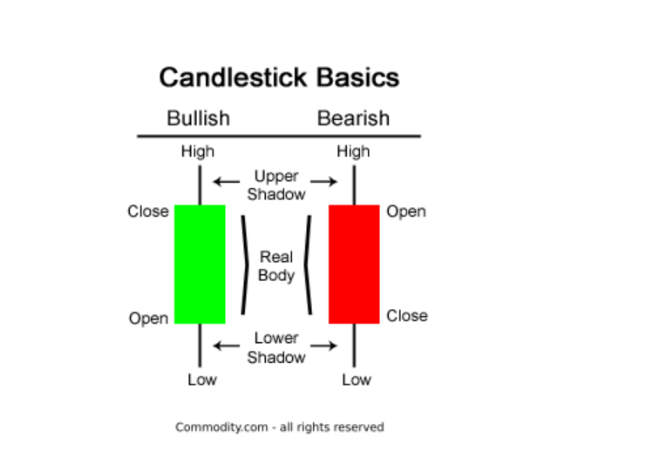

## Bullish Engulfing Pattern

​An engulfing pattern on the market’s bullish side occurs when buyers outpace sellers. This is reflected in the chart by a long green real body engulfing a small red real body. With bulls having established some control, the price could head higher.

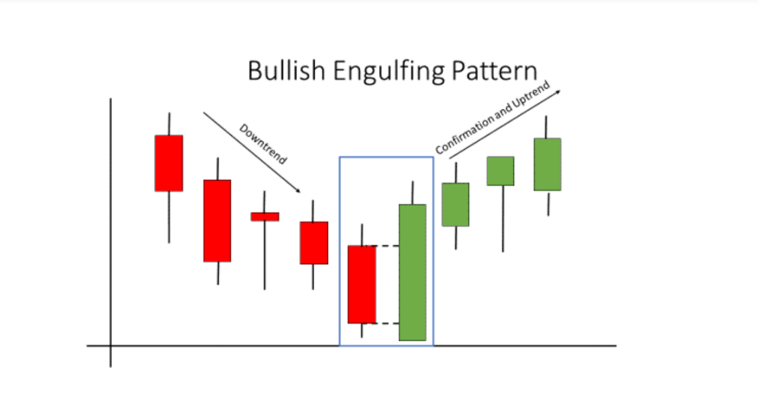

## Bearish Engulfing Pattern

​A bearish engulfing pattern develops in an uptrend when sellers outnumber buyers. This action is reflected by a long red real body engulfing a small green real body. The pattern indicates that sellers are back in control and that the price could continue to decline.

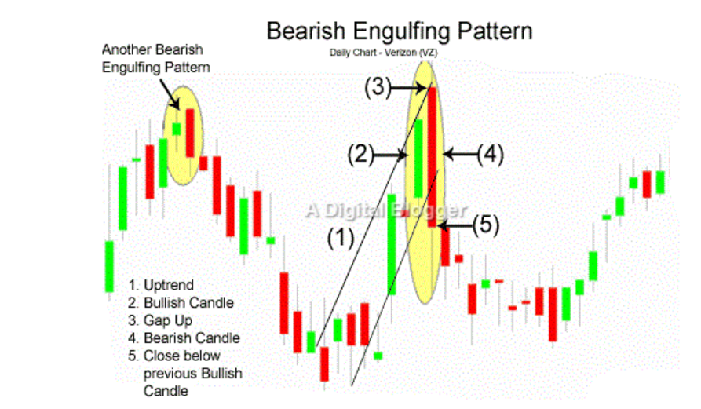

## Bullish Rising Three

This pattern starts out with what is called a "long white day." Then, on the second, third, and fourth trading sessions, small real bodies move the price lower, but they still stay within the price range of the long white day (day one in the pattern). The fifth and last day of the pattern is another long white day.

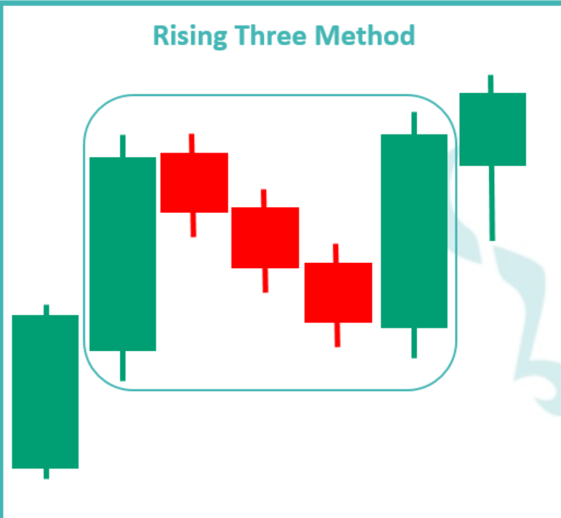

## Bearish Falling Three

The pattern starts out with a strong down day. This is followed by three small real bodies that make upward progress but stay within the range of the first big down day. The pattern completes when the fifth day makes another large downward move. It shows that sellers are back in control and that the price could head lower.

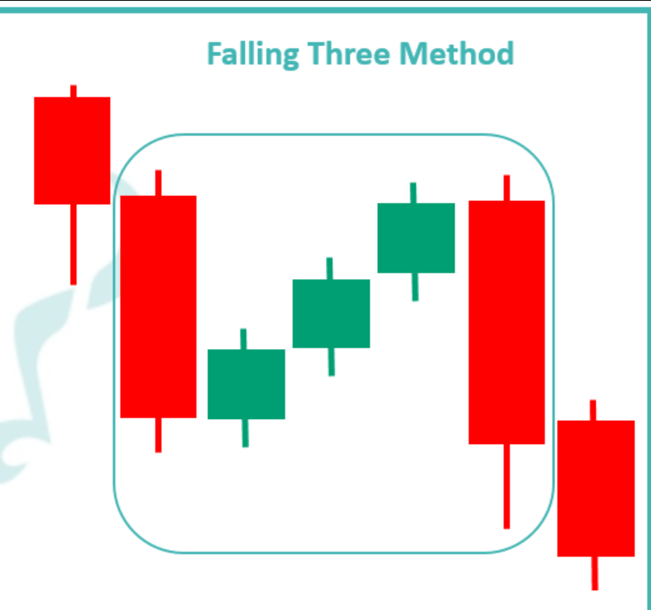

Files Structure

Creating a Folder Candlestick contains

1. main.py
2. Patterns: required patterns are:-
3. Bearish_engulfing
4. Bearish_falling_three
5. Bullish_englufing
6. Bullish_rising_three

1. Candlestick.py
2. Readme.md
3. Sample.csv : sample file consists 5 columns such as

Timestamp, Open, High, Low, Close

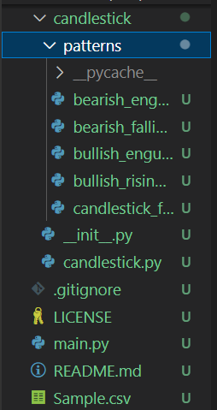

OHLC Data Pre-Processing:-

Import Python Library pandas, datetime, requests to access the sample file, and change the timestamp into datetime.

Drop Null Values using dropna() function in python.

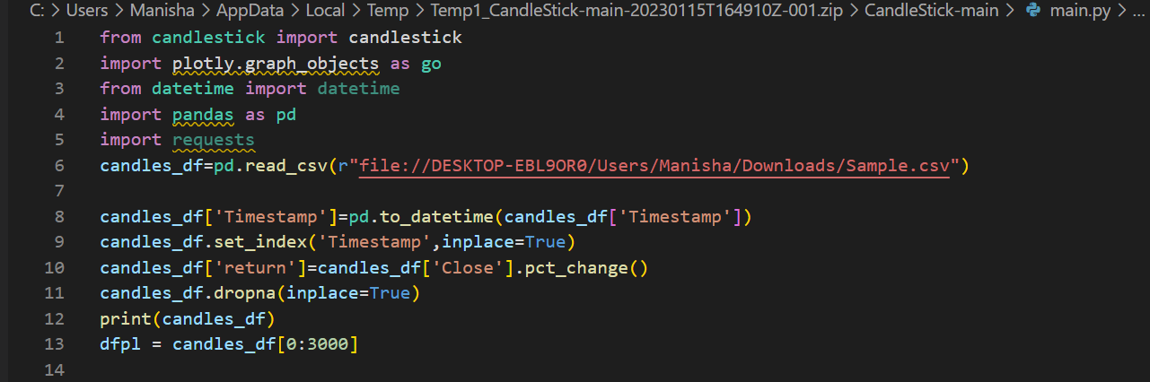

OHLC Dataset:-

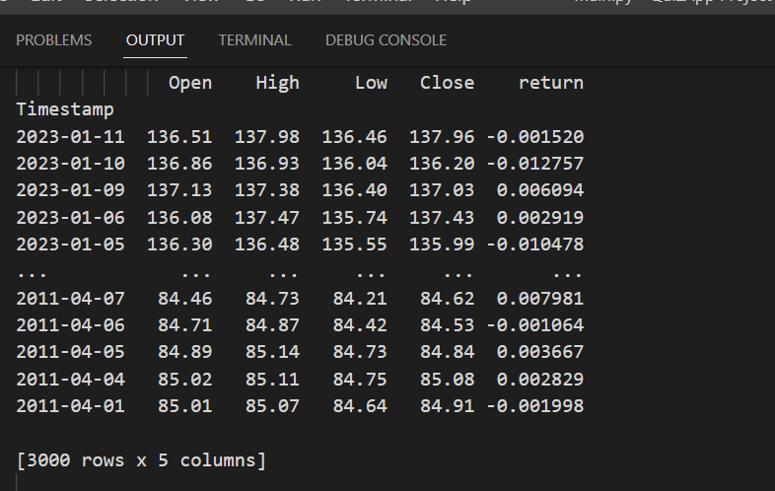

## Bullish Engulfing Code and Chart:-

## Let’s Take a Pattern of bullish engulfing for finding the chart and occurrence

## Data-Frame requirements :-

## a.) Dataframe must contain open, high, low and close prices

## b.) Open, high, low and close prices must be in numeric type.

## Import Library

## from candlestick import candlestick

## df = candlestick.bullish_engulfing(df, target='result')

## Pseudo Code

The classic bullish engulfing pattern must meet the following rules:

1. The previous candle must be **Red (downwards)**
2. The current candle must be **Green (upwards)**
3. The high of the ‘Green’ candle must be higher than the high of the ‘Red’ candle
4. The body of the Green candle must be greater than the body of the Red candle

## All pattern detection methods the receive 3 parametrs:

## * target (String) - Indicates the column to which the result of detection is saved as a boolean.

## * is_reversed (Bool) - Pass True if rows in the data frame are in time descending order, otherwise False. Default is False.

## * ohlc (List) - Pass list of strings which indicates the column names of open/high/low/close prices in dataframe. Default: ["open", "high", "low", "close"].

## Result - "True" indicates that a pattern is detected at that candle.

## 

## 

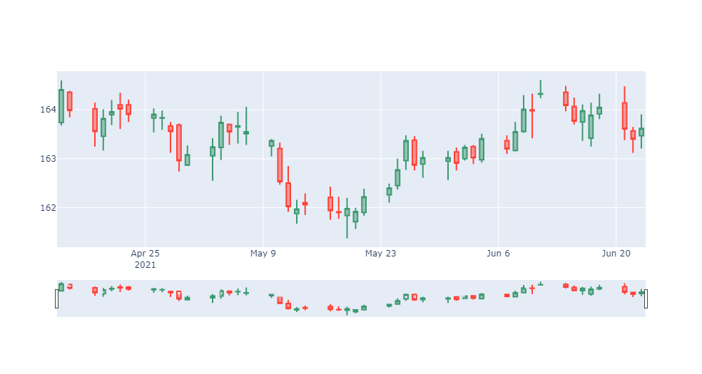

Occurrence of BullishRisingthree:-

Applying a condition returns a Boolean value “True” and the occurrence will be 76.

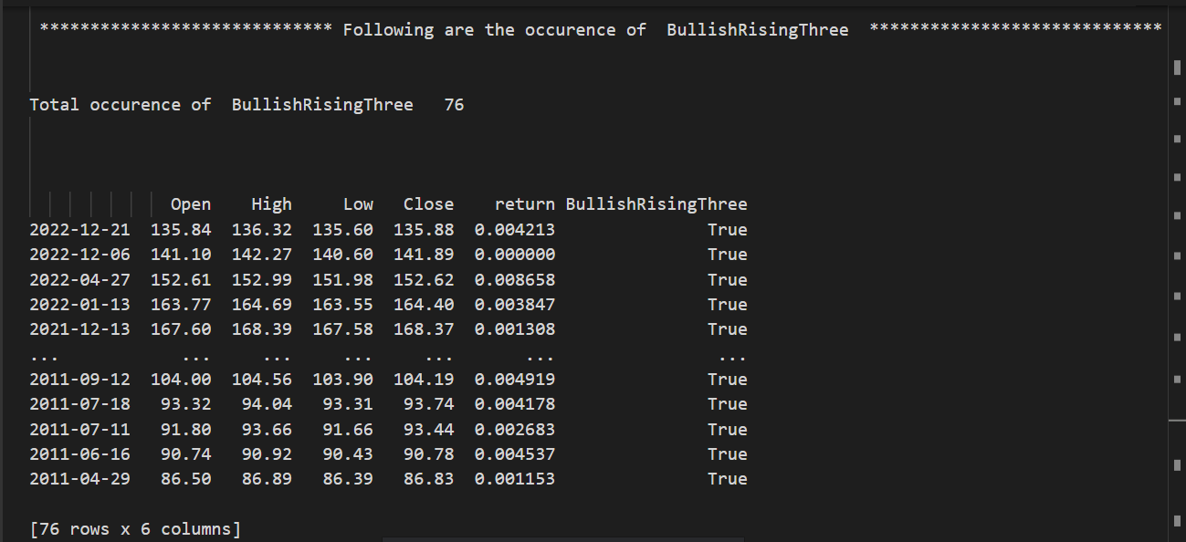

Occurrence of Bearishfallingthree:-

Applying a condition returns a Boolean value “True” and the occurrence will be 105.

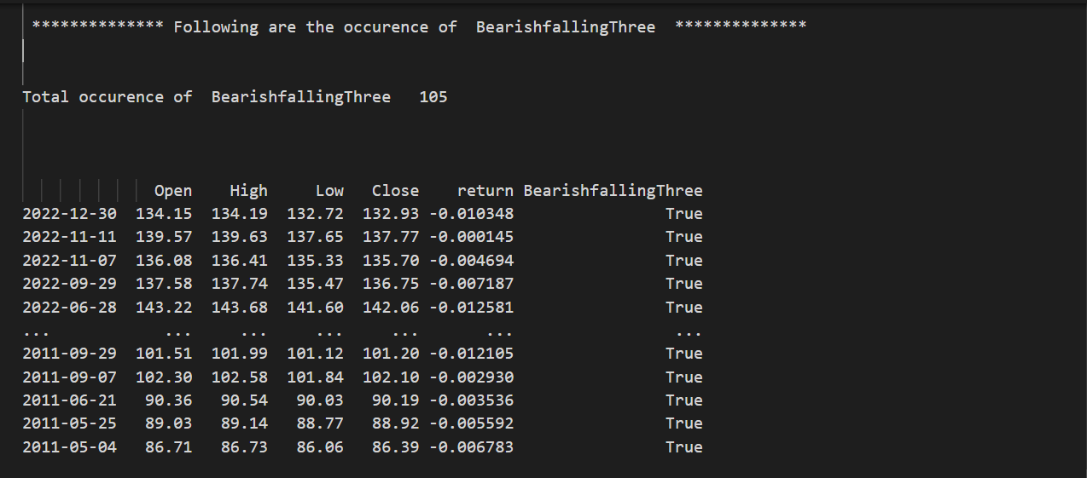

Occurrence of Bearishengulfing:-

Applying a condition returns a Boolean value “True” and occurrence will be 122.

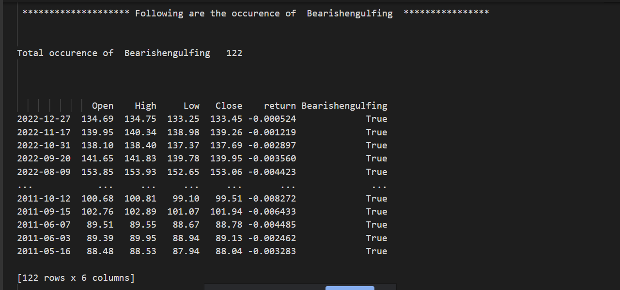

Occurrence of Bullishengulfing:-

Applying a condition returns a Boolean value “True” and occurrence will be 157.

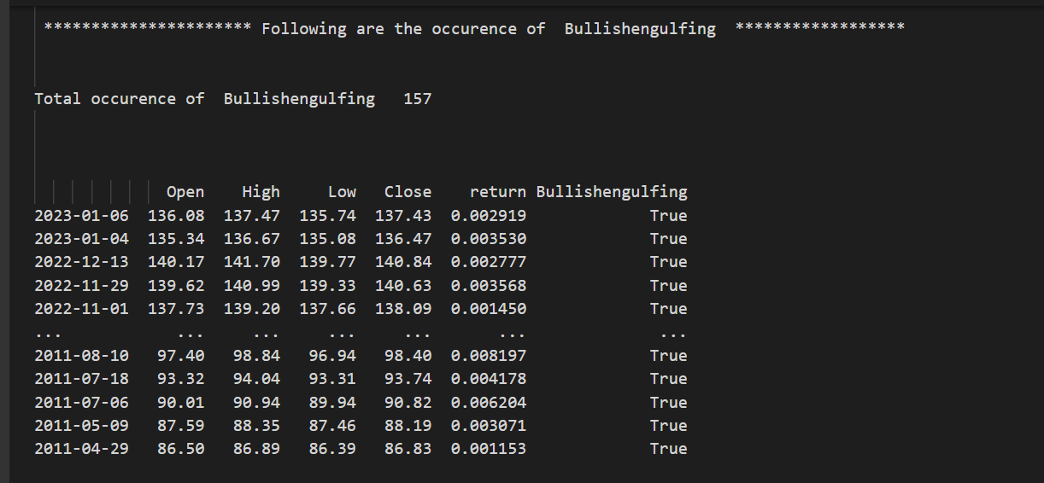

Python Program

GitHub Link:- <https://github.com/manisha-sawlani/CandleStick-Patterns-Assignment>