DATA ANALYTICS PROJECT
Global Terrorism Database:
Exploratory Data Analysis and Geospatial Visualization
Analysis Period: 2007–2017
Project Report
Prepared by
MANISHA
Tools: R • Jupyter Notebook • tidyverse • ggplot2 • GGally • rworldmap

1. Executive Summary
This project presents an exploratory data analysis of the Global Terrorism Database (GTD), focusing on incidents recorded between 2007 and 2017. The objective is to identify broad patterns in terrorism incidents through time, geography, attack type, weapon type, target type and perpetrator organization. The analysis was implemented in R using a Jupyter Notebook and combines data cleaning, feature engineering, descriptive statistics, categorical aggregation, time-series visualization, correlation analysis and geospatial visualization.
The supplied GTD CSV contains 181,691 rows. Applying the project notebook’s principal analytical filter—years 2007–2017 and doubtterr = 0—produces 83,606 records in the supplied file. Across these filtered records, the recorded death total is 180,369. The results show substantial geographic and categorical concentration, with the Middle East & North Africa having the highest recorded fatalities among regions. Explosives and firearms account for the largest recorded fatality totals among weapon categories, while private citizens and property account for the largest total among target categories.
The project is descriptive rather than causal or predictive. The findings should therefore be interpreted as patterns within the GTD data and not as evidence that a particular weapon, target or attack type independently causes higher fatalities.

2. Project Objectives
- Understand the structure and characteristics of the Global Terrorism Database for the selected period.
- Clean and standardize relevant time, geographic, numerical, binary and categorical variables.
- Examine geographic concentration of recorded fatalities across countries, cities and regions.
- Compare fatalities by attack type, weapon type, target type and terrorist organization.
- Study changes in recorded fatalities over time using daily, monthly and category-specific trends.
- Use correlation and distributional analysis to explore relationships among numerical variables.
- Visualize the geographic activity of the five highest-fatality non-unknown groups in the selected period.

3. Problem Statement
Terrorism incidents have multiple dimensions—location, timing, attack method, weapon, target and perpetrator. A large incident-level dataset can therefore be difficult to interpret without systematic cleaning, aggregation and visualization. This project addresses the following analytical questions:
- Where were recorded fatalities geographically concentrated?
- Which attack and weapon categories were associated with the largest recorded death totals?
- Which target categories experienced the largest recorded fatality totals?
- Which named organizations accounted for the largest recorded death totals in the selected period?
- How did recorded fatalities vary over the 2007–2017 period?
- What patterns can be observed in the relationship among deaths, wounded persons, perpetrators and terrorist deaths?

4. Dataset and Data Source
The project uses the Global Terrorism Database (GTD), an incident-level database documenting terrorist events. The notebook identifies the University of Maryland START GTD as the primary source and uses a Kaggle mirror for the downloaded dataset.
Item | Description
Primary source | Global Terrorism Database (GTD), START / University of Maryland
Dataset file | globalterrorismdb_0718dist.csv
Source coverage | GTD source covers incidents from 1970–2017
Project analysis window | 2007–2017
Initial rows in supplied CSV | 181,691
Rows after project filter | 83,606
Primary unit of analysis | Incident
Source links documented in the project README:
- http://start.umd.edu/gtd/
- http://start.umd.edu/gtd/downloads/Codebook.pdf
- https://www.kaggle.com/START-UMD/gtd

5. Technologies and Tools
Tool / Package | Role in the Project
R 4 | Primary programming language
Jupyter Notebook / R kernel | Interactive analysis environment
tidyverse | Data manipulation, cleaning and visualization
GGally | Correlation matrix visualization using ggcorr
rworldmap | World map data for geospatial visualization
ggrepel | Non-overlapping labels on the group activity map
mapproj | Map projection support
lubridate | Date construction and time handling
scales | Axis/value formatting
grid | Plot layout and margins

6. Methodology

6.1 Data Loading and Subsetting
The CSV is loaded using read.csv(). The notebook selects variables covering time, geospatial coordinates, numerical measures, binary indicators and categorical descriptors. The selected fields include year, month, day, latitude, longitude, number of perpetrators, deaths, wounded persons, terrorist deaths, property damage, ransom amount, city, country, region, attack type, weapon type, target type and group name.

6.2 Data Cleaning and Standardization
- Variables are renamed for readability, such as iyear → year, imonth → month, iday → day, latitude → lat and longitude → long.
- Long categorical labels are normalized for readability—for example Bombing/Explosion is represented as Explosion and Private Citizens & Property as Private.
- The analysis is restricted to 2007–2017 and observations with doubtterr = 1 are excluded.
- Negative sentinel values are converted to usable analytical values according to the notebook’s cleaning rules, and remaining missing values are replaced for selected count/binary variables.
- Month = 0 and day = 0 are replaced with month 6 and day 15 respectively so that a usable date can be constructed.
- Property damage is encoded into Unknown, Low, Medium and High categories.

6.3 Exploratory Analysis
- Top cities, countries and regions are ranked by total recorded fatalities.
- The five leading attack, weapon and target categories are compared by recorded fatalities.
- The ten highest-fatality named organizations are identified, excluding the Unknown group from the named-group ranking.
- Daily and cumulative monthly fatality trends are plotted.
- LOESS-smoothed trends are used for category-specific time-series visualizations.
- Log-transformed histograms are used to visualize strongly skewed numerical variables.
- A correlation matrix is produced for nkill, nkillter, nperps and nwound.
- A geospatial map shows incident locations associated with the five highest-fatality named groups.

7. Key Findings

7.1 Geographic Distribution
Region | Recorded fatalities
Middle East & North Africa | 78020
South Asia | 52586
Sub-Saharan Africa | 40410
Southeast Asia | 4355
Eastern Europe | 2215
The supplied data show a strong concentration of recorded fatalities in the Middle East & North Africa, followed by South Asia and Sub-Saharan Africa. This geographic concentration is also visible in the group activity map.

7.2 Countries with Highest Recorded Fatalities
Rank | Country | Recorded fatalities
1 | Iraq | 56100
2 | Afghanistan | 30449
3 | Nigeria | 20043
4 | Pakistan | 15661
5 | Syria | 9565
6 | Somalia | 5902
7 | India | 5280
8 | Yemen | 4587
9 | Democratic Republic of the Congo | 3185
10 | Philippines | 2223

7.3 Attack Types
Rank | Attack type | Recorded fatalities
1 | Bombing/Explosion | 89989
2 | Armed Assault | 51931
3 | Hostage Taking (Kidnapping) | 16300
4 | Unknown | 10826
5 | Assassination | 6600
Bombing/Explosion has the largest recorded fatality total in the supplied data, followed by Armed Assault. The project visualizes the temporal evolution of the leading attack categories using monthly aggregation and LOESS smoothing.

7.4 Weapon Types
Rank | Weapon type | Recorded fatalities
1 | Explosives | 102692
2 | Firearms | 55854
3 | Unknown | 16114
4 | Melee | 2904
5 | Incendiary | 2376
Explosives and Firearms dominate the recorded fatality totals among weapon categories. The project also visualizes attack counts by region and weapon type using a tile/heatmap-style chart.

7.5 Target Types
Rank | Target type | Recorded fatalities
1 | Private Citizens & Property | 76408
2 | Police | 33656
3 | Military | 14473
4 | Government (General) | 14420
5 | Business | 12859
Private Citizens & Property has the highest recorded fatality total among the target categories examined, followed by Police and Military. The target-specific time-series visualization shows how these categories change across the study period.

7.6 Named Organizations
Rank | Organization | Recorded fatalities
1 | Islamic State of Iraq and the Levant (ISIL) | 28022
2 | Taliban | 22935
3 | Boko Haram | 17903
4 | Al-Shabaab | 5621
5 | Tehrik-i-Taliban Pakistan (TTP) | 4762
6 | Al-Qaida in Iraq | 3176
7 | Fulani extremists | 2998
8 | Communist Party of India - Maoist (CPI-Maoist) | 1998
9 | Al-Nusrah Front | 1902
10 | Houthi extremists (Ansar Allah) | 1819
The ranking excludes records whose group name is Unknown. The five groups used in the project’s geospatial visualization are ISIL, Taliban, Boko Haram, Al-Shabaab and Tehrik-i-Taliban Pakistan (TTP).

8. Visualizations and Interpretation
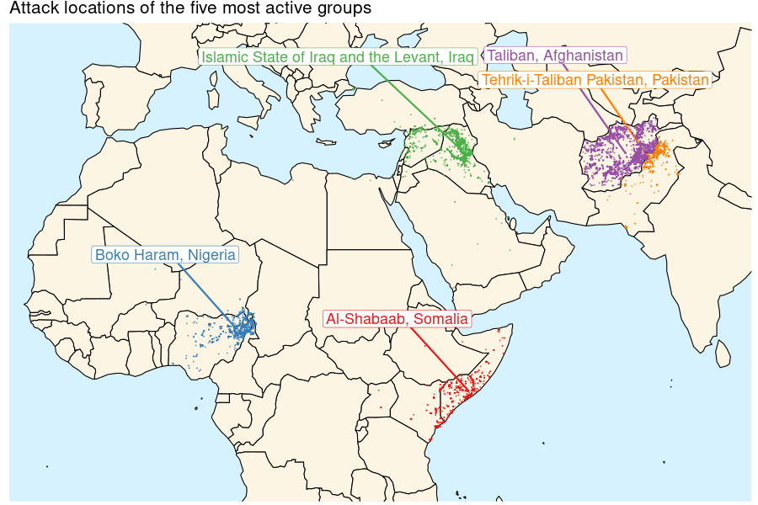
Figure 1. Attack locations associated with the five most active named groups in the project analysis.

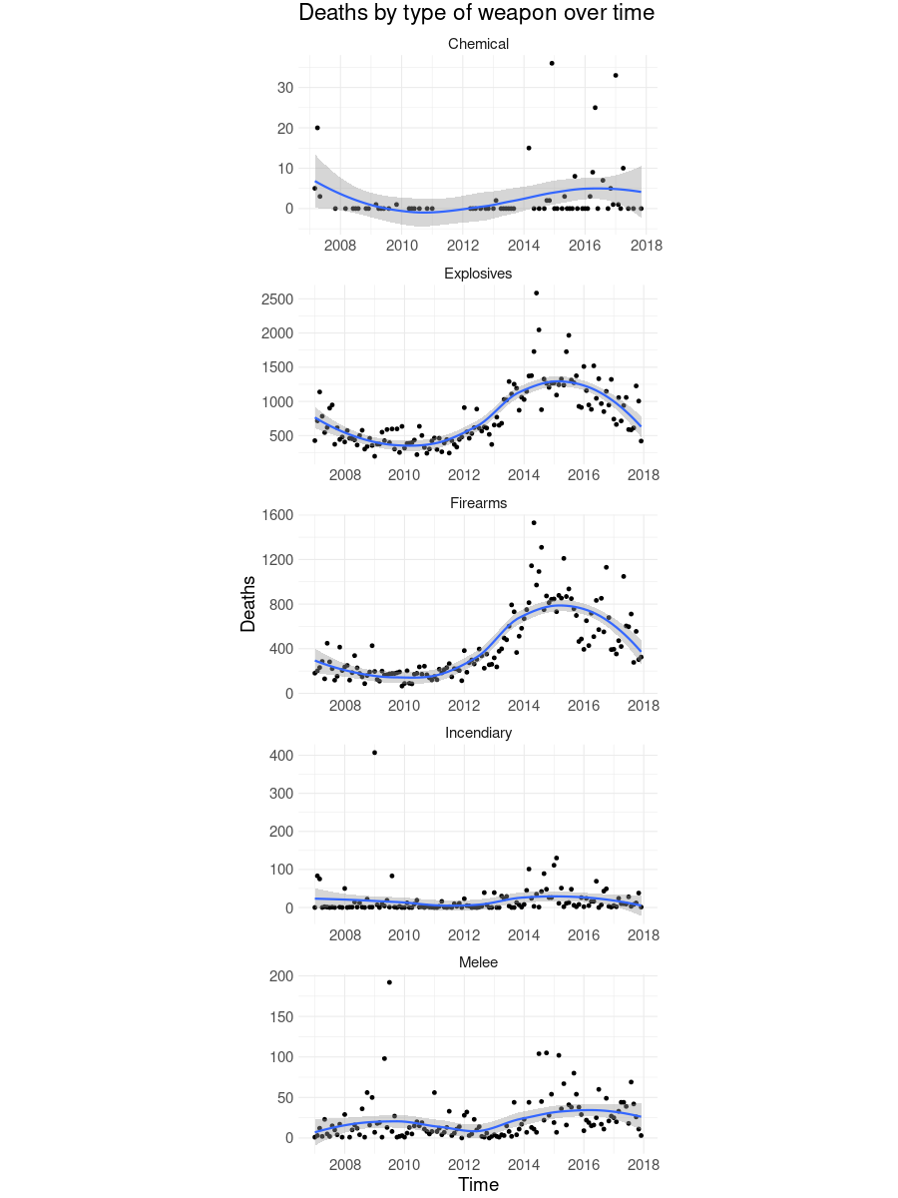
Figure 2. Recorded deaths by leading weapon categories over time, with LOESS-smoothed trends.

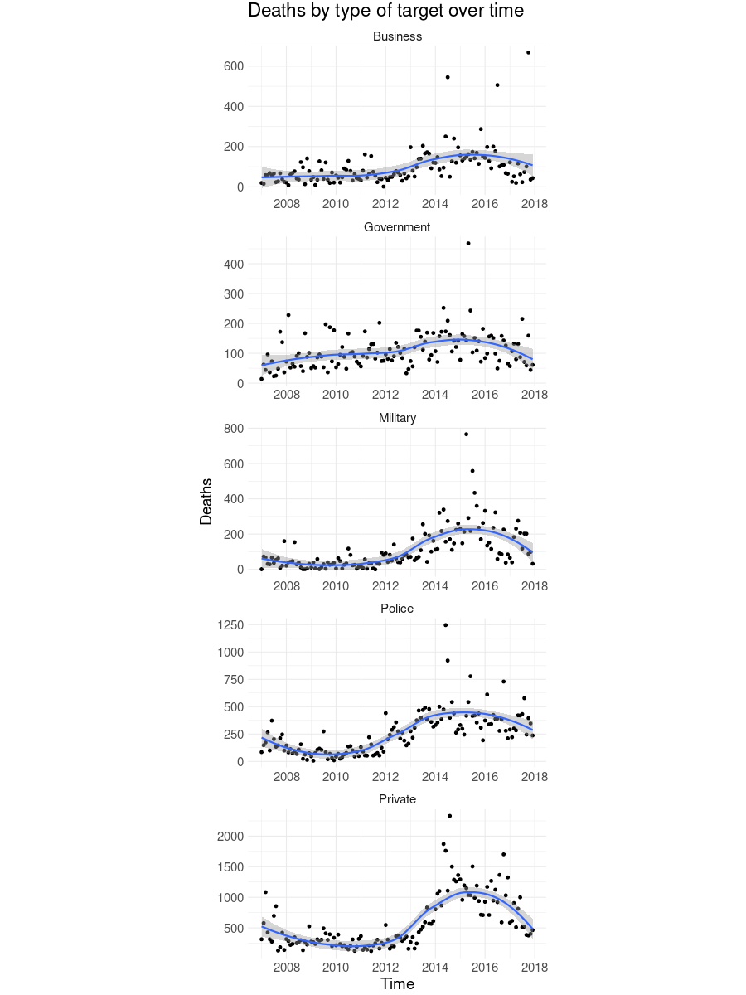
Figure 3. Recorded deaths by leading target categories over time, with LOESS-smoothed trends.

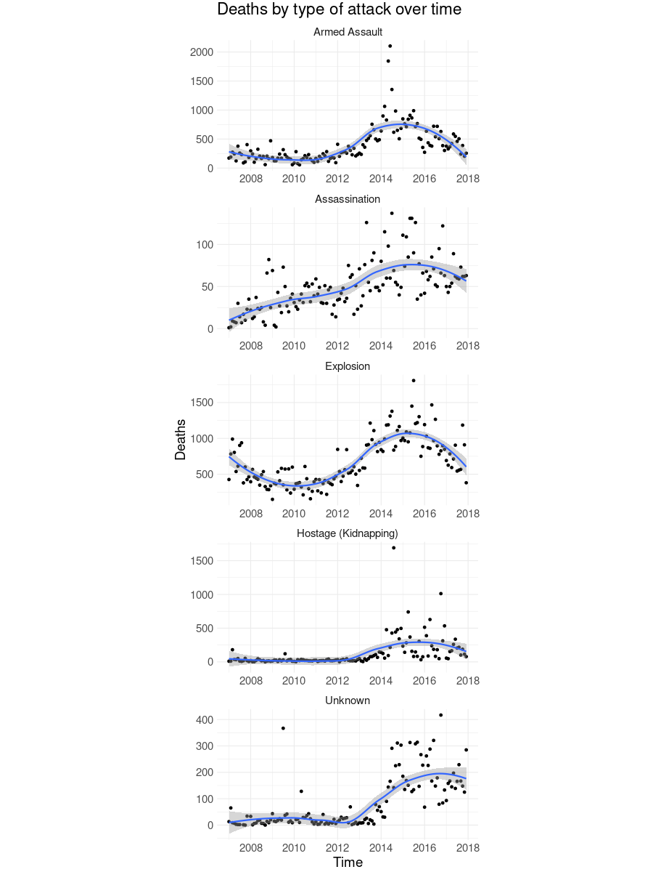
Figure 4. Recorded deaths by leading attack categories over time, with LOESS-smoothed trends.

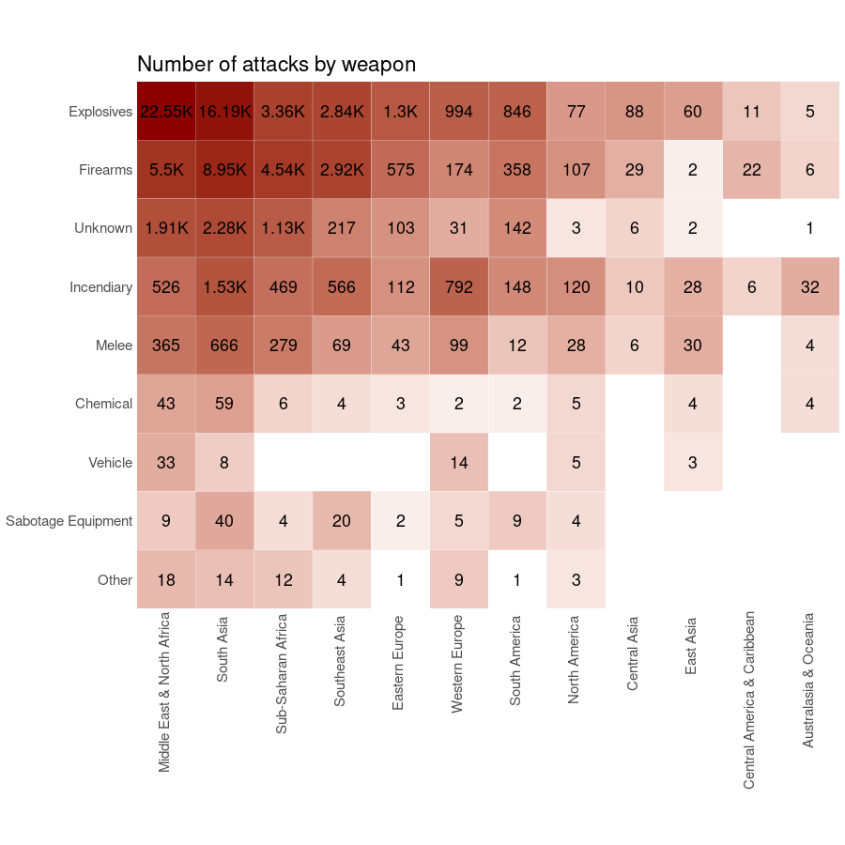
Figure 5. Number of attacks by weapon type and region; labels display counts and larger cells represent higher counts.

9. Statistical and Distributional Analysis
The notebook examines the numerical variables nperps, nkill, nwound, nkillter and ransomamt. Their distributions are highly skewed, so the notebook uses log(1 + value) transformations for histograms. This is a visualization choice intended to make long-tailed distributions easier to inspect; it does not change the underlying values used in aggregation.
A correlation matrix is calculated for nkill, nkillter, nperps and nwound. The notebook notes a positive relationship between fatalities and wounded persons, while also showing that terrorist deaths are closely related to total deaths. These are associations within the dataset and should not be interpreted as causal effects.

10. Limitations
- Selection bias: excluding doubtterr = 1 observations removes incidents whose terrorist classification was uncertain and can affect totals.
- Reporting coverage: the GTD is a historical incident database and coverage may vary across locations and years.
- Missing and sentinel values: the dataset uses special codes for unknown values, requiring explicit cleaning decisions.
- Label normalization: some category and organization names are manually simplified for readability.
- Geographic completeness: the map only uses observations with usable latitude and longitude.
- No causal inference: category-level correlations and differences do not establish that one factor causes another.
- Retrospective scope: the analysis covers 2007–2017 and is not a real-time monitoring system.

11. Reproducibility and Execution
- Install R and a Jupyter environment with an R/IR kernel.
- Install the packages listed in requirements.txt: tidyverse, GGally, rworldmap, ggrepel, mapproj, lubridate, scales and grid.
- Place globalterrorismdb_0718dist.csv in the expected data/ directory.
- Open Manisha_Global_Terrorism_Analysis.ipynb with the R kernel.
- Run the notebook sequentially to reproduce the cleaning, analysis and visualizations.
The supplied README describes the project as an exploratory data analysis and geospatial visualization of the GTD and documents the same R-based workflow.

12. Conclusion
This project demonstrates a complete exploratory data analytics workflow on a large, multidimensional real-world dataset. Through systematic cleaning, aggregation and visualization, it identifies geographic concentration and differences across attack, weapon, target and organization categories over the 2007–2017 period. The combination of time-series analysis and geospatial visualization provides complementary views of the data: temporal plots reveal changes over time, while the map highlights geographic clustering of selected named groups.
The main analytical value of the project lies in converting a complex incident-level dataset into interpretable summaries and visual patterns while explicitly recognizing data-quality and inference limitations.

13. Future Scope
- Develop an interactive dashboard with filters for year, country, region, group, weapon and target.
- Extend the analysis to network relationships between organizations, targets and locations.
- Compare GTD patterns with other conflict or event datasets for validation.
- Automate data-refresh and visualization generation when a compatible GTD release is available.
- Explore statistical or machine-learning methods only with clearly defined research questions and appropriate validation.

14. References
- Global Terrorism Database (GTD), START / University of Maryland: http://start.umd.edu/gtd/
- Global Terrorism Database Codebook: http://start.umd.edu/gtd/downloads/Codebook.pdf
- Global Terrorism Database dataset mirror documented in the project README: https://www.kaggle.com/START-UMD/gtd
- Project source notebook: Manisha_Global_Terrorism_Analysis.ipynb
- Project dependency list: requirements.txt

Appendix A. Project File Structure
- Manisha_Global_Terrorism_Analysis.ipynb — R Jupyter Notebook containing data loading, cleaning, analysis and visualizations.
- requirements.txt — R package dependencies used by the notebook.
- Manisha_Global_Terrorism_ProjectReport.docx — this project report.
- README.md — project overview, methodology, setup instructions and source links.
- globalterrorismdb_0718dist.csv — dataset used for analysis.

