AI FAQ ASSISTANT
AI-Powered FAQ and Customer Support Automation

TEAM ID : SWTID-2026-5383

TEAM LEADER :MANISHA M.

TEAM MEMBERS

- SANDHIYA P
- SARMISTA SAHANI S
- VISHNUPRIYA A.
- VAISHNAVI J.

PROJECT REPORT

ANSWERBOT
AI-Powered FAQ and Customer Support Automation

Project Type | REST API / Backend Application
Technology Stack | Node.js, Express.js, MongoDB, Mongoose, JWT, bcrypt, Google Gemini
API Verification | Postman / ThunderClient
Architecture | Layered Backend + MVC-oriented organization

Introduction
AnswerBot is a secure and intelligent REST API platform developed to streamline FAQ creation, user authentication, FAQ management, and AI-assisted content generation. The project uses Node.js and Express.js for server-side routing, MongoDB with Mongoose for data storage and schema validation, JWT for stateless authentication, and bcrypt for password protection. The backend also connects to Google Gemini services for AI-powered question-and-answer generation.
The system is designed around a practical customer-support scenario in which repetitive questions, documentation maintenance, categorization, and answer drafting can consume significant time. By moving these operations into a centralized backend, the application provides structured API endpoints for creators, authenticated users, and public consumers.
Project Objective: To build a reliable backend that combines secure authentication, FAQ CRUD operations, category organization, search, and AI-assisted content generation in a single RESTful service.

Report Structure
The following pages cover the system requirements, architecture, database and MVC design, implementation, API endpoints, and practical API testing results using the supplied screenshots.

Requirements and Problem Definition

Background and Problem
The project addresses a customer-support environment where a large number of repetitive questions must be organized and answered. The documented scenario identifies difficulty in maintaining up-to-date documentation, limited visibility into search keywords, time-consuming manual drafting of support answers, and the need for permission layers that protect private documentation.

Proposed Solution
AnswerBot provides a centralized and secure API wrapper that separates application business logic from frontend delivery. It introduces controlled services for content creation, category keywords, database persistence, authentication, and automated text inference. Authenticated creators can register, request AI assistance, create FAQs, and manage their own records, while public consumers can query published FAQ information.

Software Requirements
    - Operating System: Windows 10/11, macOS, or Linux.
    - Node.js v18 or above for the server runtime.
    - npm v9 or above for dependency management.
    - Express.js v4/v5 ecosystem for RESTful routing.
    - MongoDB with Mongoose ODM for NoSQL data storage and modeling.
    - Postman or ThunderClient for API verification.
    - Visual Studio Code or a similar code editor.

Hardware Requirements
    - Intel Core i5 (8th Gen or above), AMD Ryzen 5, or equivalent.
    - Minimum 8 GB RAM; 16 GB is recommended for concurrent MongoDB processing.
    - At least 1 GB of available storage for the project workspace.

Expected Outcome
The documented outcome is reduced operational delay, stronger structural integrity through schema validation, token-based protection for modification routes, and faster data discoverability through indexing and search mechanisms.

System Architecture and User Flow

Architecture Overview
The backend follows a layered server architecture. Incoming HTTP requests are received by the Express server gateway and pass through authentication and application logic before reaching the Mongoose database layer. AI-related requests are routed to the AI service integration, which connects to Google Gemini SDK functionality.

Layer | Main Responsibility
Interface / API Client | Postman or ThunderClient sends HTTP requests and receives JSON responses.
Express Server Gateway | Maps GET, POST, PUT and DELETE methods, parses JSON, and handles CORS.
Authentication Middleware | Extracts and validates JWT bearer tokens for protected resources.
Service / Controller Logic | Applies business rules and prepares standardized responses.
Mongoose / Database Layer | Maps application models to MongoDB collections and performs database operations.
AI Flow | Connects controllers to Google Gemini for AI-assisted question and answer generation.

Main User Roles
    - Admin: Can manage users, FAQs, categories, and AI-generated content.
    - Content Creator: Can create, edit, delete owned FAQs, generate FAQs using AI, and organize them under categories.
    - Authenticated User: Can view public FAQs, search using keywords, generate AI-assisted answers, and access profile information.
    - Public User: Can view and search published FAQs but cannot access protected API operations.

Request Flow
Client → Express route → Authentication middleware (when protected) → Controller/service logic → Mongoose/MongoDB or AI service → Standard JSON response.

Database Design, MVC Structure and Features

Database Entities

Entity | Important Fields
User | _id, name, email, password, role, createdAt, updatedAt
FAQ | _id, question, answer, category, createdBy, createdAt, updatedAt
AI Generation | topic, generatedQuestion, generatedAnswer, generatedCategory, generatedAt
Category | categoryName, description, totalFAQs

Key Relationships
    - User → FAQ: One user can create and manage multiple FAQ records.
    - Category → FAQ: A category can contain multiple FAQ documents.
    - User → AI Generated FAQ: A user can generate multiple AI-assisted FAQs.
    - FAQ → Search Results: search requests retrieve matching FAQ documents using keyword and semantic matching.

MVC-Oriented Organization
    - Model Layer: Defines Mongoose schemas, field rules, defaults, and validation before persistence.
    - Controller Layer: Receives request data, validates constraints, delegates workflows, and returns JSON responses.
    - View / Routing Layer: In this headless backend, the API routing layer connects request paths to controller handlers instead of traditional HTML views.

Key Features
    - JWT authentication and authorization.
    - AI FAQ generation using Google Gemini.
    - Keyword/semantic FAQ search.
    - Complete FAQ CRUD operations.
    - Category management and schema validation.
    - bcrypt password hashing and centralized error handling.
    - RESTful Express.js API and MongoDB integration.

Backend Implementation and API Endpoints

Project Setup
The documented setup creates a project folder with a src directory, opens it in VS Code, initializes npm, and installs the required backend dependencies.
Installation commands:
npm init -y
npm install express mongoose dotenv cors jsonwebtoken bcrypt @google/genai

Core Backend Modules
    - src/server.js: Main application entry point that loads environment configuration, starts database listeners, and binds the server port.
    - src/app.js: Express application setup and gateway configuration.
    - src/middleware/authMiddleware.js: Extracts authorization headers and validates JWT identity claims.
    - src/middleware/errorMiddleware.js: Provides centralized error handling.
    - src/models/User.js: Defines identity/profile schema and password hashing behavior.
    - src/models/FAQ.js: Defines FAQ fields and the creator reference.
    - src/routes/authRoutes.js: Authentication-related endpoints.
    - src/routes/faqRoutes.js: Protected FAQ operations.
    - src/routes/aiRoutes.js: AI automation operations.

API Endpoint Summary

Method | Endpoint | Purpose | Access
POST | /api/auth/register | Register a new user | Public
POST | /api/auth/login | Authenticate and receive JWT | Public
GET | /api/auth/profile | Retrieve authenticated profile | Bearer JWT
POST | /api/faqs | Create an FAQ | Private
GET | /api/faqs/:id | Retrieve an FAQ | Private/Public as configured
PUT | /api/faqs/:id | Update an FAQ | Private
DELETE | /api/faqs/:id | Delete an FAQ | Private
GET | /api/faqs/search?q=... | Search FAQs | Public
POST | /api/ai/generate-faq | Generate FAQ content | Private

API Testing Results – Authentication and AI
The following screenshots are the supplied Postman/ThunderClient-style test results. They demonstrate successful registration, login, profile retrieval, and AI answer generation. The visible responses show HTTP status codes and JSON payloads returned by the local API.

User Registration – POST /api/auth/register
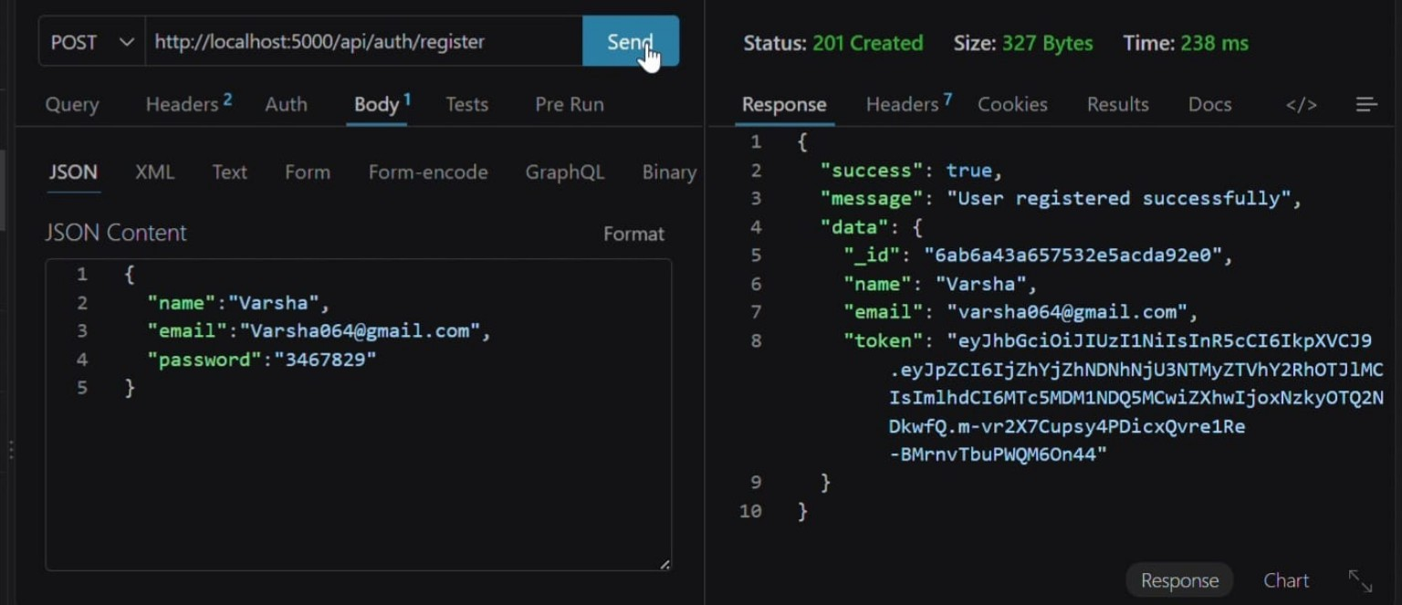
Figure 6.1 – User registration request and successful 201 Created response.

Login – POST /api/auth/login
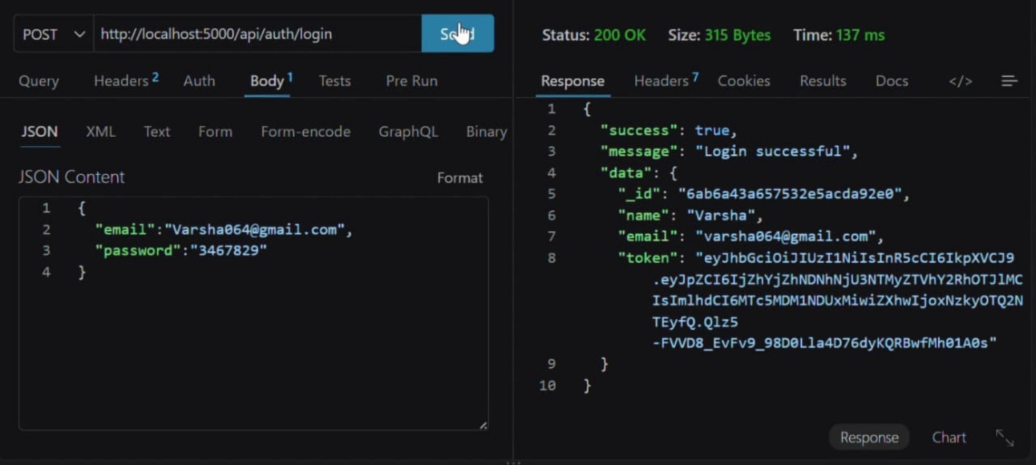
Figure 6.2 – Login request returning user information and a JWT token.

Profile – GET /api/auth/profile
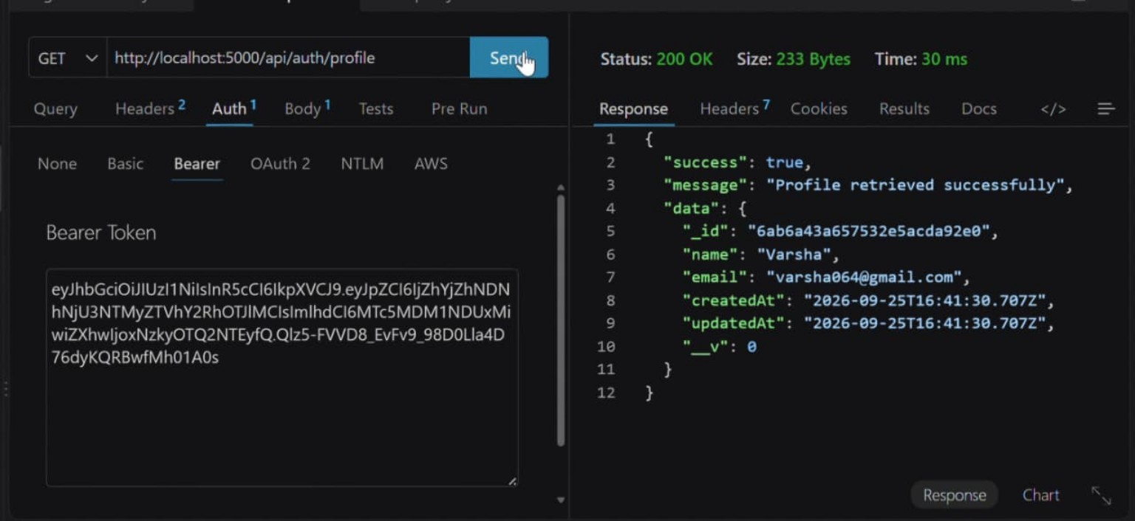
Figure 6.3 – Protected profile request using Bearer authentication.

API Testing Results – FAQ CRUD Operations
The supplied screenshots show the FAQ lifecycle through create, retrieve, update, delete, and not-found behavior. These tests demonstrate that the backend returns structured JSON messages and HTTP status codes for the tested operations.

Create FAQ – POST /api/faqs
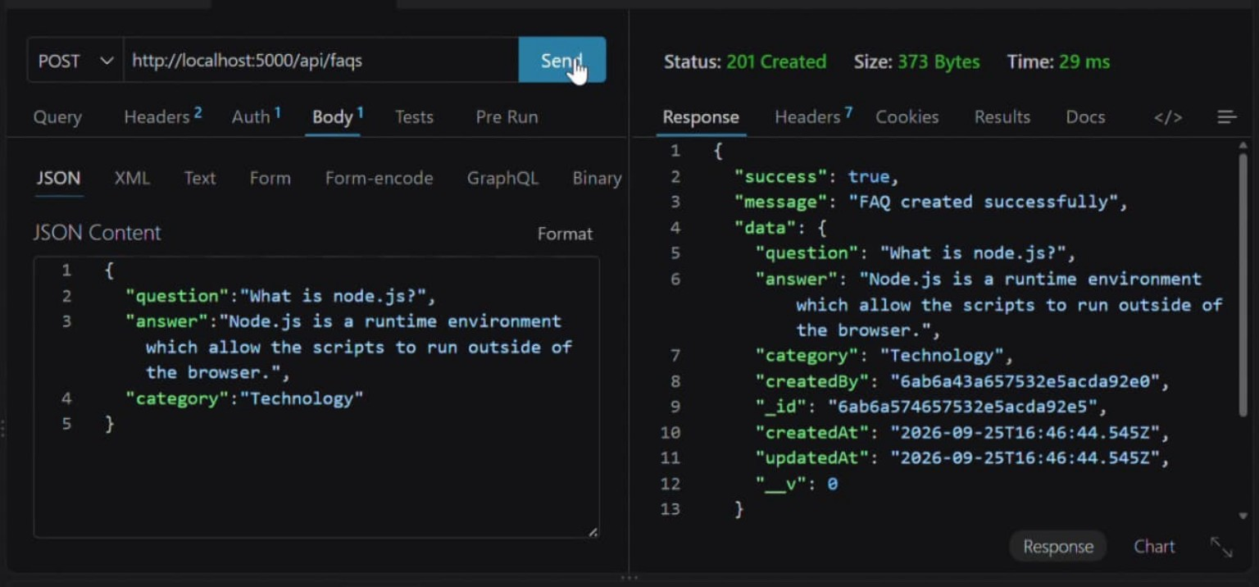
Figure 7.1 – FAQ creation with a successful 201 Created response.

Retrieve FAQ – GET /api/faqs/:id
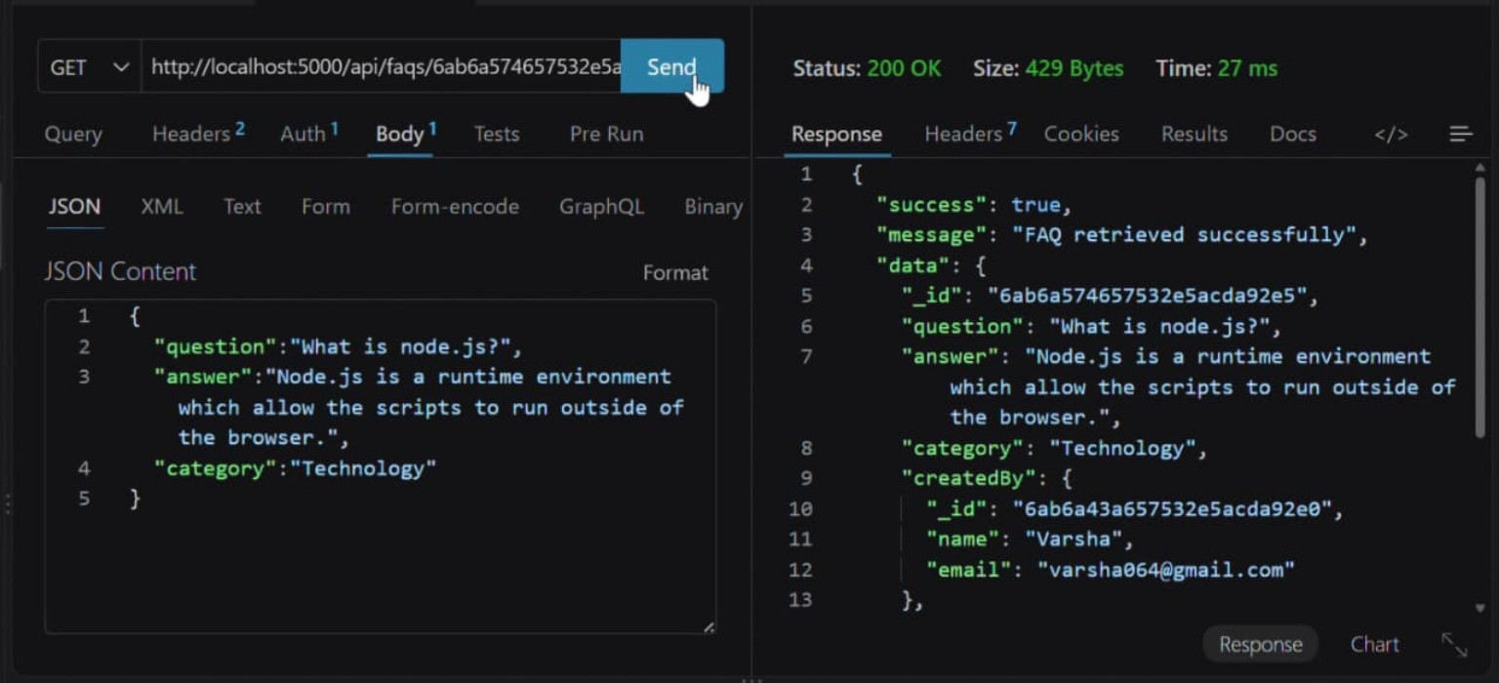
Figure 7.2 – FAQ retrieval with a successful 200 OK response.

Update FAQ – PUT /api/faqs/:id
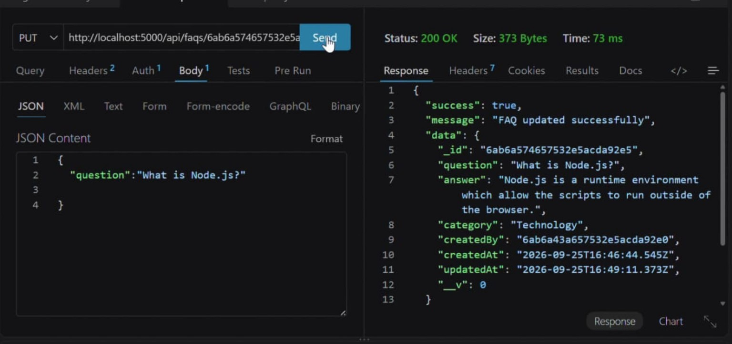
Figure 7.3 – FAQ update with a successful 200 OK response.

Testing Summary, AI Verification and Conclusion

Delete FAQ – DELETE /api/faqs/:id
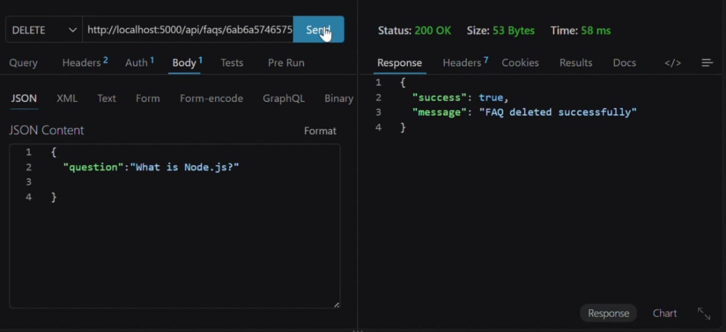
Figure 8.1 – FAQ deletion with a successful 200 OK response.

Not-Found Handling
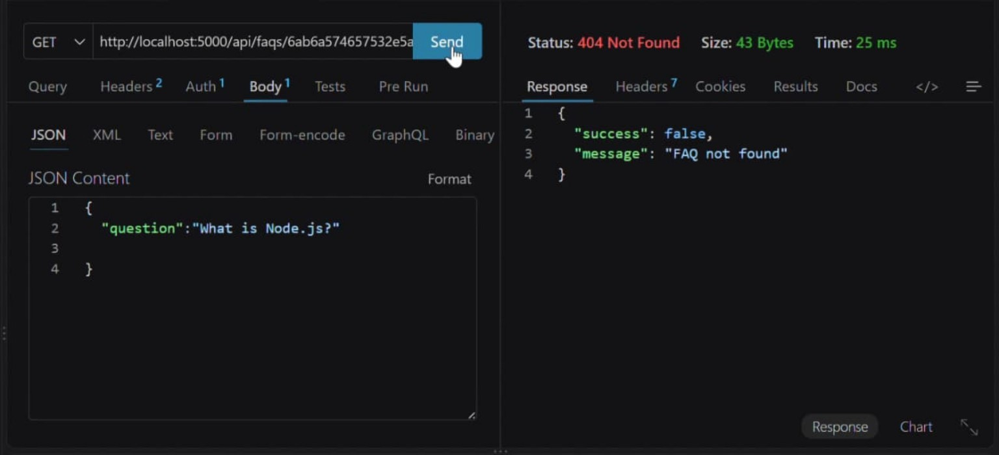
Figure 8.2 – FAQ not-found case returning a 404 response and a clear message.

AI Answer Generation
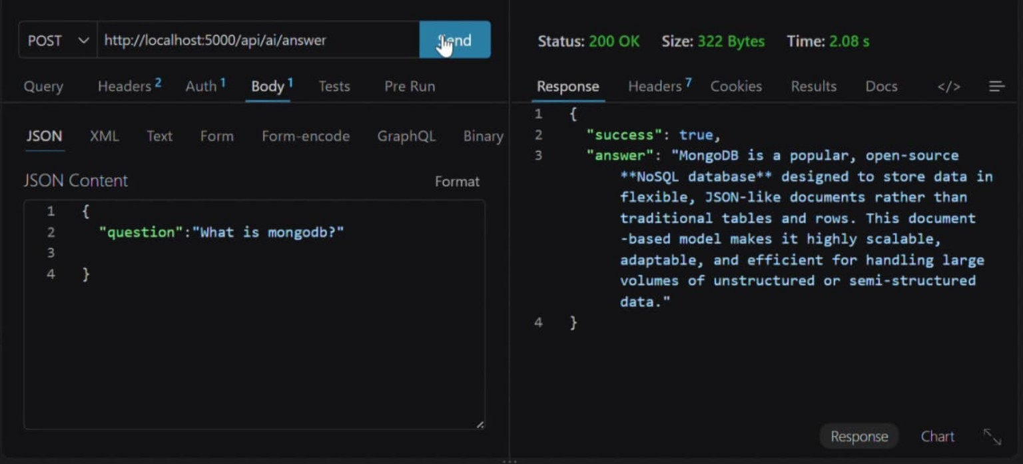
Figure 8.3 – AI answer endpoint returning a successful response for a MongoDB question.

Conclusion
AnswerBot demonstrates a structured backend approach for FAQ and customer-support automation. The project combines secure authentication, MongoDB data management, RESTful CRUD operations, search, centralized error handling, and AI-assisted content generation. The supplied API tests provide practical evidence of registration, login, protected profile access, FAQ creation, retrieval, updating, deletion, not-found handling, and AI response generation.
The implementation therefore provides a foundation that can be extended with a frontend interface, additional categories, richer search, monitoring, and further AI workflows while retaining the documented backend structure.

Video link: https://drive.google.com/file/d/1FCCpuo1vM0hZXoifQRgtJOa3uiUckJUm/view?usp=drivesdk

