LIBSPACE
TEAM MEMBERS :
- Sandhiya.M
- Sarmista Sahani.S
- Yuvasri.V
TEAM ID : 69a7da00fa5736d932f671ee
TEAM LEADER : Manisha.MManisha. M
A Robust Backend for Library Operations.
LIBSPACE

PROJECT OVERVIEW
LibSpace is a backend-based library management system developed to demonstrate the implementation of secure authentication and efficient book management operations using RESTful APIs. The system allows users to register accounts, log in securely, and manage books stored in a database. Users can perform operations such as adding books, viewing book details, updating existing records, and deleting books when necessary.

Key obejctives :
- Develop a Backend Server
To build a server-side application using Node.js and Express.js that can handle client requests and manage library data efficiently.
- Implement User Authentication
To create a secure login and registration system using JSON Web Token so that only authorized users can access the system.
- Perform CRUD Operations
To implement Create, Read, Update, and Delete (CRUD) operations for managing book records in the library database.
- Connect the Application to a Database
To integrate the backend server with MongoDB for storing and retrieving user information and book details.
- Build RESTful APIs
To design and develop REST APIs that allow different operations such as adding books, viewing books, updating book information, and deleting books.
- Test APIs Using Development Tools
To test API endpoints using tools like Thunder Client to ensure proper request and response functionality.
- Understand Backend Application Development
To gain practical knowledge of backend architecture, routing, middleware, and database integration in modern web development.

1. Technologies Used :
Technology | Description
Node.js | Backend runtime environment
Express.js | Web framework for APIs
MongoDB | Database for storing data
JWT | Authentication security
Thunder Client | API testing tool

2. Installation and Setup :
. Step 1 – Install Node.js
- Download and install Node.js.
. Step 2 – Create Project Folder
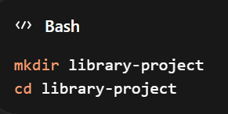
. Step 3 – Initialize Project
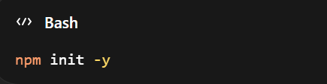
. Step 4 – Install Dependencies
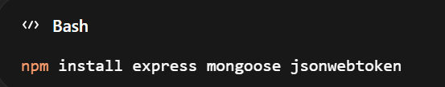
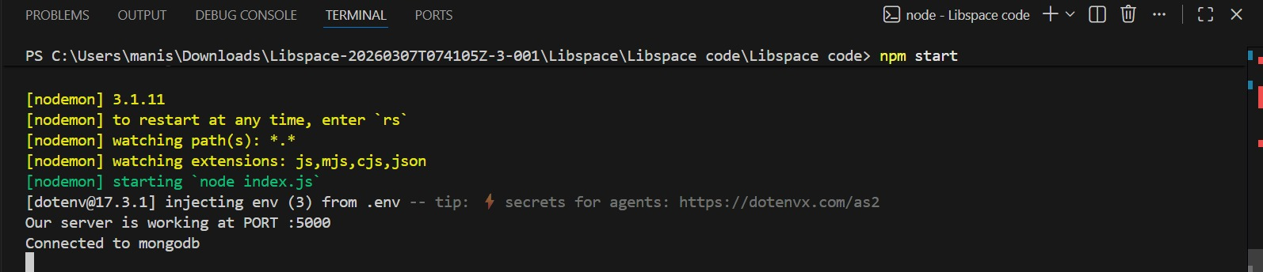
3. Basic Server Code :
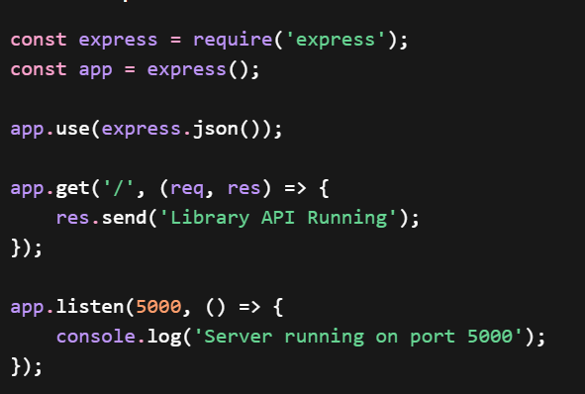
This code creates a simple server running on port 5000.

4. Database Connection Code :
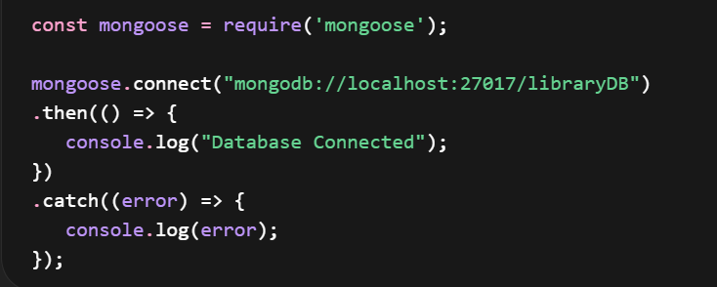
This connects the application to the MongoDB database.

5. Add Book API :
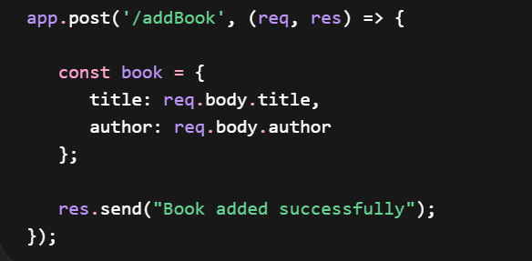

6. Output Screenshots :

- Register:
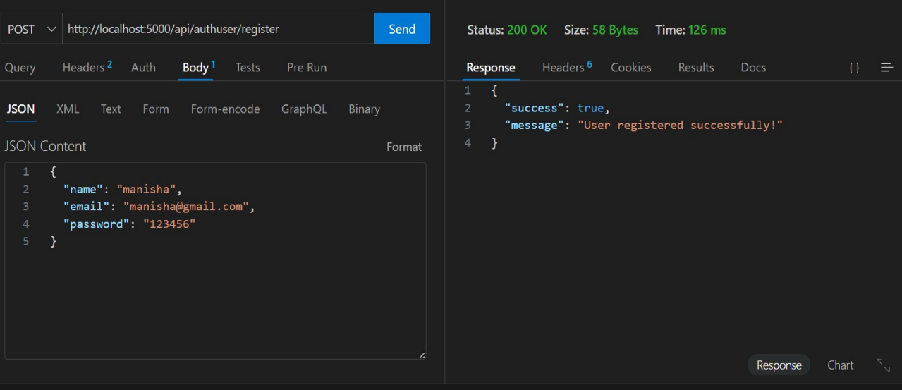
- Login :
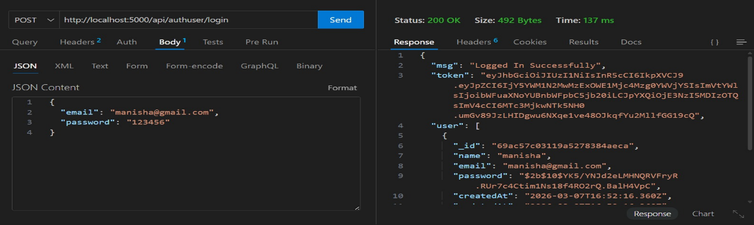

- Add Book:
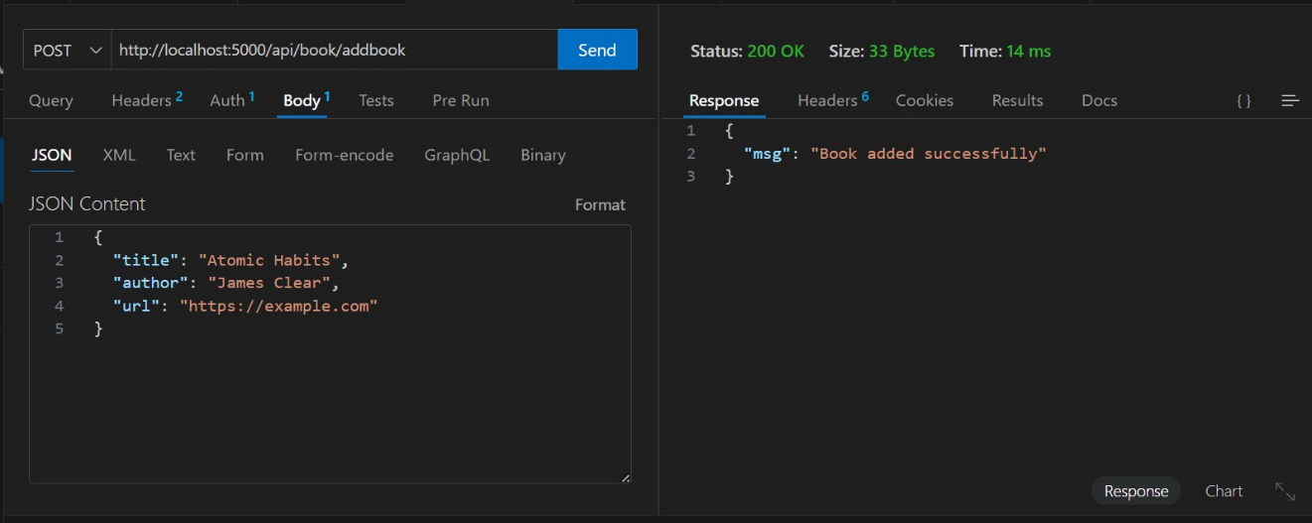

- Get Book :
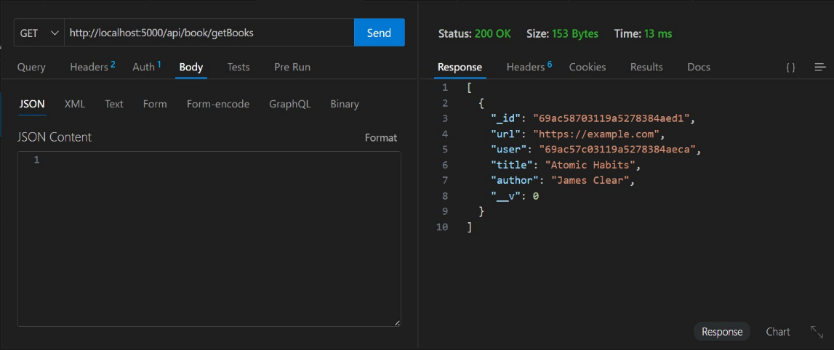

- Update :

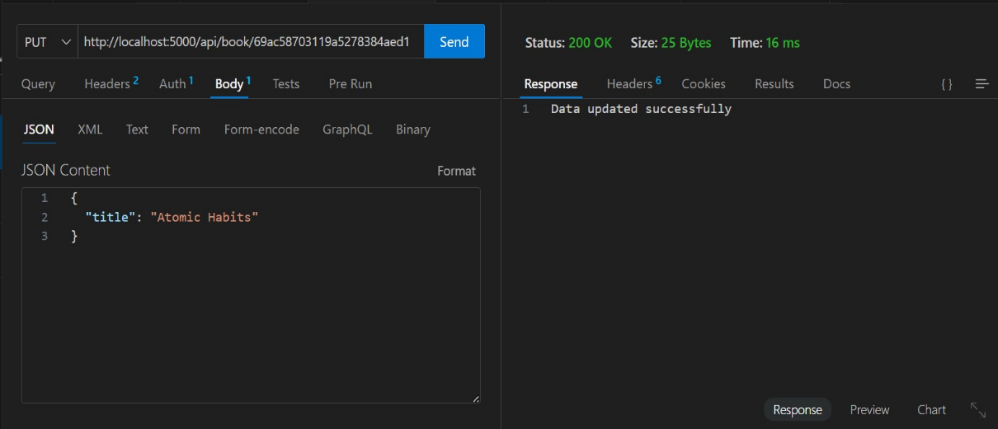

- Logout :

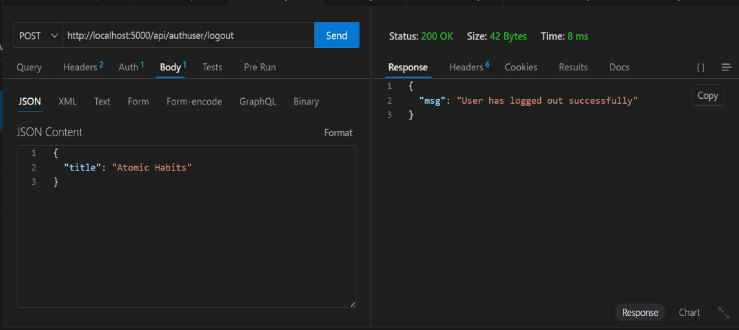

CONCLUSION :
The Library Management System successfully demonstrates how to build backend APIs using Node.js and MongoDB. The system performs CRUD operations and provides a secure authentication mechanism for managing library records.

DEMO VEDIO :
https://drive.google.com/file/d/1ddbhtOkWiuBXleFvTM-A2kcn6gw0Pj4A/view?usp=drivesdk

