1. **What are the different ways to handle exceptions in .NET Core?**

Handling exceptions in .NET Core is crucial for building robust and reliable applications. Here are several ways to manage exceptions effectively:

1. **Try-Catch Block**:
   * The most common way to handle exceptions.
   * Encloses code that may throw an exception within a try block and handles it in the catch block.
2. **Multiple Catch Blocks**:

Catch different types of exceptions separately.

1. **Finally Block**:

Code in the finally block always executes, regardless of whether an exception is thrown.

1. **Global Exception Handling**:

Using middleware to handle exceptions globally in ASP.NET Core applications.

1. **Exception Filters**:

Used in ASP.NET Core MVC to handle exceptions at the controller level.

1. **Using throw and throw ex**:

Use throw to preserve the stack trace, and throw ex to re-throw an exception with a new stack trace.

1. **Async/Await Exception Handling**:

Handle exceptions in asynchronous methods.

1. **Logging Exceptions**:

Log exceptions for further analysis using a logging framework like Serilog, NLog, or built-in .NET Core logging.

1. **How do you optimize performance in a .NET Core application?**

Optimizing performance in a .NET Core application involves a combination of best practices, code improvements, and leveraging the right tools and features of the .NET Core framework. Here are several strategies to help improve performance:

1. **Code Optimization**

* **Avoid Blocking Calls**: Use asynchronous programming with async and await to prevent blocking threads.
* **Minimize Exceptions**: Exceptions are costly in terms of performance. Use them sparingly and avoid them in regular control flow.
* **Efficient Data Structures**: Choose the right data structures for the job. For example, use List<T> for fast indexed access, Dictionary<TKey, TValue> for fast lookups, etc.

**2. Memory Management**

* **Object Pooling**: Reuse objects instead of creating new ones frequently, especially in high-performance scenarios.
* **Avoid Large Object Heap Fragmentation**: Be cautious with large objects and arrays. Frequent allocation and deallocation of large objects can fragment the Large Object Heap (LOH).
* **Garbage Collection Tuning**: Understand and tune the garbage collector (GC) settings based on your application’s needs. For example, the Server GC can be beneficial for multi-threaded applications running on multi-core machines.

**3. Efficient I/O Operations**

* **Async I/O Operations**: Use asynchronous methods for I/O operations to improve scalability.
* **Buffering**: Implement proper buffering when working with streams.

**4. Caching**

* **In-Memory Caching**: Use in-memory caching (like Memory Cache) for frequently accessed data that doesn’t change often.
* **Distributed Caching**: For scalable applications, use distributed caches like Redis or Memcached.

**5. Database Optimization**

* **Efficient Queries**: Write efficient SQL queries and use proper indexing.
* **ORM Optimization**: When using an ORM (like Entity Framework Core), avoid common pitfalls like lazy loading, and prefer explicit loading or eager loading.
* **Connection Pooling**: Utilize connection pooling to reduce the overhead of opening and closing database connections.

**6. Configuration and Environment**

* **Production Configuration**: Use production-ready configurations, such as disabling detailed error messages and enabling response compression.
* **Environment-Specific Settings**: Separate configurations for different environments (development, staging, production) to ensure optimal settings are used.

**7. Profiling and Diagnostics**

* **Profiling Tools**: Use profiling tools like dotTrace, dotMemory, and Visual Studio Profiler to identify performance bottlenecks.
* **Logging and Monitoring**: Implement comprehensive logging and monitoring to track application performance and diagnose issues in real-time.

**8. ASP.NET Core Specific Tips**

* **Middleware Pipeline**: Arrange middleware in the correct order and use short-circuiting techniques to avoid unnecessary processing.
* **Response Compression**: Enable response compression to reduce the payload size for responses.
* **Static File Caching**: Enable caching for static files to reduce server load.

**9. Compiler and Runtime Settings**

* **ReadyToRun (R2R)**: Use ReadyToRun images to improve application startup time.
* **Tiered Compilation**: Enable tiered compilation to allow the runtime to optimize hot code paths dynamically.

**10. Third-Party Libraries and NuGet Packages**

* **Update Regularly**: Keep third-party libraries and NuGet packages updated to benefit from performance improvements and bug fixes.

1. **Explain the ASP.NET Core request processing pipeline?**

The ASP.NET Core request processing pipeline is a sequence of middleware components that handle HTTP requests and responses. Middleware components are software components that are assembled into an application pipeline to handle requests and responses. Each component chooses whether to pass the request to the next component in the pipeline, and can perform operations before and after the next component in the pipeline is invoked.

Here's a step-by-step explanation of how the ASP.NET Core request processing pipeline works:

1. **Receive Request**: When a request arrives, the ASP.NET Core application receives it from the web server (e.g., Kestrel, IIS, Apache, Nginx).
2. **Middleware Execution**: The request is processed through a series of middleware components. Middleware can perform various tasks such as authentication, logging, error handling, routing, etc. The order of middleware components is critical and is determined by the order in which they are added to the pipeline.
3. **Routing**: One of the middleware components typically added to the pipeline is the routing middleware. This middleware matches the request to a route, which determines the endpoint that will handle the request.
4. **Endpoint Execution**: Once the request is routed to an endpoint, the appropriate controller action or Razor Page (or another endpoint) is executed. This part of the pipeline involves executing the business logic of the application.
5. **Generate Response**: The endpoint generates a response, which might include rendering a view, returning JSON data, or any other type of response appropriate for the request.
6. **Return Response**: The response generated by the endpoint is then passed back through the middleware pipeline. Each middleware component has the opportunity to inspect, modify, or log the response before it is sent back to the client.
7. **Send Response**: Finally, the response is sent back to the client.
8. **Explain the concept of hosting in .NET Core and the different types of hosting available.**

In .NET Core, hosting is a fundamental concept that involves setting up an environment where your application runs. This includes configuring the server, managing the application's lifetime, handling requests, and providing services. .NET Core provides several types of hosting to cater to different application needs:

**1. Kestrel Server Hosting**

Kestrel is the cross-platform web server included with ASP.NET Core. It is designed to be a high-performance, lightweight server suitable for most production workloads. Kestrel is typically used in combination with a reverse proxy like IIS, Nginx, or Apache for edge security, load balancing, and other concerns.

Key Features:

* Cross-platform support.
* High performance and lightweight.
* Can be used as an edge server or behind a reverse proxy.

1. **In-Process Hosting with IIS**

For applications running on Windows, ASP.NET Core can be hosted in-process with IIS. This allows the application to run within the IIS worker process (w3wp.exe), providing better performance compared to out-of-process hosting.

Key Features:

* Better performance due to in-process execution.
* Takes advantage of IIS features like process management, security, and configuration.

**3. Out-of-Process Hosting with IIS**

In this scenario, IIS acts as a reverse proxy to forward requests to the Kestrel server running the ASP.NET Core application. This provides a more flexible architecture, allowing the application to benefit from the features of IIS while running the application in a separate process.

Key Features:

* Flexibility to run the application separately from the IIS worker process.
* Uses IIS for advanced configuration, security, and management features.

**4. HTTP.sys Server Hosting**

HTTP.sys is a Windows-only HTTP server for ASP.NET Core that runs as a Windows service. It is an alternative to Kestrel that provides some features not available in Kestrel, such as Windows authentication, port sharing, and direct use of Windows features.

Key Features:

* Windows authentication support.
* Port sharing and kernel-mode request queuing.
* Suitable for internal or intranet applications.

**5. Generic Host**

.NET Core 2.1 introduced the Generic Host, which is used for hosting non-HTTP workloads, such as background services, console applications, and worker services. It provides a flexible model for building long-running applications with dependency injection, configuration, logging, and host lifetime management.

Key Features:

* Suitable for non-HTTP workloads.
* Consistent hosting model with dependency injection, configuration, and logging.
* Used for background services, console applications, and worker services.

1. **How to improve the performance of API in C#?**

Improving the performance of an API in C# can involve several strategies, ranging from optimizing code to enhancing infrastructure. Here are some key areas to focus on:

**1. Optimize Code Execution:**

* **Asynchronous Programming:** Use asynchronous programming (async/await) to handle I/O-bound operations without blocking the main thread.
* **Minimize Blocking Calls:** Avoid using Task.Wait or Task.Result in asynchronous code as it can cause deadlocks and degrade performance.
* **Reduce Memory Allocation:** Minimize unnecessary object creation, use StringBuilder for string concatenations, and avoid boxing/unboxing operations.
* **Efficient Data Structures:** Use the most appropriate data structures (e.g., Dictionary instead of List for fast lookups).
* **Caching:** Implement caching mechanisms for data that does not change frequently, using in-memory caching (e.g., MemoryCache) or distributed caching (e.g., Redis).
* **Reduce Exception Handling Overhead:** Avoid using exceptions for control flow; instead, use them for truly exceptional cases.

**2. Improve Data Access:**

* **Optimize Database Queries:** Use indexing, stored procedures, and efficient query designs to reduce database load.
* **Connection Pooling:** Ensure efficient database connection management through connection pooling to minimize the overhead of opening and closing connections.
* **Batch Requests:** Reduce the number of round-trips to the database by batching multiple requests into one.

**3. Efficient Serialization:**

* **Use Fast Serialization Libraries:** Choose efficient serialization libraries (e.g., System.Text.Json instead of Newtonsoft.Json) for better performance.
* **Minimize Payload Size:** Reduce the size of the data being transferred by excluding unnecessary fields or using compressed formats.

**4. Network Optimization:**

* **Compression:** Enable Gzip compression for responses to reduce bandwidth usage.
* Keep-Alive Connections: Use HTTP Keep-Alive to reuse existing connections, reducing the overhead of establishing new connections.
* **API Gateway:** Use an API Gateway to handle routing, rate limiting, and load balancing.

**5. Scalability and Load Management:**

* **Load Balancing:** Distribute the API load across multiple servers using a load balancer.
* Rate Limiting and Throttling: Implement rate limiting to prevent abuse and ensure resources are fairly distributed.
* **Horizontal Scaling:** Scale out by adding more instances of the API server to handle increased load.

**6. Profiling and Monitoring:**

* **Profiling Tools:** Use profiling tools (e.g., JetBrains dotTrace, Visual Studio Profiler) to identify bottlenecks in the code.
* **Monitoring:** Implement monitoring to track the performance of your API in real-time (e.g., using tools like Application Insights, Prometheus).

**7. Asynchronous Processing:**

* **Background Jobs:** Offload time-consuming tasks to background jobs using message queues (e.g., RabbitMQ, Azure Service Bus).
* **CDN for Static Content:** Use Content Delivery Networks (CDNs) for serving static content, reducing the load on your API server.

**8. Use Dependency Injection Efficiently:**

* **Singleton vs Transient:** Choose the appropriate lifetime (Singleton, Scoped, Transient) for services based on their usage patterns.

**9. Code Reviews and Refactoring:**

* **Regular Reviews:** Conduct regular code reviews to identify inefficient code and refactor as needed.

1. **What is Using Statement in C#?**

The using statement in C# is a convenient way to work with resources that implement the IDisposable interface. IDisposable objects typically hold onto unmanaged resources, like file handles or network connections, that need to be released when you're done using them. This is where the using statement comes into play - it helps you to ensure that these resources are properly disposed of after use.

**How the Using Statement Works**

When you use the using statement, C# will automatically call the Dispose method on the object when it's no longer needed. This means you don't have to manually call the Dispose method or worry about forgetting to do so. The using statement takes care of this for you!

static void Main()

{

using (StreamReader reader = new StreamReader("example.txt"))

{

string content = reader.ReadToEnd();

Console.WriteLine(content);

}

}

**Using Block vs. Using Declaration**

Starting with C# 8.0, you can use the using declaration instead of the using block. The using declaration is a shorter and more concise way to define a disposable object, like so:

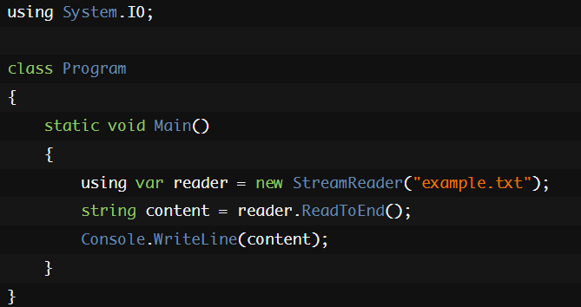

With the using declaration, you don't need the curly braces or indentation, making your code more readable. The Dispose method is still called automatically when the variable goes out of scope.

**Managing Multiple Resources**

One of the great things about the using statement is that it can handle multiple resources at once. You can stack using statements one after another, or use a single using statement to handle multiple resources in a comma-separated list. Here's an example that demonstrates both approaches:

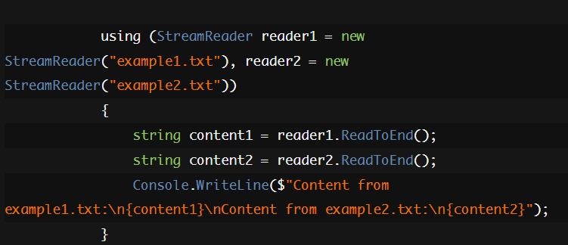

1. **Difference between throw and throw ex in C#?**

In C#, both throw and throw ex are used to raise exceptions, but they have different effects on the exception's stack trace, which is important for debugging. Here’s the difference:  
**throw:**

* When you use throw by itself, it rethrows the current exception while preserving the original stack trace.
* This means that the stack trace will show where the exception originally occurred, which is helpful for debugging.

try

{

// Some code that throws an exception

}

catch (Exception ex)

{

// Handle exception or log it

throw; // Rethrows the same exception

}

**throw ex:**

* When you use throw ex, it throws the exception object ex as a new exception.
* This resets the stack trace to the current location, so the original point where the exception occurred is lost. The stack trace will start from the point where throw ex is used, making it harder to trace back to the original error source.

try

{

// Some code that throws an exception

}

catch (Exception ex)

{

// Handle exception or log it

throw ex; // Throws the exception but resets the stack trace

}

It is generally recommended to use throw without ex to preserve the original stack trace, unless you have a specific reason to reset it. Preserving the original stack trace makes it easier to debug and understand the flow of the application when an exception occurs.

1. **How to do Session Management in ASP.NET MVC?**

Session management in an ASP.NET MVC application is crucial for maintaining user state and managing data across different requests. Here’s a guide on how to implement session management:

**1. Understanding Session State in ASP.NET MVC**

* **Session**: A session is a server-side storage of user data that can be accessed across multiple requests during a user’s visit to the web application.
* **Session State**: It's a mechanism for storing user-specific data that can be accessed across multiple pages within a web application.

**2. Configuring Session State**

* **Web.config Configuration**: Ensure that the session state is enabled and properly configured in the Web.config file.

<configuration>

<system.web>

<sessionState mode="InProc" timeout="20" />

</system.web>

</configuration>

* **Session Modes**:
  + InProc: Stores session state in the memory of the Web server (default mode).
  + StateServer: Stores session state in a separate process called the ASP.NET state service.
  + SQLServer: Stores session state in a SQL Server database.
  + Custom: Allows for custom session-state storage providers.

**3. Using Session in Controllers**

You can access and manipulate session data using the Session property in your controllers.

* **Setting Session Data:**

public ActionResult Index()

{

Session["Username"] = "JohnDoe";

return View();

}

* **Getting Session Data**

public ActionResult About()

{

string username = Session["Username"] as string;

ViewBag.Username = username;

return View();

}

* **Removing Session Data**

public ActionResult Logout()

{

Session.Remove("Username");

return RedirectToAction("Index");

}

**4. Session Timeout**

* The session timeout is configured in the Web.config file using the timeout attribute. This value represents the number of minutes the session can remain idle before it is abandoned.
* You can also set it programmatically

Session.Timeout = 30; // Set timeout to 30 minutes

**5. Persisting Session Data Across Requests**

Ensure that your session data is properly stored and managed across requests. You may need to consider using TempData for temporary data that only needs to persist across a single redirect.

**6. Handling Session Expiry**

* **Redirect on Expiry**: You might want to redirect users to a login page or show a message when their session expires.
* **Global.asax**: You can handle session expiration globally using Session_End in the Global.asax file:

protected void Session_End(object sender, EventArgs e)

{

// Handle session end, e.g., logging or cleanup

}

**7. Security Considerations**

* **Session Hijacking**: Use HTTPS to protect session IDs from being intercepted.
* **Session Fixation**: Always regenerate session IDs upon login to prevent fixation attacks.
* **Session State Protection**: Encrypt and sign session state data if stored externally to prevent tampering.

**8. Session in Distributed Applications**

* For distributed applications or web farms, consider using SQLServer or StateServer session modes, or implement a custom session provider to handle session state in a distributed environment.

**9. Best Practices**

* **Minimal Use**: Use session sparingly to minimize the amount of data stored server-side.
* **Clear Unused Sessions**: Always clear session variables when they are no longer needed.
* **Avoid Large Objects**: Storing large objects in session can lead to performance issues.

1. **Eager loading and Lazy loading in Entity Framework?**

In C#, **eager loading** and **lazy loading** are techniques used to manage how data is loaded from a database when using an Object-Relational Mapping (ORM) tool like Entity Framework.

**Eager Loading**

**Eager loading** means that related data is loaded from the database as part of the initial query. This is typically done using the Include method in Entity Framework, ensuring that all necessary data is retrieved in a single query. This can be efficient when you know you'll need the related data immediately and want to avoid multiple queries.

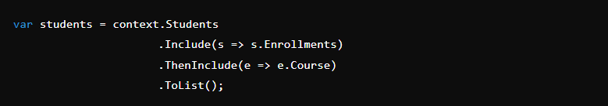

In this example, the Students are loaded along with their related Enrollments and the associated Course data. All of this is fetched in a single query.

**Lazy Loading**

**Lazy loading** means that related data is only loaded when it is explicitly accessed. This is often enabled by default in Entity Framework but can be configured. With lazy loading, the initial query only loads the primary entity, and the related data is retrieved later as needed, usually resulting in multiple queries to the database.

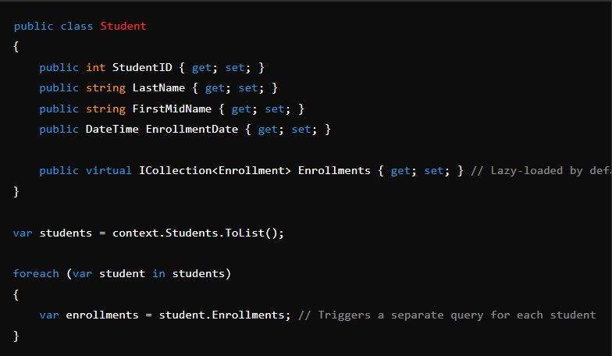

In this example, the Enrollments collection is not loaded until it's accessed, resulting in a separate database query for each student's enrollments.

**Key Differences**

* **Eager Loading**: Fetches all required data in a single query, potentially reducing the number of database queries but increasing the amount of data loaded upfront.
* **Lazy Loading**: Delays the loading of related data until it's needed, which can minimize the amount of data initially loaded but might result in multiple queries and increased database access times.

**When to Use Which?**

* **Eager Loading**: Use when you know you'll need the related data immediately and want to minimize the number of database queries.
* **Lazy Loading**: Use when you might not need the related data or when you want to load it only when necessary, reducing initial data retrieval overhead.

1. **Lazy Loading vs Eager Loading in Singleton Design Pattern**

In the context of the Singleton design pattern in C#, *Lazy Loading* and *Eager Loading* refer to two different approaches for initializing the singleton instance.

**1. Eager Loading:**

Eager Loading initializes the singleton instance at the time of class loading, meaning the instance is created as soon as the singleton class is referenced for the first time, whether it's needed or not.

**When to use?**  
This approach is simple and works well when the instance creation is lightweight and you are sure that the instance will be used. It also avoids any potential multi-threading issues because the instance is created before any thread accesses it.

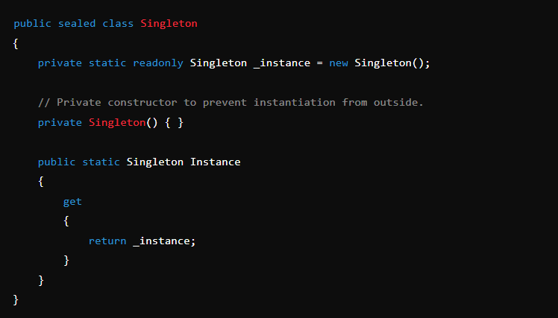

In this example, the Singleton instance is created as soon as the class is loaded, and it remains in memory for the lifetime of the application.

**2. Lazy Loading:**  
Lazy Loading defers the creation of the singleton instance until it is actually needed, meaning the instance is created when the Instance property is accessed for the first time.

* **When to use?**  
  This approach is useful when the singleton instance is resource-intensive to create and may not always be needed. Lazy Loading also helps with the "lazy initialization" problem, where you want to delay the creation of the instance until it's required.

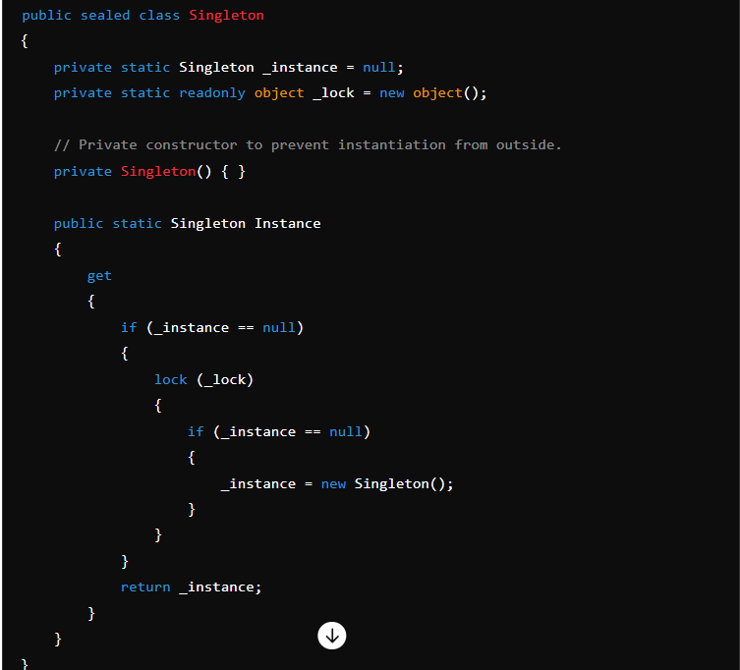

In this example, the instance is only created when it is first accessed. The use of double-check locking ensures that the instance is created only once even in a multi-threaded environment.

**Key Differences:**

* **Initialization Time:**
  + *Eager Loading:* The instance is created at the time of class loading.
  + *Lazy Loading:* The instance is created only when it is needed.
* **Resource Usage:**
  + *Eager Loading:* May lead to unnecessary resource usage if the instance is never used.
  + *Lazy Loading:* More efficient in terms of resources as the instance is only created when needed.
* **Thread Safety:**
  + *Eager Loading:* Thread safety is guaranteed without any additional code.
  + *Lazy Loading:* Requires additional code (like double-check locking) to ensure thread safety.

**Choosing Between Them:**

* Use *Eager Loading* when the singleton is lightweight and will definitely be used.
* Use *Lazy Loading* when the singleton is resource-heavy or might not be used at all during the application's lifetime.

1. **Difference between middleware and filter in .net?**

In the context of .NET, specifically within ASP.NET Core, **middleware** and **filters** are two concepts used to handle various aspects of HTTP request processing, but they serve different purposes and operate at different levels of the request pipeline.

**Middleware**

* **Purpose**: Middleware is used to handle cross-cutting concerns (such as logging, authentication, and error handling) at the application level. Middleware components can inspect, modify, or short-circuit HTTP requests and responses as they move through the pipeline.
* **Pipeline**: Middleware components are part of the request pipeline and are configured in the Startup.cs file within the Configure method. Each middleware component decides whether to pass the request to the next middleware in the pipeline.
* **Scope**: Middleware operates at the global level, affecting all requests handled by the application unless specifically scoped or branched.

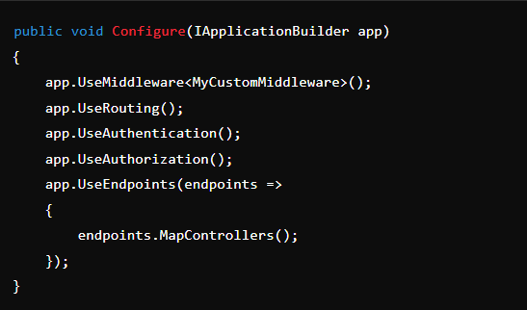

**Filters**

* **Purpose**: Filters are used to add behaviour before or after the execution of an action method in an MVC or Razor Pages application. Filters are specific to the MVC framework and are generally used for tasks such as input validation, authorization checks, or modifying the result of an action.
* **Types**: There are several types of filters in ASP.NET Core:
  + **Authorization filters**: Run before anything else to determine if the user is authorized.
  + **Resource filters**: Run after authorization but before model binding, useful for caching.
  + **Action filters**: Run before and after the action method is executed.
  + **Exception filters**: Handle exceptions thrown by action methods or other filters.
  + **Result filters**: Run before and after the result of an action is executed (e.g., before rendering a view).
* **Scope**: Filters can be applied globally, to specific controllers, or to individual action methods.

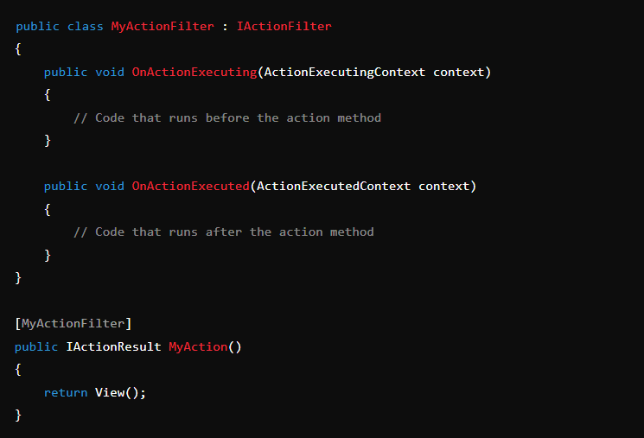

**Key Differences**

1. **Level of Operation**:
   * Middleware operates at the application level, handling requests as they pass through the pipeline.
   * Filters operate at the MVC action level, handling tasks before or after an action method executes.
2. **Configuration**:
   * Middleware is configured globally in the Startup.cs file.
   * Filters can be applied globally, at the controller level, or at the action method level.
3. **Flexibility**:
   * Middleware can handle any aspect of the HTTP request/response process.
   * Filters are more focused on MVC-specific tasks like action execution and result processing.
4. **Usage**:
   * Middleware is used for general cross-cutting concerns.
   * Filters are used for concerns specific to controller actions, such as validation, caching, or authentication.

In summary, middleware is a broader concept used for handling requests throughout the application, while filters are specific to the MVC framework and are used to manage the execution flow of controller actions.

1. **Difference between Kestrel and IIS Server in .NET?**

**Kestrel** and **IIS (Internet Information Services)** are both web servers used to host and manage web applications, but they differ significantly in terms of architecture, purpose, and typical use cases.

**Kestrel**

* **Type:** Cross-platform web server.
* **Primary Use:** Kestrel is the default web server for ASP.NET Core applications. It is lightweight and optimized for high performance, making it ideal for modern web applications.
* **Cross-Platform:** Kestrel runs on Windows, Linux, and macOS, which makes it versatile for different deployment environments.
* **Performance:** Kestrel is designed for speed and efficiency. It can handle high loads with low overhead.
* **Standalone or Reverse Proxy:** Kestrel can be used as a standalone server for development purposes. However, in production environments, it is often used in conjunction with a reverse proxy like IIS, Nginx, or Apache to handle advanced features like SSL termination, load balancing, and logging.
* **Connection Handling:** Kestrel is optimized for asynchronous I/O, which makes it very efficient at handling large numbers of concurrent connections.

**IIS (Internet Information Services)**

* **Type:** Web server software.
* **Primary Use:** IIS is a full-featured web server developed by Microsoft for hosting websites and web applications on Windows Server and Windows operating systems.
* **Windows-Only:** IIS is specific to Windows environments and integrates deeply with other Microsoft technologies, making it a preferred choice for enterprises that are already using a Windows-based infrastructure.
* **Feature-Rich:** IIS comes with a wide range of features like application pools, request filtering, logging, security features (like authentication and authorization), and support for various protocols (HTTP, HTTPS, FTP, etc.).
* **Ease of Management:** IIS provides a user-friendly management console and integrates with other Microsoft management tools, making it easier for administrators to manage and configure.
* **Support for Older Frameworks:** IIS supports not only ASP.NET Core but also older ASP.NET versions, PHP, and other web technologies, which can be important for legacy applications.

**Key Differences:**

1. **Platform Support:**
   * Kestrel: Cross-platform (Windows, Linux, macOS).
   * IIS: Windows-only.
2. **Performance and Use Case:**
   * Kestrel: Lightweight and highly performant, often used for hosting modern web applications, typically behind a reverse proxy in production.
   * IIS: Full-featured with extensive capabilities, used primarily in enterprise environments for hosting web applications and services on Windows servers.
3. **Deployment:**
   * Kestrel: Often used in combination with other web servers like IIS or Nginx in production.
   * IIS: Can serve as both the web server and reverse proxy.
4. **Integration:**
   * Kestrel: Works well with various environments and is designed for seamless integration with ASP.NET Core.
   * IIS: Deeply integrated with Windows Server, offering tight integration with other Microsoft technologies like Active Directory, SQL Server, and more.

In practice, Kestrel is often used for development and in combination with IIS or other reverse proxies for production, while IIS is a mature solution used primarily in Windows-based environments for hosting a variety of web applications and services.

1. **What is difference between Dispose and Finalize in C#?**

In C#, both Dispose and Finalize are used for resource management, but they serve different purposes and have different usage patterns.

**Dispose Method**

* **Purpose**: Dispose is part of the IDisposable interface and is used for explicitly releasing unmanaged resources (like file handles, database connections, etc.) when they are no longer needed. This allows for deterministic cleanup of resources.
* **Usage**: It should be called manually by the developer, typically in a using statement or by explicitly invoking the Dispose method.
* **Implementation**: Classes that implement IDisposable need to provide an implementation for the Dispose method. It is a good practice to follow the [Dispose Pattern](https://learn.microsoft.com/en-us/dotnet/standard/garbage-collection/implementing-dispose) when implementing this method.

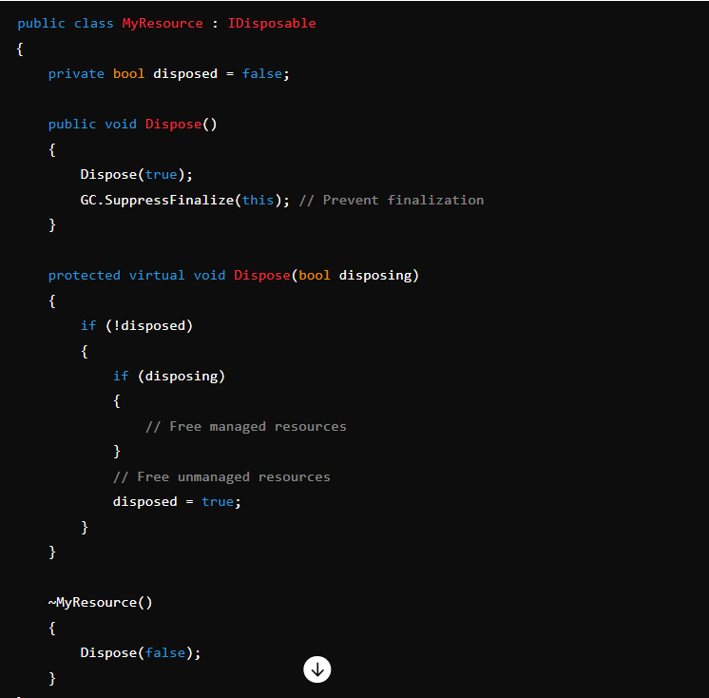

* **Advantages**: Allows developers to release resources as soon as they are done with them, avoiding the non-deterministic timing of garbage collection.

**Finalize Method**

* **Purpose**: Finalize is a method that allows an object to clean up unmanaged resources before the object is reclaimed by garbage collection. It acts as a safeguard in case Dispose was not called.
* **Usage**: The Finalize method is automatically called by the garbage collector and cannot be called directly. It is implemented using a destructor in C# (~ClassName).
* **Implementation**: You should only use Finalize if your class directly handles unmanaged resources, and even then, it’s usually better to implement Dispose and call GC.SuppressFinalize(this) to prevent the finalizer from running.

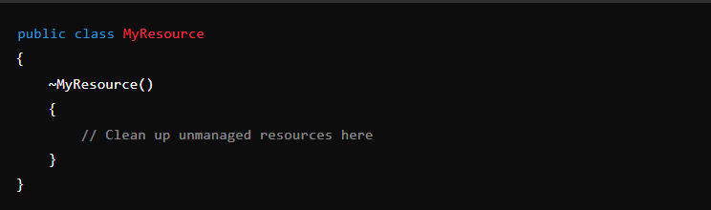

* **Disadvantages**: Finalizers add overhead to garbage collection since the garbage collector must perform additional work to finalize the objects. They also introduce non-determinism, as the timing of finalization is up to the garbage collector.

**Key Differences**

* **Determinism**: Dispose provides deterministic release of resources, while Finalize is non-deterministic.
* **Control**: Dispose is called by the developer, whereas Finalize is called by the garbage collector.
* **Usage**: Dispose should be implemented and called for most resource cleanup scenarios. Finalize should only be used for cleaning up unmanaged resources and should be combined with Dispose in most cases.

In summary, Dispose is the preferred method for managing resource cleanup in C#. Finalize is a safety net and should be used sparingly, in conjunction with Dispose.

1. **How to fix if you are getting 500(internal server error) after hosting the application in IIS Server?**

A 500 Internal Server Error in IIS (Internet Information Services) can be tricky to diagnose, as it is a generic error message indicating something went wrong on the server but not providing specifics. Here's a step-by-step guide to troubleshoot and potentially fix this issue:

**1. Check the Error Details:**

* **Enable Detailed Errors:** By default, IIS may show a generic error message. To see more detailed error information:
  1. Open IIS Manager.
  2. Navigate to your site.
  3. In the right pane, double-click on "Error Pages."
  4. Click on "Edit Feature Settings."
  5. Select "Detailed Errors" and click "OK."
* **Check the IIS Log Files:** IIS logs are located at C:\inetpub\logs\LogFiles. Check the logs for the specific subfolder related to your site and see if there are more details on what caused the error.

**2. Check the Application Event Log:**

* Open the Event Viewer (eventvwr.msc).
* Navigate to Windows Logs > Application.
* Look for any errors related to your application around the time of the 500 error.

**3. Permissions Issues:**

* **File Permissions:** Ensure that the IIS user (often IUSR or NETWORK SERVICE) has read, write, and execute permissions to the application's folder.
* **Application Pool Identity:** Ensure the identity running the application pool has sufficient permissions.

**4. Application Code Errors:**

* Ensure there are no unhandled exceptions in your code. For example, check your error logs if your application has custom error logging.
* If you're using a web.config file, ensure it's correctly configured and doesn't contain any syntax errors.

**5. Web.config Configuration:**

* **Custom Errors Mode:** Ensure the customErrors mode in your web.config file is set to Off to see more detailed error messages.

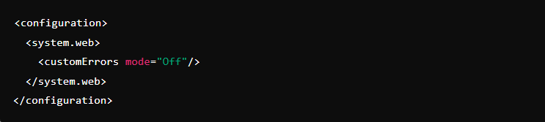

**Trace and Debug:** Enable tracing and debugging in the web.config to get more insight into what's happening.

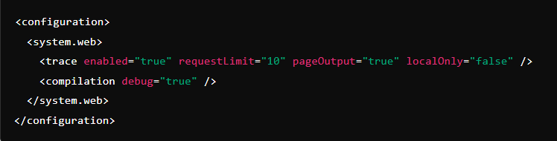

**6. Check Dependencies:**

* Make sure all required dependencies (libraries, database connections, etc.) are correctly installed and configured on the server.
* Verify that the correct version of the .NET Framework (or other runtime) is installed and used by the application pool.

**7. Recycle Application Pool:**

* Sometimes recycling the application pool can resolve issues caused by temporary glitches.
* In IIS Manager, right-click on the application pool associated with your application and select "Recycle."

**8. Review Recent Changes:**

* If the error started occurring after a recent code deployment or configuration change, review those changes for potential causes.

**9. Consult Documentation and Forums:**

* If the issue persists, consider consulting Microsoft documentation or seeking help on forums like Stack Overflow, providing details about your specific setup and the error you're encountering.

If you go through these steps and still have issues, providing detailed error messages or logs can help narrow down the problem further.

1. **If you are doing code review then what are the thing you will focus on?**

When doing a code review, it's important to focus on several key aspects to ensure the code is maintainable, efficient, and error-free. Here's a checklist of things to focus on:

**1. Code Quality**

* **Readability:** Is the code easy to read and understand? Are variable and function names meaningful?
* **Consistency:** Does the code follow the project's coding standards and style guidelines?
* **Commenting:** Are there appropriate comments where necessary, and are they clear and helpful?

**2. Functionality**

* **Correctness:** Does the code do what it’s supposed to do? Are all requirements met?
* **Edge Cases:** Are edge cases and potential errors handled appropriately?
* **Testing:** Are there tests for new code? Do they cover different scenarios and edge cases?

**3. Performance**

* **Efficiency:** Is the code optimized for performance without unnecessary complexity?
* **Resource Management:** Is memory and resource usage efficient? Are there potential memory leaks or resource mismanagement?

**4. Security**

* **Vulnerabilities:** Are there any security risks, such as SQL injection, XSS, or insecure data handling?
* **Data Validation:** Is user input properly validated and sanitized?

**5. Modularity and Reusability**

* **Separation of Concerns:** Is the code logically separated into different modules or functions?
* **Reusability:** Is the code written in a way that allows for reuse in other parts of the project?

**6. Maintainability**

* **Documentation:** Is there sufficient documentation to help future developers understand the code?
* **Dependencies:** Are external libraries or dependencies necessary and up-to-date?
* **Code Smell:** Are there any signs of bad practices, such as overly complex functions or duplication?

**7. Compliance**

* **Standards:** Does the code adhere to relevant standards, whether industry-specific or internal?
* **Legal and Ethical:** Are there any licensing issues or ethical considerations (e.g., data privacy)?

**8. Integration**

* **Compatibility:** Does the new code integrate well with existing code without causing issues?
* **Build and Deployment:** Does the code work within the existing build and deployment processes?

**9. User Experience**

* **Usability:** If the code affects the user interface, is it user-friendly?
* **Accessibility:** Are accessibility considerations (e.g., for users with disabilities) taken into account?

**10. Feedback and Communication**

* **Clarity:** Are comments and feedback provided in a constructive and clear manner?
* **Actionable:** Is feedback actionable with clear suggestions for improvements?

Focusing on these areas will help ensure a thorough and effective code review.

1. **What is the restful principle in .NET?**

RESTful principles are guidelines for creating web services that follow the REST (Representational State Transfer) architectural style. In .NET, these principles are typically implemented using ASP.NET Core Web API. Here are the core RESTful principles:

**1. Statelessness**

* Each request from a client to a server must contain all the information the server needs to fulfill that request. The server should not store any state about the client session on the server between requests.
* Example: If a client wants to fetch data from a server, it should send all necessary authentication details and parameters with each request.

**2. Client-Server Separation**

* The client and the server should be independent of each other, meaning they can be developed and deployed separately.
* Example: A web application (client) communicates with a web API (server) to retrieve data. The client only interacts with the API through HTTP requests, not directly with the database or server logic.

**3. Cacheability**

* Responses from the server should be cacheable either by the client or by intermediate servers (proxies). This reduces the need to make repeated requests for the same data.
* Example: HTTP headers like Cache-Control can be used to specify the caching policies for a particular response.

**4. Uniform Interface**

* A consistent interface between clients and servers simplifies the interaction. This involves:
  + **Resource Identification**: Resources are identified in requests using URIs (Uniform Resource Identifiers).
  + **Manipulation of Resources through Representations**: Clients manipulate resources by sending representations (like JSON or XML) to the server.
  + **Self-descriptive Messages**: Each request and response contains enough information to describe how to process the message.
  + **Hypermedia as the Engine of Application State (HATEOAS)**: Clients interact with resources using links provided dynamically by the server.

**5. Layered System**

* The architecture can be composed of hierarchical layers by encapsulating the servers, improving scalability and flexibility.
* Example: A proxy or gateway could be used to handle some aspects of the request before forwarding it to the appropriate server.

**6. Code on Demand (optional)**

* Servers can extend client functionality by transferring executable code. This is an optional principle.
* Example: A server could send a JavaScript code to the client, which can then be executed in the browser.

**7. Resource-Based Operations**

* Resources are the key abstractions of information. They are represented as URIs, and operations on these resources are performed via standard HTTP methods:
  + **GET**: Retrieve a resource.
  + **POST**: Create a new resource.
  + **PUT**: Update an existing resource.
  + **DELETE**: Remove a resource.
  + **PATCH**: Partially update a resource.

**Implementing RESTful Services in .NET**

* In .NET, you can implement RESTful APIs using ASP.NET Core. Controllers in an ASP.NET Core application typically handle HTTP requests and map them to appropriate actions/methods that handle business logic.
* **Routing**: Define routes that map to resources.
* **Model Binding**: Automatically bind data from requests to .NET objects.
* **Filters**: Implement cross-cutting concerns like error handling, authorization, and logging.
* **Dependency Injection**: Inject dependencies to keep the code modular and testable.

[ApiController]

[Route("api/[controller]")]

public class ProductsController : ControllerBase

{

private readonly IProductService _productService;

public ProductsController(IProductService productService)

{

_productService = productService;

}

[HttpGet]

public async Task<IActionResult> GetAllProducts()

{

var products = await _productService.GetAllProductsAsync();

return Ok(products);

}

[HttpGet("{id}")]

public async Task<IActionResult> GetProductById(int id)

{

var product = await _productService.GetProductByIdAsync(id);

if (product == null) return NotFound();

return Ok(product);

}

[HttpPost]

public async Task<IActionResult> CreateProduct([FromBody] ProductDto productDto)

{

if (!ModelState.IsValid) return BadRequest(ModelState);

var createdProduct = await _productService.CreateProductAsync(productDto);

return CreatedAtAction(nameof(GetProductById), new { id = createdProduct.Id }, createdProduct);

}

[HttpPut("{id}")]

public async Task<IActionResult> UpdateProduct(int id, [FromBody] ProductDto productDto)

{

if (!ModelState.IsValid) return BadRequest(ModelState);

var updatedProduct = await _productService.UpdateProductAsync(id, productDto);

if (updatedProduct == null) return NotFound();

return NoContent();

}

[HttpDelete("{id}")]

public async Task<IActionResult> DeleteProduct(int id)

{

var result = await _productService.DeleteProductAsync(id);

if (!result) return NotFound();

return NoContent();

}

}

1. **What is the difference between Integration Test and Unit test in .NET?**

In .NET, as in other programming environments, unit tests and integration tests serve different purposes and are used at different stages of the development process. Here's a breakdown of their differences:

**Unit Tests**

* **Scope:** Unit tests are designed to test individual components or units of code, such as a single method or function.
* **Isolation:** Unit tests typically isolate the code being tested from the rest of the application. This is often done by using mocking frameworks (like Moq in .NET) to simulate dependencies, such as databases or external services.
* **Speed:** Because unit tests focus on small pieces of code and run in isolation, they are usually very fast.
* **Purpose:** The primary goal of unit tests is to ensure that each component of your application works correctly on its own.
* **Example in .NET:** A unit test for a method that calculates the sum of two numbers would only test the logic within that method, without any dependencies on external services or databases.

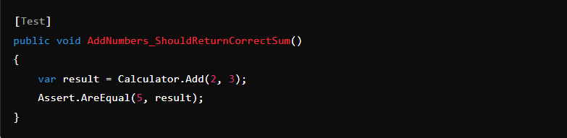

**Integration Tests**

* **Scope:** Integration tests evaluate how different components or modules of the application work together. They test the interactions between these components.
* **Dependencies:** Integration tests often include real dependencies, such as databases, file systems, or external APIs. This means they are not isolated and require a more complete environment to run.
* **Complexity and Speed:** Integration tests are generally more complex and slower than unit tests because they test the interaction between multiple components and often involve setting up and tearing down infrastructure.
* **Purpose:** The goal of integration tests is to ensure that different parts of the application work together as expected.
* **Example in .NET:** An integration test might check if a service correctly retrieves data from a database and processes it.

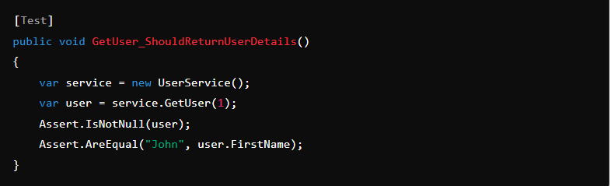

**Key Differences**

* **Isolation:** Unit tests isolate the unit of work, whereas integration tests involve real components working together.
* **Dependencies:** Unit tests use mocks to simulate dependencies, while integration tests use actual dependencies.
* **Purpose:** Unit tests check the correctness of individual components, while integration tests verify the interaction between components.

Both types of tests are crucial in building reliable .NET applications. Unit tests ensure that individual components work correctly, and integration tests ensure that these components work together as expected.

1. **How to secure your service in WEB API in .NET?**

Securing a Web API in .NET involves several layers of security to protect against common threats and vulnerabilities. Here’s a guide on how to secure your Web API in .NET:

**1. Authentication and Authorization**

* **Authentication**: Ensure that only authenticated users can access the API. This can be done using OAuth2, JWT (JSON Web Token), or ASP.NET Core Identity.
* **Authorization**: Control access to different resources and actions within your API using role-based or policy-based authorization.

**2. Use HTTPS**

* Always use HTTPS to encrypt the data transmitted between the client and the server. This prevents man-in-the-middle attacks.

**3. Use Strong API Keys or Tokens**

* Generate strong API keys or tokens and avoid embedding them directly in your source code. Store them securely, and rotate them periodically.

**4. Rate Limiting and Throttling**

* Implement rate limiting to prevent abuse by limiting the number of requests a client can make in a given time period.
* Throttling can help control the flow of requests and protect the API from being overwhelmed.

**5. Input Validation and Sanitization**

* Validate and sanitize all inputs to protect against injection attacks (like SQL injection, XSS).
* Use model validation attributes in ASP.NET Core to enforce validation rules.

**6. Use CORS (Cross-Origin Resource Sharing) Properly**

* Restrict the domains that can access your API by configuring CORS policies appropriately. Allow only trusted origins.

**7. Implement Logging and Monitoring**

* Enable logging to track access and errors. Monitor the logs for suspicious activity.
* Use application monitoring tools like Application Insights to detect anomalies.

**8. Exception Handling**

* Implement global exception handling to ensure that your API doesn’t expose sensitive information in error messages.
* Return standardized error responses to clients.

**9. Use Security Headers**

* Add security headers like X-Content-Type-Options, X-Frame-Options, and Strict-Transport-Security to reduce vulnerabilities.

**10. Use Dependency Injection and Secure Your Dependencies**

* Use dependency injection to manage dependencies securely.
* Regularly update your libraries and dependencies to avoid known vulnerabilities.

**11. Secure Data at Rest**

* Encrypt sensitive data stored in your database or on disk.
* Use tools like Data Protection API (DPAPI) in .NET Core for encrypting data.

**12. Use Anti-Forgery Tokens**

* For APIs exposed to web clients, use anti-forgery tokens to prevent CSRF (Cross-Site Request Forgery) attacks.

**13. Limit Data Exposure**

* Return only the necessary data in API responses. Avoid exposing sensitive data unnecessarily.
* Implement output filtering or use DTOs (Data Transfer Objects) to control what data is exposed.

**14. Implement API Gateway or Reverse Proxy**

* Use an API Gateway or reverse proxy to manage traffic, handle load balancing, and add an additional layer of security.

**15. Regular Security Audits and Penetration Testing**

* Perform regular security audits and penetration testing to identify and mitigate vulnerabilities in your API.

**16. Implement Data Protection Policies**

* Implement and enforce policies for data protection, especially for sensitive and personal information, in compliance with regulations like GDPR.

By following these steps, you can significantly enhance the security of your Web API in .NET and protect it from common threats.

1. **Difference between ref and out keyword in C#?**

In C#, both ref and out are keywords used to pass arguments by reference to methods, but they have different use cases and behavior:

**ref Keyword:**

* **Purpose**: The ref keyword is used to pass an argument by reference, meaning any changes made to the parameter in the method will affect the original variable passed in.
* **Initialization Requirement**: The variable passed with ref must be initialized before it is passed to the method.

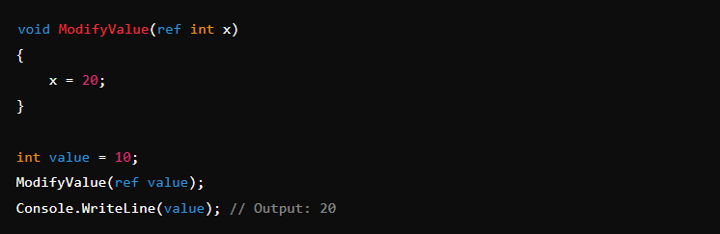

In this example, the value variable is passed by reference, and changes made within the method affect the original variable.

**out Keyword:**

* **Purpose**: The out keyword is also used to pass an argument by reference, but it is specifically used when a method needs to return multiple values.
* **Initialization Requirement**: The variable passed without does not need to be initialized before being passed. However, the method that receives an out parameter is required to assign it a value before the method returns.

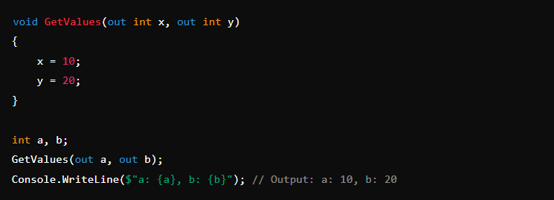

In this example, the variables a and b are passed to the method uninitialized, and the method assigns them values before returning.

**Key Differences:**

1. **Initialization**:
   * **ref**: The variable must be initialized before it is passed.
   * **out**: The variable does not need to be initialized before passing, but the method must initialize it before returning.
2. **Method Implementation**:
   * **ref**: The method can read and modify the passed value.
   * **out**: The method must assign a value to the parameter before exiting.
3. **Use Case**:
   * **ref**: Used when the method should modify the input value and potentially read its original value.
   * **out**: Used when a method needs to return multiple values.

These keywords provide flexibility in method signatures, allowing for more versatile and expressive code.

1. **Difference between Task.WhenAll and Task.WhenAny method in C#?**

In C#, Task.WhenAll and Task.WhenAny are methods used to work with multiple asynchronous tasks, but they serve different purposes:

**1. Task.WhenAll**

* **Purpose:** Waits for all the provided tasks to complete.
* **Usage:** Task.WhenAll is used when you want to execute multiple tasks concurrently and wait until all of them are finished.
* **Return Value:** It returns a single task that completes when all the provided tasks have completed. The result of this task is an array containing the results of all the tasks.
* **Error Handling:** If any of the tasks fail, the returned task will complete with a faulted status, and the exception will contain all the exceptions from the faulted tasks.

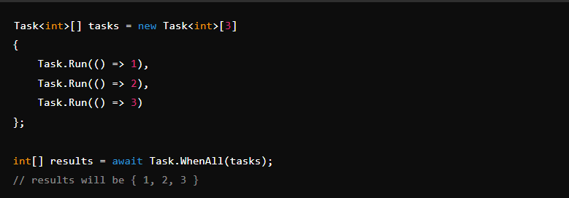

**2. Task.WhenAny**

* **Purpose:** Waits for any one of the provided tasks to complete.
* **Usage:** Task.WhenAny is used when you want to execute multiple tasks concurrently but are only interested in the first one that completes.
* **Return Value:** It returns a single task that completes when any one of the provided tasks has completed. The result of this task is the task that completed first.
* **Error Handling:** If the first task to complete fails, the returned task will complete with a faulted status, but only the exception from that first completed task will be available.

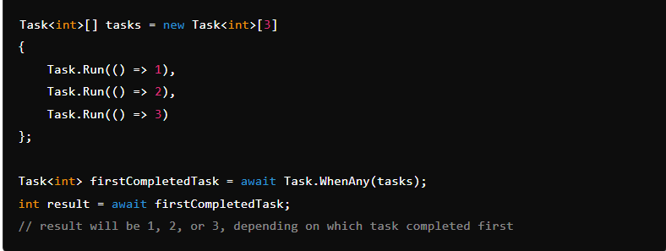

**Key Differences:**

* **Task.WhenAll** waits for all tasks to complete, while **Task.WhenAny** waits for just one task to complete.
* **Task.WhenAll** returns an array of results, while **Task.WhenAny** returns the task that completed first.
* **Error handling:** With Task.WhenAll, all exceptions from faulted tasks are captured, whereas with Task.WhenAny, only the exception from the first completed task is captured.

1. **Boxing and Unboxing in C#?**

Boxing and unboxing are fundamental concepts in C# that involve converting value types to reference types and vice versa. Here’s a brief explanation:

**Boxing**

* **Boxing** is the process of converting a value type (such as int, char, bool, struct) to a reference type (typically object).
* When a value type is boxed, it is wrapped inside an object or System.Object and stored on the heap rather than the stack.

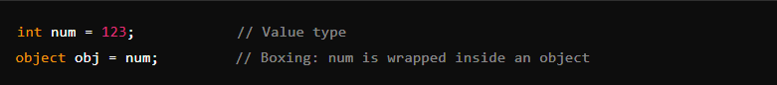

**Unboxing**

* **Unboxing** is the reverse process, where a reference type (boxed object) is converted back into a value type.
* During unboxing, the runtime checks to ensure the object being unboxed is actually a boxed value of the target type. If it isn’t, an InvalidCastException is thrown.



**Performance Considerations**

* **Boxing and unboxing operations are relatively expensive** because they involve allocating memory on the heap and copying data between the stack and the heap.
* Frequent boxing and unboxing can lead to performance issues and increased garbage collection overhead.

**Common Scenarios**

Boxing and unboxing often occur in scenarios such as:

* Passing value types to methods that accept parameters of type object.
* Storing value types in collections that hold objects, like ArrayList (although generics like List<T> reduce the need for boxing/unboxing).

1. **Difference between String and String Builder in C#?**

In C#, String and StringBuilder are both used to work with text, but they have different characteristics and use cases:

**1. String:**

* **Immutable**: A String in C# is immutable, meaning that once it is created, it cannot be changed. Any operation that modifies a string (e.g., concatenation, substring, replacement) creates a new string object, leaving the original unchanged.
* **Performance**: Due to immutability, operations that modify strings can lead to a lot of memory allocations and copying, especially in loops or when dealing with large amounts of text. This can affect performance.
* **Usage**: String is typically used when you have a fixed or small number of string manipulations, or when the string operations are infrequent.

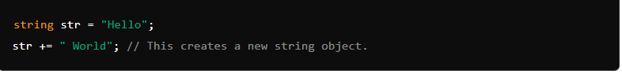

**2. StringBuilder:**

* **Mutable**: StringBuilder is mutable, meaning that you can modify its contents without creating a new object. This makes it more efficient for scenarios where you need to perform numerous string manipulations, such as in loops or when building a large string dynamically.
* **Performance**: Since StringBuilder does not create new objects on each modification, it is generally faster and more memory-efficient when dealing with many string operations.
* **Usage**: StringBuilder is used when you expect to perform many modifications to a string, such as in loops, or when constructing large strings from many smaller ones.

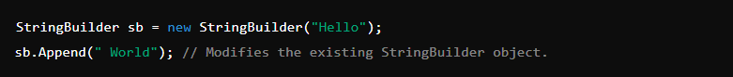

**Key Differences:**

* **Mutability**: String is immutable, while StringBuilder is mutable.
* **Performance**: String is less efficient for multiple modifications, while StringBuilder is designed for scenarios involving many string changes.
* **Use Cases**: Use String for simple, few modifications; use StringBuilder for complex, repetitive, or large-scale string operations.

1. **What is Subject and BehaviorSubject in Angular?**

In Angular, **Subject** and **BehaviorSubject** are both types of Observables provided by the RxJS library, but they have some key differences in behavior and usage.

**Subject**

* A Subject is a type of observable that allows multiple observers to subscribe to it, and it emits values to all its subscribers.
* When a new subscriber subscribes to a Subject, it only receives values emitted **after** it has subscribed. It does not receive any previous values.
* A Subject can also act as an observer, allowing you to next(), error(), or complete() values directly on it.

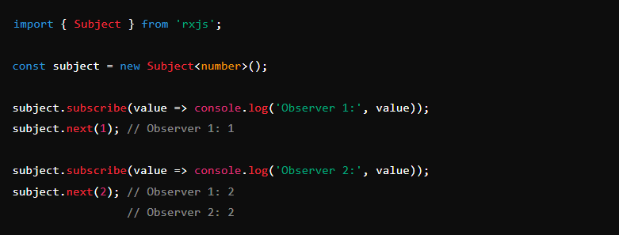

**BehaviorSubject**

* A BehaviorSubject is a type of Subject that requires an initial value and emits its current value (or the latest emitted value) to new subscribers.
* Unlike a Subject, when a new subscriber subscribes to a BehaviorSubject, it immediately receives the most recent value.
* It is useful for representing "current state" that needs to be shared and observed by multiple parts of an application.

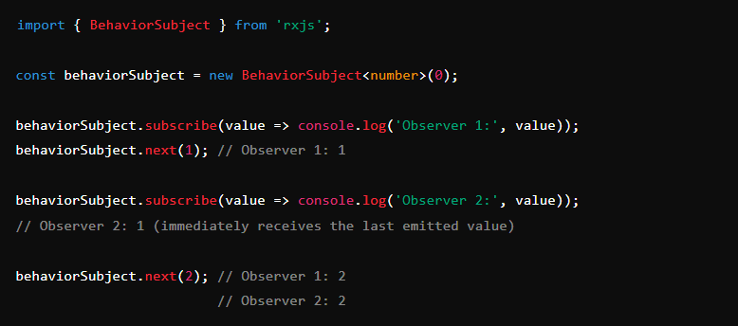

**Key Differences**

* **Initial Value**: BehaviorSubject requires an initial value when it is created, while Subject does not.
* **Value Emission**: Subject only emits values to subscribers after they have subscribed, whereas BehaviorSubject emits the last value to new subscribers immediately upon subscription.
* **Current Value**: BehaviorSubject has the ability to get the current value using the getValue() method, which is not available for a regular Subject.

These are useful in different scenarios depending on whether you need to handle a stream of events (using Subject) or need to keep track of and share a state that might change over time (using BehaviorSubject).

1. **Session Management in Angular?**

Session management is an essential aspect of web development, as it helps ensure the security and privacy of user data. In Angular, session management can be implemented using various techniques, such as browser cookies, local storage, and session storage. Here are some steps to implement session management in Angular:

* 1. **Install the necessary packages:** You can use the ngx-webstorage package to implement session management in Angular. To install it, use the following command:

npm install ngx-webstorage –save

* 1. **Import the necessary modules:** After installing the package, you need to import the LocalStorageModule or SessionStorageModule in your app.module.ts file.

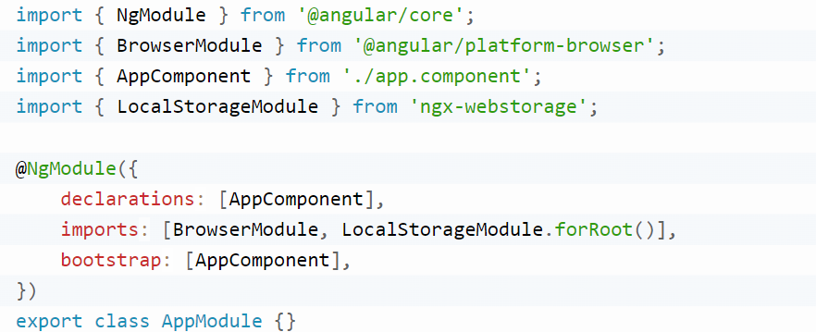

* 1. **Set and Get session data:** After importing the module, you can use the localStorage or sessionStorage service to set and get session data.

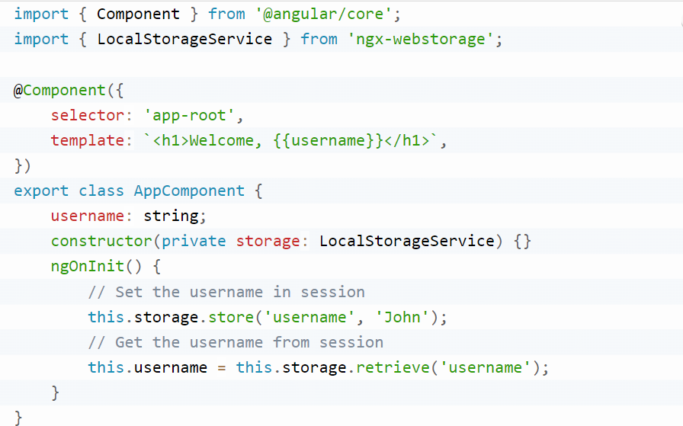

In the example above, we used LocalStorageService to set and get the username data. We store the username in the session using store() and retrieve it using retrieve().

* 1. **Clear session data:** You can clear the session data using the clear() method.

this.storage.clear('username');

This will clear the username data from the session.

1. **Session management in Angular**

Session management in Angular involves handling user sessions securely and efficiently, usually after they log in to an application. Here’s a basic overview of how session management works in Angular:

**1. Storing Session Data**

* **LocalStorage:** Stores data with no expiration time, meaning it will persist even when the browser is closed.
* **SessionStorage:** Similar to LocalStorage, but the data persists only until the browser window or tab is closed.
* **Cookies:** Can be used for session storage with expiration dates and additional security features.

**2. Authentication Tokens**

* **JWT (JSON Web Tokens):** Commonly used for session management. The token is generated upon user login and stored on the client side. Each subsequent request includes the token in the headers for server validation.
* **OAuth Tokens:** Used in cases where OAuth is used for authentication.

**3. Angular Services**

* Create an Angular service to handle session management. This service can include methods to set, get, and clear session data.

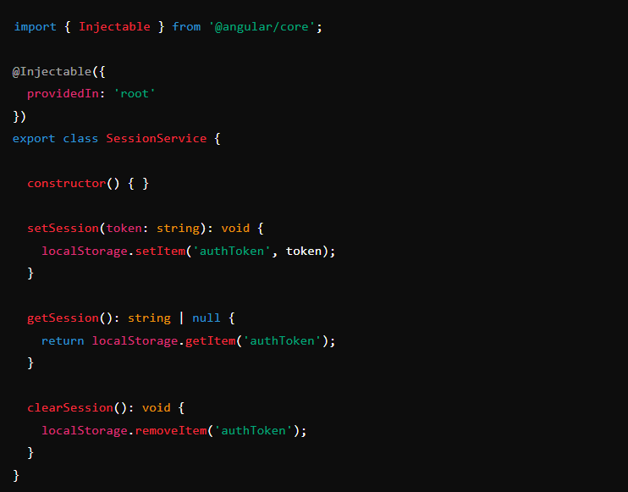

**4. HTTP Interceptors**

* Use an HTTP Interceptor to automatically attach the token to every HTTP request.

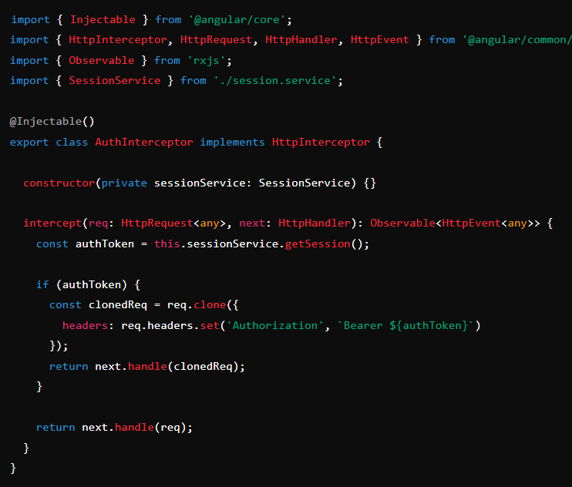

**5. Automatic Logout**

* Implement automatic logout if the token expires or becomes invalid. You can handle this using Angular's route guards and token expiry checks.

**6. Session Expiry and Refresh**

* Monitor token expiry times, and implement logic to refresh tokens or log the user out when necessary.
* You might use ngx-webstorage-service or similar libraries to handle more advanced session storage needs.

**7. Security Considerations**

* Always ensure that tokens are securely handled and transmitted over HTTPS.
* Use XSRF tokens if dealing with CSRF protection.

**8. Route Guards**

* Protect routes by implementing route guards that check if the user is authenticated before allowing access.

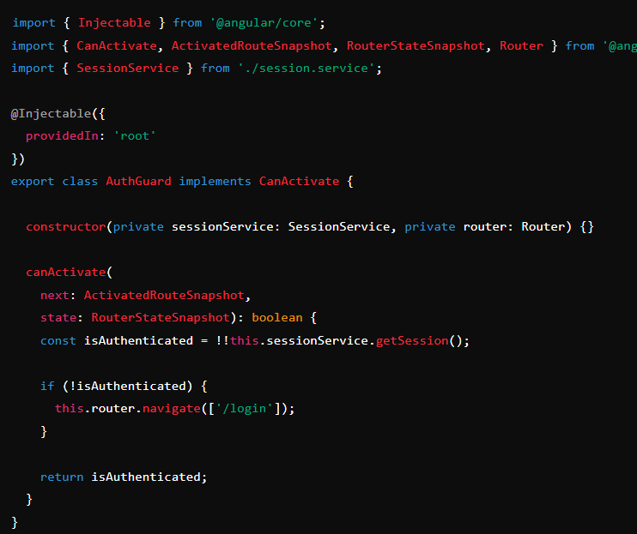

These are the core elements of session management in Angular. You can customize and extend these examples based on your application’s specific needs.

1. **What is ViewEncapsulation in Angular**

View Encapsulation is a powerful concept that **helps developers manage styles and avoid style conflicts in their applications**. It ensures the isolation of styles defined within a component and prevents styles defined in one component from affecting or being affected by styles in other components

Angular provides three types of ViewEncapsulation:

**1. Emulated (Default)**

* **Description:** Styles from the component are scoped to the component itself, but they are not isolated completely from the global styles or from other components' styles.
* **How it works:** Angular uses a mechanism where it adds unique attributes to the component's HTML elements and corresponding styles. These attributes make sure that the styles are only applied to the elements within that component, simulating Shadow DOM behavior.
* **Usage:** It's the default encapsulation method used in Angular.

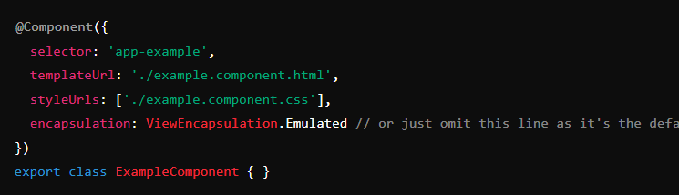

**2. Shadow DOM (ViewEncapsulation.ShadowDom)**

* **Description:** Styles are completely encapsulated within the component, and they do not leak out or are affected by any global styles. This encapsulation mode uses the browser's native Shadow DOM.
* **How it works:** The component's HTML is enclosed within a Shadow DOM boundary, isolating its styles and preventing them from affecting other components.
* **Usage:** Use this when you need complete style encapsulation and are okay with the performance trade-offs and browser support constraints.

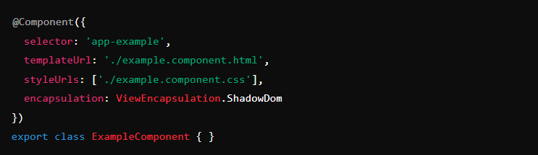

**3. None (ViewEncapsulation.None)**

* **Description:** No encapsulation is applied to the component's styles. The styles are global and can affect other components or be affected by global styles.
* **How it works:** Styles are added directly to the document’s <head>, making them global.
* **Usage:** Use this when you want your component’s styles to be global and affect the entire application, similar to how CSS works traditionally.

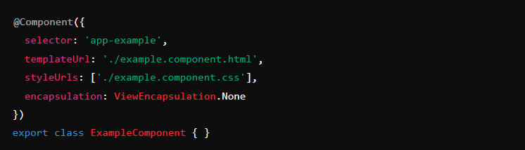

**Summary**

* **Emulated:** Scoped styles with simulated Shadow DOM (default).
* **Shadow DOM:** Fully isolated styles using native Shadow DOM.
* **None:** No encapsulation, making styles global.

Understanding and choosing the right encapsulation strategy is crucial for maintaining and scaling large Angular applications, as it directly impacts how styles are applied and maintained.

1. **Difference between Join and IsAlive method in C#?**

In C#, both the Join and IsAlive methods are used in the context of threads, but they serve different purposes. Here’s a breakdown of the differences between them:

**Join Method**

* **Purpose**: The Join method is used to block the calling thread until the thread on which Join is called has completed execution.
* **Usage**: This method ensures that the calling thread waits for the other thread to finish before it continues. This is useful when you need to ensure that a particular thread has finished its work before proceeding with other operations.

Syntax: thread.Join();

* You can also specify a timeout in milliseconds:

bool completed = thread.Join(1000); // Waits for 1 second

If the thread completes within the specified time, Join returns true; otherwise, it returns false.

**IsAlive Property**

* **Purpose**: The IsAlive property is used to check if a thread is still running (alive) or if it has terminated.
* **Usage**: This property returns true if the thread has been started and has not yet terminated, and false otherwise. It’s useful for checking the status of a thread without blocking the calling thread.

**Syntax:**

bool isRunning = thread.IsAlive;iy

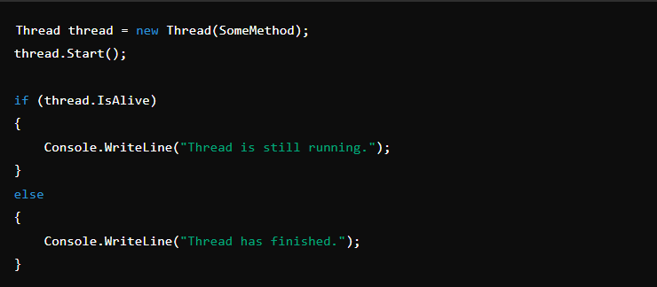

**Key Differences**

* **Blocking vs. Non-blocking**:
  + **Join:** Blocks the calling thread until the target thread finishes.
  + **IsAlive**: Does not block the calling thread; simply checks the status of the target thread.
* **Return Value**:
  + **Join**: No return value (unless a timeout is specified), but it blocks until the thread completes.
  + **IsAlive**: Returns a boolean value indicating whether the thread is still running.
* **Use Case**:
  + **Join**: Used when you need to wait for a thread to complete before proceeding.
  + **IsAlive**: Used when you want to check if a thread is still running without waiting for it to finish.

These methods are commonly used in multithreading scenarios to manage and coordinate thread execution.

1. **What is content negotiation in .NET Core?**

Content negotiation is the process in which the client and server agree to exchange data in a representational format when the server is allowed to exchange data in multiple representational formats. Just like JSON, XML, HTML, and plain text.

**How Content Negotiation Works in .NET Core:**

1. **Client Request**: The client sends a request to the server, often specifying the desired response format using the Accept header. For example, the client might request JSON by including Accept: application/json in the header.
2. **Server Response**: The server, typically an ASP.NET Core API, examines the Accept header to determine the best possible format it can provide. If the server can fulfill the request in one of the formats specified by the client, it serializes the response accordingly.
3. **Media Type Formatters**: ASP.NET Core uses media type formatters to handle different response formats. The framework includes built-in support for JSON and XML, and you can add custom formatters for other media types.
4. **Default Behavior**: If no Accept header is specified or the requested format isn't supported, the server returns a default response format, usually JSON.
5. **Content Negotiation Result**: The result of the content negotiation is an ObjectResult that is processed by a specific formatter (e.g., JsonResult, XmlResult) based on the negotiated media type.

**Custom Formatters:**

You can create custom media type formatters to support additional formats, such as YAML or CSV, by implementing OutputFormatter or InputFormatter and adding them to the MvcOptions.

**Practical Usage:**

* **API Versioning**: Content negotiation is often used in conjunction with API versioning, where different versions of the API might support different media types.
* **Client Flexibility**: It allows clients to specify their preferred data format, making the API more flexible and easier to consume by different types of clients.

Content negotiation is a powerful feature in ASP.NET Core that enables APIs to serve different clients effectively by understanding and fulfilling their preferred data formats.

1. **OAuth Authentication for Web API?**

Authentication means verifying the user who is accessing the system. We have available different types of authentication in .NET programming like Windows Authentication, Forms Authentication, Claim Based Authentication, Token-Based Authentication, etc.

**Token-based Authentication**

In token-based authentication, you pass your credentials [user name and password], to the server, which verifies your credentials and if it is a valid user, then it will return a signed token to the client system, which has an expiration time. The client can store this token locally using any mechanism like local storage, session storage, etc. and if the client makes any other call to the server for data, then it does not need to pass its credentials every time. The client can directly pass the token to the server, which will be validated by the server and if the token is valid, then you will able to access your data.

**OAuth**

(Open Authorization) is an open standard for token-based authentication and authorization on the Internet. OAuth (Open Authorization) is a protocol that allows users to grant third-party applications limited access to their resources without exposing their credentials. In ASP.NET Web API, you can implement OAuth authentication to secure your API endpoints.

**OAuth versions**

There are two versions of OAuth authorization [**OAuth 1**](https://www.soapui.org/docs/oauth1/oauth1-overview.html)(using HMAC-SHA signature strings) and **OAuth 2** (using tokens over HTTPS).

**OAuth Tokens Types**

There are two types of tokens involved in OAuth 2,

**Access Token:** The access token is used to for authentication and authorization to get access to the resources from the resource server.

**Refresh Token:** The refresh token normally is sent together with the access token. The refresh token is used to get a new access token when the old one expires. Instead of the normal grant type, the client provides the refresh token and receives a new access token.

**Token Types**

Access tokens have a type, which defines how they are constructed.

* **Bearer Tokens**  
  The bearer tokens use HTTPS security, and the request is not signed or encrypted. Possession of the bearer token is considered authentication.
* **MAC Tokens**  
  More secure than bearer tokens, MAC tokens are similar to signatures, in that they provide a way to have (partial) cryptographic verification of the request.

**How To Implement OAuth in WebAPI**

**Step 1: Install the Required NuGet Packages**

First, you need to install the necessary NuGet packages:

* Microsoft.Owin
* Microsoft.Owin.Security.OAuth
* Microsoft.Owin.Host.SystemWeb

You can install them via the NuGet Package Manager Console:



**Step 2: Create the OAuth Authorization Server Provider**

Create a class that inherits from OAuthAuthorizationServerProvider and override methods like ValidateClientAuthentication and GrantResourceOwnerCredentials.

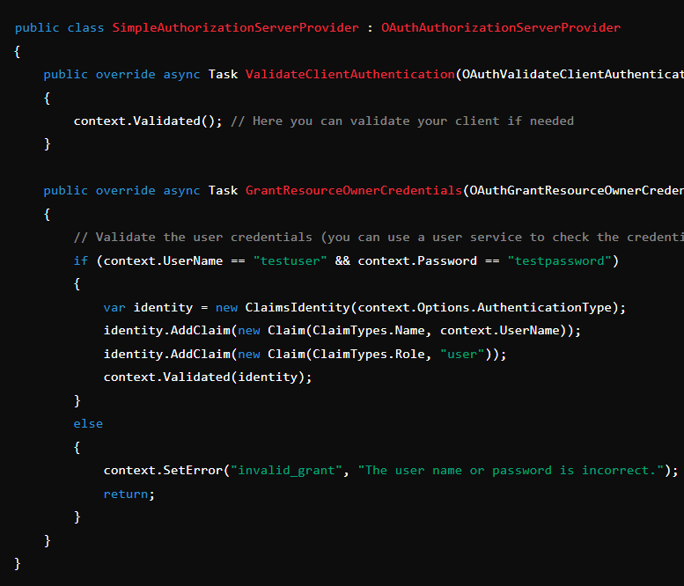

**Step 3: Configure OAuth in Startup Class**

In the Startup class, configure OAuth authentication by adding the OAuth options.

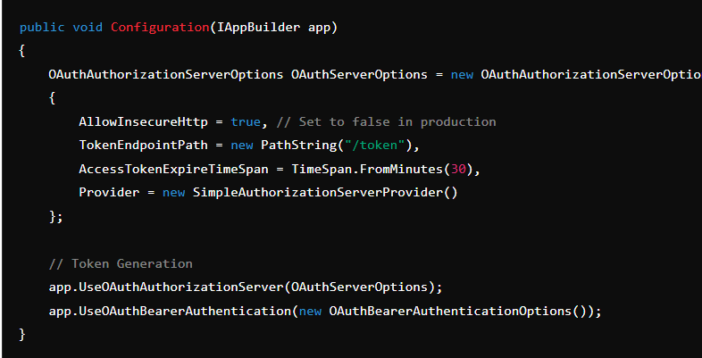

**Step 4: Protect API Endpoints**

To secure your API endpoints, you can use the [Authorize] attribute on controllers or actions.

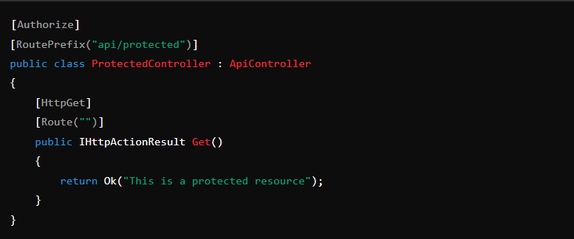

**Step 5: Requesting a Token**

To get a token, you can make a POST request to the /token endpoint with the user's credentials.

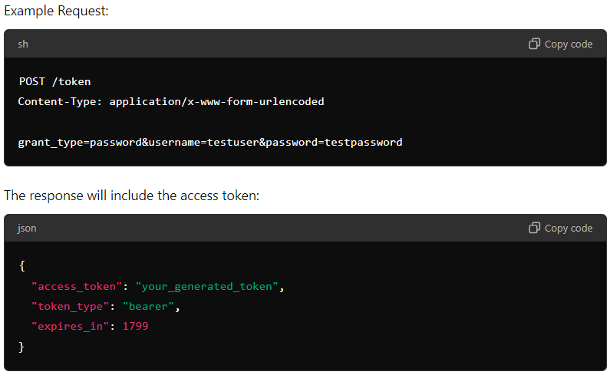

**Step 6: Using the Token**

When calling the protected API, include the token in the Authorization header:



This will authenticate the request and allow access to the protected endpoints.

**Final Notes**

* In production, always use HTTPS.
* You may need to implement additional validation, such as checking the client ID and secret.
* Customize token expiration, claims, and other settings according to your application's needs.

1. **What is AOT and JIT compiler in Angular?**

In Angular, Ahead of Time (AOT) and Just in Time (JIT) compilation are two different ways to compile Angular applications.

**Ahead of Time (AOT) compiler**

When you serve/build your angular application, the Ahead of Time compiler converts your code during the build time before your browser downloads and runs that code. From Angular 9, by default compiling option is set to true for ahead of time compiler.

**Why should you use the Ahead of Time compiler?**

* When you are using Ahead of Time Compiler, compilation only happens once, while you build your project.
* It can minimize the size of your application.
* The browser does not need to compile the code in run time, it can directly render the application immediately, without waiting to compile the app first so, it provides quicker component rendering.
* The Ahead of time compiler detects template error earlier. It detects and reports template binding errors during the build steps before users can see them.
* AOT provides better security. It compiles HTML components and templates into JavaScript files long before they are served into the client display. So, there are no templates to read and no risky client-side HTML or JavaScript evaluation. This will reduce the chances of injections attacks.

**Just in Time (JIT) compiler**

[Just in time compiler](https://www.geeksforgeeks.org/just-in-time-compiler/) provides compilation during the execution of the program at a run time before execution. In simple words, code get compiles when it’s needed, not at the build time.

* In case of Just in time, not all code is compiled at the initial time. Only necessary component which are going to be needed at the starting of your application will be compiled. Then if the functionality is need in your project and it’s not in compiled code, that function or component will be compiled.
* This process will help to reduce the burden on the CPU and make your app render fast.

**Why and When Should you use Just In Time Compiler?**

* Just in time compiler compiles each file separately and it’s mostly compiled in the browser. You don’t have to build your project again after changing your code.
* Most compiling is done on the browser side, so it will take less compiling time.
* If you have a big project or a situation where some of your components don’t come in use most of the time then you should use the Just in time compiler.
* Just in Time compiler is best when your application is in local development

**Comparison between Ahead of Time (AOT) and Just in Time (JIT) –**

|  |  |
| --- | --- |
| **JIT (Just in Time)** | **AOT(Ahead of Time)** |
| JIT downloads the compiler and compiles code exactly before Displaying in the browser. | AOT has already complied with the code while building your application, so it doesn’t have to compile at runtime. |
| Loading in JIT is slower than the AOT because it needs to compile your application at runtime. | Loading in AOT is much quicker than the JIT because it already has compiled your code at build time. |
| JIT is more suitable for development mode. | AOT is much suitable in the case of Production mode. |
| Bundle size is higher compare to AOT. | Bundle size optimized in AOT, in results AOT bundle size is half the size of JIT bundles. |
| You can run your app in JIT with this command:  ng build OR ng serve | To run your app in AOT you have to provide –aot at the end like:  ng build --aot OR ng serve --aot |
| You can catch template binding error at display time. | You can catch the template error at building your application. |

**Conclusion:**You can compile your angular application in two ways: JIT and AOT. Both are suitable for a different scenario like you can use JIT for development mode and AOT is better in production mode.  Implementing features and debugging is easy in JIT mode since you have to map files while AOT does not have it. However, that AOT provides a big benefit to angular developers for production mode by reducing bundle size and making your app render faster.

1. **Difference between Promises and Observable**

|  |  |  |
| --- | --- | --- |
|  | **Promise** | **Observable** |
| **Handling multiple values** | Handles single value. | Handle multiple values at a time. |
| **Asynchronous support** | Suitable for asynchronous communication | Suitable for both synchronous and asynchronous communication |
| **Cancellation** | Cannot be canceled once initiated. | Can be canceled whenever we want. |
| **Complex data transformation** | Limited support. | Wide range of support. |
| **Error Handling** | The catch() method is used for handling errors. | This offers different mechanisms. |
| **Conciseness** | Simple and concise syntax. | More complex due to extensive support. |
| **Use Cases** | Suitable for one-time tasks like reading files. | Suitable for continuous real-time updates like in stock market dashboards. |

1. **What are the main building blocks of an Angular Applications?**

**Angular Application Architecture**

An [Angular](https://www.geeksforgeeks.org/angular-8-introduction/) application follows the Model-View-Controller (MVC) and Model-View-ViewModel (MVVM) principle design patterns. The [Model View Controller (MVC)](https://www.geeksforgeeks.org/mvc-design-pattern/) design pattern specifies that an application consists of a data model, presentation information, and control information. In the [Model-View-ViewModel (MVVM)](https://www.geeksforgeeks.org/introduction-to-model-view-view-model-mvvm/) design pattern, the Model component resembles the same concepts as in the traditional Model-View-Controller (MVC) pattern, along with facilitating the extended and adapted to better support the requirements for data binding and the ViewModel.

**Building Blocks of an Angular Application**

The main building block of an Angular application is as follows:

* Module
* Component
* Templates
* Metadata
* Data Binding
* Directives
* Service
* Dependency Injection
* Decorators
* Pipes
* Routing

## ****Module****

[Modules](https://www.geeksforgeeks.org/angularjs-modules/) are like containers for components, directives, services, etc. They help to organize an Angular application which makes it easier to manage or scale application. Modules also support lazy loading means it is used to improve application performance by loading specific parts of the application only when they are required. The root module also known as App Module provides a starting point for the application.

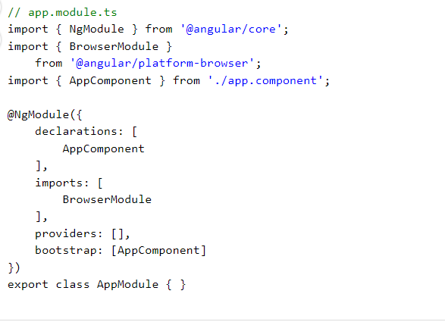

**Components**

[Components](https://www.geeksforgeeks.org/angular-7-components/) are the fundamental block for the Angular application interface. They combine the presentation layer (template) and component class. They also enable the creation of custom HTML elements and help in transforming the user interface into a collection of self-contained and easily maintainable units. Each component is recognized by means of a completely unique selector, which acts as a custom HTML detail, enabling you to embed it within other components or templates. Components are the visible entities in which users interact with it without any delay, making it a crucial part of the user experience.

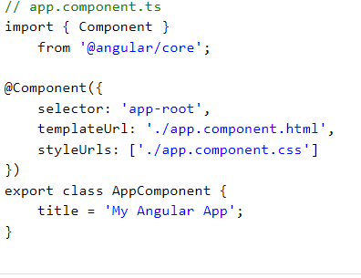

**Templates**

Templates define the structure of components using Angular templating syntax. They display the data and provide the structure for the user interface. Angular template syntax is also used to combine HTML with Angular-precise directives and bindings. Directives work as markers in the template that teach Angular how they can transform the DOM earlier than rendering it.

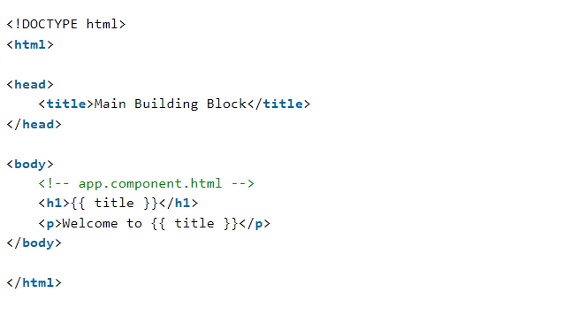

**Metadata**

Metadata refers to the facts that are associated with various elements in an Angular application like components, modules, directives, and so forth. Metadata is furnished using decorators, which can be special capabilities that attach extra statistics to the elements. This metadata facilitates Angular to apprehend the method and use these factors. They also are used to configure and define numerous factors of application elements such as their behavior, look, and relationships with other elements.

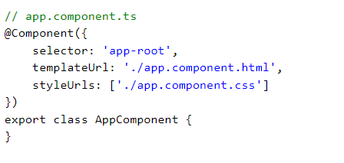

**Data Binding**

[Data binding](https://www.geeksforgeeks.org/angularjs-data-binding/)is responsible for connecting the component’s logic with its template through which data can be updated automatically. Angular supports various types of data binding like interpolation, property binding, event binding, and two-way binding which help to develop a responsive experience for the user.

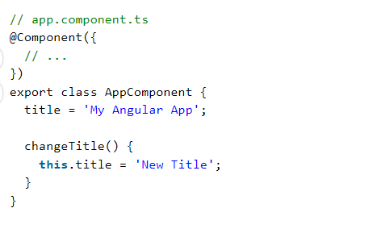

Angular supports multiple kinds of Data Binding:

* [**Interpolation**](https://www.geeksforgeeks.org/what-is-interpolation-in-angularjs/): Embedding expressions inside double curly braces ( expression ) in the template.
* [**Property Binding**](https://www.geeksforgeeks.org/property-binding-in-angular-8/): Binding a component property to an element’s property with the usage of square brackets.
* [**Event Binding**](https://www.geeksforgeeks.org/event-binding-in-angular-8/): Binding an element’s occasion to an issue technique using parentheses.
* [**Two-Way Binding**](https://www.geeksforgeeks.org/two-way-data-binding-in-angularjs/): Combining property and event binding to achieve bidirectional data synchronization using the [(ngModel)] directive.

**Directives**

[Directives](https://www.geeksforgeeks.org/angular-7-directives/) are the special kind of markers that tell Angular to attach specific behavior to elements. Angular has three types of directives:

* **Component Directives**: They are used to create reusable UI components.
* **Attribute Directives**: They are used to change the appearance or behavior of an element like changing its color depending on the condition.
* [**Structural Directives**](https://www.geeksforgeeks.org/structural-directives-in-angular/): They are used to modify the structure of the DOM, like adding or removing elements depending on the condition. for example ngIf and ngFor.

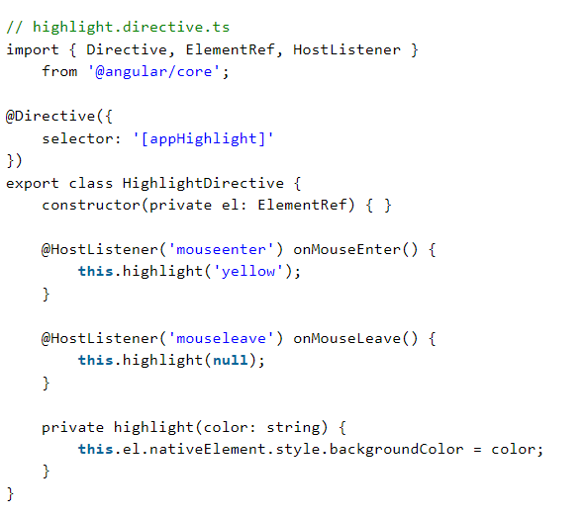

**Services**

[Services](https://www.geeksforgeeks.org/angularjs-services/) refer to those classes that provide functionality. They are designed to be embedded into components, services, or modules that assist in sharing statistics, imposing enterprise good judgment, and handling communication with API. This makes it less complicated to reuse the code again and additionally allows for higher testing and preservation.

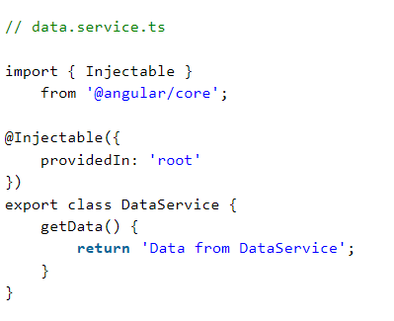

**Dependency Injection**

An [Angular-Dependency Injection](https://www.geeksforgeeks.org/how-to-inject-service-in-angular-6-component/)system could be a very beneficial function that allows the control of dependencies internally on the software itself. DI encourages unfastened coupling by using decoupling additives and services from the context of ways their dependencies are mapped. It lets you declare the dependencies of a factor or service. This enhances modularity, testability, and code reusability and additionally makes code bendy and smooth to use.

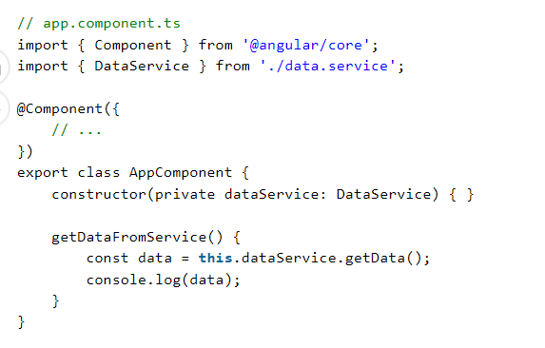

**Decorators**

Decorators in Angular are special sorts of capabilities that may be used to modify or add metadata to classes, methods, properties, or parameters. Angular decorators play a critical function in configuring and enhancing numerous elements of an Angular application. Decorators in Angular offer an easy and declarative way to configure and increase the behavior of various elements of your software. They are a necessary part of the Angular metadata system, allowing you to outline how additives, modules, and other factors ought to behave and interact inside your utility.

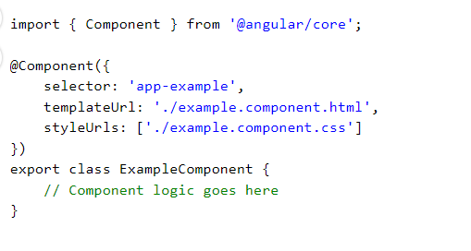

**Pipes**

Pipes are a function in Angular that allows you to transform and format data without delay inside the template. They are used to modify the appearance of statistics before it is exhibited to the user. Angular affords built-in pipes for formatting dates, numbers, and text, and you may also create custom pipes to shape unique software desires. Pipes assist in maintaining clean and readable template code by means of abstracting statistics transformation common sense.

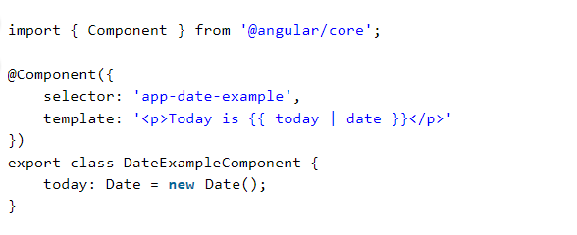

**Routing**

[Angular router](https://www.geeksforgeeks.org/angularjs-routing) allows the advent of single-page packages (SPAs) by permitting customers to navigate between distinct views or additives without complete web page reloads. The router maps URLs to perspectives and manages the nation of the utility’s UI. It supports capabilities like route parameters, slow loading, guards (for defensive routes), and more.

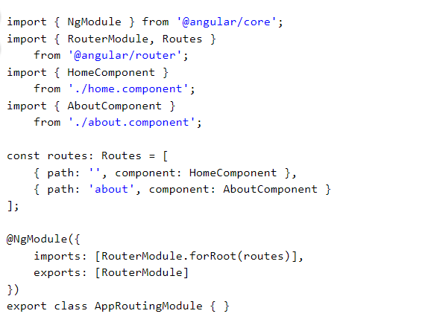

1. **What are Custom Pipes in Angular?**

Custom pipes are user-defined functions that transform input data into a desired output format. They provide a convenient way to encapsulate data transformation logic and reuse it throughout your Angular application. Custom pipes can be used to perform various operations on data, such as formatting strings, filtering arrays, or performing complex calculations.

**Features:**

* **Reusability**: Custom pipes can be used across multiple components, which helps in code reusability and maintainability.
* **Separation of Concern**s: By encapsulating data transformation logic within pipes, you can separate presentation concerns from business logic, making your code more organized and easier to understand.
* **Declarative Syntax**: Custom pipes can be used directly in component templates using a simple and declarative syntax, making it easier to apply data transformations without cluttering the component’s logic.
* **Chainability**: Pipes in Angular can be chained together, allowing you to apply multiple transformations in a single expression.

**Uses:**

* Formatting dates, currency, or numbers
* Transforming text (e.g., uppercase, lowercase, truncation)
* Filtering and sorting arrays or collections
* Implementing custom business rules or calculations
* Applying complex transformations based on multiple inputs or conditions

**Steps to Create Custom Pipes**

By creating custom pipes, you can enhance the functionality of your Angular application, improve code organization, and provide a consistent and reusable way to handle data transformations across your components. Let us create our own round-number pipe and use it in our application.

**Step 1: Generate a New Pipe**

You can create a new pipe using the Angular CLI:

ng generate pipe customPipeName

Replace customPipeName with the name you want for your pipe.

**Step 2: Implement the Pipe Logic**

Once the pipe is generated, Angular will create two files: custom-pipe-name.pipe.ts and custom-pipe-name.pipe.spec.ts.

Here’s an example of a simple custom pipe that converts text to uppercase:

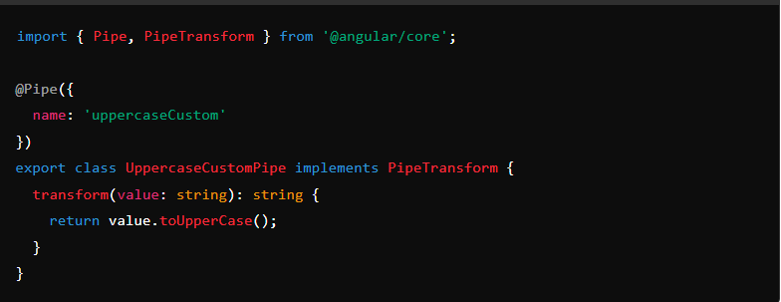

**Step 3: Register the Pipe in a Module**

To use the pipe in your Angular application, you need to register it in an Angular module. This is typically done in the module where you intend to use the pipe.

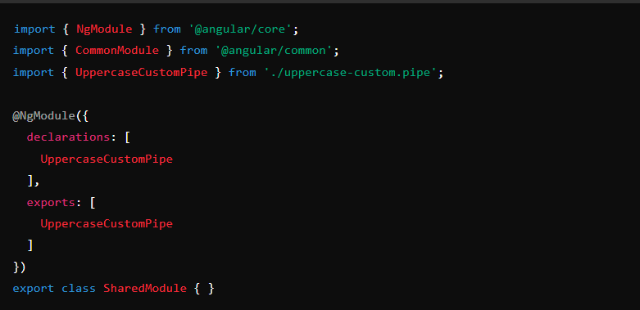

**Step 4: Use the Pipe in a Template**

Once the pipe is registered, you can use it in your templates:

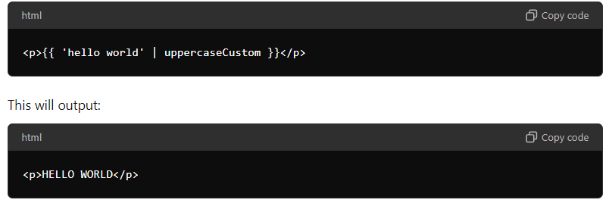

**Step 5: Add Optional Parameters (if needed)**

You can also create a pipe that accepts parameters. Here's an example that appends a given suffix to a string:

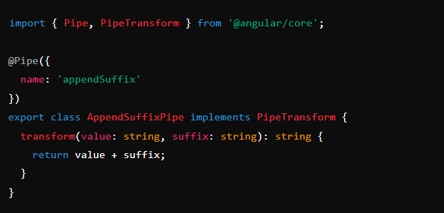

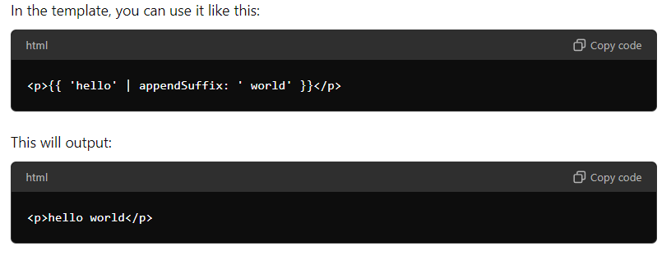

**Summary**

* **Generate the pipe** using Angular CLI.
* **Implement the pipe logic** by overriding the transform method.
* **Register the pipe** in an Angular module.
* **Use the pipe** in your templates.

1. **What is lazy loading and how to implement it in Angular?**

**Lazy loading** is a design pattern in Angular that helps improve the performance of an application by loading modules only when they are needed, instead of loading them all at once at the start. This reduces the initial load time and overall resource consumption.

**How Lazy Loading Works in Angular**

1. **Modular Structure**: Angular applications are divided into modules. By default, all the modules are eagerly loaded, meaning they are all loaded when the application starts. With lazy loading, only the root module is loaded initially, and other feature modules are loaded on demand.
2. **Route Configuration**: Lazy loading is typically implemented using Angular’s router. Routes are configured to load specific modules only when the user navigates to a particular path.

**Steps to Implement Lazy Loading in Angular**

1. **Create a Module for Lazy Loading**:
   * Use the Angular CLI to generate a module and a component for lazy loading.

ng generate module lazy --route lazy-route --module app.module

This command will create a new module named LazyModule and configure it to be lazily loaded.

1. **Configure Routes for Lazy Loading**:

* In the app-routing.module.ts, configure the route to load the module lazily:

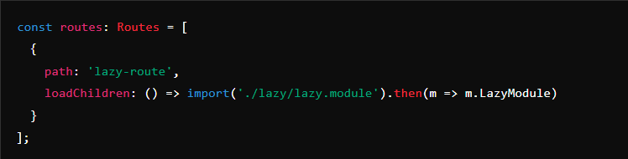

1. **Structure of the Lazy Loaded Module**:

* The module generated will have its own routing configuration in a separate file (e.g., lazy-routing.module.ts):

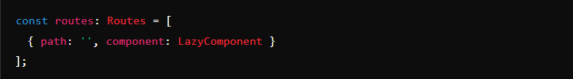

1. **Ensure Correct Imports and Declarations**:
   * Make sure that the module, component, and routing module are correctly imported and declared in the lazy.module.ts.
2. **Test the Lazy Loading**:
   * When navigating to the lazy-loaded route (e.g., /lazy-route), the LazyModule will be loaded on demand. You can verify this by checking network requests in the browser’s developer tools.

**Benefits of Lazy Loading**

* **Improved Load Time**: Only the necessary modules are loaded initially, reducing the time taken to load the application.
* **Better User Experience**: Users experience faster interaction as they don’t need to wait for the entire application to load.
* **Efficient Resource Utilization**: Resources like memory and bandwidth are used more efficiently since only required parts of the application are loaded.

**Example Scenario**

Suppose you have an e-commerce application with different sections like Home, Products, and Admin. You can implement lazy loading for the Admin module since it’s not needed by all users initially. Only when an admin logs in, the AdminModule is loaded, improving the overall performance for general users.

1. **What is CTE in SQL Server?**

In SQL Server, a **CTE (Common Table Expression)** is a temporary result set that you can reference within a SELECT, INSERT, UPDATE, or DELETE statement. CTEs make queries more readable and maintainable, especially when dealing with complex joins, subqueries, or recursive queries.

**Key Features of CTEs:**

1. **Temporary Result Set:** A CTE is valid only for the duration of the query it's used in.
2. **Readability:** CTEs can simplify complex queries by breaking them into more manageable parts.
3. **Recursion:** CTEs support recursive queries, which are useful for working with hierarchical data (e.g., organizational charts, folder structures).

**Basic Syntax:**

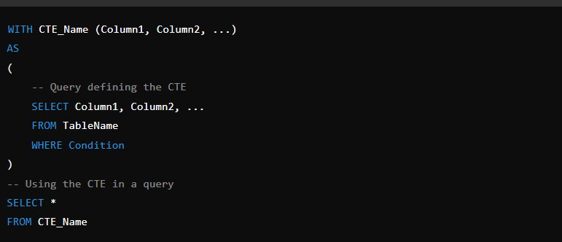

**Example:**

Let's say you have a table called Employees with columns EmployeeID, FirstName, LastName, and ManagerID, and you want to list employees and their managers:

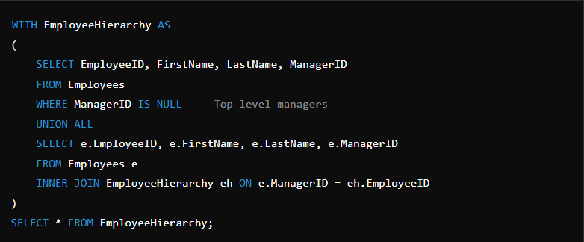

In this example, the CTE EmployeeHierarchy helps to recursively build the hierarchy of employees and their managers.

**Use Cases:**

* Simplifying complex queries by splitting them into smaller, more understandable parts.
* Working with hierarchical data using recursion.
* Improving query readability and maintainability.

1. **What is CORS in WEB API?**

CORS, or **Cross-Origin Resource Sharing**, is a security feature implemented in web browsers to restrict web pages from making requests to a domain different from the one that served the web page. It's a mechanism to allow or disallow requests for resources, like fonts, images, or data, from other origins (domains).

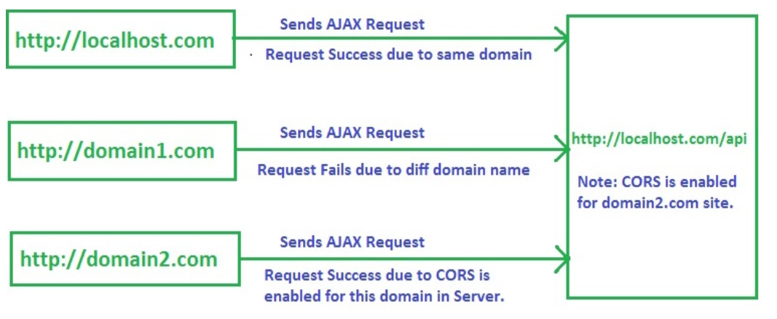

**How CORS Works:**

* **Same-Origin Policy (SOP)**: By default, web browsers enforce SOP, meaning a web page can only make requests to the same origin (protocol, domain, and port) that served the web page.
* **CORS**: To enable cross-origin requests, servers can send specific HTTP headers that indicate which origins are permitted to access resources. These headers include:
  + Access-Control-Allow-Origin: Specifies which origin is allowed to access the resource. It can be set to a specific domain, or to * (which allows any domain).
  + Access-Control-Allow-Methods: Lists the HTTP methods (GET, POST, PUT, etc.) allowed when accessing the resource.
  + Access-Control-Allow-Headers: Lists the HTTP headers that can be used during the actual request.
  + Access-Control-Allow-Credentials: Indicates whether credentials (cookies, HTTP authentication) are allowed in cross-origin requests.
* **Preflight Requests**: For some types of requests (e.g., PUT, DELETE, or custom headers), the browser sends an HTTP OPTIONS request before the actual request to ask the server if the actual request is allowed. This is known as a "preflight request."

**Example Scenario:**

Suppose you have a front-end application hosted on https://example.com and you want to access an API hosted on https://api.example.com. Since these are different origins, CORS comes into play. If the API server sets the appropriate CORS headers, the browser will allow the request. If not, the browser will block the request for security reasons.

**Why CORS is Important:**

* **Security**: It helps prevent malicious websites from making unauthorized requests to another site on behalf of a user without their knowledge.
* **Flexibility**: It allows legitimate web applications to interact with resources across different origins safely.

In web development, handling CORS correctly is crucial when dealing with APIs, especially in Single Page Applications (SPAs) like those built with Angular, React, or Vue.

1. **What are Mocking Frameworks?**

Mocking Frameworks (Moq, NSubstitute, Rhino Mocks, FakeItEasy, and NMock3) are used to create fake objects. We can stub, i.e., completely replace the body of member and function. It is used to isolate each dependency and help developers in performing unit testing in a concise, quick, and reliable way.  
  
Creating mock objects manually is very difficult and time-consuming. So, to increase your productivity, you can go for the automatic generation of mock objects by using a Mocking Framework. A developer can build his/her unit test by using any of the NUnit, MbUnit, MSTest, xUnit etc. unit test frameworks.

1. **What is the difference between the Virtual and Abstract methods in C#?**

In C#, both **virtual** and **abstract** methods are used in the context of inheritance and polymorphism, but they have different purposes and behaviors. Here's a breakdown of the differences:

**Virtual Methods:**

1. **Definition**: A virtual method is a method in a base class that can be overridden by a derived class. The base class provides a default implementation, which can be optionally overridden by derived classes.
2. **Implementation**: Virtual methods have an implementation in the base class. If a derived class does not override a virtual method, the base class's implementation is used.
3. **Usage**: Use a virtual method when you want to provide a default behavior in the base class but allow derived classes to modify or extend it.

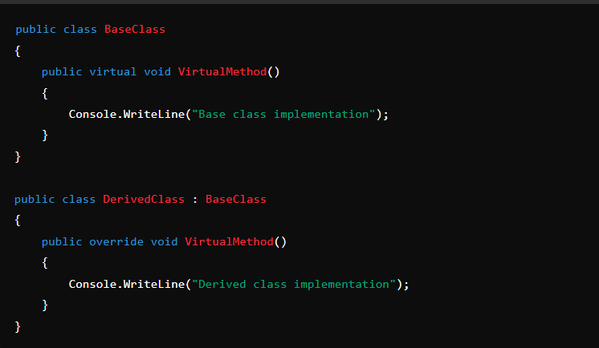

**Abstract Methods:**

1. **Definition**: An abstract method is a method that is declared in an abstract class and does not have an implementation in the base class. Derived classes must provide an implementation for the abstract method.
2. **Implementation**: Abstract methods do not have any implementation in the base class. They act as a contract that forces derived classes to implement the method.
3. **Usage**: Use an abstract method when you want to enforce that all derived classes must implement a particular method, without providing any default behavior in the base class.

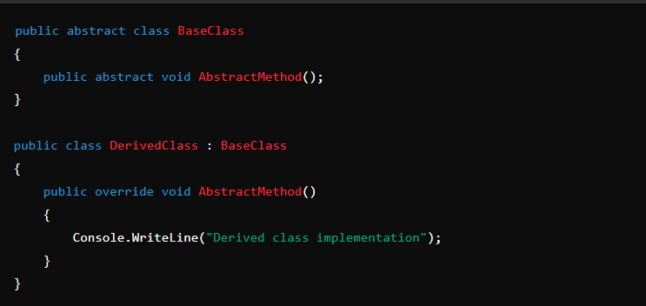

**Key Differences:**

* **Implementation**: Virtual methods have an implementation in the base class, while abstract methods do not.
* **Requirement**: Abstract methods must be overridden in derived classes, whereas virtual methods can be optionally overridden.
* **Class Type**: Abstract methods can only exist in abstract classes, while virtual methods can exist in both regular and abstract classes.

In summary, use virtual methods when you want to provide optional default behavior, and use abstract methods when you want to enforce that derived classes provide a specific implementation.

1. **Difference between .NET Framework and .NET Core?**
2. **h**
3. **njkhihi**