Full Stack Development with MERN Project Documentation format

1. Introduction
- Project Title: TradeSphere

2. Project Overview
- Purpose: TradeSphere is a full-stack MERN-based stock trading simulation platform designed to help users understand and practice stock market trading in a risk-free environment. The platform enables users to explore stocks, monitor market trends, perform virtual buy and sell transactions, and track portfolio performance using a virtual balance. The project aims to provide hands-on experience with stock trading concepts while demonstrating the implementation of modern web development technologies.
- Features: • User Registration and Login using JWT Authentication
• Role-Based Access Control (User and Admin)
• Real-Time Stock Market Simulation
• Stock Search and Filtering
• Stock Detail View with Price Information
• Virtual Buy and Sell Trading System
• Portfolio Management and Holdings Tracking
• Transaction History Management
• Interactive Market Dashboard
• Admin Dashboard for Monitoring Platform Activities
• Responsive User Interface using React and Bootstrap
• Secure Password Encryption using bcrypt.js
• RESTful API Integration between Frontend and Backend

3. Architecture
- Frontend: The frontend of TradeSphere is developed using React.js and follows a component-based architecture. React Router is used for client-side navigation, while Axios handles communication with backend APIs. Bootstrap is utilized to create a responsive and user-friendly interface. The frontend consists of multiple pages including Home, Login, Registration, Dashboard, Market, Portfolio, and Admin Dashboard.
- Backend: The backend is developed using Node.js and Express.js. Express handles API routing, middleware integration, authentication, and business logic. JWT authentication is used to secure user sessions, while bcrypt.js is used for password encryption. The backend exposes RESTful APIs for user management, stock operations, transactions, portfolios, and administrative functions.
- Database: MongoDB is used as the primary database for storing application data. Mongoose is used as the Object Data Modeling (ODM) library to interact with MongoDB.
Database Collections:
Users
- User ID
- Name
- Email
- Password (Encrypted)
- Role (User/Admin)
Stocks
- Symbol
- Company Name
- Current Price
- Daily Statistics
- Historical Data
Transactions
- User ID
- Stock Symbol
- Transaction Type (Buy/Sell)
- Quantity
- Price
- Timestamp
Portfolio
- User ID
- Holdings
- Quantity Owned
- Portfolio Value
- Profit/Loss Summary

4. Setup Instructions
- Prerequisites: Before running the project, ensure the following software is installed:
- Node.js (v18 or above)
- npm (Node Package Manager)
- MongoDB Community Server
- Git
- Visual Studio Code

- Installation: Step 1: Clone the Repository
git clone https://github.com/manisha186/TradeSphere.git
cd TradeSphere
Step 2: Install Backend Dependencies
cd backend
npm install
Step 3: Install Frontend Dependencies
cd ../frontend
npm install
Step 4: Configure Environment Variables
Create a .env file inside the backend folder.
PORT=5000
MONGO_URI=mongodb://localhost:27017/tradesphere
JWT_SECRET=your_jwt_secret_key
NODE_ENV=development
Step 5: Start Backend Server
cd backend
npm run dev
Step 6: Start Frontend Server
cd frontend
npm run dev
- The application will be available at:
Frontend: http://localhost:5173
Backend: http://localhost:5000

5. Folder Structure
- Client: frontend/
│
├── public/
├── src/
│ ├── components/
│ ├── pages/
│ ├── services/
│ ├── context/
│ ├── assets/
│ ├── App.jsx
│ └── main.jsx
│
├── package.json
└── vite.config.js
- Description:
- components/: Reusable UI components.
- pages/: Application pages and views.
- services/: API communication functions.
- context/: State management and authentication context.
- assets/: Images, icons, and static resources.
- Server: backend/
├── config/
├── controllers/
├── middleware/
├── models/
├── routes/
├── services/
├── utils/
├── app.js
├── server.js
└── .env
- Description:
config/: Database configuration.
controllers/: Business logic implementation.
middleware/: Authentication and error handling.
models/: MongoDB schemas.
routes/: API route definitions.
services/: Trading and market services.
utils/: Utility functions and helper modules.
6. Running the Application
Start Backend Server
cd backend

npm run dev

Backend URL:

http://localhost:5000

Start Frontend Server

cd frontend

npm run dev

Frontend URL:

http://localhost:5173

Default Test Credentials

Admin Account:

Email: admin@tradesphere.com

Password: adminpassword

User Account:

Email: user@tradesphere.com

Password: userpassword

7. API Documentation

Authentication APIs

Register User

POST /api/auth/register

Request Body:

{

"name": "Patra Manisha",

"email": "user@example.com",

"password": "password123"

}

Response:

{

"message": "User registered successfully"

}

Login User

POST /api/auth/login

Request Body:

{

"email": "user@example.com",

"password": "password123"

}

Response:

{

"token": "jwt_token"

}

Stock APIs

Get All Stocks

GET /api/stocks

Response:

[

{

"symbol": "AAPL",

"price": 184.71

}

]

Get Stock Details

GET /api/stocks/:symbol

Response:

{

"symbol": "AAPL",

"company": "Apple Inc.",

"price": 184.71

}

Portfolio APIs

Get Portfolio

GET /api/portfolio

Response:

{

"holdings": [],

"totalValue": 100000

}

Trading APIs

Buy Stock

POST /api/trade/buy

Request Body:

{

"symbol": "AAPL",

"quantity": 5

}

Sell Stock

POST /api/trade/sell

Request Body:

{

"symbol": "AAPL",

"quantity": 2

}

Transaction APIs

Get Transaction History

GET /api/transactions

Response:

[

{

"symbol": "AAPL",

"type": "BUY",

"quantity": 5

}

]

Admin APIs

Get All Users

GET /api/admin/users

Get All Transactions

GET /api/admin/transactions

Manage Stocks

POST /api/admin/stocks

PUT /api/admin/stocks/:id

DELETE /api/admin/stocks/:id

Authentication
TradeSphere implements secure authentication and authorization using JSON Web Tokens (JWT) and role-based access control.
Authentication Process
- Users register using their name, email address, and password.
- Passwords are encrypted using bcrypt.js before being stored in the database.
- During login, user credentials are validated against stored records.
- Upon successful authentication, a JWT token is generated and returned to the client.
- The token is stored on the client side and included in subsequent API requests.
- Protected routes validate the token before granting access to secured resources.
Authorization
The application supports two user roles:
User
- Register and login
- Browse available stocks
- View market data
- Buy and sell stocks
- Manage portfolio
- View transaction history
Admin
- Manage stock listings
- Monitor user activities
- View transactions
- Access administrative dashboard
Security Features
- Password encryption using bcrypt.js
- JWT-based authentication
- Protected API routes
- Role-based authorization
- Input validation and error handling
- Secure session management through token verification

- User Interface
The TradeSphere platform provides a modern, responsive, and user-friendly interface developed using React.js and Bootstrap.

Home Page
The landing page displays real-time stock information, market highlights, and navigation options for registration and login.

Registration Page
Users can create new accounts by providing their personal details and secure credentials.

Market Dashboard
The stock catalog allows users to browse, search, and filter available stocks with real-time simulated price updates.

Stock Detail Page
Users can view stock information, market statistics, and perform buy or sell transactions.

Portfolio Page
Displays current holdings, portfolio value, profit/loss analysis, and investment summaries.

Admin Dashboard
Provides administrative controls for monitoring users, transactions, and stock management.
- Testing
Testing Strategy
The application was tested using both manual testing and functional verification techniques to ensure reliability and correctness.
Functional Testing
The following modules were tested:
- User Registration
- User Login and Authentication
- Stock Browsing and Search
- Stock Detail View
- Buy Stock Functionality
- Sell Stock Functionality
- Portfolio Management
- Transaction History
- Admin Dashboard Access
- Protected Routes and Authorization
Validation Testing
Input validation was performed for:
- User registration forms
- Login forms
- Trading forms
- Portfolio operations
Integration Testing
Frontend and backend communication was verified using Axios API requests.
Tools Used
- React Developer Tools
- Browser Developer Tools
- Postman (API Testing)
- Node.js Runtime Environment
- MongoDB Database
Test Results
All major modules functioned successfully and met the project requirements. Authentication, trading operations, portfolio updates, and administrative functionalities were verified during testing.

- Screenshots or Demo
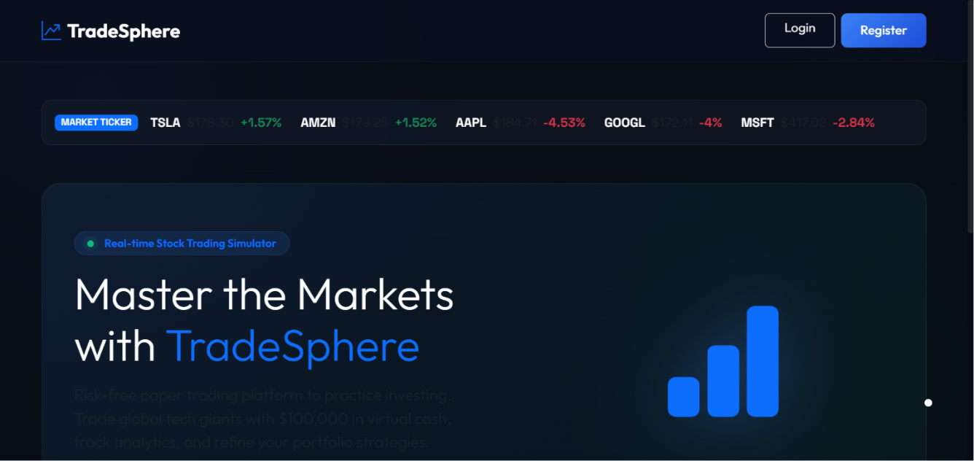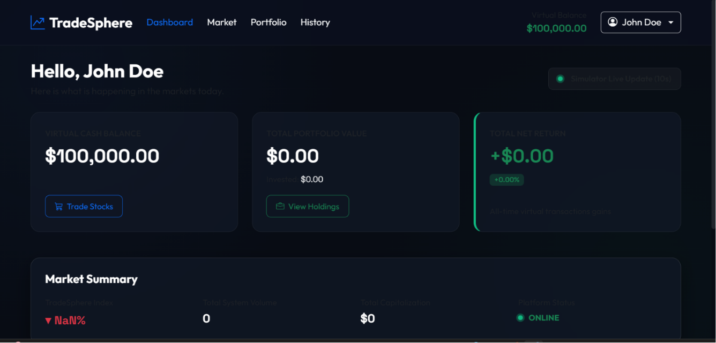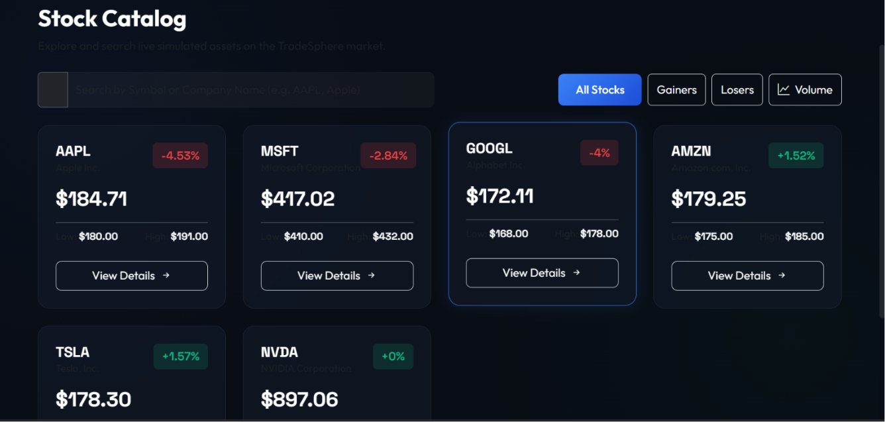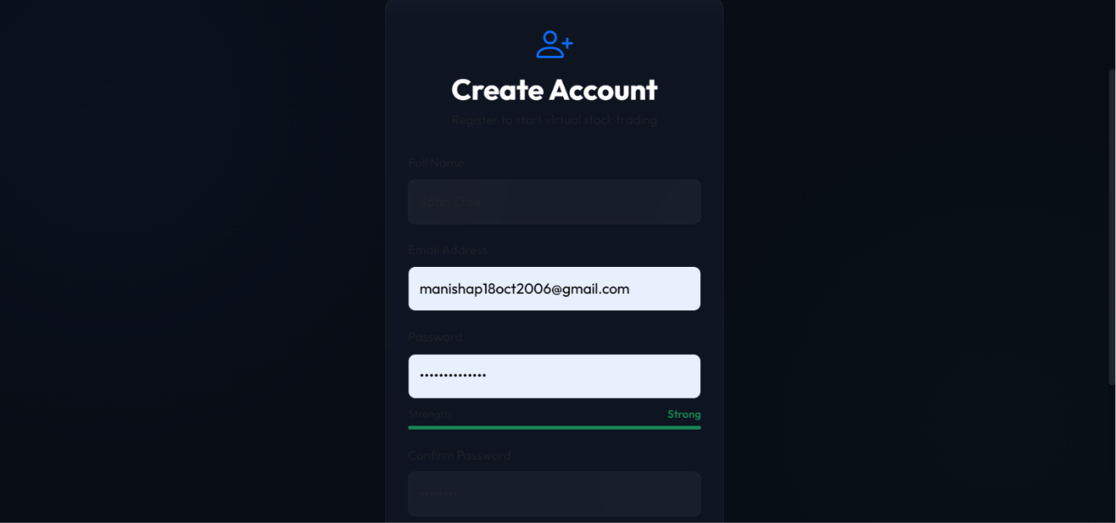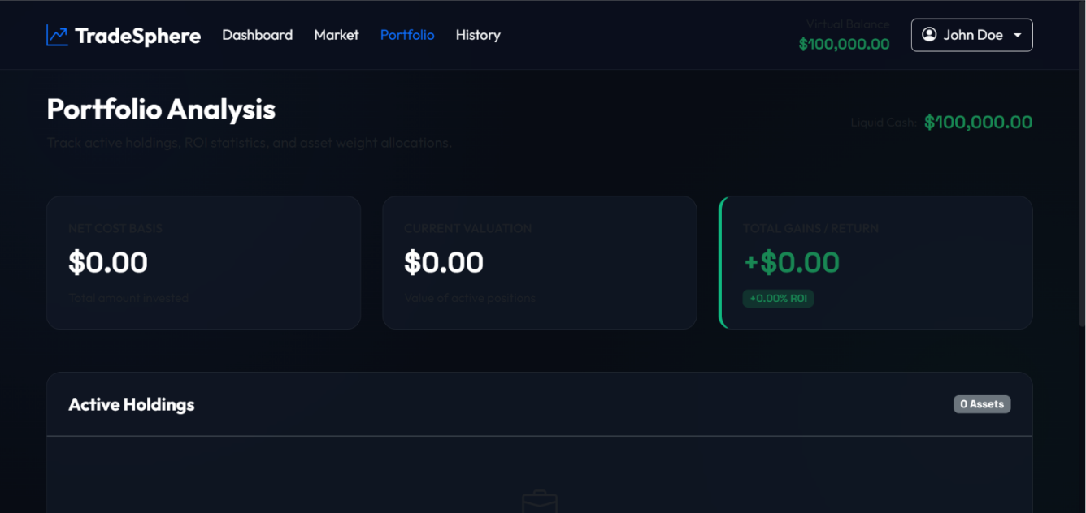

Demo Video
Demo Link:
https://drive.google.com/file/d/1GvG5IWKLADmzgh0ox0jtJVmq9zXpZpvV/view?usp=drive_link

GitHub Repository
Repository Link:
https://github.com/manisha186/TradeSphere

- Known Issues
The following limitations were identified during development:
- Real-time stock prices are simulated rather than connected to a live stock exchange API.
- In-memory fallback database resets data when the backend server restarts.
- Historical stock data is limited compared to commercial trading platforms.
- Advanced technical indicators and charting tools are not currently available.
- Portfolio analytics can be further enhanced with additional financial metrics.
These limitations do not affect the core functionality of the application.

13. Future Enhancements
The following improvements can be implemented in future versions of TradeSphere:
- Integration with live stock market APIs for real-time market data.
- Advanced candlestick charts and technical analysis indicators.
- Watchlist and favorite stock management..

