- Git Setup https://confluence.atlassian.com/bitbucket/set-up-git-744723531.html
- Initialize a Git Repository
git init
- Add files to the repository
git add filename
git add .

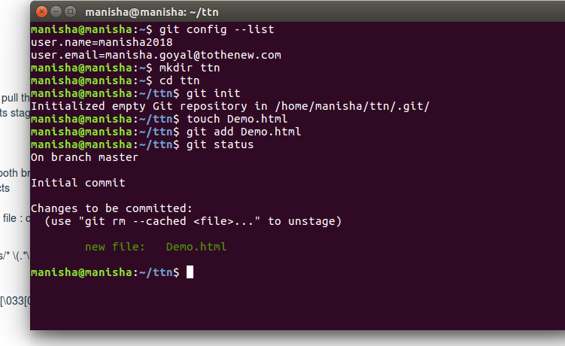
- Unstage 1 file
git rm –cached file name
git reset HEAD filename
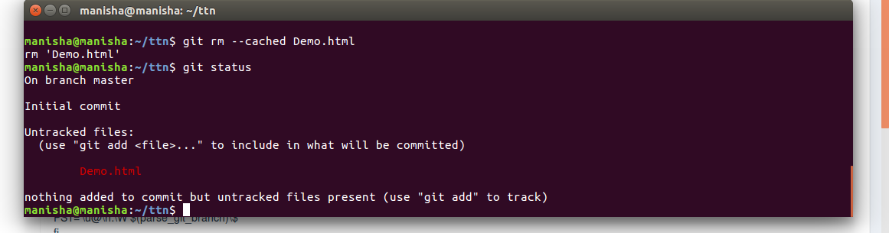

- Commit the file
git commit -m <message> filename //for committing particular file
git commit -m <message> // for committing all files
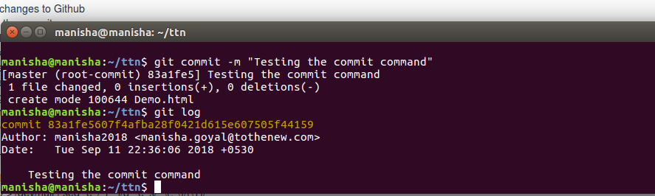
- Add a remote
git remote add origin <url>
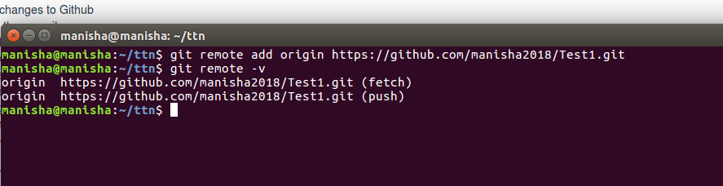
- Undo changes to a particular file
git checkout filename
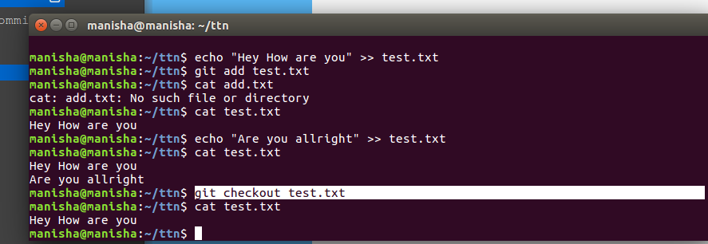

- Push changes to Github

git push -u origin master // origin contains the remote url.Basically the location of the file where push has to be performed.
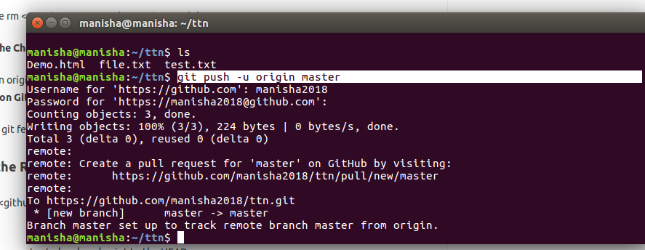
- Clone the repository
git clone url
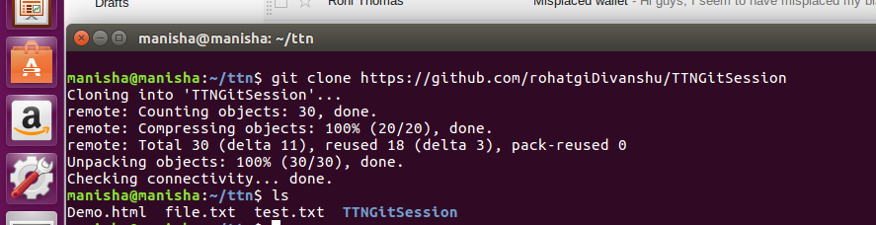
- Add changes to one of the copies and pull the changes in the other.
Continuation with 9,
- git chekout branchname
- make changes in that branch
- push the changes.
- Git checkout another branch
- git fetch

- Check differences between a file and its staged version
git diff --staged
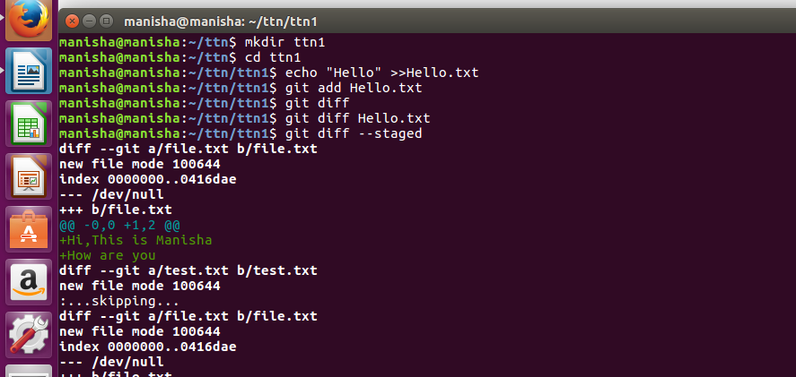
- Ignore a few files to be checked in
.gitignore
- Create a new branch.
git branch branchname
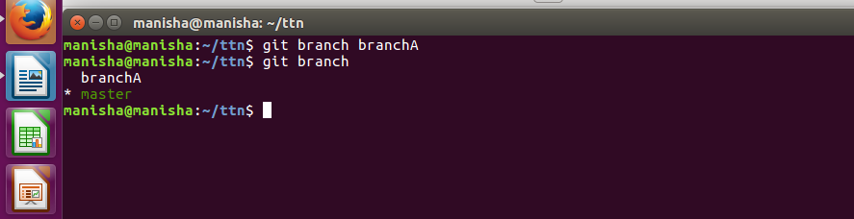
- Diverge them with commits
step-1 git branch <Branchname> // create the branch
step-2 git push origin <branchname> // push the branch
step-3 echo “this is batman” >> <filename> // create-add-commit-push the file
step-4 git commit -am “committing from branch ” <filename>
Do the same process in another branch

- Edit the same file at the same line on both branches and commit
With continuation of above question 14,
- change in both the files and in same line
- add the files to staging area git add .
- Commit this and push to the branch
git commit -m “changes done”
git push origin branchname

- Try merging and resolve merge conflicts
- Continuation of 15, Merge both the branch git merge <branchname>
- Generate the error.Developers will have to solve this manually.

- Stash the changes and pop them
modify the file
git stash
git stash pop

- Add the following code to your .bashrc file : color_prompt="yes"
parse_git_branch() {
git branch 2> /dev/null | sed -e '/^[^*]/d' -e 's/* \(.*\)/(\1)/'
}
if [ "$color_prompt" = yes ]; then
PS1='\u@\h\[\033[00m\]:\[\033[01;34m\]\W\[\033[01;31m\] $(parse_git_branch)\[\033[00m\]\$ '
else
PS1='\u@\h:\W $(parse_git_branch)\$ '
fi
unset color_prompt force_color_prompt
1) cd //come to the home directory
2)vim ~/.bashrc //Add the above code
3)Open new Terminal
