1.How are inline and block elements different from each other?
A block-level element always starts on a new line and takes up the full width available (stretches out to the left and right as far as it can).
<div> tag is a block level element. Whereas An inline element does not start on a new line and only takes up as much width as necessary. The <span> element is an inline element.
Example: <div>main</div> and <span>main</span>
2.Explain the difference between visibility:hidden and display:none
The display property specifies if/how an element is displayed. Every HTML element has a default display value depending on what type of element it is. The default display value for most elements is block or inline.
Display: none; is commonly used with JavaScript to hide and show elements without deleting and recreating them. Whereas,
Hiding an element can be done by setting the display property to none. The element will be hidden, and the page will be displayed as if the element is not there:
h1.hidden{
display:none;
}
3. Explain the clear and float properties.
The float property is used for positioning and layout on web pages.It can have one of the following values.
left - The element floats to the left of its container
right- The element floats to the right of its container
none - The element does not float (will be displayed just where it occurs in the text). This is default inherit - The element inherits the float value of its parent
The clear property specifies what elements can float beside the cleared element and on which side.It can have one of the following values.
none - Allows floating elements on both sides. This is default
left - No floating elements allowed on the left side
right- No floating elements allowed on the right side
both - No floating elements allowed on either the left or the right side
inherit - The element inherits the clear value of its parent

4. explain difference between absolute, relative,fixed and static.
Static is the default type of positioning. When elements don’t have a position specifically set, they default to static. There’s not much you can do with a statically positioned element.
Relative : In order to see a relatively positioned element move you also need to tell it where to go using one of the following top: XXX ; bottom: XXX; left: XXX; right: XXX;.
Absolute : This is a very powerful type of positioning that allows you to literally place any page element exactly where you want it. You use the positioning attributes top, left, bottom. and right to set the location.
Fixed : This type of positioning is fairly rare but certainly has its uses. A fixed position element is positioned relative to the viewport, or the browser window itself.This is basically fixed for the page.
5. Write the HTML code to create a table in which there are 4 columns( ID , Employee Name, Designation, Department) and at least 6 rows. Also do some styling to it.
<!DOCTYPE html>
<html lang="en">
<head>
<meta charset="UTF-8">
<meta name="viewport" content="width=device-width, initial-scale=1.0">
<meta http-equiv="X-UA-Compatible" content="ie=edge">
<title>Document</title>
<style>
table{
border:solid 2px black;
width:70%;
}
table tr th{
background-color: blue;
text-align: center;
}
table tr td{
border: 1px solid black;
background-color: cadetblue;
text-align: center;
}
</style>
</head>
<body>
<h1>Employee Table</h1>
<table cellpadding=10 cellspacing=10>
<tr>
<th>Employee ID</th>
<th> Employee Name</th>
<th>Designation</th>
<th>Department</th>
</tr>
<tr>
<td>101</td>
<td>Ram</td>
<td>Software Developer</td>
<td>IT</td>
</tr>
<tr>
<td>102</td>
<td>Karan</td>
<td>BA</td>
<td>Analytics</td>
</tr>
<tr>
<td>103</td>
<td>Manisha</td>
<td>Developer</td>
<td>IT</td>
</tr>
<tr>
<td>104</td>
<td>Shakti</td>
<td>Quality Assurance</td>
<td>Testing</td>
</tr>
</table>
</body>
</html>
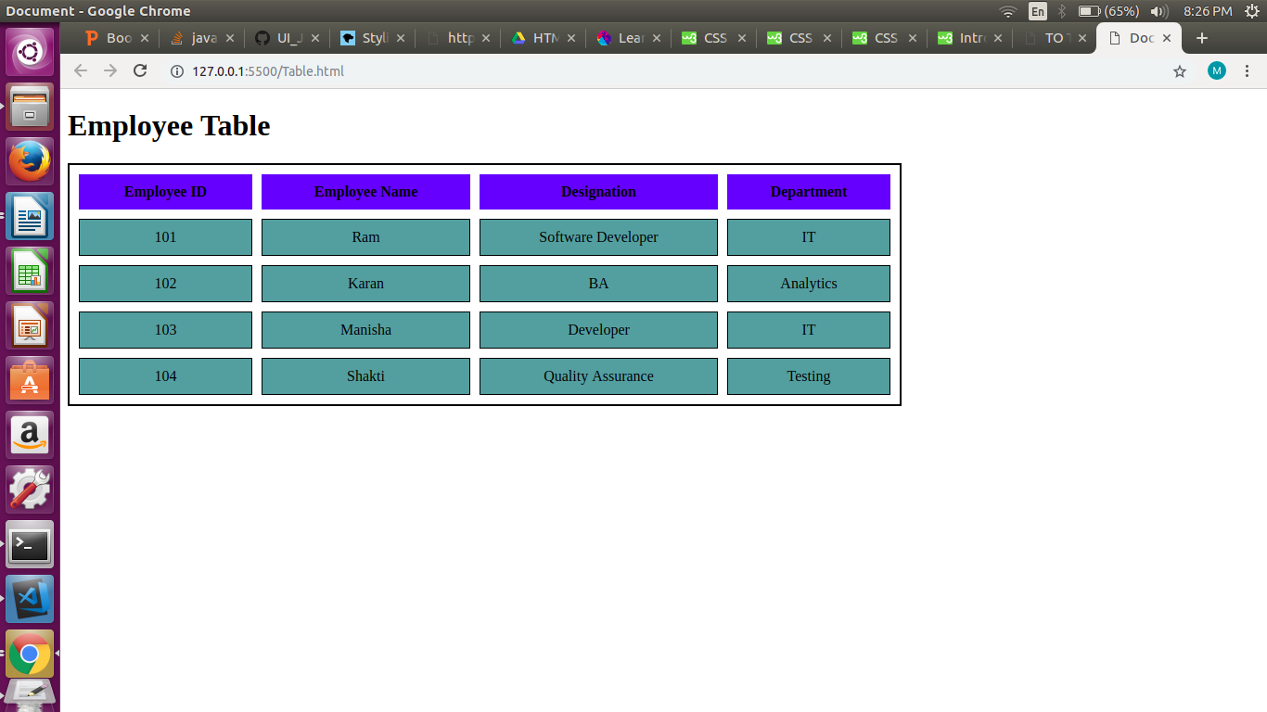
6. Why do we use meta tags?
Meta tags provides meta information about the html document.It will not be displayed on the page but will be machine parsable.They are used to specify page description,keywords,author of the document,last modified etc.Meta tags are most basic elelments of SEO(Search Engine Optimization) Meta tags makes the search quite easier.Hence, we use meta tags.
7. Explain box model.
The term box model is used when we are talking about design and layout.The css box model is a box which is wrapped around every html element.it consists of margins,borders,padding and the actual content.
Margin: margin is transparent that clears an area outside the border.
Border : A border which is formed around padding and content.
Padding : Padding is also transparent and clears an area around the content.
Content : The portion where the text and images appears.
8. What are the different types of CSS Selectors?
CSS selectors synatx:
Selector{Declaration;Declaration;}
Declaration contains : Property:value
1. Element Selector : It selects elements based on element name.
2. Id Selector : It uses id attribute of an html element to select a specific element.It is denoted by “#”.
3. Class Selector : It selects elements with a specific class attribute.It is denoted by “.”
4. Group Selectors: If you have elements with the same style definitions.
It will be better to group the selectors, to minimize the code.
To group selectors, separate each selector with a comma.
Example:
h1, h2, p{
text-align:center;
color:red;
}
9. Define Doctype.
A document type declaration, or DOCTYPE, is an instruction that associates a particular SGML or XML document with a document type definition (DTD).It must be the very first thing in your HTML document, before the <html> tag.It is not an HTML tag; it is an instruction to the web browser about what version of HTML the page is written in.
10. Explain 5 HTML5 semantic tags.
A semantic element clearly describes its meaning to both the browser and the developer.
Examples of non-semantic elements: <div> and <span>.Examples of semantic elements: <form>, <table>, and <article>
1. Section : The <section> element defines a section in a document.
2 Article : The <article> element specifies independent, self-contained content.
Examples of where an <article> element can be used:
Forum post
Blog post
Newspaper article
3 Header : The <header> element specifies a header for a document or section.
4 Footer : The <header> element specifies a header for a document or section.
5 nav : The <nav> element defines a set of navigation links.

11. Create HTML for web-page.jpg (check resources, highest weightage for answers)
12. Create HTML for form.png (check resources, highest weightage for answers)
Note: 50% of marks are for last 2 exercises of creating html pages

