- Create a directory "exercise" inside your home directory and create nested(dir1/dir2/dir3) directory structure inside "excerise" with single command.
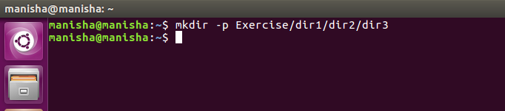
- Create two empty files inside dir2 directory: emptyFile1,emptyFile2 in single command
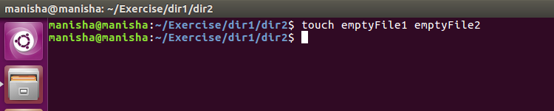
- Create one file file1.txt containing text "hello world" and save it.
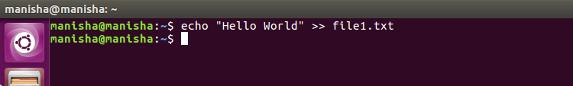
- Find a "passwd" file using find command inside /etc. copy this files as passwd_copy and then rename this file as passwd_backup.
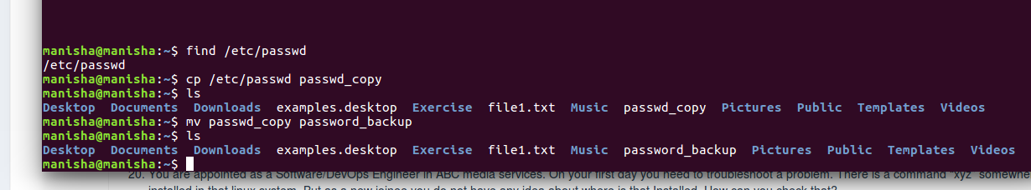

- Try reading passwd_backup file in multiple tools: less,more,cat,strings etc and find the difference in their usage.
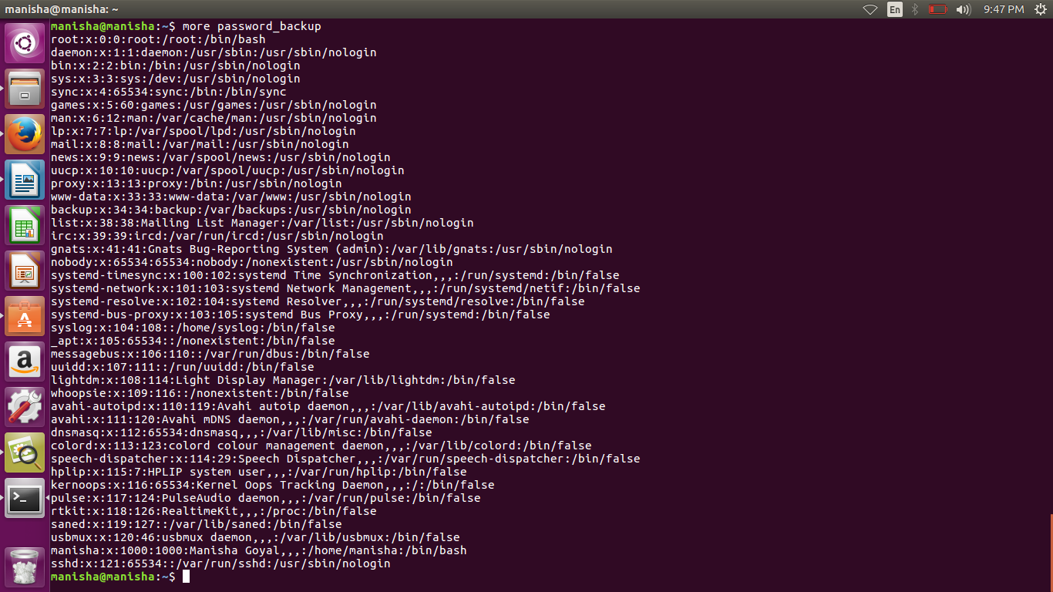
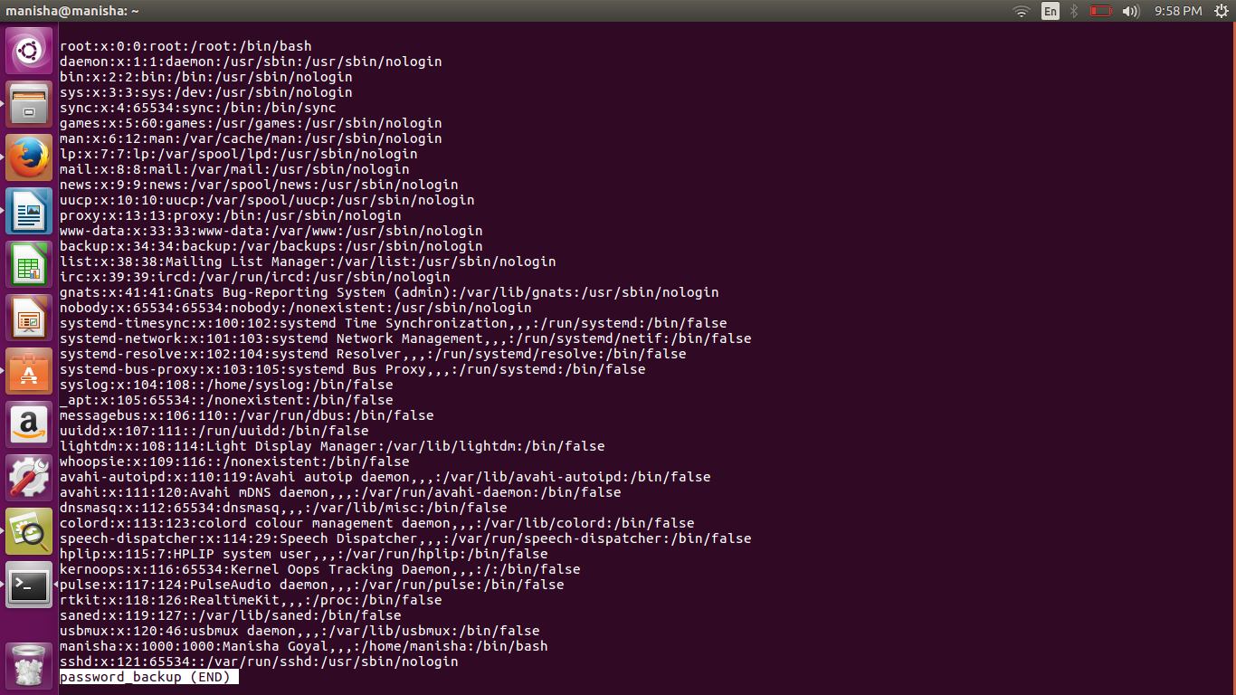
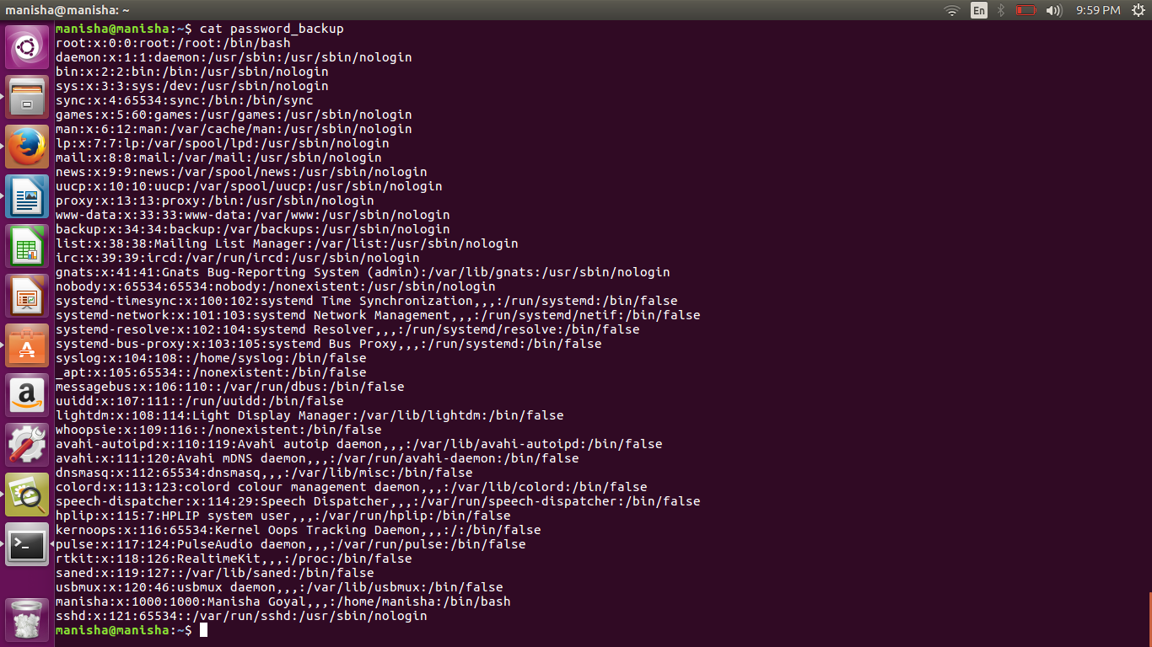

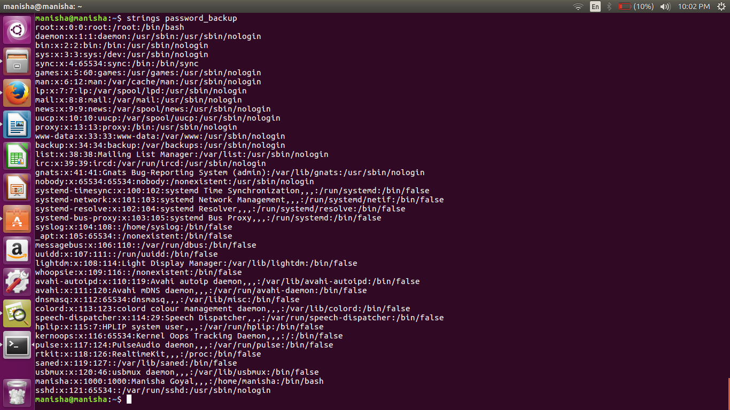
- Find out the number of line in password_backup containing "/bin/false".
grep “/bin/false” password_backup | wc -l
- Get the first 5 lines of a file “password_backup” and Redirect the output of the above commands into file "output".
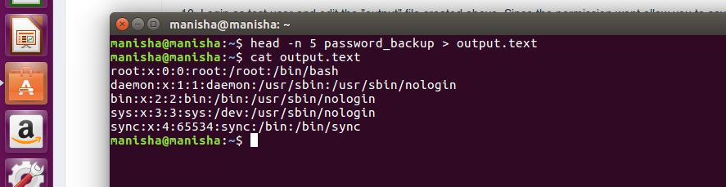
- Create a "test" user,create its password and find out its uid and gid.
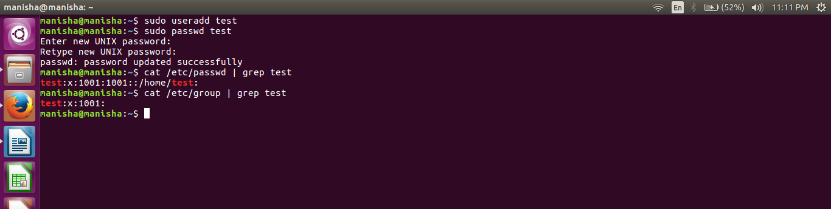
- Change the timestamp of emptyFile1,emptyFile2 which are exist in dir2
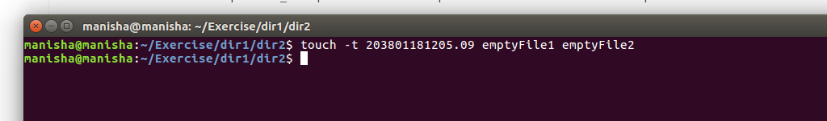
- Login as test user and edit the "output" file created above. Since the permission wont allow you to save the changes. Configure such that test user can edit it.
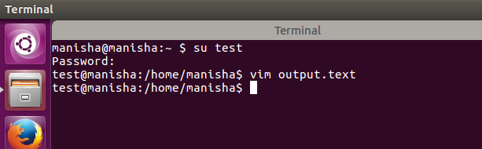
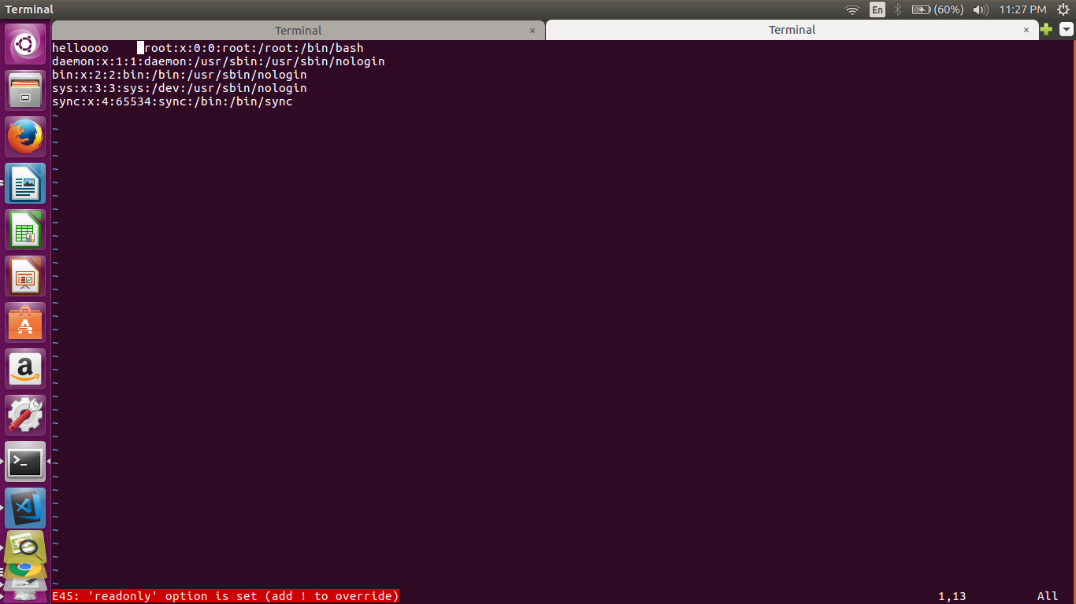

  - Add group owner of the "output" file as the secondary group of testuser and check/change the "output" file permission if it is editable by group. Once done revert the changes

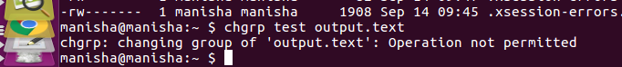

  - Make the file editable to the world so that test user can access it. Revert the changes after verification
sudo chmod 664 output
  - Change the ownership to edit the file.
- Create alias with your name so that it creates a file as "/tmp/aliastesting".
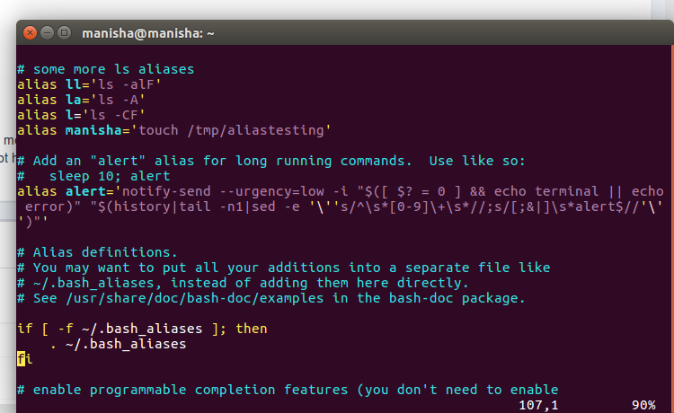

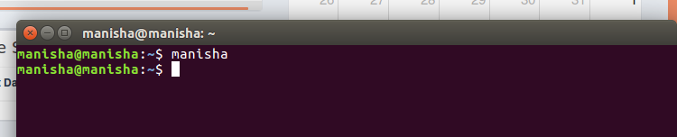

- Edit ~/.bashrc file such that when you change to "test" user it should clear the screen and print "Welcome".
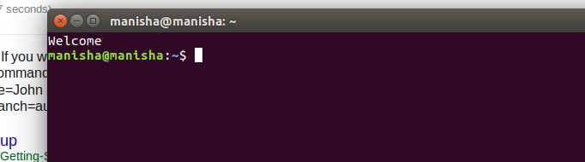

- Install “zip” package.
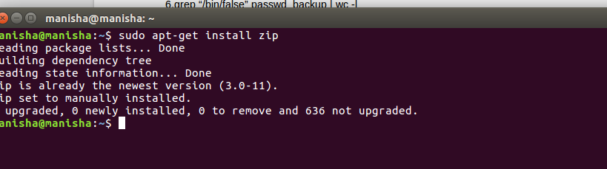
- Compress "output" and "password_backup" files into a tar ball. List the files present inside the tar created.
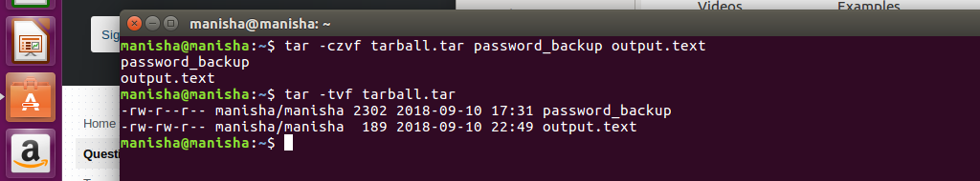

- scp this file to test user
Approach 1:
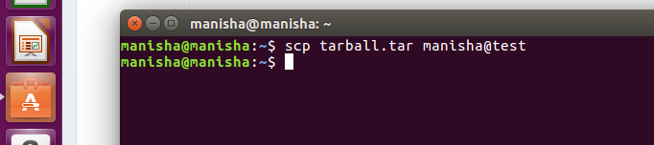
Approach 2:
Switch to test user.Tried to create directory.Permission Denied.
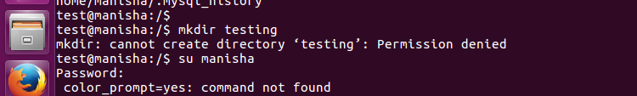
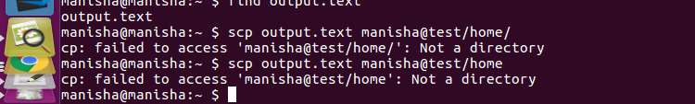
- Unzip this tar bar by logging into the remote server
use ssh
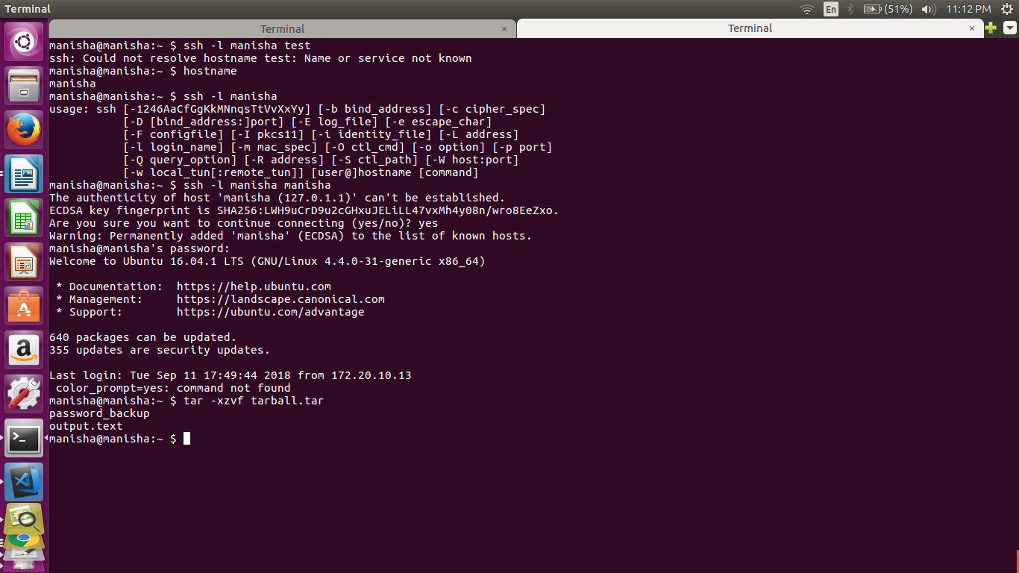
- Download any image from web and move to desktop
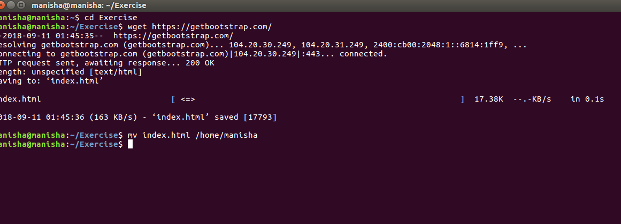
- How to get help of commands usages.
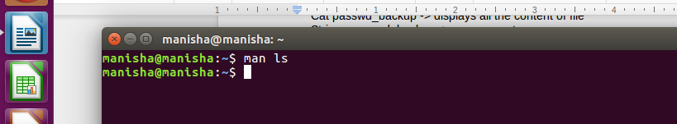
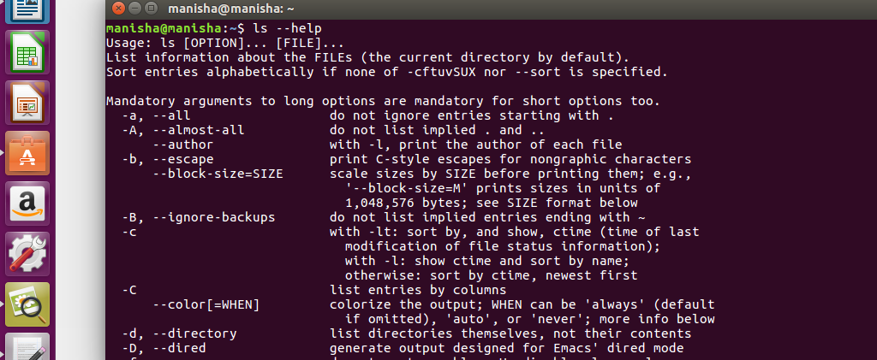
- Create a symlink of /etc/services into /tmp/ports-info
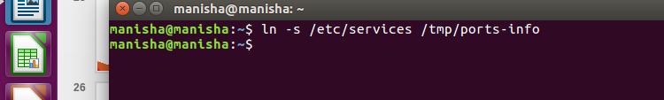
- You are appointed as a Software/DevOps Engineer in ABC media services. On your first day you need to troubleshoot a problem. There is a command “xyz” somewhere installed in that linux system. But as a new joinee you do not have any idea about where is that Installed. How can you check that?


