Satellite Self-Healing Communication Network using Orbital Dynamics and Adaptive Routing

Report submitted by
MANISHA K

ABSTRACT

Satellite communication plays a vital role in global communication systems. However, satellite links often face several challenges such as rain attenuation, signal degradation, orbital motion variations, link failures, and power limitations. These issues can affect the reliability and performance of satellite networks. Therefore, developing a self-healing communication mechanism is essential for maintaining stable communication between ground stations.

This project presents a simulation model for a satellite communication network consisting of Ground Stations, Low Earth Orbit (LEO), Medium Earth Orbit (MEO), and Geostationary Earth Orbit (GEO) satellites. The proposed system uses a dynamic routing approach based on Dijkstra’s algorithm to determine the optimal communication path between two ground stations. The simulation considers realistic communication parameters such as Free Space Path Loss (FSPL), Signal-to-Noise Ratio (SNR), Bit Error Rate (BER), rain attenuation, orbital motion effects, and power constraints.
The system also includes random link failure models to represent real-world satellite communication disturbances. If a link fails or signal quality becomes poor, the algorithm automatically selects an alternative path, demonstrating self-healing capability. Various performance metrics such as propagation delay, throughput, packet loss, reliability, and network availability are evaluated through multiple simulation cycles.
The results are visualized using graphs to analyze network performance under different conditions. This simulation helps in understanding the behavior of satellite communication networks and can be useful for future research in intelligent satellite routing systems.

INTRODUCTION

Satellite communication systems are widely used for broadcasting, navigation, disaster management, and global internet connectivity. Unlike terrestrial networks, satellite networks operate over long distances and are affected by environmental conditions and orbital motion.
Different satellite orbits such as Low Earth Orbit (LEO), Medium Earth Orbit (MEO), and Geostationary Earth Orbit (GEO) provide different communication characteristics. LEO satellites move quickly and introduce dynamic changes in communication links, while GEO satellites remain relatively stable.
However, satellite communication networks may experience signal degradation due to rain attenuation, path loss, power limitations, and random link failures. These factors may reduce network reliability and increase delay or packet loss.
To overcome these issues, intelligent routing techniques are required to dynamically select the best communication path. In this project, a satellite communication network simulation is developed that models realistic conditions and uses a self-healing routing algorithm to maintain reliable communication between ground stations.

LITERATURE SURVEY

1. Satellite Communication Performance Analysis
Researchers have studied the performance of satellite communication systems by analysing signal propagation characteristics such as Free Space Path Loss (FSPL), Signal-to-Noise Ratio (SNR), and Bit Error Rate (BER). These parameters significantly affect the quality of satellite communication links. Studies show that long transmission distances between satellites and ground stations increase signal attenuation, which may reduce communication reliability. Therefore, accurate modelling of these parameters is essential for evaluating satellite network performance.
2. Rain Attenuation in Satellite Links
Rain attenuation is one of the major challenges in satellite communication systems, especially for high-frequency bands such as Ku and Ka bands. Heavy rainfall can cause signal absorption and scattering, leading to communication degradation. Researchers have proposed various rain attenuation models to analyse the effect of rainfall on satellite signals. These models help predict signal loss during adverse weather conditions and improve communication reliability.
3. Dynamic Routing in Satellite Networks
Traditional satellite communication networks often use static routing methods, which may not adapt effectively to dynamic network conditions. Recent research focuses on dynamic routing algorithms such as Dijkstra’s algorithm to identify optimal communication paths. Dynamic routing enables the network to adapt to changing conditions such as satellite movement, signal degradation, and link failures. This approach improves network efficiency and reduces communication delays.
4. Orbital Motion Impact on Satellite Communication
Satellite movement plays a significant role in communication performance. Low Earth Orbit (LEO) satellites move rapidly around the Earth, causing frequent changes in communication distances and link conditions. Researchers have developed orbital motion models to simulate satellite movement and analyse its effect on communication parameters such as delay and path loss. These models help create more realistic satellite network simulations.
5. Self-Healing Communication Networks
Modern communication networks are increasingly adopting self-healing mechanisms to improve reliability. Self-healing networks automatically detect failures and reroute communication paths to maintain connectivity. In satellite communication systems, self-healing routing can help overcome link failures, signal degradation, and power limitations. This approach ensures continuous communication and improves overall network performance.

PROPOSED SYSTEM

The proposed system simulates a satellite communication network consisting of two ground stations connected through multiple satellite layers.
The network includes:
- Ground Station 1
- LEO Satellite, MEO Satellite, GEO Satellite
- Ground Station 2
The system dynamically calculates communication parameters such as Free Space Path Loss, Signal-to-Noise Ratio, rain attenuation, and Bit Error Rate.
A dynamic routing mechanism based on Dijkstra’s algorithm determines the optimal path between the ground stations. The system also includes random link failure models and power constraints to simulate real-world conditions.
If a communication link fails, the system automatically searches for an alternative route, demonstrating self-healing capability.
The performance of the system is evaluated using metrics such as propagation delay, throughput, packet loss, reliability, and network availability.
System flowchart
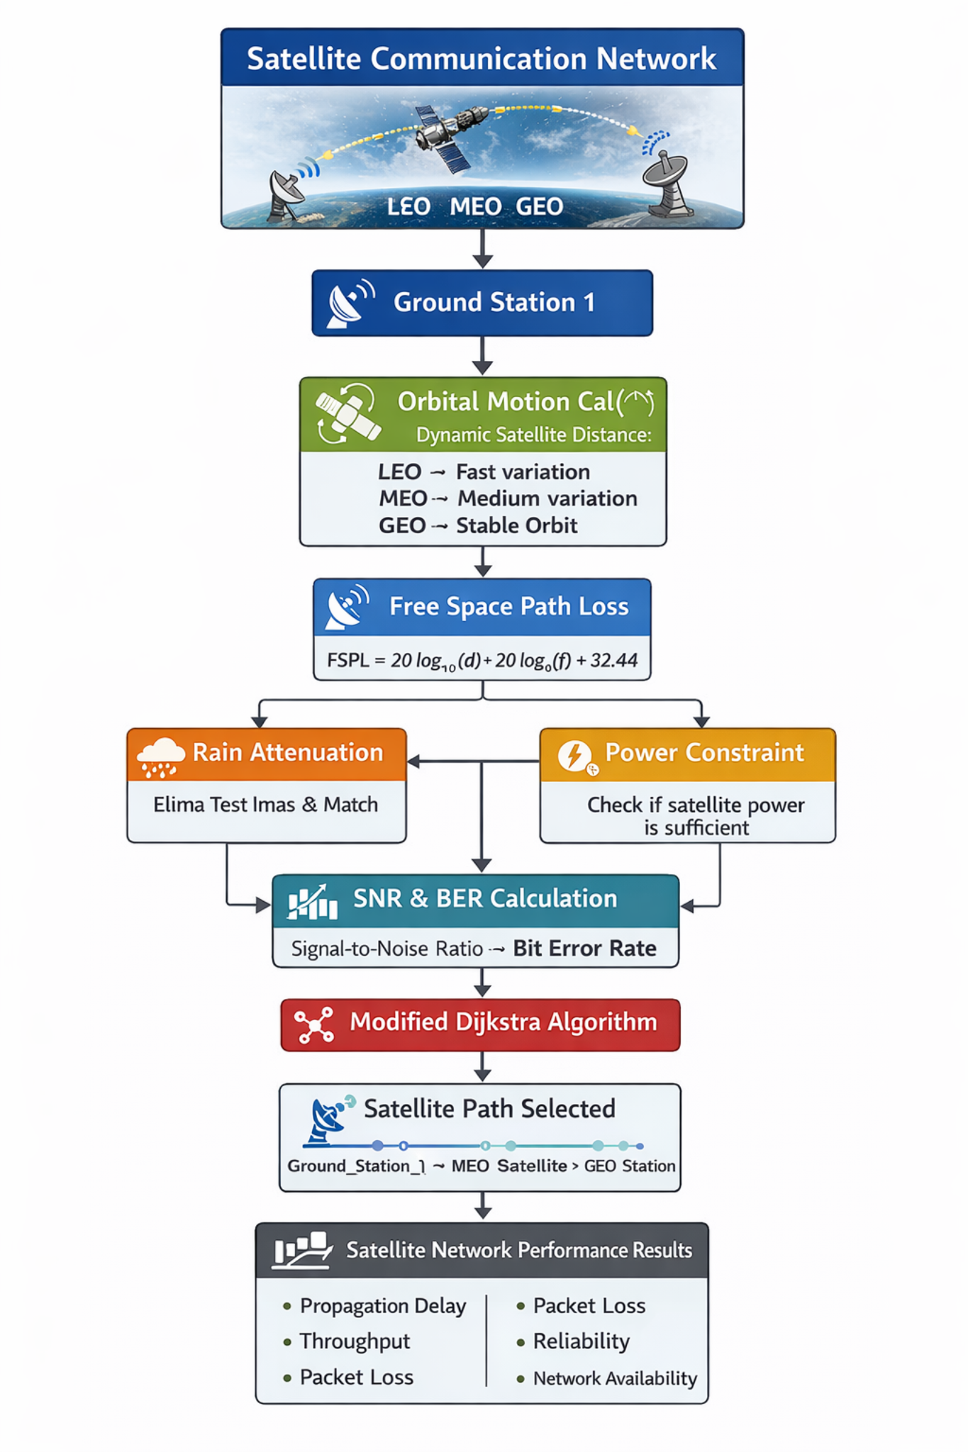

METHODOLOGY

The simulation follows the following steps:

Create a satellite network topology consisting of ground stations and satellites.

Assign distances between satellites and ground stations.

Calculate Free Space Path Loss for each communication link.

Determine Signal-to-Noise Ratio and Bit Error Rate.

Apply rain attenuation and random link failure models.

Check power availability constraints for communication.

Use Dijkstra’s algorithm to find the optimal communication path.

Calculate performance metrics such as delay, throughput, and packet loss.

Repeat the process for multiple simulation cycles.

10.Display statistical results and graphical analysis.

FUTURE ENHANCEMENT

The proposed system can be further improved by introducing more advanced features.

Future enhancements may include:

Machine learning-based adaptive routing algorithms

Real satellite orbital data integration

Weather prediction models for accurate rain attenuation analysis

Multi-satellite constellation simulations such as Starlink

Real-time satellite communication system implementation

These improvements can make the simulation closer to real satellite communication systems and support advanced research in space communication networks.

CONCLUSION
The project demonstrates a self-healing satellite communication system capable of dynamically selecting optimal communication paths.
By combining orbital motion modeling, environmental effects, and adaptive routing algorithms, the simulation provides a realistic representation of satellite communication networks.
Adaptive routing significantly improves reliability, availability, and communication performance.

