SUPPLY
CHAIN
DELIVERY PERFORMANCE
REPORT
(End -to-End order Fulfillment analysis & Predictive Insights)



CREATED BY MANISHA

TABLE OF CONTENTS

- Executive Summary
- Business Context & Objectives
- Key Performance Indicator (KPI’s)
- Profitability Analysis
4.1 Profitability Distribution
4.2 Delay Distribution % Profit vs. Delay Days
- Bottleneck Detection
- Root Cause Analysis
- Time-Based Delay Patterns
- Machine Learning Model Result
- Strategic Recommendations
- Conclusion

1. EXECUTIVE SUMMARY
This report presents a comprehensive analysis of the delivery operations of a global e-commerce company managing end-to-end order fulfilment across multiple regions. The analysis covers 172,765 orders spanning January 2015 through January 2018, focusing on identifying root causes of chronic late deliveries, quantifying their financial impact, and establishing a data-driven framework for improvement.

The headline finding is stark : 54.71% of all orders are delieverd late, costing the business $ 2.1 M in eroded profitability on delayed orders alone. While total Profit across fulfilled orders reached $7.5 M, the persistent late-delivery problem represents both a significant, financial drain, and a major customer experience risk. A Random Forest predictive model achieved 74% accuracy in identifying at-risk orders before they become late.

Key Finding | Metric
Overall Late Delivery Rate | 54.71%
On-Time Delivery Rate | 45.29%
Total Orders Analyzed | 172,765
Total Profit(profit orders) | $7.5M
Profit at Risk (delayed orders) | $2.1M
Predictive Model Accuracy (RF) | 74%

2.Business Context & Objectives
A company operates a global e-commerce platform selling products across categories including sports,goods,fitness equipment, outdoor gear, footwear, and apparel across multiple international regions.

Core Business Problem
Actual shipping times frequently deviate from scheduled delivery windows,creating eroded customer trust, reduced order profitability ,and an inability to make reliable commitments to buyers at point of purchase.

Analytical Objectives
- Understand the current state of delivery performance across all dimensions(region,mode,time,segment).
- Quantify the financial impact of delays on order profitability.
- Identify the primary operational bottlenecks driving late deliveries
- Build a predictive model to flag high risk orders before they are shipped
- Delivery actionable recommendations to improve on time delivery and profitability

3. Key Performance Indicators (KPI’s)
The following KPI’s were computed directly from the cleaned dataset to establish a performance baseline.

172,765  Total Orders | 94,523  Late Deliveries | 54.71%  Late Delivery % | 45.29%  On-time Delivery %

$7.5M | $2.1M | 3days | $22.03

Total Profit (profitable orders) | Profit at Risk(delayed orders) | 90th Percentile Delay | Avg Order Profit

Late Delivery Rate At 54.71% | More than half of all orders arrive late. This is not an edge-case problem – it is the default experience for the majority of customers.

2.1M Profit at Risk | Orders that experienced delays collectively generated $2.1M in profit that is under constant pressure from further operational deterioration.

90th Percentile Delay = 3 days | Even the most extreme cases are contained within 3 days of lateness, suggesting the problem is systematic and process-driven rather than catastrophic.

4. Profitability Analysis
4.1 Profitability Distribution
Orders level profitability are classified into three tiers based on Order Profit Per Order.While 80.7% orders are profitability the 18.7% loss-making share represent a meaningful drag that is disproportionately concentrated among delay shipments.

Profitability Distribution %
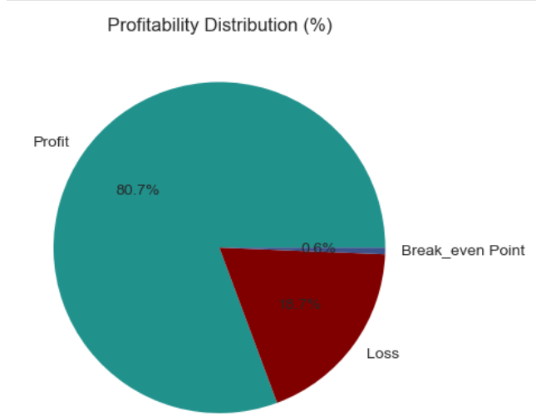

4.2 Delay Distribution & Profit Vs. Delay Days
The delay distribution showed that 31.0% of all orders arrive exactly 1 day late the single largest cohort combined, orders delayed by 1-4 days account for 54.7% of all order volume, directly mapping to the overall late delivery rate.
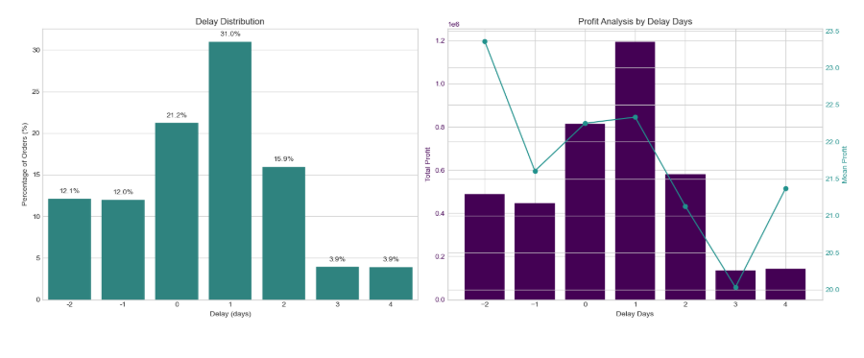

A critical observation: mean profit per order remains stable at approximately $21-$23 across all delay levels. The profitability problem is therefore driven by volume of delayed orders, not by individual order economics making the system throughout improvement the highest-leverage intervention.

5.Bottleneck Detection
Delta percentage was computed across six key operational dimensions. The charts below reveal where the fulfilment process breaks down most severely.
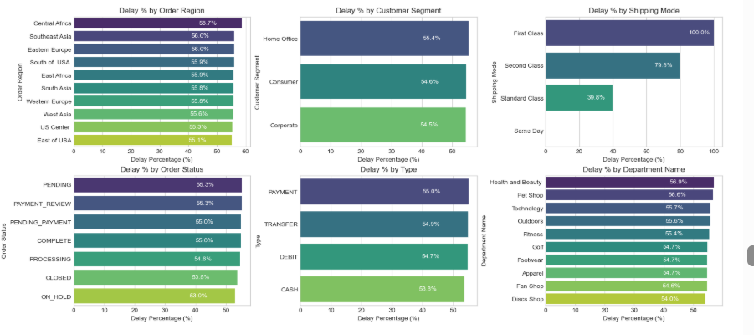

Shipping mode is the  #1 Lever | First class: 100% delay rate, Second class: 79.8%. Standard Class: 39.8%.Same Day :0%. The mode assignment logic is the most impactful single variable to fix.

Regional Spread is Narrow(55-59%) | Central Africa leads at 58.7% but all regions cluster between 55-59%. This rules out a localised logistics failure and confirms a company-wide system issue.

Customer segments nearly identical (54.5-55.4%) | No segment receives preferential service. All customers- Consumer, Corporate,Home, Office- Experienced the same broken delivery promise.

Health & Beauty (56.9%) and Pet Shop (56.6%) Lead by Department | These departments marginally outspace others in delay rate, warranting an inventory and carrier audit for these product categories.

6.Rootcause Analysis
Central America was selected for deep-dive root-cause analysis as the highest-delay region(58.7%). The chart below ranks the top 10 drivers factors by delay percentage within the region.
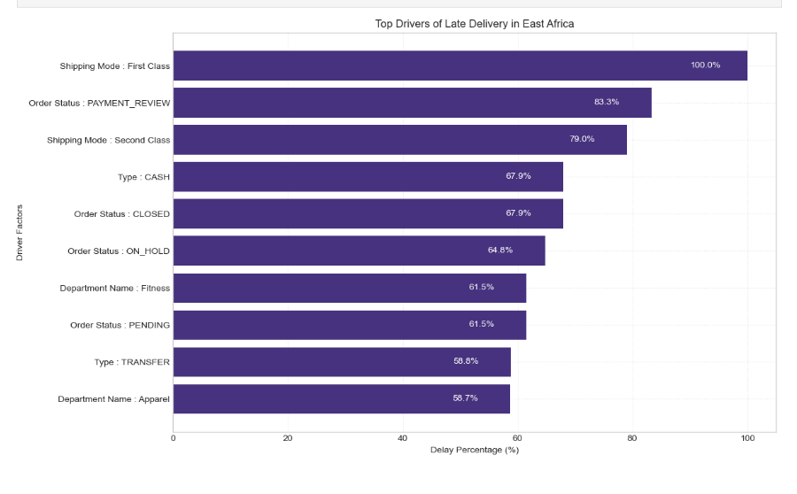

7. Time Based Delay Patterns
Three temporal dimensions were analysed: month of year, day of weeks, and hours of day. While delay rates are relatively stable across all dimensions (53-57%), specific peaks highlight opportunities for targeted capacity planning.

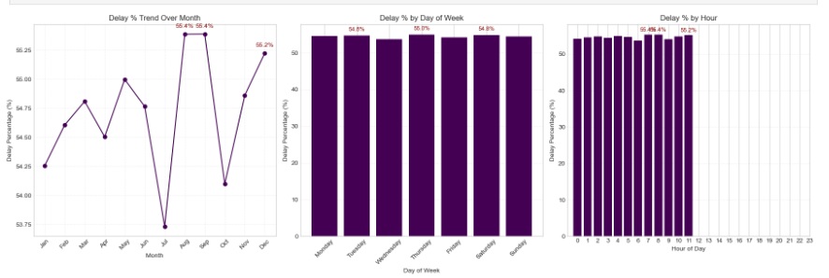

Prank Delay Months: August & September (55.4%) and December (55.2%) | August and September are the highest months at 55.4%. With December close behind. These reflect mid -year promotions and Q4 holiday surge overwhelming fulfillment capacity. July represents a notable low-point (-53.75%), confirming seasonal variation is plannable.

Day-of-Week Variance i Minimal | Monday (55.5%) and Sunday(55.2%) are the peak days, but the spread across the week is less than 1 percentage point. Day-of-Week is not a meaningful lever for operational intervention.

Intra- Day Peaks: Hours 21 (57.1%), Hour 11(58.7%) Hour 12 (56.0%) | Late evening orders (hour 21) have the highest delay rate at 57,.1%, likely reflecting processing cutoff windows. Midday pranks suggest bottlenecks during peak-volume hours.
8.Machine Learning Model Results
A supervised classification model was built to predict whether an individual order will be delivered late ( Late_deleivery_risk=1).The pipeline included frequency encoding of categorical variables, stratified train/test split SMOTE oversampling to address class imbalance, and Random Forest classification.

Class Imbalance Handling(SMOTE)

Split | Class 0(on-time)
Before SMOTE(train) | 59.030
After SMOTE(train) | 79.182

Random Forest Classifier - Test set Performance (34,553 records)

Metrics | Class 0(ON-time) | Class 1 (Late) | Overall(Weightage)
Precision | 0.68 | 0.78 | 0.74
Recall | 0.72 | 0.75 | 0.74
F-1 Score | 0.70 | 0.77 | 0.74
Accuracy | _ | _ | 0.74
Support | 14,758 | 19,795 | 34,553

74% Overall Accuracy | The model correctly classifies nearly 3 in 4 orders - a strong foundation for production deployment as an order-level late-delivery alert system.

Higher Precision on Late Orders(0.78) | When the model predicts on order will be late, it is correct 78% of the time – sufficient to trigger targeted interventions without generating excessive false alarms

Recall for late orders at 0.75 | The model captures 75% of actual late orders. The 25% miss rate is acceptable for a first-generation alert system, with clear improvement potential.

Class 0 Harder to Predict (Precision 0.68) | On-time deliveries share many characteristics with late ones given the systemic nature of delay, making them genuinely difficult to distinguish.

9.Strategic Recommendations
Based on the findings across all analytical dimensions, the following prioritised actions are recommended:

Critical | 1.Immediately Audit First class & Second Class shipping capacity  First class shipping has a 100% delay rate, and second class 79.8%.These modes operate in complete contradiction to their brand promise. Conduct an immediate carrier SLA audit. Until resolved, consideration suspending First Class or repricing to reflect actual performance.

HIGH | 2.Delay the Predictive Alert System  The Random Forest model(74% accuracy,78% precision on late orders) is ready for production piloting. Integrate it into the order management system to flag high-risk orders at confirmation and trigger proactive customer communication and priority handling queues.

HIGH | 3. Resolve Payment Processing Bottlenecks  Orders in PAYMENT_REVIEW (55.3% overall:80.0% in Central Africa) and PENDING_PAYMENT(55.0%) have significantly elevate delay rates. Introduce automated escalation for stalled payment reviews exceeding 2 hours.

MEDIUM | 4. Develop Seasonal Surge Capacity Plans  August,October(55.4%) and December(55.2%) are peak delay months. Build pre-season capacity including temporary logistics partnership, inventory pre-positioning, and adjusted delivery promise windows.

MEDIUM | 5.Default to Standard Class for Eligible Orders  Standard Class achieves a 39.8% delay rate – far superior to First and Second Class, Re-evaluate shipping mode assignment logic to default eligible orders to Standard Class, particularly in regions and departments with poor premium mode performance.

MEDIUM | 6.Investing High -Delay Departments in Africa  Outdoors (61.3%) and Golf (60.8%) in Central Africa show significantly elevated delay rates Conduct a warehousing-level audit of stock availability, pick-and-pick times, and carrier assignment for these product categories.

LOW | 7.Reduce Loss-Making Orders Share(18.7%)  The 18.7% loss- making orders share warrants a separate pricing and discount review. Combine with delay analysis to identify whether discounted orders are disproportionately late, creating a compounded margin problem.

LOW | 8 Continuously Retrain th PRedictive Model  Retrain the model quarterly. Explore adding carrier-level data, weather events, and warehouse utilisation features. Target a recall improvement to above 80% on late orders within 6 months.

10. Conclusion
This analysis has surfaced a clear and urgent picture : a global e-commerce operation where the majority of orders (54.71%) fail to meet their promised delivery windows, costing $2.1M in at-risk profit undermining customer trust at scale.

The root causes are identifiable and addressable. Shipping mode misconfiguration (First Class at 100% late, Second Class at 79.8%) is dominated by operational failure, Payment processing friction creates a secondary bottleneck. Seasonal volume spikes are not adequately planned for. And geographic disparities, while present, are secondary to the systemic company-wide pattern.

A Random Forest predictive model trained on readily available order features already archives 74% accuracy in identifying at-risk orders, This is a deployable tool, not future aspiration.

Priority Area | Current state | Target State
Late Delivery Rate | 54.71% | <30% within 12 months
First Class On-time Rate | 0% | >80%
Second Class On-time Rate | 20.2% | >60%
Predictive Model Accuracy | 74% | 82% (enhanced model)
Loss Making Orders | 18.7% | <12%
Profit at Risk | $2.1M | Reduce by 40%

With focused execution on the wight recommendation in this report starting with the critical shipping mode audit and predictive alert system deployment the business can systematically recover its delivery performance protect its $7.5M profit base and build operational reliability
The sustained e-commerce growth demands.

