Zero Discrimination day

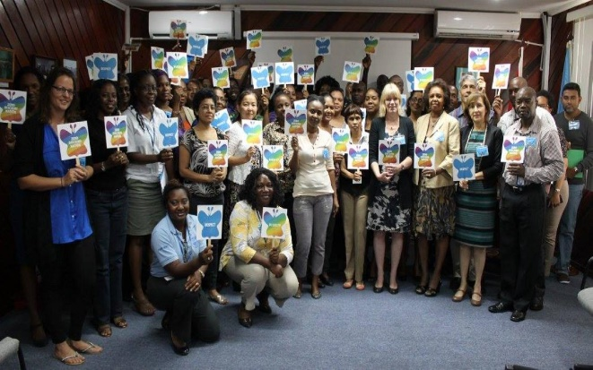In a world enriched by myriad cultures, identities, and perspectives, the notion of zero discrimination stands as an indispensable pillar of societal progress and harmony. Yet, despite strides towards inclusivity, discrimination persists in multifaceted forms, tarnishing the fabric of societies and impeding the realization of true equality. As we navigate the complexities of the modern era, it is imperative to champion the principles of zero discrimination, fostering environments where every individual is celebrated for their uniqueness rather than marginalized for their differences.

At its core, zero discrimination encapsulates the fundamental belief in the inherent worth and dignity of every person, irrespective of race, ethnicity, gender, sexual orientation, religion, disability, or any other characteristic. It embodies the commitment to dismantle barriers, challenge prejudices, and cultivate environments that nurture diversity and promote equal opportunities for all.

One of the most poignant battlegrounds in the fight against discrimination is the realm of gender equality. Women worldwide continue to face systemic barriers and entrenched biases that limit their access to education, employment, and decision-making roles. Achieving zero discrimination necessitates not only legislative reforms but also concerted efforts to challenge ingrained gender norms and stereotypes, empowering women to realize their full potential.

Similarly, the LGBTQ+ community confronts pervasive discrimination and violence, often fueled by ignorance and prejudice. Embracing zero discrimination entails creating safe spaces where individuals can express their authentic selves without fear of reprisal, and where love is celebrated in all its forms.

Moreover, racial and ethnic discrimination persist as enduring stains on the tapestry of humanity. Communities of color grapple with systemic inequalities, ranging from disparities in healthcare and education to racial profiling and police brutality. Upholding zero discrimination requires a collective commitment to dismantle structural racism, amplify marginalized voices, and cultivate cultures of inclusivity and belonging. 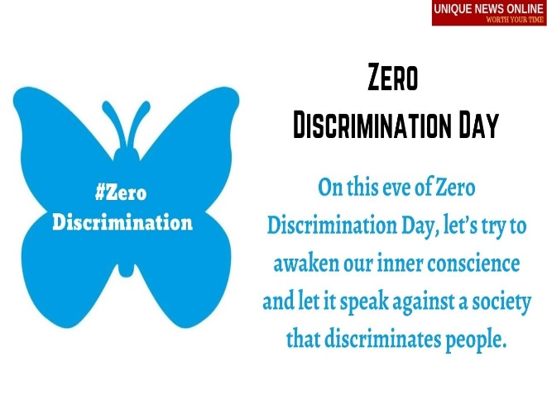Religious discrimination also poses a significant challenge to the principle of zero discrimination. Across the globe, religious minorities face persecution, intolerance, and violence, perpetuated by extremist ideologies and sectarian conflicts. Embracing diversity entails fostering interfaith dialogue

Top of Form