Day2

Create Azure key vault

Lab - Azure Key Vault Service

Disk Encryption Sets

**SSE with PMk** – server side encryption with Platform manage key

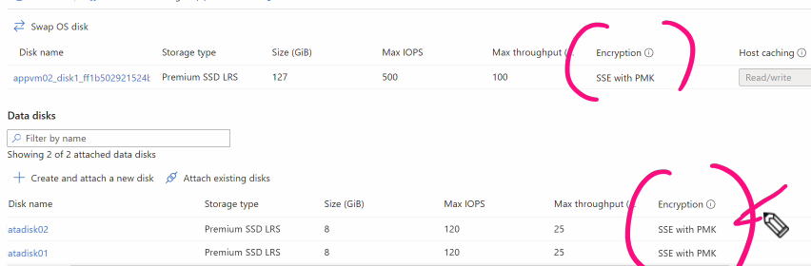

Lab Disk Encryption Sets

1.Create key vault

2.Role based access control set for key vault

Create key encryption

Now cre

ate disk encryption set

Add resource group, disk encryption name, kevault name, key and version and create

Once disk encryption created –

On overview its shows grant permission -> click on it and provide permission

Permission assigned

Now goto appvm02-> disk and detach **datadisk02** -> click on apply

Goto data disk encryption set -> encryption -> and select key management “customer-managed key:encryptionset “

 Lab - Azure Disk Encryption

How to change encryption setting(os and disk )

1.click on datadisk02 and click on additional settings-> add kevault name, key and version and click on save

Once deployment completed ->login to vm and check data valume encryption

**Custom script extensions**

This feature can be used to download and run scripts on azure virtual machines

Now will create powershell script fill that will automate the installation on internet information services

Lab - Custom Script Extensions

1. Create storage account to stotoring powershell script
2. A screenshot of a computer

   AI-generated content may be incorrect.

Upload powershell

Create vm

Add information -> click on advanced -> select an extension to install

Search “Custom script extension” and brows file storage account name and container

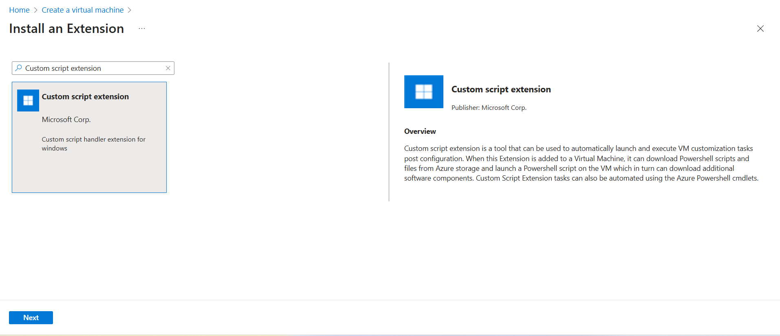

Create vm

Once deployment completed copy public ip of windows vm machin and check

Lab - Custom Script Extensions for Linux Virtual Machines

1.upload script on storage account

Once deployment complete – goto linux machin and copy public ip and check on browser, it will shows below output

 Lab - Linux Virtual Machines - Cloud init

Create linuxvm -> add required details

Add below script in advanced tab “**Custom data and cloud init”** click and review click on create

#cloud-config

package_upgrade: true

packages:

  - nginx

Virtual Machine - Boot Diagnostics

boot diagnostics to check logs for vm to check why vm is not starting

we can check details boot diagnostics->

[Azure boot diagnostics - Azure Virtual Machines | Microsoft Learn](https://learn.microsoft.com/en-us/azure/virtual-machines/boot-diagnostics)

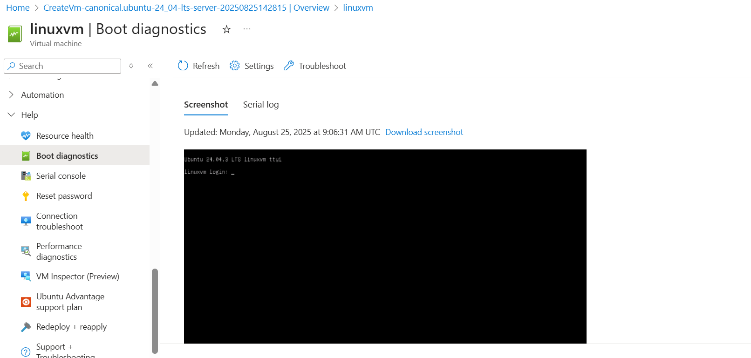

Lab - Virtual Machine - Run command

We can execute command from operations -run command

Can't connect to your virtual machine?

Redeploy vm

Availability Sets

This is logical grouping of machines that helps to reduce the chances of multiple vm’s going down

because of hardware issues

**Fault domains** are used to define the group of virtual machines that share a common source and network switch. You can have up to 3 fault domains.

**Update domains** are used to group virtual machines and physical hardware that can be rebooted at the same time. You can have up to 20 update domains.

Lab - Availability Sets

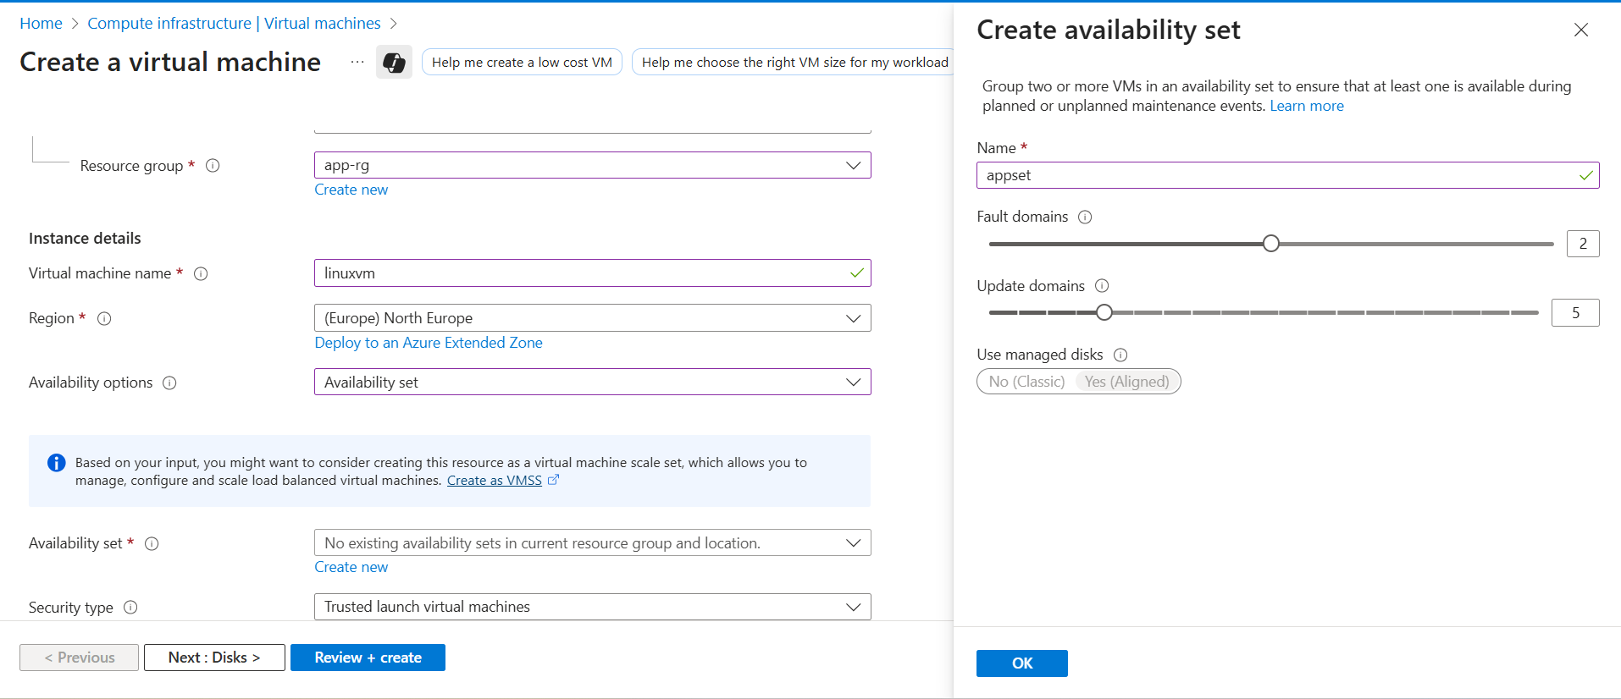

Availability Zones

Avaibility zone is a group of data centers there are fast links across availability zones to ensure low latency

Azure region has multiple avaibility zones

**Availability Zones Review**

* This features help provides better availability for your application by protecting them from datacenter failures.
* Each Availability zone is a unique physical location in an Azure region.
* Each zone comprises of one or more data centers that has independent power, cooling, and networking
* Hence the physical separation of the Availability Zones helps protect applications against data center failures
* Using Availability Zones, you can be guaranteed an availability of 99.99% for your virtual machines. You need to ensure that you have 2 or more virtual machines running across multiple availability zones.

Lab - Azure Virtual Machine Scale Sets

