Transferring and Copying Files

You already know how to copy files from one location to another on the same system using the cp command. But what if you want to copy files from your local workstation to a Linux server or between Linux servers? For that you can use SCP or SFTP.

SCP is secure copy and SFTP is SSH file transfer protocol. Sometimes SFTP is referred to as secure file transfer protocol. SCP and SFTP are both extensions of the secure shell (SSH) protocol. This means that if you have SSH key authentication configured for SSH, it will also work with SCP and SFTP.

In order to use SCP or SFTP you need a client. Mac and Linux come with scp and sftp command line utilities. If you are running Windows, you can use the PuTTY Secure Copy Client ( pscp.exe ) and the PuTTY Secure File Transfer client ( psftp.exe ) programs. Command line utilities aren't your only option. There are graphical clients for each platform as well. Some run on Windows, Linux, and Mac like [FileZilla](https://filezilla-project.org/), while others only run on one platform like [WinSCP](http://winscp.net/) for Windows.

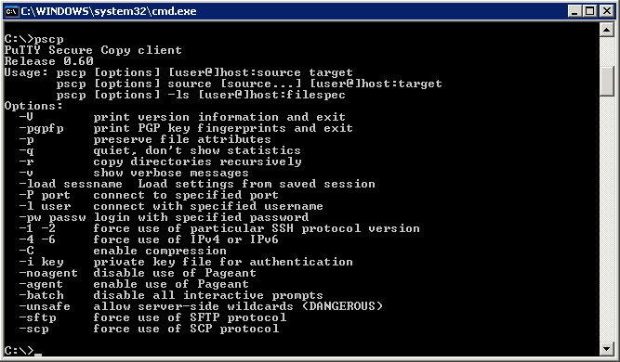

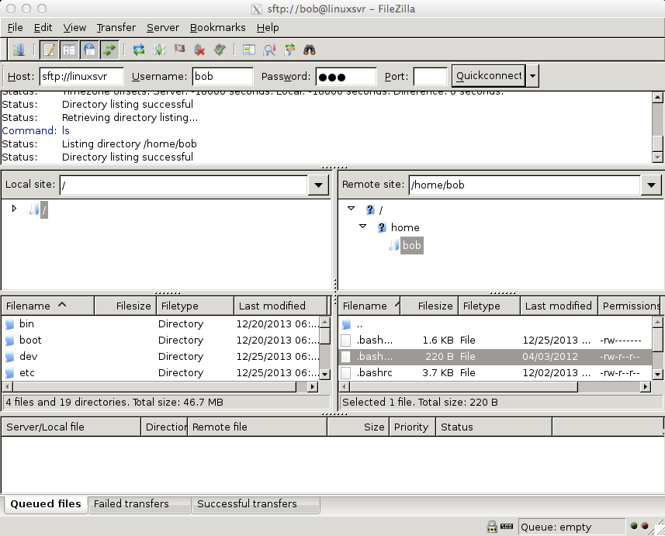scp source destination - Copy source to destination.

sftp [username@]host - Connect to host as username to begin a secure file transfer session.

If you are looking for a more interactive experience where you can examine the local and remote file systems, use SFTP. With SCP you need to know what files you want to transfer before using the command. Here is a sample SFTP session.

bobby@laptop:/tmp $ sftp bob@linuxsvr bob@linuxsvr's password:

Connected to linuxsvr. sftp> pwd

Remote working directory: /home/bob sftp> ls -la

drwxr-xr-x drwxr-xr-x

-rw-------

-rw-------

-rw-r--r--

-rw-r--r--

-rw-r--r--

drwx------ sftp> lpwd

4 bob bob

4 root root

1 bob bob

1 bob bob

1 bob bob

1 bob bob

1 bob bob

2 bob bob

4096 Dec 25 19:00 .

4096 Dec 2 22:01 ..

52 Dec 25 19:00 .Xauthority

1504 Dec 25 18:53 .bash_history

220 Apr 3 2012 .bash_logout

3655 Dec 2 22:02 .bashrc

675 Apr 3 2012 .profile

4096 Dec 25 19:00 .ssh

Local working directory: /tmp sftp> lls

file1.txt

sftp> put file1.txt

Uploading file1.txt to /home/bob/file1.txt

file1.txt 100%

18 0.0KB/s 00:00

sftp> ls file1.txt sftp> ls -la

drwxr-xr-x 4 bob bob 4096 Dec 25 19:02 .

drwxr-xr-x 4 root root 4096 Dec 2 22:01 ..

-rw-------

-rw-------

-rw-r--r--

-rw-r--r--

-rw-r--r--

drwx------

-rw-rw-r-- sftp> quit

1 bob bob 52 Dec 25 19:00 .Xauthority

1 bob bob 1504 Dec 25 18:53 .bash_history

1 bob bob 220 Apr 3 2012 .bash_logout

1 bob bob 3655 Dec 2 22:02 .bashrc

1 bob bob 675 Apr 3 2012 .profile

2 bob bob 4096 Dec 25 19:00 .ssh

1 bob bob 18 Dec 25 19:02 file1.txt

bobby@laptop:/tmp $

Using scp , you can copy from your local system to a remote system, from a remote system to your local system, or from one remote system to another remote system. Here is how that looks.

bob@linuxsvr $ scp test.txt linuxsvr1:~/ test.txt 100% 35KB 35.3KB/s 00:00 bob@linuxsvr $ scp linuxsvr1:~/test.txt . test.txt 100% 35KB 35.3KB/s 00:00

bob@linuxsvr $ scp linuxsvr1:~/test.txt linuxsvr2:/tmp/test-copy.txt bob@linuxsvr $

SCP and SFTP aren't the only ways to transfer files to remote systems. Sometimes FTP (file transfer protocol) is enabled. In such cases you can use the built-in ftp command on Linux and Mac and a graphical client like WinSCP for windows. Just be aware that FTP is not using a secure transfer protocol like SCP and SFTP. This means that your login credentials are sent in plain text over the network. Also, the files that you upload and download are not encrypted either. If given the choice between SCP/SFTP or FTP, use SCP/SFTP.

bobby@laptop:~$ ftp linuxsvr Connected to linuxsvr.

220 ubuntu FTP server (Version 6.4) ready. Name (linuxsvr:bobby): bob

331 Password required for bob. Password:

230 User bob logged in. Remote system type is UNIX.

Using binary mode to transfer files. ftp> pwd

257 "/home/bob" is current directory. ftp> quit

221 Goodbye.

If FTP is not enabled, you will see a "Connection refused" error message.

bobby@laptop:~$ ftp linuxsvr ftp: connect: Connection refused ftp> quit

bobby@laptop:~$

**Deep dive**

 [Cyberduck](http://cyberduck.io/) - FTP and SFTP client for Mac and Windows.

 [FileZilla](https://filezilla-project.org/) - FTP and SFTP client for Mac, Linux, and Windows.  [FlashFXP](https://secure.avangate.com/order/product.php?PRODS=4531615&QTY=1&AFFILIATE=56777) - FTP and SFTP client for Windows.

 [FireFTP](https://addons.mozilla.org/en-US/firefox/addon/fireftp/) - FTP and SFTP client Firefox that is Mac, Linux, and Windows compatible.  [PuTTY](http://www.linuxtrainingacademy.com/putty/?utm_source=linux-for-beginners-ebook&utm_medium=ebook&utm_campaign=linux-for-beginners-ebook)

 [PSCP.EXE](http://the.earth.li/~sgtatham/putty/latest/x86/pscp.exe) - SCP client for Windows

 [PSFTP.EXE](http://the.earth.li/~sgtatham/putty/latest/x86/psftp.exe) - SFTP client for Windows  [Transmit](http://www.panic.com/transmit/) - FTP and SFTP client for Mac.

 [WinSCP](http://winscp.net/) - FTP and SFTP client for Windows. [http://www.LinuxTrainingAcademy.com](http://www.linuxtrainingacademy.com/)