1. Considering the database schema displayed in the SQLServer-style diagram below, write a SQL query to return a list of all the invoices. For each invoice, show the Invoice ID, the billing date, the customer’s name, and the name of the customer who referred that customer (if any). The list should be ordered by billing date.

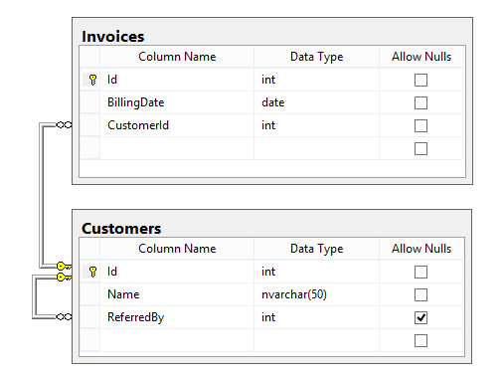

Answer:

**Select** i.Id, i.BillingDate, c.Name, cr.Name **AS** ReferredByName **from** Invoices i **Join** Customers c **ON** i.CustomerId=c.Id **Left** **Join** Customers cr **ON** c.ReferredBy = cr.Id **Order** **By** i.BillingDate

1. Given a table SALARIES, such as the one below, that has m = male and f = femalevalues. Swap all f and m values (i.e., change all f values to m and vice versa) with a single update query and no intermediate temp table.

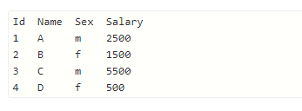

Answer:

**Update** SALARIES **Set** Sex=**Case** **When** sex= ‘m’ **Then** ‘f’ **else** ‘m’ **end**

1. Write a SQL query to find the 10th highest employee salary from an Employee table. Explain your answer.

(Note: You may assume that there are at least 10 records in the Employee table.)

Answer:

**Select** **Top(1)** Salary **from**

(

**Select** **Distinct** **TOP(10)** Salary **from** Employee **Order** **By** Salary **Desc**

) **Order** **by** Salary **ASC**