Business Analytics with R

**ACADGILD**

**Page 1**

Session 2: Introduction to R

Assignment 1 Business Analytics with R

**A C A D G I L D**

**Page 2**

*Session 2: Introduction to R*

Assignment – Install R base and R Studio on Desktop

Install Swirl and complete the tutorials

**Table of Contents**

1. Introduction .......................................................................................................................................... 3

2. Objective ............................................................................................................................................... 3

3. Prerequisites ......................................................................................................................................... 3

4. Associated Data Files ............................................................................................................................ 3

5. Problem Statement ............................................................................................................................... 3

6. Expected Output ................................................................................................................................... 3

7. Approximate Time to Complete Task ................................................................................................... 3 Business Analytics with R

**A C A D G I L D**

**Page 3**

**1. Introduction**

In this assignment, you will learn to Install R base and R Studio on Desktop and install Swirl and complete the tutorials. Swirl teaches you R programming and data science interactively, at your own pace, and right in the R console!

**2. Objective**

The objective of this course is to install R base and R Studio on desktop and install Swirl and complete the tutorials.

**3. Prerequisites**

Not applicable.

**4. Associated Data Files**

Not applicable.

**5. Problem Statement**

install R base and R Studio on desktop and install Swirl

**6. Expected Output**

R base, R studio and Swirl are installed.

Given below images for Installation for R-base,Rstudio and Swirl Packages.

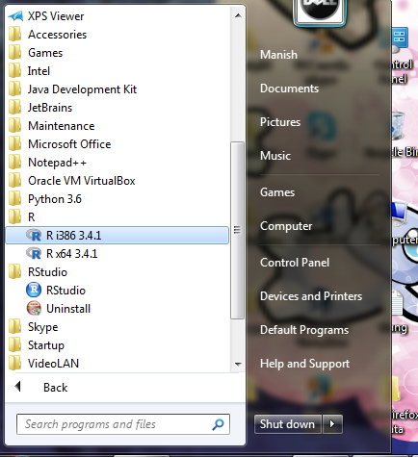

RStudio🡪Console Images;

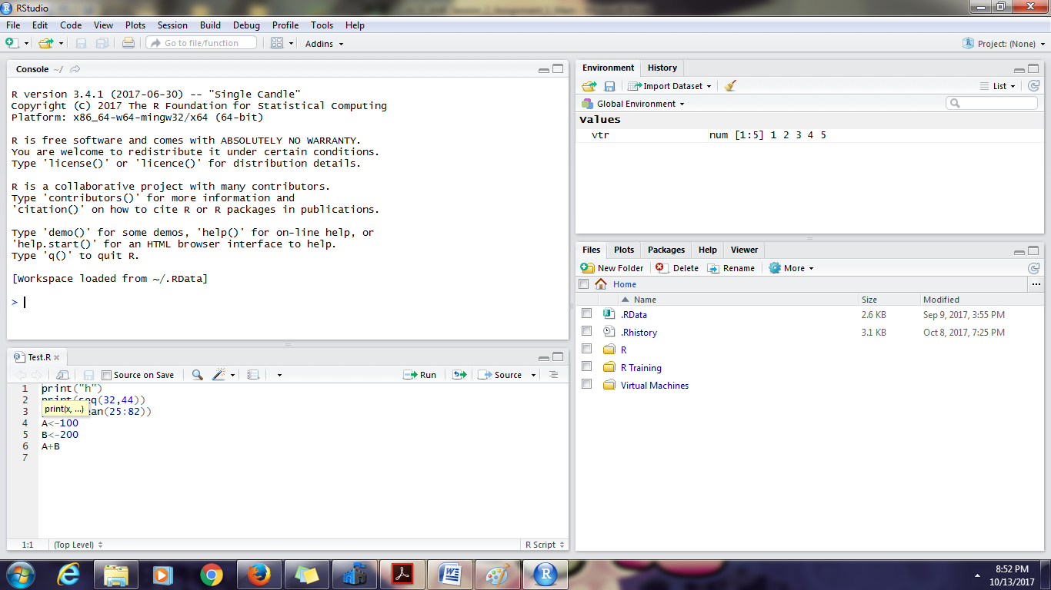

Install.packages(“swirl) images

