*Spark*

**A C A D G I L D Page 1**

Session 2: Introduction to Spark

Assignment 3*Spark*

**A C A D G I L D Page 2**

*Session 2: Introduction to Spark*

*Assignment 3*

**Table of Contents**

1. Introduction .......................................................................................................................................... 3

2. Objective ............................................................................................................................................... 3

3. Prerequisites ......................................................................................................................................... 3

4. Associated Data Files ............................................................................................................................ 3

5. Problem Statement ............................................................................................................................... 3

6. Approximate Time to Complete Task ................................................................................................... 3 *Spark*

**A C A D G I L D Page 3**

**1. Introduction**

In this assignment you need to import AcadGild VM into Virtual box and start all the Spark daemons.

**2. Objective**

This assignment will help you to understand Big Data basics.

**3. Prerequisites**

None

**4. Associated Data Files**

N/A

**5. Problem Statement**

Import AcadGild VM into Virtual box and start all the Spark daemons and take the screen shot.

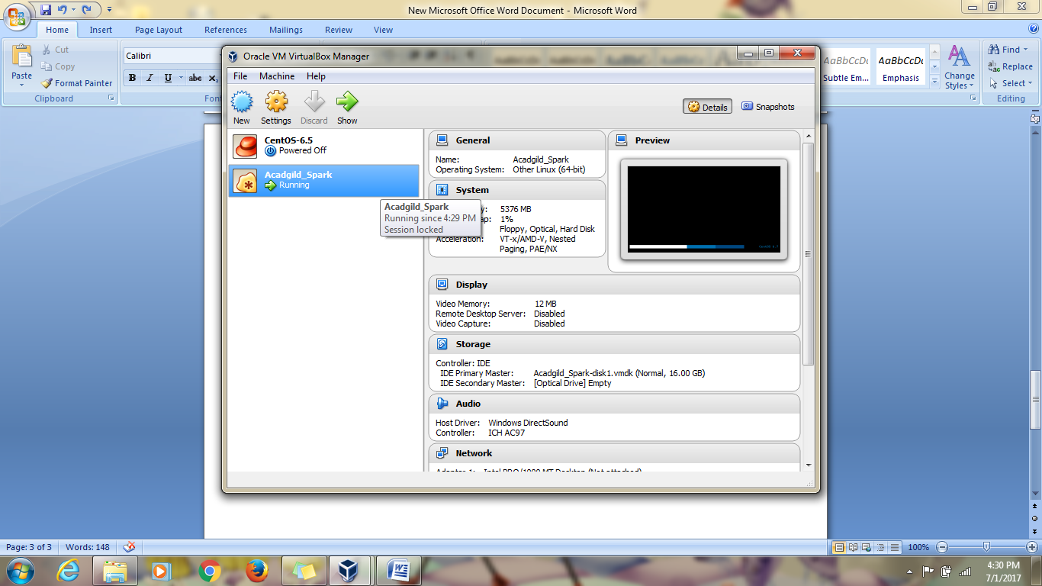

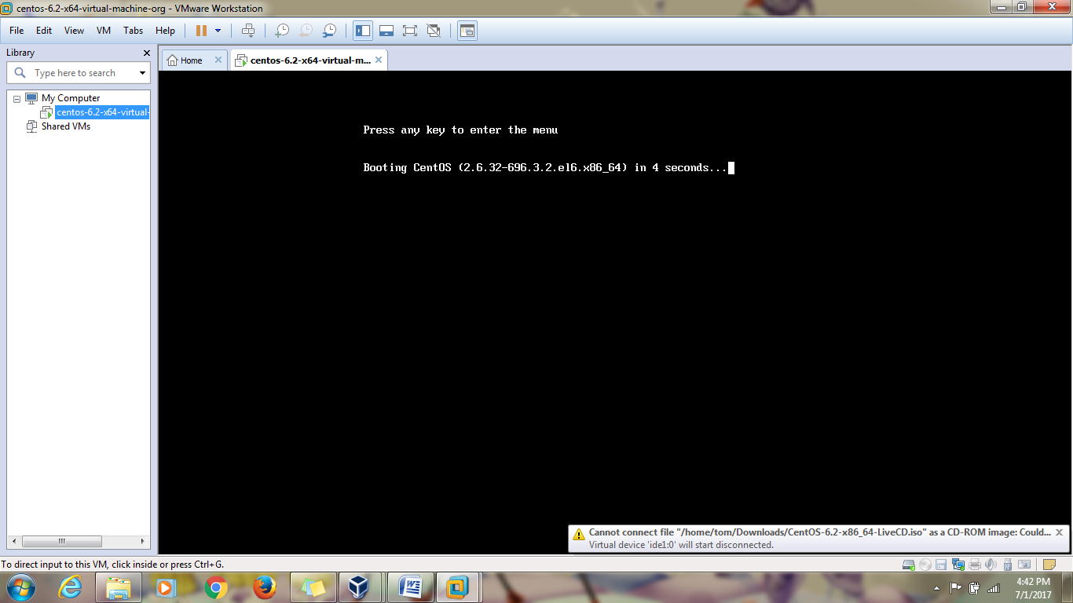

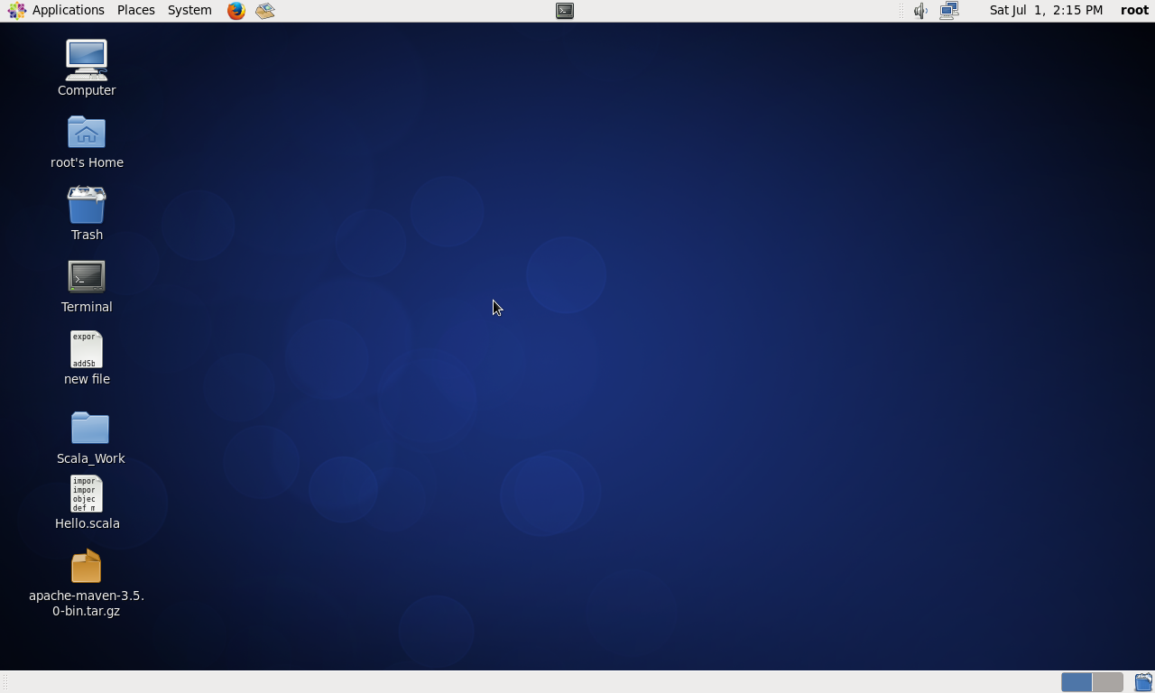

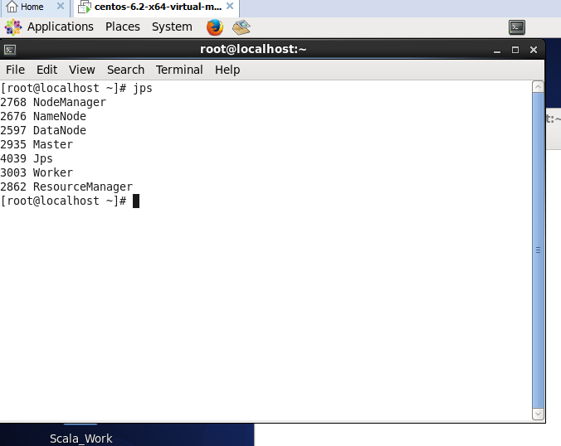

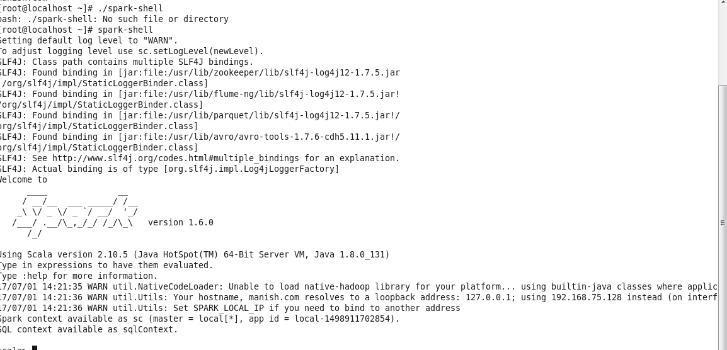

All the demons are started as per given above of the screen shot.

**6. Approximate Time to Complete Task**

60 min