**SpringBoot**

package com.demo;

 import org.springframework.boot.SpringApplication;

import org.springframework.boot.autoconfigure.SpringBootApplication;

import org.springframework.web.bind.annotation.GetMapping;

import org.springframework.web.bind.annotation.RestController;

@SpringBootApplication

@RestController

public class Demodocker25Application {

@GetMapping("/message")

public String getMessage() {

return "welcome to session";

}

@GetMapping("/Hi")

public String getHi() {

return "welcome to API";

}

public static void main(String[] args) {

[SpringApplication.run](http://SpringApplication.run)(Demodocker25Application.class, args);

}

}

Pom.xml

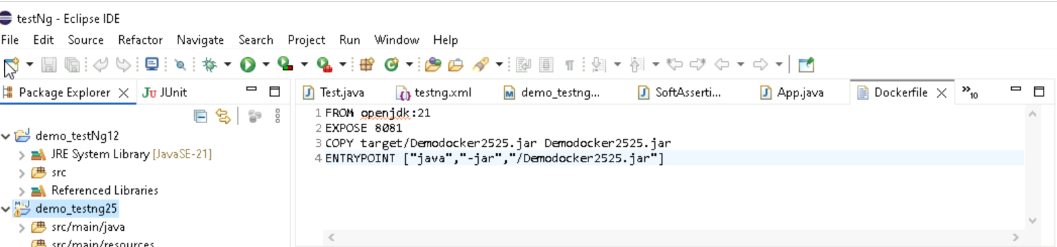

dockerfile

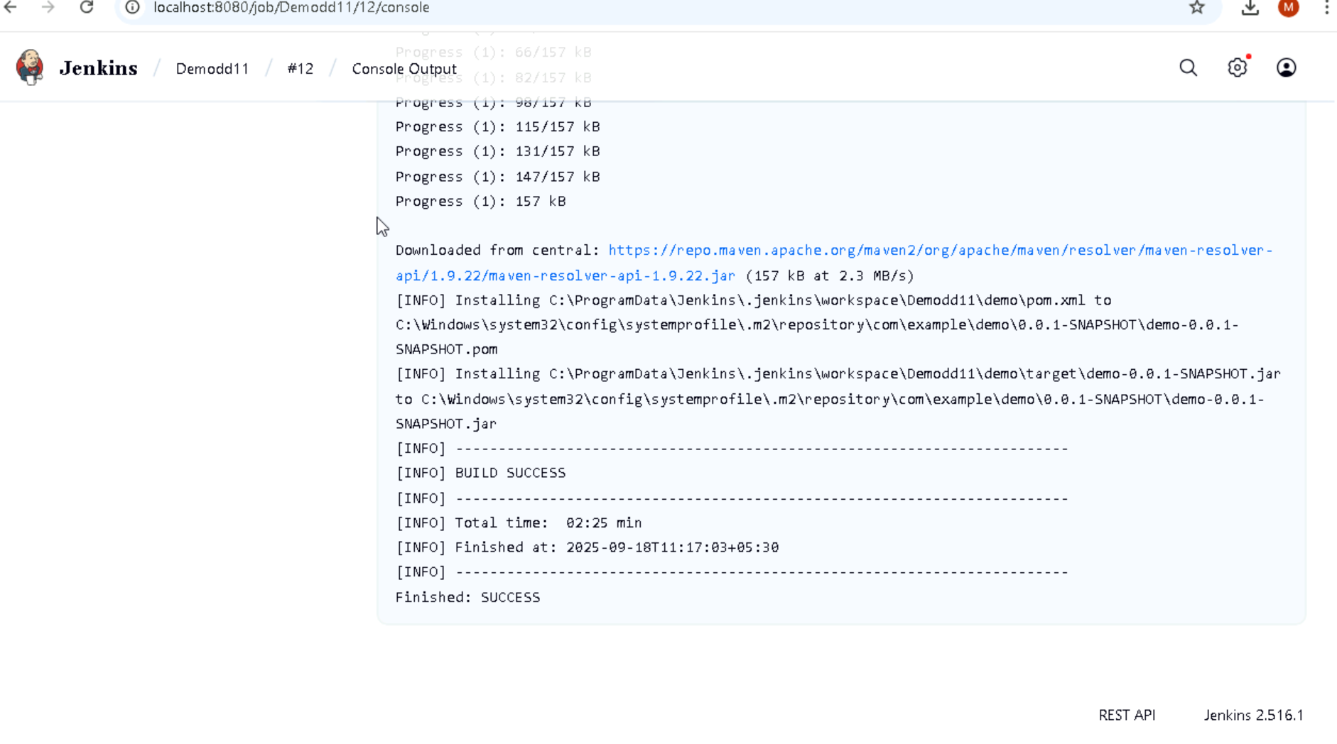

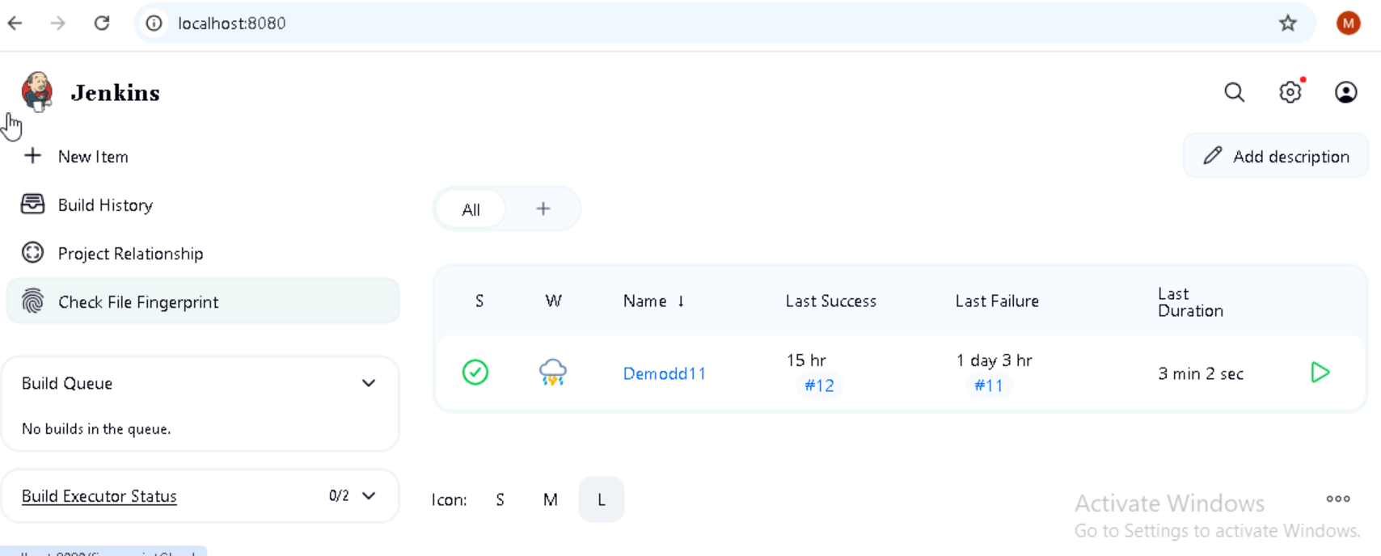

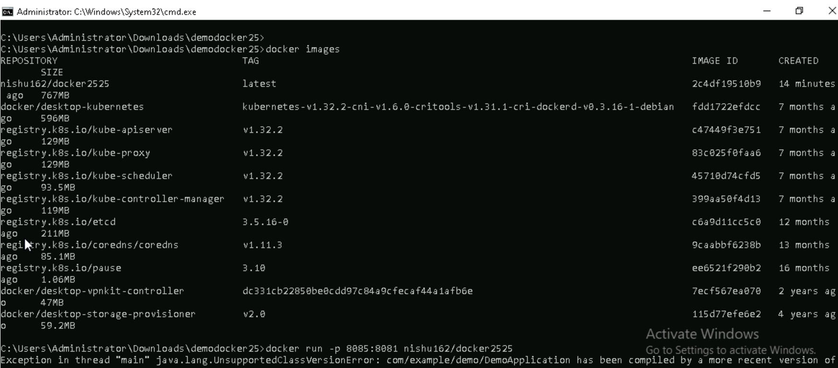

Pushed into docker

