Supporting Document for the Job Finder/Job Search App

* INTRODUCTION.

This app has been created to help the blue collar workforce come back to work after the pandemic situation getting normal slowly. This app will help the applicants to get the jobs openings available as per their qualification or experience. The people who want to recruit people can list the jobs and the applicants can refer them and apply for those.

Keeping in mind the blue collar workforce, the UI of the app has been kept very simple for them to use it efficiently. The app not only focuses on listing jobs but also to empower them through online trainings, important news and latest trends. It also focuses on women empowerment and has special emphasis on the women who want to join the workforce by making a dedicated portal exclusively for them. The main aim of this app is to enhance the financial conditions of the working class who has been affected the most by the pandemic.

* SALIENT FEATURES

*Simple and Self Explanatory UI* – The app is developed for the blue collar working force who are not expected to be highly qualified. Thus the interface of the app has been kept very simple and self explanatory so that they do not need any external help while browsing through the app.

*Responsiveness* – The web app has been made responsive so that it fits in all the screen devices irrespective of the screen size so that the users do not have problem in using be it a laptop, desktop or tab.

*Browser Compatibility*– The app works irrespective of the browser that it is run on, be it Google chrome, Mozilla firefox or Microsoft edge, thus making easier for the users.

*User Meets Demands*– The app is made for the blue collar job seekers and stands by its purpose easing out the entire process in every possible way be it helping them out with recruiters or empowering them.

* FLOWCHART

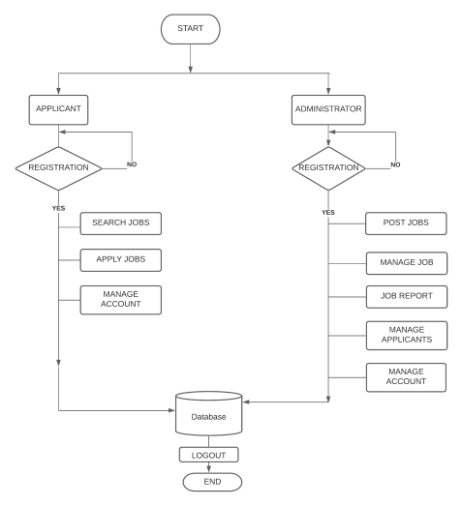

* FUTURE WORK

Considering that this web app was made in the Microsoft IDC WIT Hackathon and due to time constraints, all the ideas visualised could not be completed. Hence these are the features that are supposed to be added in the future to make this app more efficient and simpler to use:-

1. Integrating voice to text.
2. Including a ChatBot.
3. Search Bar.
4. Notification Status.
5. Language Change Option.