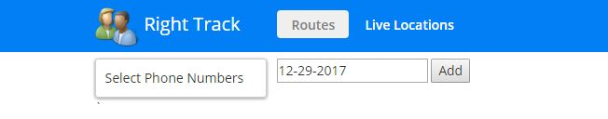

1. Live Locations name should be changed to Live Tracking
2. Date_time" : ISODate("1970-01-01T00:00:00Z") Date and Time not coming in the database
3. Route function is not working (Route is not displayed on map)
4. Change the name of URL to Righttrack.co.in
5. The name of app Right Track should be in the centre with bold font. The font to be used is shown in image below.

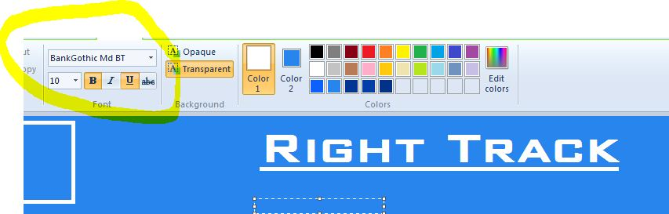

1. The name Right Track should have shadow effect as shown in image below



1. Background colour of the bar should be the colour code mentioned in image below

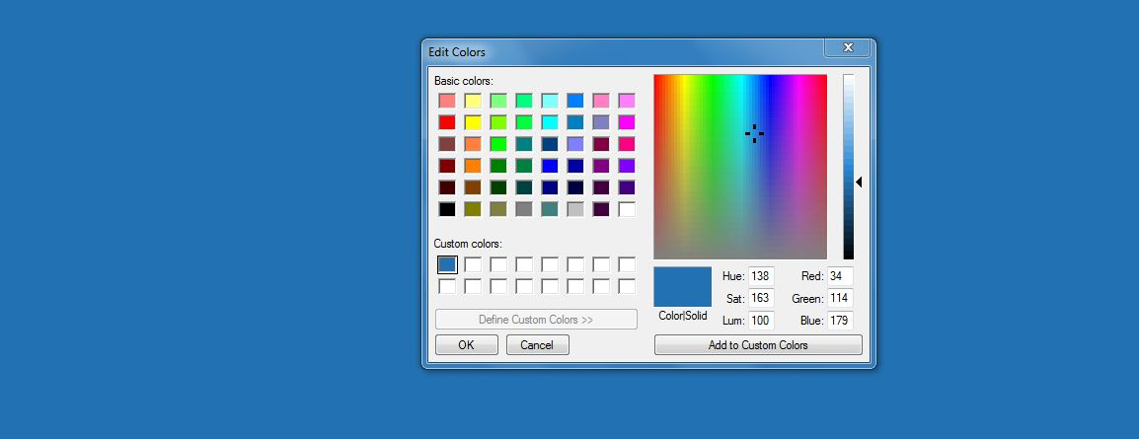

1. The design of the console should be like this

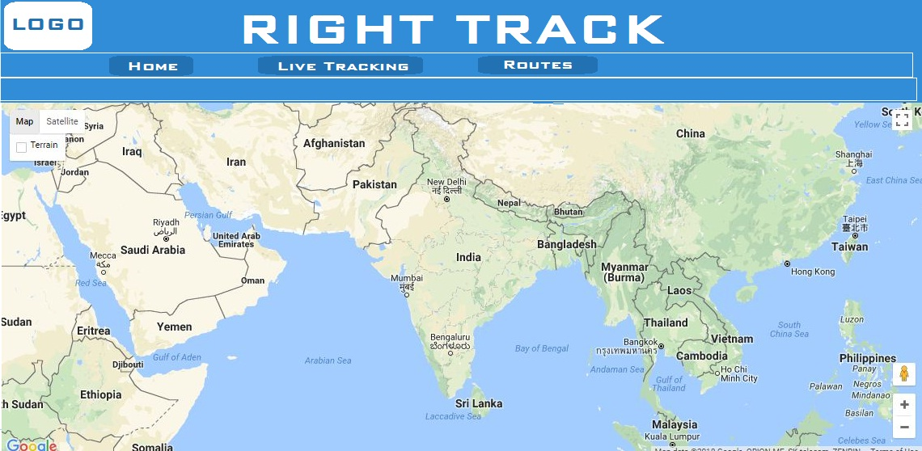

1. After selecting any button/ option from Live Tracking or Routes the button should be highlighted.
2. The clear map button should be removed and it will be replaced by Home button which will be used to exit from Live tracking as well as Routes function.
3. In Live tracking option Select IMEI Number should be replaced by Select User

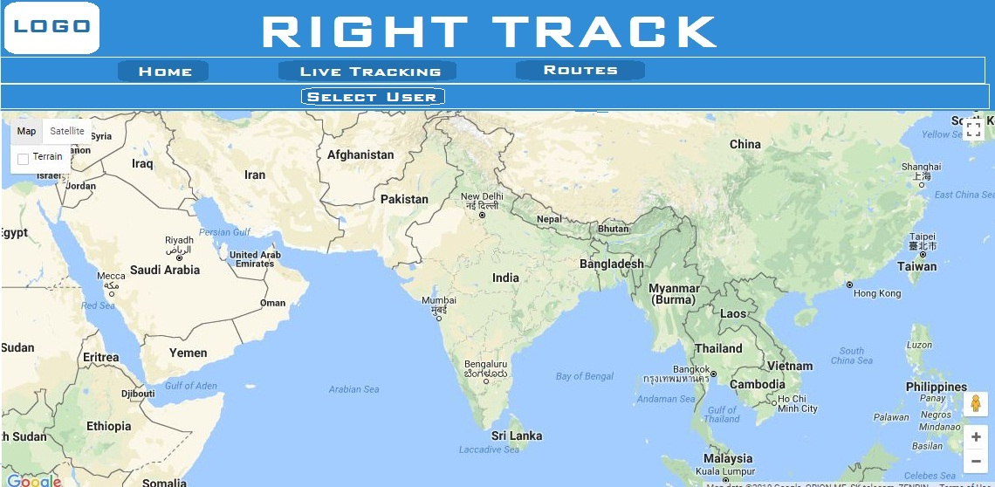

1. Add OK and Cancel button at the bottom of the live tracking dropdown list. Remove the submit button.

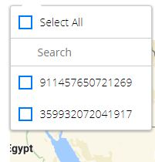

1. Permanent label should be present on balloon with IMEI No
2. Make the map full screen
3. After selecting Routes option the option appearing should be Select User and date

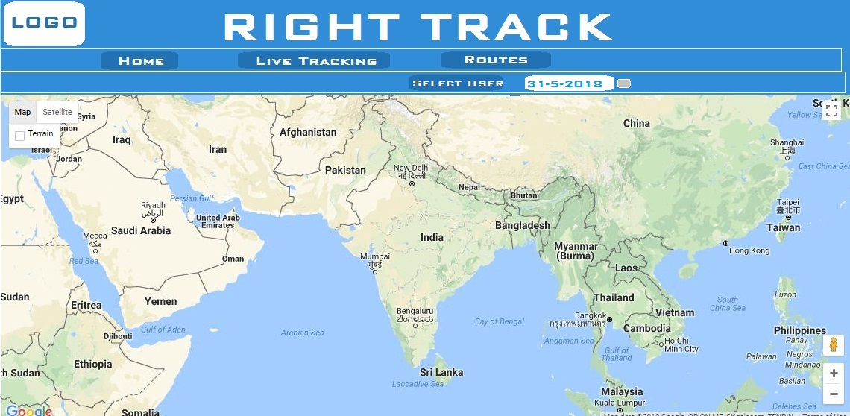

1. Only one user at a time should get selected for viewing the route.
2. Add OK and Cancel button to the list of users
3. IMEI No should be replaced by User ID. Source and Destination options will be removed.

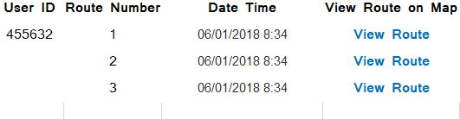

1. Balloons of Green color at starting point and Red color at end point should be present in Route
2. Rout option UI should be like google map

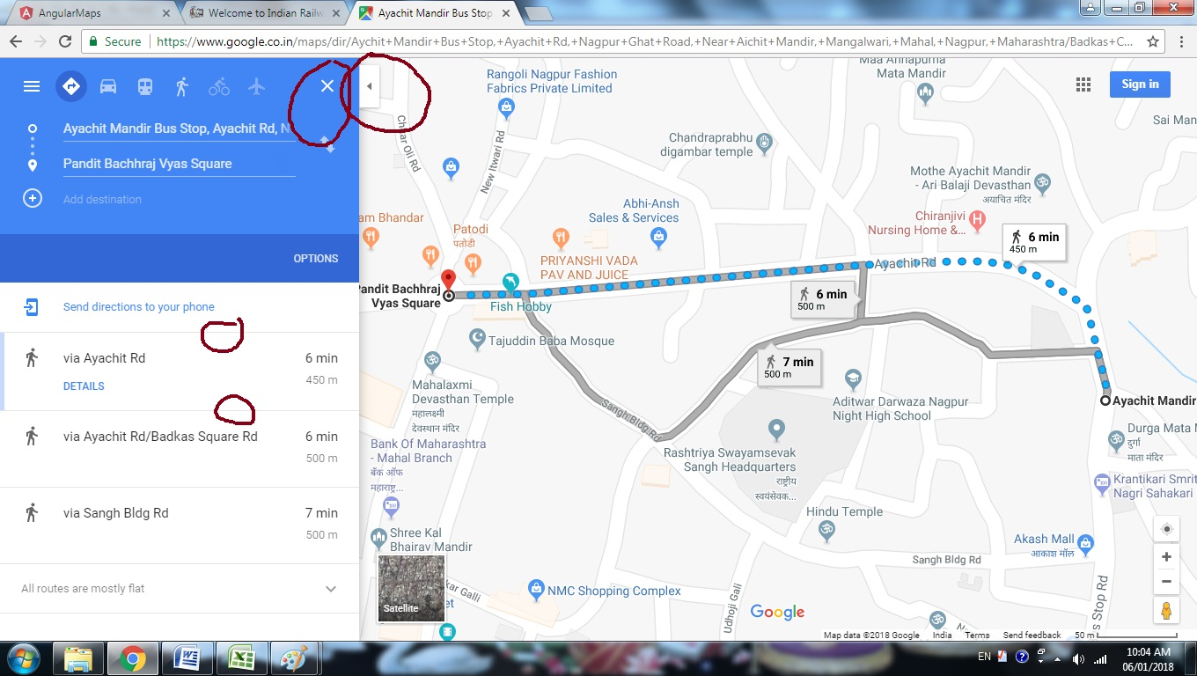

22.

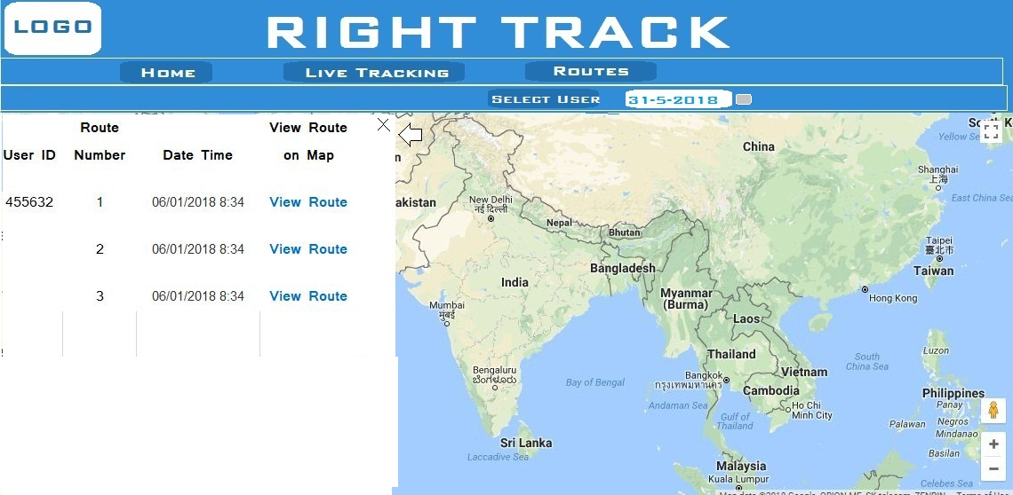

1. The map should be properly zoom to the route shown on map