**Q2. I have provided a dataset PIMS.dat which has data on industrial goods manufacturers. The variables in the data are in the following order. These variables and definitions are given in the paper by Robinson and Fornell (1985) on pioneering advantages (see Tables 1, 2 and 3). As in the paper by Robinson and Fornell (1985), we will estimate a simultaneous system of five equations. While the paper considered consumer goods industries, we are interested in replicating the analysis for industrial goods industries**.

Please estimate a 2SLS model with the following five equations.

model MS=qual plb price pion ef phpf plpf psc papc ncomp mktexp

model Qual=price dc pion ef tyrp mktexp pnp

model PLB=dc pion tyrp ef pnp custtyp ncust custsize

model Price=ms qual dc pion ef tyrp mktexp pnp

model DC=ms qual pion ef tyrp penew cap rbvi emprody union

1. Run the 2SLS model using SAS (PROC SYSLIN) and estimate the effect of pioneering on market share. Be sure to consider the direct effects as well as the indirect effects. (read the paper on pioneering advantages for this interpretation).

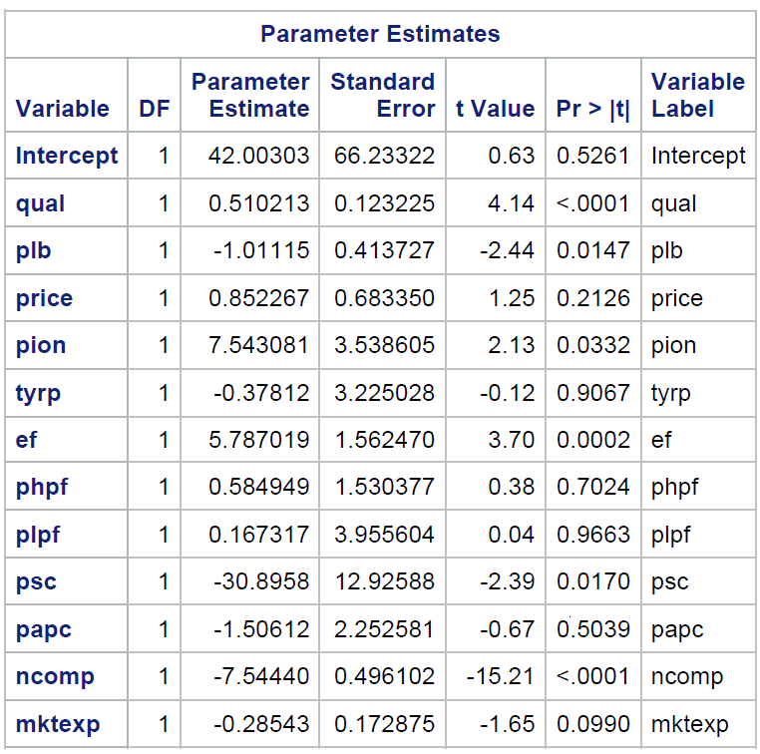 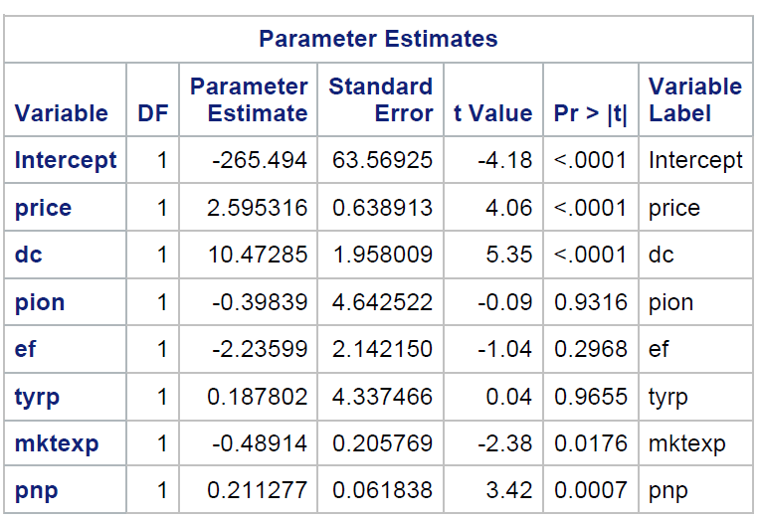

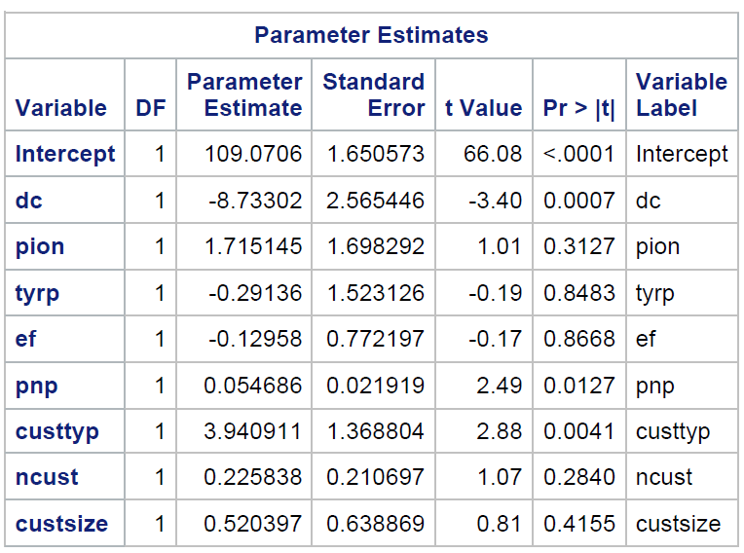 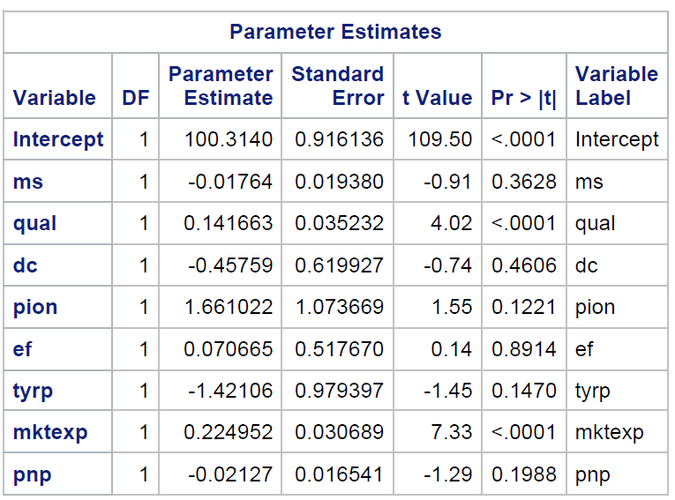

The below table shows the 2SLS estimations for five models. Estimations for pion variable show the pioneering effect on market share. Pioneering has direct effect on market share. In models where dependent variable is not market share, the coefficient of “pion” are insignificant.

|  |  |  |  |  |  |
| --- | --- | --- | --- | --- | --- |
| **Dependent Variable** | **ms** | **qual** | **plb** | **price** | **dc** |
|  |  |  |  |  |  |
| **Intercept** | 42.00303 | -265.494 | 109.0706 | 100.314 | 1.140754 |
| **ms** |  |  |  | -0.01764 | 0.004963 |
| **qual** | **0.510213** |  |  | **0.141663** | **0.035383** |
| **price** | 0.852267 | **2.595316** |  |  |  |
| **plb** | **-1.01115** |  |  |  |  |
| **dc** |  | **10.47285** | **-8.73302** | -0.45759 |  |
| **pion** | **7.543081** | -0.39839 | 1.715145 | 1.661022 | -0.07697 |
| **ef** | 5.787019 | -2.23599 | -0.12958 | 0.070665 | 0.140887 |
| **phpf** | 0.584949 |  |  |  |  |
| **plpf** | 0.167317 |  |  |  |  |
| **psc** | -30.8958 |  |  |  |  |
| **papc** | -1.50612 |  |  |  |  |
| **ncomp** | -7.5444 |  |  |  |  |
| **mktexp** | -0.28543 | **-0.48914** |  | 0.224952 |  |
| **tyrp** | -0.37812 | 0.187802 | -0.29136 | **-1.42106** | 0.221522 |
| **pnp** |  | **0.211277** | **0.054686** | -0.02127 |  |
| **custtyp** |  |  | **3.940911** |  |  |
| **ncust** |  |  | 0.225838 |  |  |
| **custsize** |  |  | 0.520397 |  |  |
| **penew** |  |  |  |  | -0.0034 |
| **cap** |  |  |  |  | 0.000041 |
| **rbvi** |  |  |  |  | -0.04885 |
| **emprody** |  |  |  |  | **0.002523** |
| **union** |  |  |  |  | 0.00146 |

Endogenous Variables: MS, QUAL, PLB, PRICE, DC; hence 5 simultaneous equations.

Instrument Variables: PION, EF, PHPF, PLPF, PSC, PAPC, NCOMP, MKTEXP, TYRP, PNP, CUSTTYP, NCUST,

Product quality, Product Line Breadth, If a business is a market pioneer, Whether a firm is an early follower, Pioneer is selling seasonally changed goods/inventory, and Number of competitors are significant (i.e. |t-value|>1.96 and p-value<0.05) at 95% confidence level.

**Direct Effect:** Pioneering is a significant variable. (t value = 2.13 and p-value = 0.0332) so there is an effect of pioneering on market share. If the firm is a pioneer, the market share will increase by 7.54 units. Also, if a firm is a pioneer and sells goods that are changed seasonally then the market share will decrease by 30.89 units.

Indirect Effect: (where pion = 1)

PION-QUAL-MS: -0.39839* 0.510213= -0.20

PION-PLB-MS: 1.715145*(-1.01115) = -1.73

PION-PRICE-MS: 1.661022*0.852267 = 1.41

Total indirect effect is -0.52

Total Effects = Direct Effect + Indirect effect = 7.02

1. **Run a simple regression model of market share as given in the first equation. What is the effect of pioneering on market share using this simple model? How does this effect change across different models.**

# 

We observed following differences between regression and 2sls model-

1. Pioneering is significant in both the models, but its coefficient is high in simple regression (12.6) as opposed to 2SLS (7.54 direct and -0.52indirect). The reason is- there is endogeneity due to simultaneity occurring in MS, QUAL, PLB, PRICE, DC. That is why simple regression is violating the unbiased assumption. The solution is to use 2SLS model instead of simple regression which removes endogeneity issue.
2. **Both models have common significant coefficients except price. Price** is significant in the simple regression model since it is correlated with Quality, however, Price is insignificant in 2SLS model. This endogeneity is removed by 2SLS and so it becomes insignificant.
3. Considering 95% significance level, Product Quality, Product Line Breadth, Whether firm is an early follower, Pioneer Seasonal Product Change, Number of competitors are significant in both the models but have higher coefficients in simple regression that confirms endogeneity as variables are showing effects of relation with each other. The remaining variables remain insignificant in both 2SLS and simple regression model.

2 SLS model has resolved endogeneity and unobserved heterogeneity and is giving unbiased results.