**HW6- Group -10- Shweta Siddha, Manisha Gupta, Achint Khanijo, Kartikay Nigam**

1. **Run the following Tobit model (Use PROC QLIM)**

**Model profit = age, totaltrans, rewards, limit, numcard, modes of acquisition, type of card, types of affinity**

**Write a summary of the results. Focus on important effects, interpretation, model fit etc**

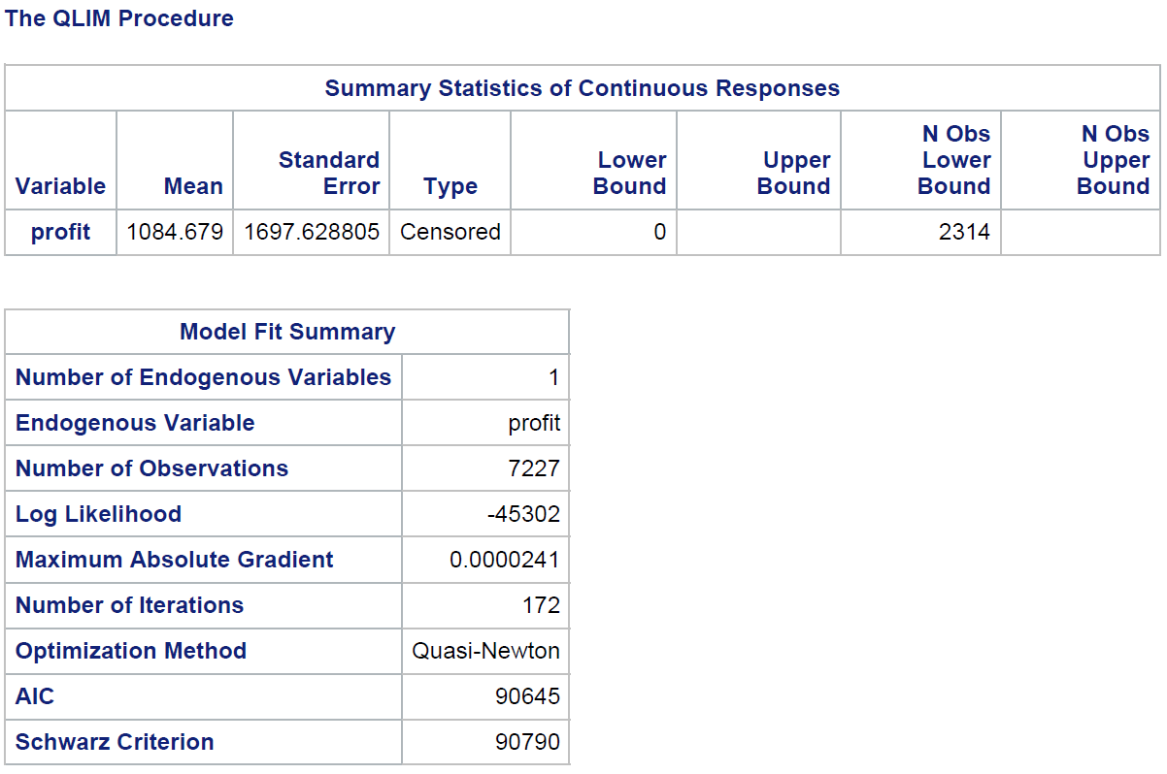 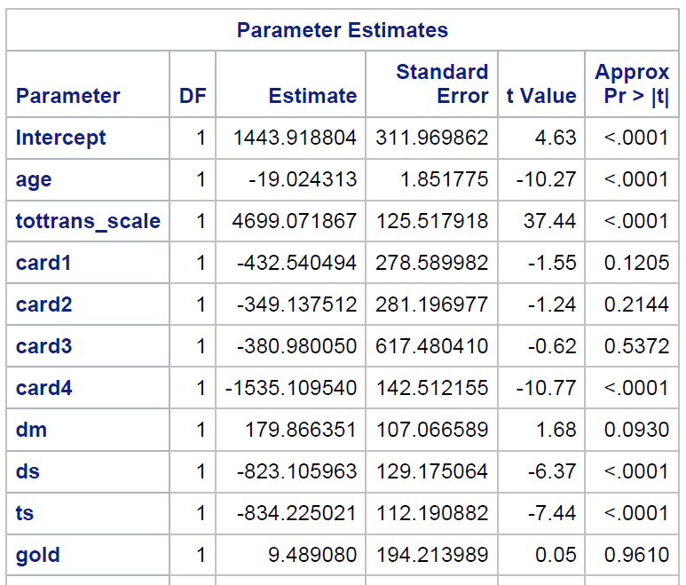 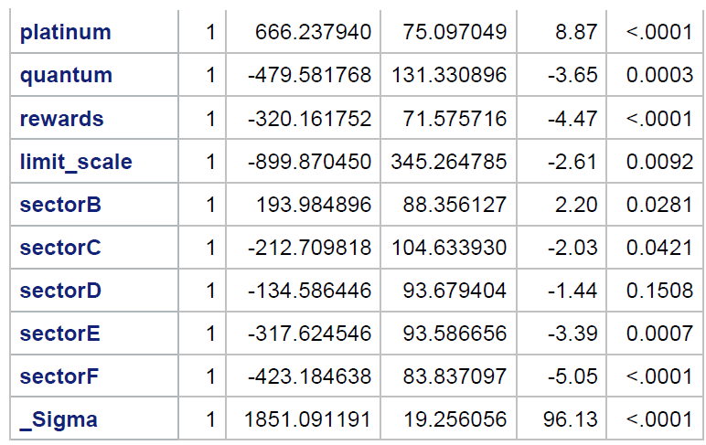

**Model Fit Summary:**

Total number of observations: 7227

Log likelihood: -45302

**Age:** One-year increase in **age** of the customer is associated with approx. 19 units decrease in profit over a 3-year period, keeping all other variables constant. And this impact is statistically significant.

**Total transaction**: 100000 units increase in **Total transaction** is associated with approx. 4699 units increase in profit over a 3-year period, keeping all other variables constant. And this impact is statistically significant.

**Number of Card 0:** Reference category

**Number of Card 1:** Customer who has one card is not statistically significant as compared to person having no card.

**Number of Card 2:** Customer who has two card is not statically significant as compared to person having no card.

**Number of Card 3 -** Customer who has three card is not statically significant as compared to person having no card.

**Number of Card 4:** Profit is 1535.1 units less from customers with four cards from this bank as compared to those who have 0, 1, 2 or 3cards.

**NET**: Customer acquired through net is taken as reference category.

**DM:** Profit is 179.86 units more for customers who are acquired via direct mail as compared to those who are acquired through internet, keeping all other variables constant. It is not significant at 95% confidence interval as its p value is above the threshold value of 5%. It can be significant at around 90% confidence level.

**TS:** Profit is 834.22 units less for customers who are acquired via telephone selling as compared to those who are acquired through internet, keeping all other variables constant. And this impact is statistically significant.

**DS:** Profit is 823.10 units less for customers who are acquired via direct selling as compared to those who are acquired through internet, keeping all other variables constant. And this impact is statistically significant.

**Standard:** whether the customer has standard card is taken as Reference category

**Gold**: There is no significant difference in Total finance charges paid by a customer over a 3-year period between customers with Standard card & Gold card.

**Platinum**: Profit is 666.237 units more for customers who have PLATINUM card as compared to customers who have STANDARD card, keeping all other variables constant. And this impact is statistically significant

**Quantum:** Profit is 479.58 dollar less for customers who have QUANTUM card as compared to customers who have STANDARD card, keeping all other variables constant. And this impact is statistically significant.

**Reward card**: Customer having **reward card** are associated with 320.16 dollar less profit as compared to customer who do not have reward cards, keeping all other variables constant. And this impact is statistically significant.

**Limit:** Every 100000 dollar increase in limit of a card is associated with 899.87 dollar decrease in profit, keeping all other variables constant. And this impact is statistically significant.

**SectorA:** No affinity card is taken as reference category.

**SectorB:** profit is 193 dollar more for Affinity card affiliated with Professional organization as compared to customers who have No affinity card, keeping all other variables constant. And this impact is statistically significant

**SectorC:** profit is 212.71 dollar less for Affinity card affiliated with Sports as compared to customers who have No affinity card, keeping all other variables constant. And this impact is statistically significant.

**SectorD:** profit is 134.58 dollar less for Affinity card affiliated with Financial institution as compared to customers who have No affinity card, keeping all other variables constant. And this impact is not statistically significant

**SectorE:** profit is 317.62 dollar less for Affinity card affiliated with University as compared to customers who have No affinity card, keeping all other variables constant. And this impact is statistically significant.

**SectorF:** Profit is 423.18 dollar less for Affinity card affiliated with Commercial as compared to customers who have No affinity card. And this impact is statistically significant.

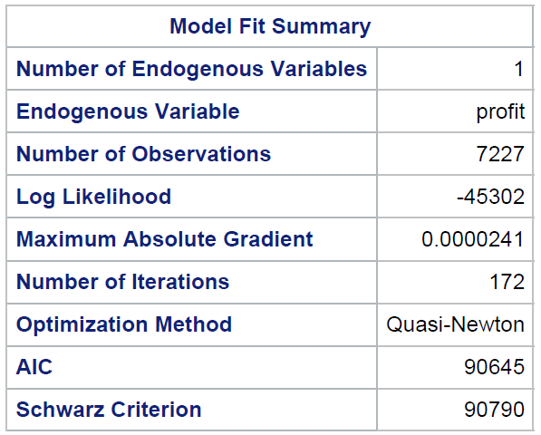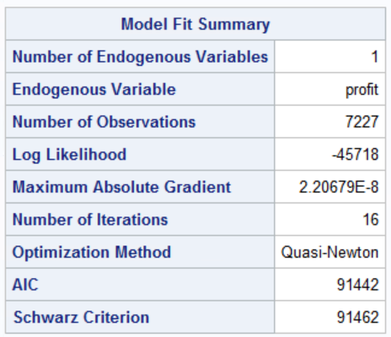**Model Fit Statistics:**

AIC – This is the Akaike Information Criterion. AIC, like Adjusted R-square in linear regression, penalize the log-likelihood for the number of predictors in the model. Ultimately, the model with the smallest AIC is considered good.

SC – This is the Schwarz Criterion. Like AIC, SC penalizes for the number of predictors in the model and the smallest SC is most desirable.

As AIC and SC value for Intercept and covariates (122734.33 and 122837.81 respectively) is better (lower) than Intercept only (124729.23 and 124738.64 respectively) model, we can say that our model does better.

**Q2. Run a selection model (Use PROC QLIM)**

**Model active = age, rewards, limit, numcard, modes of acquition, type of card, types of affinity**

**Model profit = age, totaltrans, rewards, limit, numcard, modes of acquition, type of card, types of affinity**

**Write a summary of the results. Focus on important effects, interpretation, model fit etc**.

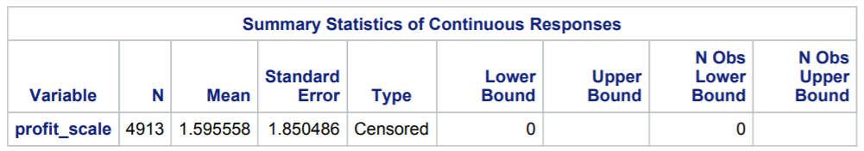

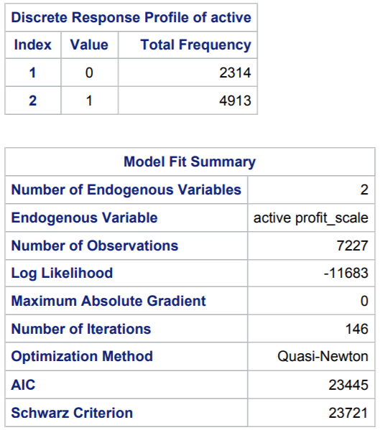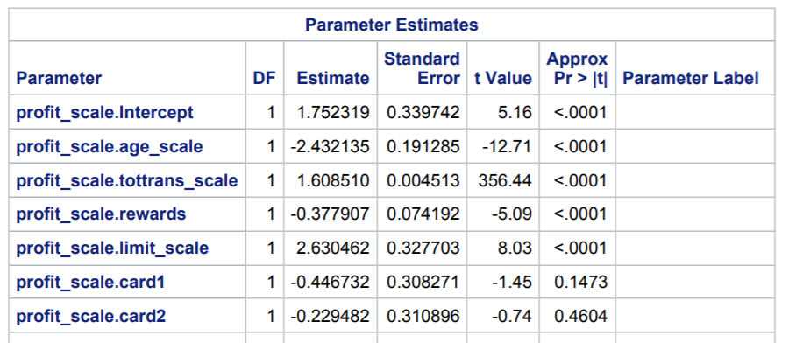

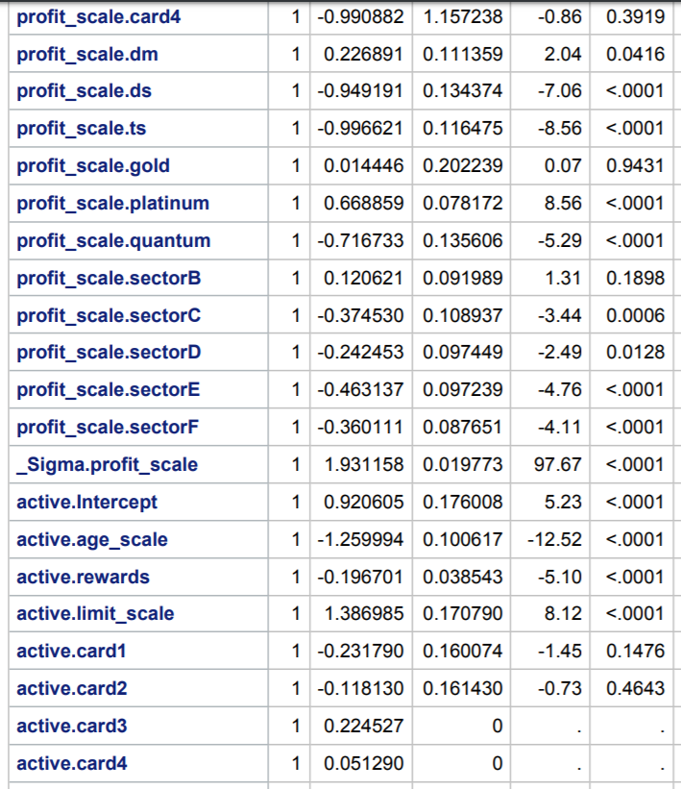 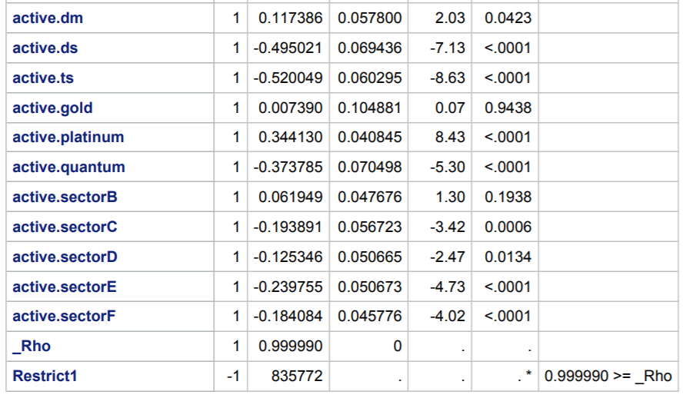

**Q3: Survival analysis**

**1. Delete all customers who are inactive.**

**2. Run a proportional hazards model (PROC PHREG)**

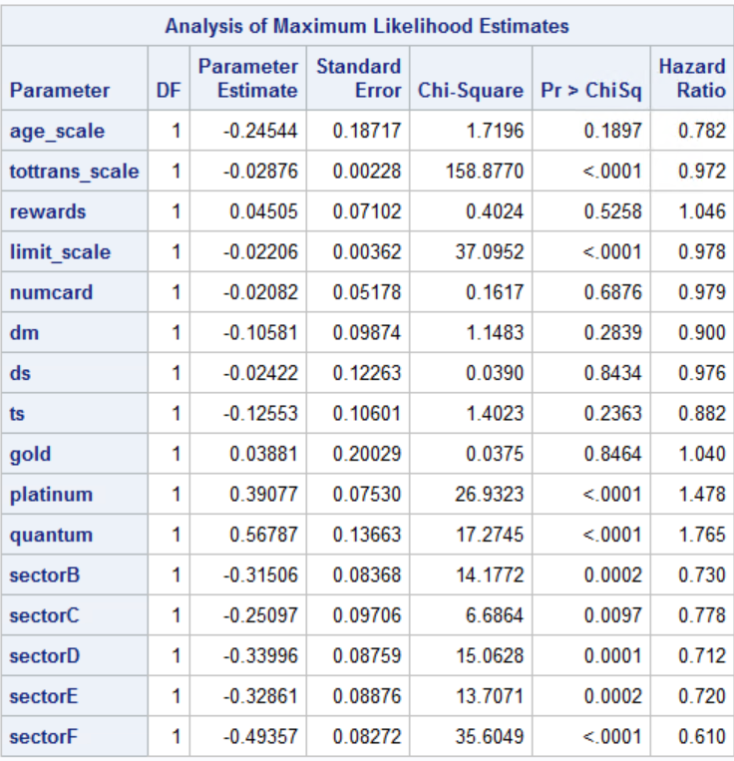

*Censoring variable is Status, if status = 0 that means duration is censored otherwise it is not. There are no intercepts in the model as it is a characteristic of partial likelihood.*

* Every $1000 increase in total transaction by the customer over 3-year period decreases the hazard of leaving the firm by 2.8%.
* Every $1000 increase in credit limit of the customer decreases the hazard of leaving the firm by 2.2%.
* The hazard of a platinum card customer leaving the firm is 47.8% more than the standard card customer.
* The hazard of a quantum card customer leaving the firm is 76.5 % more than the standard card customer.
* The hazard of customers with cards affiliated to professional organisations is 27% less than non-affinity card holders.
* The hazard of customers with cards affiliated to sports organisations is 22.2% less than non-affinity card holders.
* The hazard of customers with cards affiliated to Financial organisations is 28.8% less than non-affinity card holders.
* The hazard of customers with cards affiliated to University organisations is 28% less than non-affinity card holders.
* The hazard of customers with cards affiliated to commercial organisations is 39% less than non-affinity card holders.

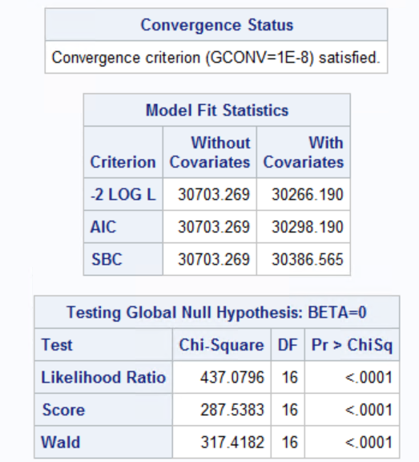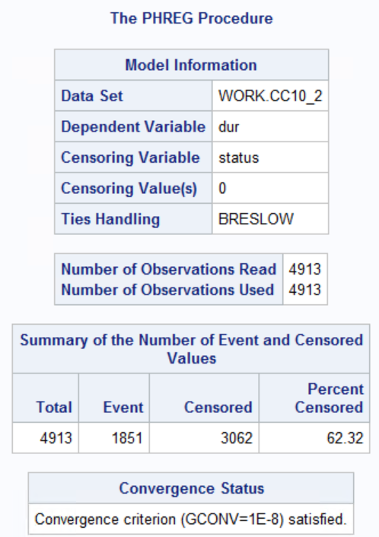

Based on all the above three criteria, we can see that the values of the model with intercept and covariates is less than the intercept only criterion. Therefore, the model which we used is a better fit than the intercept only model.