Financial Statement Analysis

Starbucks Corp vs Dunkin’ Group

By: Manisha Gupta

Net ID: mxg176230

Email:Mxg176230@utdallas.edu

University of Texas at Dallas

ACCT 6301

Table of Contents

Industry and company overview 2

Starbucks Corp 2

Dunkin’s Brands Group, Inc 2

Cash and cash equivalents 3

Receivables 3

Results, Analysis 4

Current liabilities 7

Long-term liabilities 8

Stockholders' equity 10

# **Industry and company overview**

The industry - Eating and drinking places include retail companies selling prepared foods and drinks to customers in the exchange of money on its premises but many establishments have option to take out as well. This industry-type encompasses a wide variety of lunch counters, roadside cafes and refreshment stands selling fast foods and drinks for immediate consumption.  Restaurants, lunch counters, and drinking places operated as a subordinate service facility by other companies are not included in this industry type, unless they are operated as leased departments by outside operators.  In other words, a company whose primary business is to provide prepared food and drinks to customers, comes under this category. The restaurants and lunch counters operated by hotels are classified in Services, and not included in this industry type because their primary aim is to provide accommodation to customers.

## **Starbucks Corp**

Starbucks Corp is an American coffee company and coffee house chain. It is based in Seattle Washington, United States and listed in NASDAQ stock exchange under the symbol “SBUX”. Starbucks has secured a position in top 20 world’s most admired company list. It has retail stores in 75 countries such as Tokyo, Russia, United Kingdom, Canada, etc. and sells everything from freshly brewed coffees, bakery, tea, fast foods and merchandises such as mugs and accessories. Starbucks’s aim is to stand out as one of the most recognized and respected brands in the world. To attain this goal, Starbucks is thriving to expand globally in a thoughtful fashion. They are opening more outlets in both existing, developed markets such as the U.S. U.K., and in newer, higher growth markets such as China, Japan. Along with adding new stores worldwide, they are using their experience gained through their conventional store model to offer consumers new coffee and other variety of products. It also provides warm and pleasant coffeehouse atmosphere that attract customers to stay and enjoy their coffee while they read, work, and chat with friends. Starbucks is committed towards “Global Social Impact strategy” under which they adhere regulations related to ethically sourcing high-quality coffee and contribute positively to the communities. Starbucks results for fiscal 2017 is outstanding. They added 2320 new stores worldwide and reported net revenues of $22.4 billion (increased by 5% or total $1.1 billion from last year). Starbucks anticipate that the diluted earnings per share for fiscal 2018 is expected to grow in excess of 40% when compared to fiscal 2017, largely due to the anticipated gain associated with the pending acquisition of East China.

## **Dunkin’s Brands Group, Inc**

Dunkin’ Brands Group, Inc. is one of the world’s leading franchisors of quick service restaurant and coffee chain. They offer variety of coffee, ice cream, muffins, sandwiches and other baked items. Dunkin’ Brands Group consist of Dunkin’ Donuts and Baskin- Robbins brands. The company franchises restaurants under its Dunkin’ Donuts and Baskin-Robbins brands. They license Dunkin’ Donuts brand products and sell their products in certain retail establishments such as retail packaged coffee, Dunkin’ K-Cup® pods, and ready-to-drink bottled iced coffee. Through their Baskin-Robbins brand, they franchise restaurants selling ice cream, frozen beverages, and related products. The company has grown as one of the major global brands with 20500 stores in more than 60 countries worldwide. They have four major operating segments- Dunkin’ Donuts U.S., Dunkin’ Donuts International, Baskin-Robbins U.S., and Baskin-Robbins International. The Dunkin’ Group derives major portion of revenue from four sources - (i) royalty income and fees associated with franchised restaurants; (ii) rental income from restaurant properties that they lease or sublease to franchisees; (iii) sales of ice cream and other products to franchisees in global markets; and (iv) other income including fees for the licensing of the Dunkin’ Donuts brand for products sold in retail channels. Dunkin’ Group reported total sales growth of $43.1 million or 8%, which was the result of 440 new restaurants opened in fiscal year 2017. Approximately 69% of company’s revenue for fiscal year 2017 was derived from royalty income and franchise fees. Net income attributable to Dunkin’ Brands increased $155.3 million, or 79.4%, for fiscal year 2017 driven by a net benefit from income taxes of $11.6 million compared to income tax expense in the prior fiscal year of $117.7 million, as well as the increase in operating income of $32.3 million.

# **Cash and cash equivalents**

Cash and cash equivalent are the most liquid current asset found in company’s “Consolidated Balance Sheets” sections. Starbucks and Dunkin’s balance sheet can be found on page 67 and page 63 respectively in their annual report. Both Dunkin' Donuts and Starbucks’s cash and cash equivalents increased from 2015 to 2016 and 2016 to 2017.

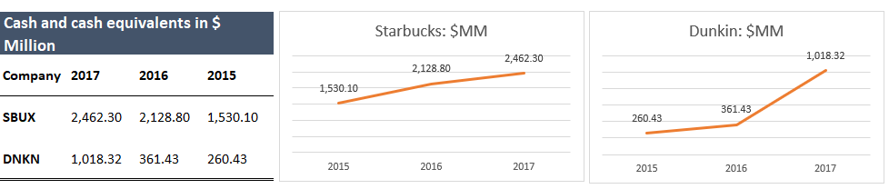

**Analysis and insights:** Starbucks’s cash and cash equivalents augmented from 2015 to 2016 and 2016 to 2017, suggesting total growth of $932.2 million or 61% over the period of two fiscal years. Starbucks’s cash and cash equivalents increased more during 2016, primarily as a result of net cash provided by operating activities increased from 2015 to 2016 but then it slightly declined from 2016 to 2017. As shown in above graph, Dunkin’ Group’s cash and cash equivalents also improved from 2015 to 2016 and 2016 to 2017.The company witnessed a drastic positive change in cash and cash equivalents of $656.89M or 182% in 2017, mainly because of the financing activities that brought net cash of $418M in the form of repayment of loan or other interest income.

# **Receivables**

Receivables are created by providing goods and services to customers on credit and are reported as current assets on a company's balance sheet. They are considered a liquid asset as they require payment within one year. Receivable are the amount owned by customer to company for used goods or services. According to Notes to Financial statements, mentioned in the company’s annual report, Starbucks has account receivable while Dunkin’ Group has account receivable, notes receivable and other receivable in their balance sheet statement. Below table and graphs represent total receivable for both companies-

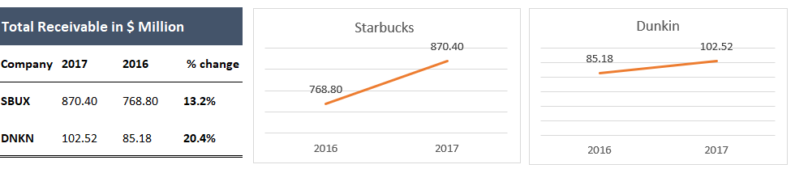

Starbucks reported account receivable of $870.4M in 2017 and $768.8M in 2016, suggesting total growth of 13.2% during the mentioned period whereas Dunkin showed total receivable of $102.52M in 2017 and $85.18M in 2016, growth of 20.4% from last year. Dunkin had account receivable of $44M and $51M and notes and other receivable of $40M and $51M in 2016 and 2017 respectively.

**Allowance for doubtful accounts receivable** (bad debts) is a contra account which decrease the balance of the company's gross accounts receivable. Dunkin’s allowance for doubtful accounts information can be found on page 77 and page 103 on its 2017 annual report. Dunkin’s allowance for doubtful accounts was $0.5M and $0.1M in 2017 and 2016. As per page 77 of Starbucks annual report, Company had doubtful accounts of $9.8M and $9.4M in 2017 and 2016.

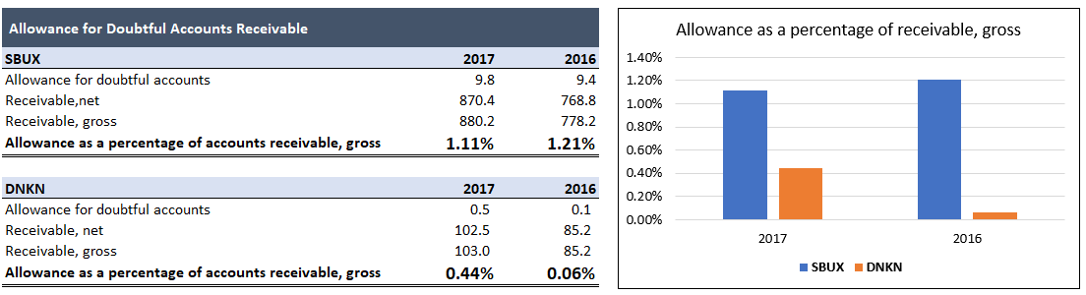

As shown in above graph, in 2016 and 2017, Starbucks’s gross receivable was $778.2M and $880.2M whereas Dunkin had $85.2M and $103M respectively. Starbucks’s allowance as percentage of receivable was 1.1% in 2017, slightly decreased but still way higher than Dunkin. On the other hand, Dunkin’s allowance ratio deteriorated from 2016 to 2017(0.44% in 2017 and 0.06% in 2016).

## **Results, Analysis**

The goal of this section is to analyze companies’ short-term liquidity ratio and find the areas where they are performing good or bad. Liquidity ratio analyze the ability of a company to meet both its current liability as they become due and their long-term liability as they become current. In the simple words, these ratios demonstrate the cash levels of a company and the ability to convert other assets into cash to pay off liability and other current obligations. Current assets include account receivable, inventory as they are easy to turn in to cash in the short term. If current assets of a business at the point in time are more than its current liabilities that means positive working capital, which tells that the company is not expected to suffer from liquidity crunch in near future. However, if current assets are less than current liabilities that indicates negative working capital, meaning that the business may not be able to pay off its current liabilities when due. Dunkin and Starbucks both showed positive net working capital during fiscal year 2017.

Note - Starbucks’s values are in $millions while Dunkin’s are in $thousands throughout this paper.

Here are the most common short-term liquidity ratios.

**1. Current Ratio-** The current ratio is a short-term liquidity ratio that measures a firm’s ability to pay off its short-term liabilities with its current assets within the period of one year. A company’ s current ratio is calculated by dividing current asset by current liabilities.

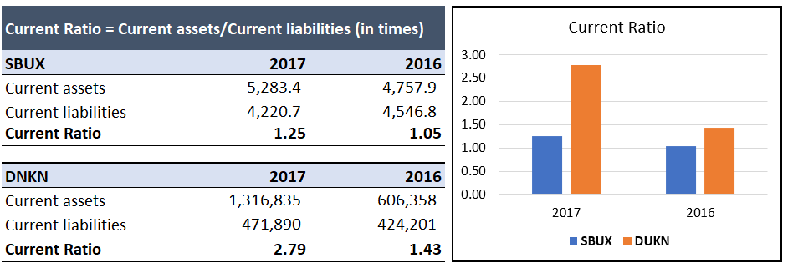

**Analysis and insights:** As presented above, Starbucks and Dunkin both have healthy current ratio fluctuating between 1.00 and 2.79, suggesting both company are well positioned to cover its current or short-term liabilities. As shown above for the last two, Dunkin demonstrated higher current ratio than Starbucks. Starbucks had current ratio 1.25 (i.e. 20% growth) in 2017 while Dunkin had 2.79 (95% growth) during this period. Dunkin has consistently displayed high current ratio, though significantly beyond 2.5 in 2017. Therefore, Dunkin is in a better position to repay its dues which are due next year. But as a barometer of short-term liquidity, the current ratio is limited by the nature of its components. As balance sheets are prepared as of a particular date, the actual amount of liquid assets may vary considerably from the date the balance sheets are prepared. Furthermore, accounts receivable and inventory may not truly be liquid.

**2. Quick Ratio -** Quick ratio is similar to current ratio but has the inventory and prepaid expenses excluded. The acid test of finance shows how quick assets can be converted to cash within 90 days or in the short-term. For the purpose of calculation of quick assets we are, including cash and cash equivalents, short term investment and account receivable from Starbucks’s current assets, and excluding restricted cash, restricted assets of advertising funds, prepaid income taxes and prepaid expenses & other current asset from the Dunkin’ current assets.

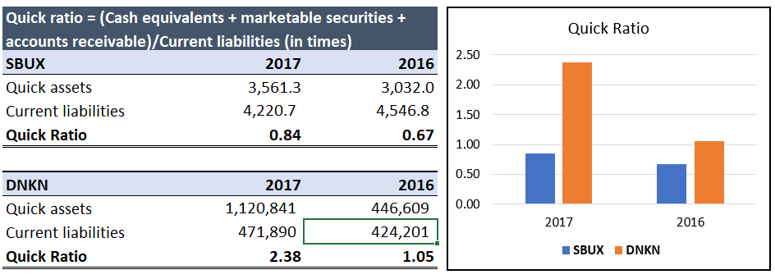

**Analysis and insights:** As a supplement to current ratio, quick ratio aims to show the more liquid current assets available to pay the more immediately payable liabilities. Quick ratio for Dunkin was higher than Starbucks from past two years. In 2017, Dunkin’s quick ratio was 2.38 times (increased by 127% from last year) which means Dunkin has more than enough money to cover its current liabilities; whereas Starbucks had 0.84 times (27% better than previous year) which tells the company has less current assets than required current liabilities when less liquid assets such as inventories, prepaid expenses were excluded.

**3. Accounts receivable turnover -** The ratio is used to evaluate the ability of a company to efficiently issue credit to its customers and collect funds from them in a timely manner. To calculate receivables turnover, add together beginning and ending accounts receivable to arrive at the average accounts receivable for the measurement period, and divide into the net credit sales for the year.

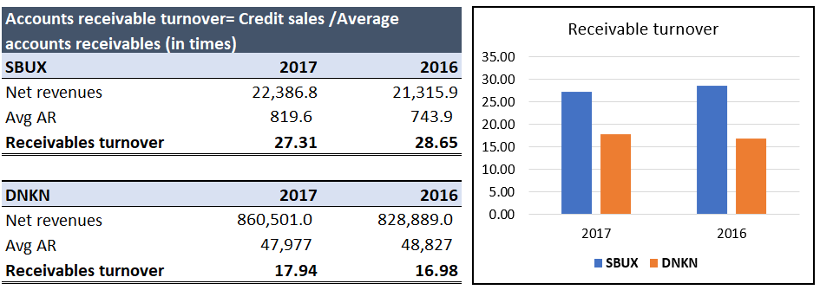

**Analysis and insights:** Account receivable turnover indicates how rapidly collections occurs. High receivable turnovers shows that company collects its receivable quickly - lower receivable turnover indicates slower collection cycles. In 2017 Starbucks’s account receivable turnover was 27.31 means high turnover ratio, that tells us that Starbucks collected its receivable 27.31 times in 2017. Dunkin’s account receivable turnover ratio was 17.94 in 2017, slightly higher than previous year, however, Starbucks has much better ratio than Dunkin which indicates more cash inflow in Starbucks.

**4. Average collection period (in days) -** The average collection period is the average number of days required by company to collect its account receivables.

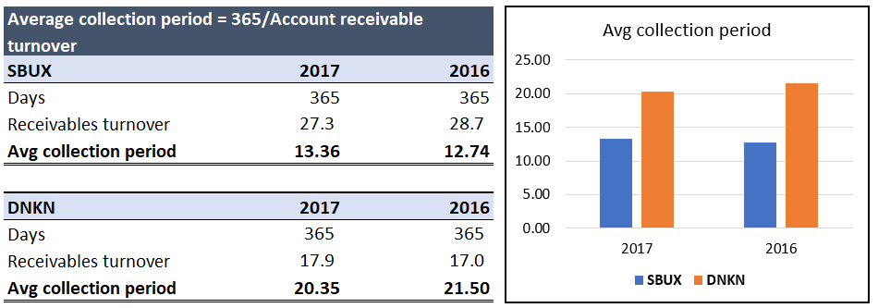

**Analysis and insights:** As seen above, Starbucks collects cash from sales in just 13.3 days, while Dunkin needs 20.4 days in average to collect its receivable. It is better to get account receivable collected as soon as possible and re-invest the collected amount in to business.

# **Current liabilities**

Current liabilities represents obligations of a company that are due within next 12 months or with in one fiscal year. These are short term debts and are important in analyzing a company’s financial health as it requires to covert its current assets in to cash to pay.

Current liabilities appears on the company’s balance sheet statement and include all short-term debt account, account and notes payable, accrued liabilities other similar debts. The balance sheet statement of Starbucks and Dunkin’ Group are mentioned on page 67 and page 63 respectively on their 2017 annual report. Apart from account payable and current portion of long-term debt as they are common items in both, Starbucks has accrued liability, insurance reserves and stored value card liability whereas Dunkin’Group has capital lease obligations, liabilities of advertising funds, deferred income and other current liabilities in its current liability part. The balance sheet of Starbucks shows the current liability over total liabilities and shareholder’s equity are 29% in 2015, 32% in 2016 and again 29% in 2017. Starbucks’s total current liabilities increased by 16% during these three years. Dunkin’s balance sheet exhibits that total current liabilities decreased slightly as a percentage of total assets - 13% in 2015, 13% in 2016 and 12% in 2017. Dunkin’s total current liabilities has increased by 13% from 2015 to 2017.

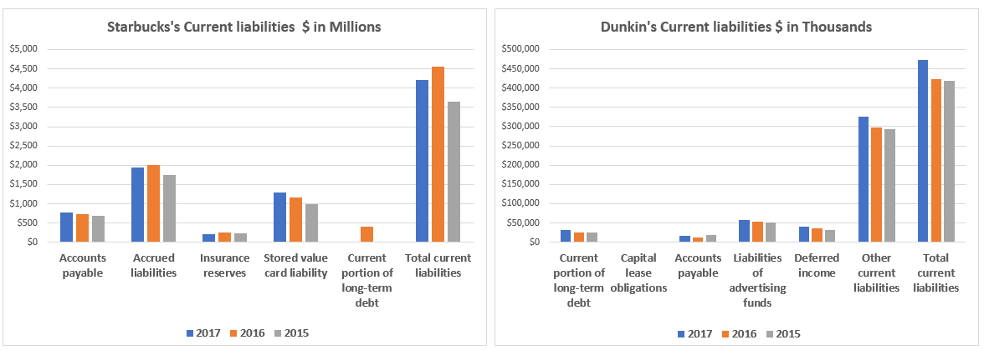

Starbucks stated on its 2017 annual report that as of Oct 2017, they don’t have any contingency liability that affects its financial statements. Although, Starbucks is party to various other legal proceedings emerging in the ordinary course of business but is not currently facing any legal proceeding that could have an adverse effect on its consolidated financial position, results of operations or cash flows. However, they signed an agreement to acquire the remaining 50% ownership of their East China joint venture from Uni-President Enterprises Corporation (“UPEC”) and President Chain Store Corporation (“PCSC”) for approximately $1.3 billion to unify their business operations across mainland China. The acquisition will turn these licensed stores to company-operated stores.

Dunkin’s Group has various supply chain agreements that require various purchase commitments, the majority of which result in the company being contingently liable upon early termination of the agreement. As of December 30, 2017, and December 31, 2016, the Company was contingently liable under such supply chain agreements for approximately $116.7 million and $136.2 million, respectively.

Further, Canada had filed a lawsuit against Dunkin’s group in 2003 for breaching its franchising agreements. During fiscal year 2016, Dunkin’ Group received the final decision and paid net C$17.4 million with respect to this matter. Additionally, the Company is engaged in several litigation matters arising in the ordinary course of its business as a franchisor. Such matters include disputes related to compliance with the terms of franchise and development agreements, including claims or threats of claims of breach of contract, negligence, and other alleged violations by the Company. On December 30, 2017 and December 31, 2016, contingent liabilities totaling $3.6 million and $5.6 million respectively, were mentioned under the other current liabilities in the consolidated balance sheets to reflect the company’s estimate of the probable losses which may be incurred in connection with all outstanding litigation.

# **Long-term liabilities**

Long term liabilities is a non-current liability and appears on the statement of balance sheet. It represents obligations that is not due within one year of the balance sheets date. It’s a debt that must be paid sometimes beyond one year.

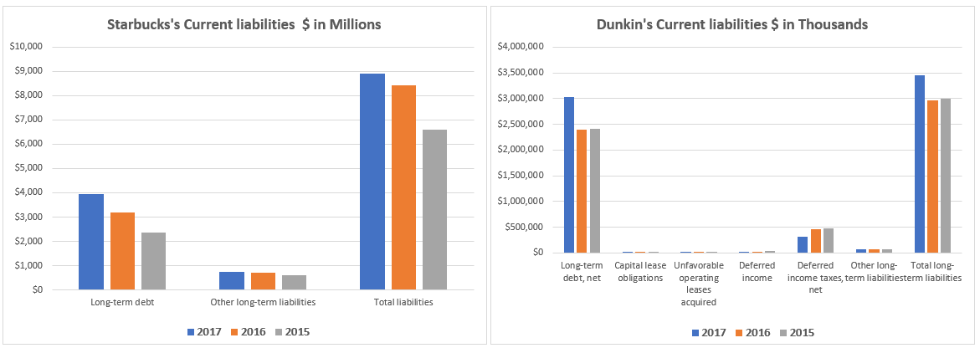

Starbucks’s long-term debt and other long-term liabilities items are recorded in long-term liabilities section on the its balance sheet - this information can be found on page 67 on its 2017 annual report. In the past 3 years, Starbucks reported an increase of 68% and 26% in long-term debt and other long-term liability respectively. The company issued long term debt of ¥85 billion to hedge the foreign currency exposure of its investment in Japan and also paid $400 million of senior notes at maturity. Long term-debt grew from 19% to 27% of assets. Starbucks’s percentage of other long-term liabilities was relatively stable - 5 % in 2015, 2016 and 2017. Dunkin recorded long-term debt, net capital lease obligations, unfavorable operating leases acquired, deferred income, deferred income taxes and other long-term liabilities under long-term liability section on its balance sheet documented on page 63 on its 2017 annual reports. Dunkin’s long-term liabilities has increased by 16.5%, mainly due to increase in long term debt and other liabilities. Dunkin’s long-term debt has also increased by 25% in last 3 years. On the other hand, deferred income taxes has decreased by 34% during the same period. Dunkin’s balance sheet showed slight increase of long term debt over total asset i.e. 76% in 2015, 74% 2016 and 77% in 2017. As of December 30, 2017, Dunkin’s financing facility included original borrowings of approximately $1.75 billion, $1.40 billion, and $150.0 million related to the 2015 Class A-2-II Notes, the 2017 Class A-2 Notes, and the 2017 Variable Funding Notes respectively.

Let’s discuss solvency ratio for Starbucks and Dunkin.

**1. Interest coverage Ratio**- This ratio measures a company’s ability to make interest payments on its debt in a timely manner and is defined as a company's earnings before interest and taxes (EBIT) divided by interest expense. An interest coverage ratio of two or higher is generally considered satisfactory. In the below calculation, EBIT is calculated by adding interest expense in income before income tax.

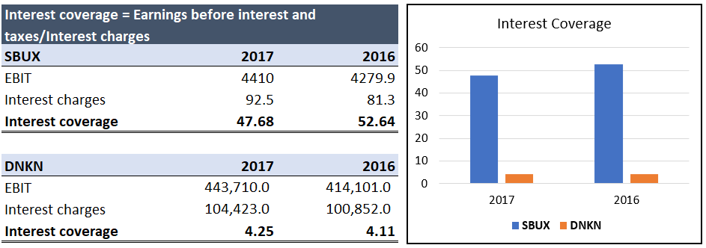

**Analysis and insights**: as presented above, both companies reported coverage ratio more than two that means both company are making more than enough money to pay its interest obligations. Starbucks’s coverages ratio deteriorated from 2016 to 2017 whereas Dunkin’s coverage ratio improved for the same period. Starbucks has more than ten times the interest coverage than Dinkins. Starbucks enjoyed coverage ratio of 46.68 while Dunkin reported 4.28 in the year of 2017 that exhibits, Starbucks has the biggest margin of safety in paying interest while Dunkin has the smallest margin of safety.

**2. Total-debt-to-total-assets -** Total Debt to total assets ratio indicates the proportion of a company's assets that are being financed with debt rather than equity. This ratio is used to measure the financial risk of a business. The total debt to total assets ratio is calculated by dividing a corporation's total liabilities by its total assets. Creditors prefer low debt ratios because the lower the ratio, the greater the cushion against creditors’ losses in the event of liquidation. A ratio greater than 1 shows that company has more liabilities than assets, while a low ratio indicates that the bulk of asset funding is coming from equity.

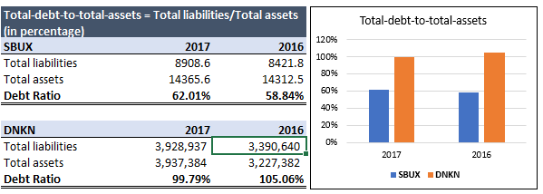

**Analysis and insights** Dunkin had higher ratio than Starbucks from last 2 years. Starbucks reported 62% of debt to asset ratio, a slight increase as compared to prior year while Dunkin exhibited 99.8% of debt to asset ratio, approx. 5% decrease with respect to last year. Starbucks’s debt to asset of 0.62 means that 62% assets of the company are owned by creditors and 38% by the shareholders. The Dunkin group reported 0.99 of debt to asset ratio suggesting that Dunkin’ brands Inc is progressively becoming more dependent on debt to grow its business. In summary when comparing Debt ratios, Starbucks will be highly favored than Dunkin’s.

# **Stockholders' equity**

Stockholder’s equity is an account on a company’s balance sheet that consists of share capital plus retained earnings. By rearranging the original accounting equation, Assets = Liabilities + Stockholders Equity, it can also be expressed as Stockholders Equity = Assets – Liabilities.

Stockholders Equity provides highly useful information when analyzing financial statements. In events of liquidation, equity holders are later in line than debt holders to receive any payments which means that bond holders are paid before equity holders. Preferred stock, common stock, additional paid‐in‐capital, retained earnings, and treasury stock are all reported on the balance sheet in the stockholders' equity section. Starbucks and Dunkin’s balance sheet are on page 67 and 63 on their 2017 annual reports.

Statement of stockholders' equity is one of the financial statement prepared in the accounting cycle. This statement displays how equity changes from the beginning of an accounting period to the end.

Starbucks mentioned its equity statement under the title “Consolidated Statements of equity” on page 71 while Dunkin reported under “Consolidated Statements of Stockholders’ Equity (Deficit)” on page 67.

Starbucks’s common stocks are as follows - 2400 million shares of authorized, 1431.6 million shares are issued and 1460.5 million are outstanding as of Oct 2017. In addition to that, they also authorized 7.5 million shares of preferred stock, none of which was outstanding at Oct, 2017. Also, Starbucks repurchased 37.5 million shares of common stock at a total cost of $2.1 billion, and 34.9 million shares at a total cost of $2.0 billion for the years ended October 1, 2017 and October 2, 2016, respectively. As of October 1, 2017, 80.3 million shares remained available for repurchase under current authorizations. Shares repurchased are not displayed separately as treasury stock on the financial statements. Instead, the par value of repurchased shares is deducted from common stock and the excess repurchase price over par value is deducted from additional paid-in capital and from retained earnings, once additional paid-in capital is depleted. Starbucks declared cash dividend of $1.05 per share on its recent consolidated statement of equity.

On the other hand, as of Dec 2017, Dunkin had 475,000,000 shares authorized; 90,404,022 shares issued and 90,377,245 shares outstanding of common stock. They had 91,464,229 shares issued and 91,437,452 shares outstanding at December 31, 2016. Further, they authorized 25,000,000 shares preferred stock, none of which was issued and outstanding. As reported in the balance sheet, Dunkin had treasury stock of 26777 shares with total cost of 1060 thousands. As of Dec 2017, cash dividends declared per common share was $1.29.

**1. Return on equity:** This ratio is used to determine a corporation's profitability by revealing how much profit a company generates with the money shareholders have invested. ROE is expressed as Net Income divided by Shareholder's Equity.

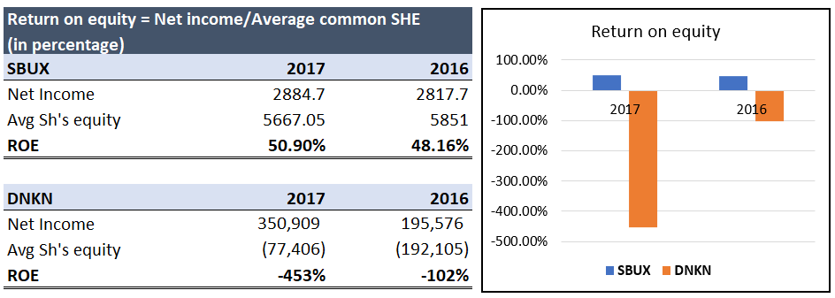

**Analysis and insights**: as shown in above graph, return on equity of Starbucks has improved from 2016 to 2017. Starbucks reported 50.9% in 2017 and 48.16% in 2016 which is pretty high as per industry standard. Starbucks’s ROE of 50.9% means that $0.509 net income for every dollar that has been invested by shareholder. In contrast, Dunkin has negative shareholder equity that means that liabilities exceed its total assets.

**2. Price to earnings ratio:** PE ratio is one of the most widely used tools for stock selection. It is calculated by dividing the current market price of the stock by its earning per share (EPS). it demonstrates how much an investor is willing to pay for one dollar of earnings. A high PE ratio generally indicates increased demand because investors anticipate earnings growth in the future. Stock price as of July 13, 2018 and EPS- basic as of fiscal year 2017 are considered for the P-E ratio calculations

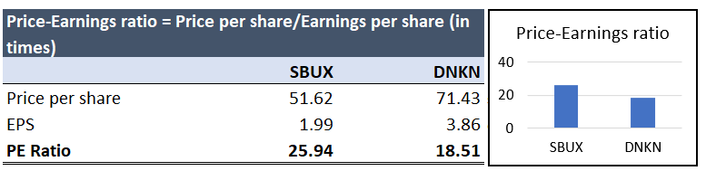

**Analysis and insights**: This ratio shows how much investors are willing to pay per peso of reported profits. Between two, Starbucks seems to be the firm of choice of the investors as it has high PE ratio. As you can see, the Starbucks’s ratio is 25.9 times, means that investors are willing to pay 25.9 dollars for every dollar of earnings. Usually this ratio is relatively higher for firms with strong growth prospects and little risk, but low for slowly growing and risky firms. Sometimes, high PE ratio means overpriced stock when we compare other stock of same industry.

**3. Dividend yield:** This ratio measures how much a company pays out in dividends each year relative to its share price. To calculate dividend yield, we divided dividend per share by current market price of the stock.

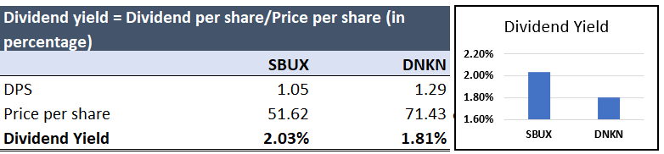

**Analysis and insights**: It is important to realize that this ratio shows the return that shareholders are actually achieving on their investment, using current market value for listed shares. As a rule of thumb, a yield of three percent to five percent is considered enticing. As depicted in above table, Starbucks has greater dividend yield towards its shareholders as compared with Dunkin’s. Investors will prefer Starbucks over Dunkin because they are getting 2.03% (13% higher than Dunkin) on their investment in the form of dividends if they buy the company’s common stock at current market price.