Statistics for Management and Economics, Tenth Edition
Formulas

Numerical Descriptive techniques
Population mean
= 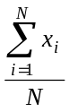
Sample mean
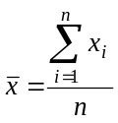
Range
Largest observation - Smallest observation
Population variance
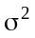= 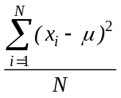
Sample variance
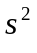 = 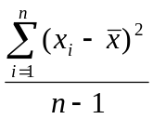
Population standard deviation
= 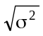
Sample standard deviation
s = 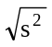
Population covariance
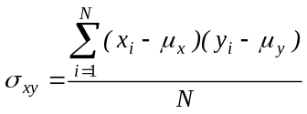
Sample covariance
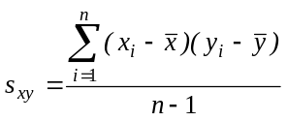
Population coefficient of correlation
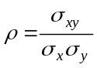
Sample coefficient of correlation
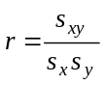
Coefficient of determination
R² = r²
Slope coefficient
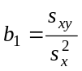
y-intercept
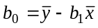

Probability

Conditional probability
P(A|B) = P(A and B)/P(B)
Complement rule
P(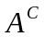) = 1 – P(A)
Multiplication rule
P(A and B) = P(A|B)P(B)

Addition rule
P(A or B) = P(A) + P(B) - P(A and B)
Bayes’ Law Formula
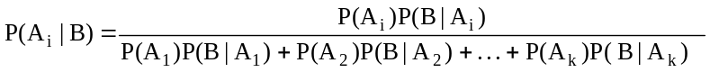
Random Variables and Discrete Probability Distributions
Expected value (mean)
E(X) = 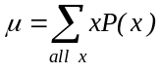
Variance
V(x) =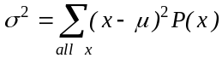
Standard deviation
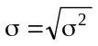

Covariance

COV(X, Y) = σ_{xy} = 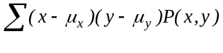

Coefficient of Correlation
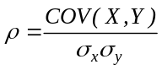

Laws of expected value
1. E(c) = c
2. E(X + c) = E(X) + c
3. E(cX) = cE(X)

Laws of variance
1.V(c) = 0
2. V(X + c) = V(X)
3. V(cX) = 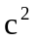V(X)

Laws of expected value and variance of the sum of two variables
1. E(X + Y) = E(X) + E(Y)
2. V(X + Y) = V(X) + V(Y) + 2COV(X, Y)

Laws of expected value and variance for the sum of more than two variables
1. 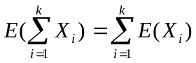
2. 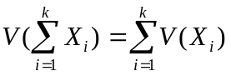if the variables are independent

Mean and variance of a portfolio of two stocks
E(R_{p}) = w₁E(R₁) + w₂E(R₂)
V(R_{p}) = 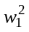V(R₁) + 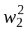V(R₂) + 2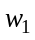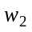COV(R₁, R₂)
= 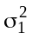 + 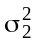 + 2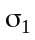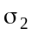

Mean and variance of a portfolio of k stocks
E(R_{p}) = 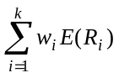
V(R_{p}) = 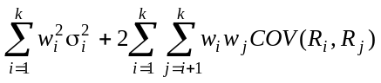
Binomial probability
P(X = x) = 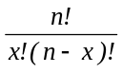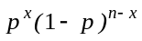
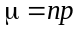
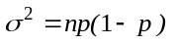
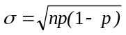
Poisson probability
P(X = x) = 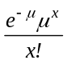

Continuous Probability Distributions
Standard normal random variable
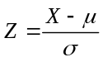
Exponential distribution
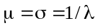
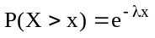
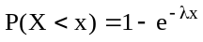
F distribution
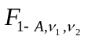= 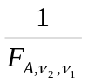

Sampling Distributions
Expected value of the sample mean
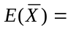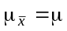
Variance of the sample mean
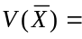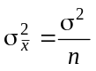
Standard error of the sample mean
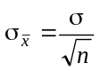
Standardizing the sample mean
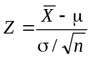
Expected value of the sample proportion
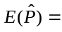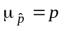
Variance of the sample proportion
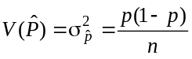
Standard error of the sample proportion
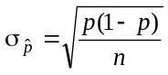
Standardizing the sample proportion
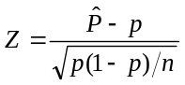
Expected value of the difference between two means
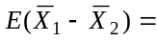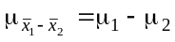
Variance of the difference between two means
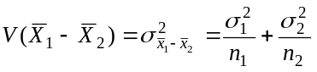
Standard error of the difference between two means
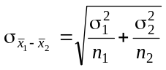
Standardizing the difference between two sample means
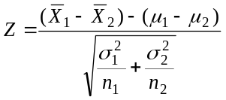

Introduction to Estimation
Confidence interval estimator of
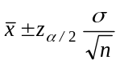
Sample size to estimate
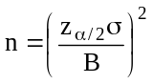

Introduction to Hypothesis Testing
Test statistic for
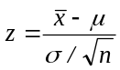

Inference about One Population
Test statistic for
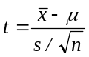
Confidence interval estimator of
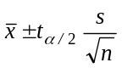
Test statistic for
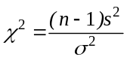
Confidence interval Estimator of
LCL = 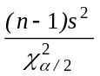
UCL = 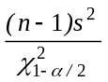
Test statistic for p
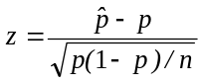
Confidence interval estimator of p
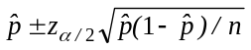
Sample size to estimate p
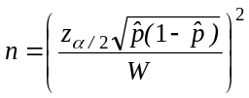
Confidence interval estimator of the total of a large finite population
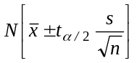
Confidence interval estimator of the total number of successes in a large finite population
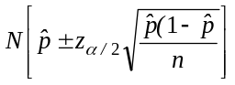

Inference About Two Populations
Equal-variances t-test of 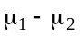
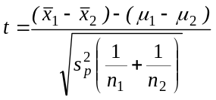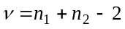
Equal-variances interval estimator of
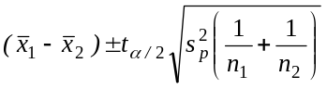
Unequal-variances t-test of
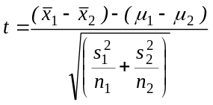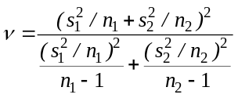
Unequal-variances interval estimator of
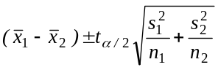
t-Test of 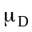
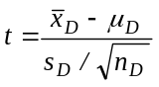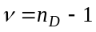
t-Estimator of
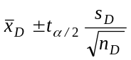
F-test of 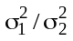
F = 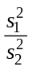 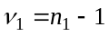and 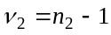
F-Estimator of 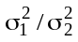
LCL = 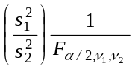
UCL = 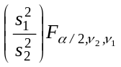
z-Test and estimator of 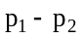
Case 1: 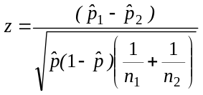
Case 2: 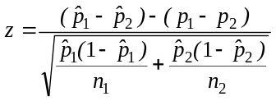
z-estimator of
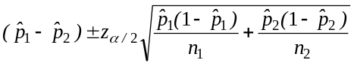

Analysis of Variance
One-way analysis of variance
SST = 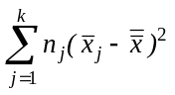
SSE = 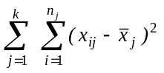
MST = 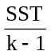
MSE = 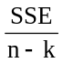
F = 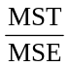
Two-way analysis of variance (randomized block design of experiment)
SS(Total) = 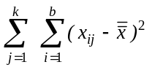
SST =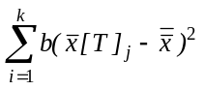
SSB =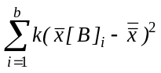
SSE = 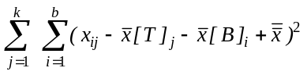
MST =
MSB = 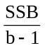
MSE = 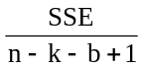
F =
F= 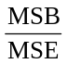
Two-factor experiment
SS(Total) = 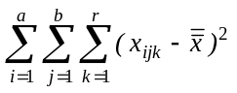
SS(A) = 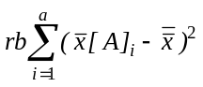
SS(B) =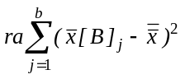
SS(AB) =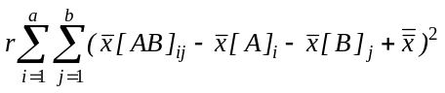
SSE = 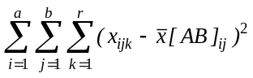
F = 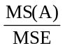
F = 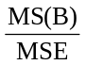
F = 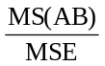
Least Significant Difference Comparison Method
LSD = 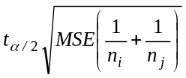
Tukey’s multiple comparison method
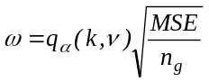

Chi-Squared Tests
Test statistic for all procedures
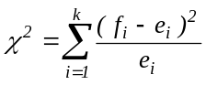

Simple Linear Regression
Sample slope
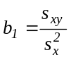
Sample y-intercept
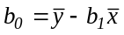

Sum of squares for error
SSE = 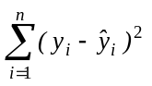

Standard error of estimate
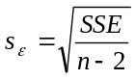
Test statistic for the slope
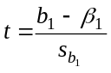
Standard error of 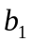
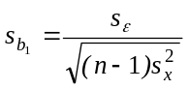

Coefficient of determination
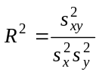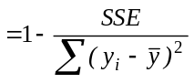

Prediction interval
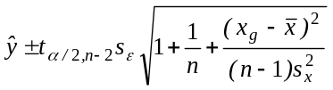

Confidence interval estimator of the expected value of y
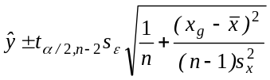
Sample coefficient of correlation
Test statistic for testing = 0
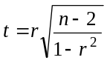

Multiple Regression

Standard Error of Estimate
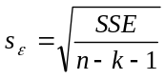
Test statistic for
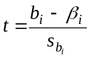

Coefficient of Determination

Adjusted Coefficient of Determination
Adjusted 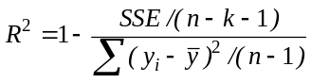
Mean Square for Error
MSE = SSE/k
Mean Square for Regression
MSR = SSR/(n-k-1)
F-statistic
F = MSR/MSE

Durbin-Watson statistic
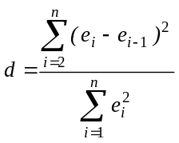

Nonparametric Statistical techniques

Wilcoxon rank sum test statistic

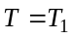

E(T) = 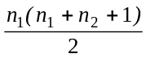

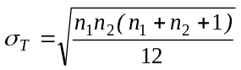

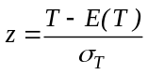

Sign test statistic

x = number of positive differences

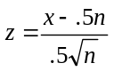

Wilcoxon signed rank sum test statistic

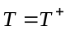
E(T) = 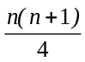

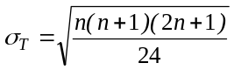

Kruskal-Wallis Test

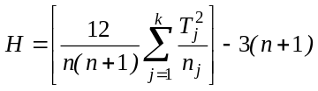

Friedman Test

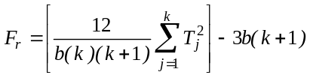

Spearman rank correlation coefficient

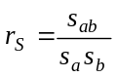

Spearman Test statistic for n > 30

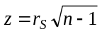
Time Series Analysis and Forecasting
Exponential smoothing
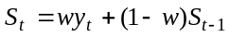

Statistical Process Control
Centerline and control limits for chart using S
Centerline =
Lower control limit = 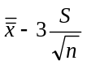
Upper control limit = 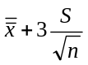
Centerline and control limits for the p chart
Centerline =
Lower control limit = 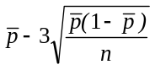
Upper control limit = 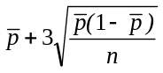

Decision Analysis
Expected Value of perfect Information
EVPI = EPPI - EMV*
Expected Value of Sample Information
EVSI = EMV' - EMV*

