**Applied Parallel Computing HW 1**

**Manisha Agrawal**

**1). A pThreads C program to multiply two square matrices. I am multiplying two 8*8 matrices using 4 threads. Also I have included a non-threaded routine to test against the threaded routine output. A structure is used to pass arguments to mulArrayPthread function. The members of which are 2 input vectors, output vector and startId.**

/* ============================================================================

Name : mul_pthreads.c

Author : Manisha Agrawal

Create a pThreads or C++11 program to multiply two square matrices of arbitrary size.

Fill matrices with random double data. Include a non-threaded routine to multiply

the matrices in order to check. Write a test routine to make sure that both methods

produce the same answer to within a reasonable tolerance. ============================================================================

*/

#include <pthread.h>

#include <stdio.h>

#include <stdlib.h>

#define NTHREADS 4

#define ARRAYSIZE 8

typedef struct

{

int startIdx;

double **arrC, **arrA, **arrB;

} mulType;

void *mulArrayPthread(void *x)

{

mulType *p = (mulType *) x;

int blockSize = ARRAYSIZE/NTHREADS;

int end = (*p).startIdx + blockSize;

printf("Start=%d\tEnd=%d\n",(*p).startIdx, end);

int i, j ,k;

for (i=(*p).startIdx;i<end;i++)

{

for(j=0; j<ARRAYSIZE; ++j)

for(k=0; k<ARRAYSIZE; ++k)

(*p).arrC[i][j] += (*p).arrA[i][k]*(*p).arrB[k][j];

}

return NULL;

}

int main(int argc, char *argv[])

{

int i, j, k, tids[NTHREADS];

pthread_t threads[NTHREADS];

pthread_attr_t attr;

double **A_array=(double**)malloc(ARRAYSIZE*sizeof(double*));

double **B_array=(double**)malloc(ARRAYSIZE*sizeof(double*));

double **Non_array=(double**)malloc(ARRAYSIZE*sizeof(double*));

double **Thread_array=(double**)malloc(ARRAYSIZE*sizeof(double*));

for(i=0;i<ARRAYSIZE;i++)

{

A_array[i]=(double*)malloc(ARRAYSIZE*sizeof(double));

B_array[i]=(double*)malloc(ARRAYSIZE*sizeof(double));

Non_array[i]=(double*)malloc(ARRAYSIZE*sizeof(double));

Thread_array[i]=(double*)malloc(ARRAYSIZE*sizeof(double));

}

for (i = 0; i < ARRAYSIZE; i++)

{

for(j=0; j < ARRAYSIZE; j++)

{

A_array[i][j] = rand()/(float)RAND_MAX;

B_array[i][j] = rand()/(float)RAND_MAX;

}

}

//Non-threaded routine

for(i=0; i<ARRAYSIZE; ++i)

{

for(j=0; j<ARRAYSIZE; ++j)

{

Non_array[i][j]=0.0;

for(k=0; k<ARRAYSIZE; ++k)

Non_array[i][j] = Non_array[i][j] + (A_array[i][k] * B_array[k][j]) ;

}

}

int index=ARRAYSIZE/NTHREADS ;

mulType **datas = malloc(NTHREADS*sizeof(mulType));

for (i = 0; i != NTHREADS ; i++)

{

datas[i] = malloc(sizeof(mulType));

datas[i]->startIdx = index*i;

datas[i]->arrA = A_array;

datas[i]->arrB = B_array;

datas[i]->arrC = Thread_array;

}

for (i=0; i< NTHREADS; i++)

{

tids[i] = i;

pthread_create(&threads[i], NULL, mulArrayPthread, (void *)(datas[i]));

}

/* Wait for all threads to complete then print global sum */

for (i=0; i<NTHREADS; i++)

{

pthread_join(threads[i], NULL);

}

for (i=0;i<ARRAYSIZE;i++)

{

for (j=0;j<ARRAYSIZE;j++)

{

printf("[%d][%d]:Serial=%f\tThread=%f\n",i,j, Non_array[i][j], Thread_array[i][j]);

}

}

/* Clean up and exit */

pthread_attr_destroy(&attr);

pthread_exit (NULL);

return 0;

}

**Output**

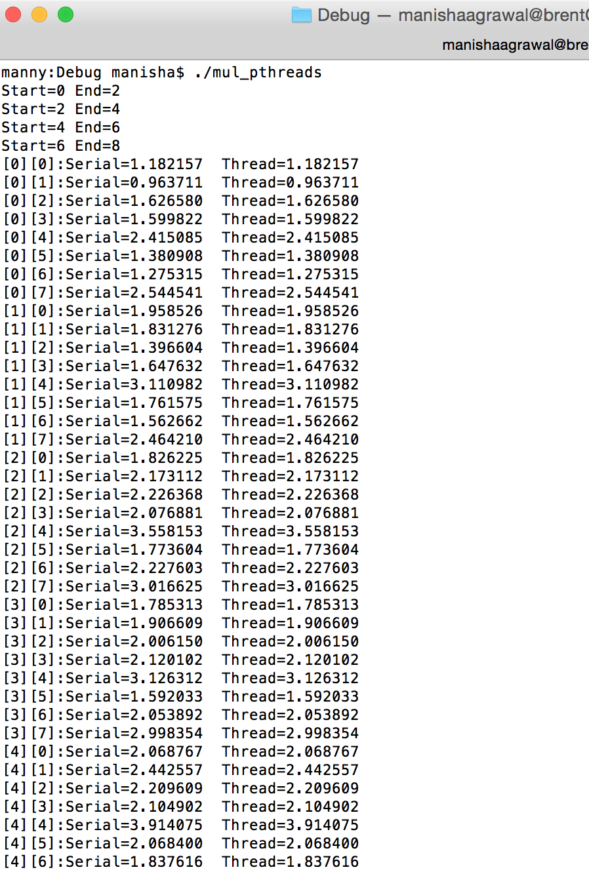

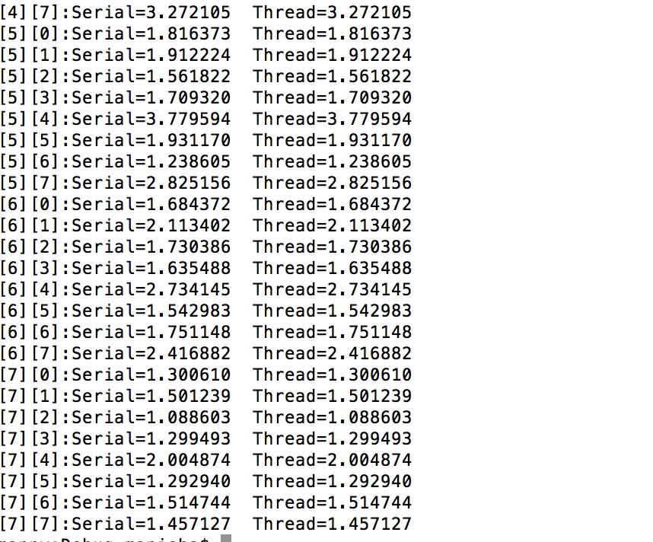

**2). A Cuda program to multiply two square matrices. I am multiplying two 2-D matrices, also I have included a serial routine to test against the parallel routine output. Random floating point values were stored in the 2 input matrix. After the computation of parallel resultant array, each element was compared with their corresponding serial array elements. A root mean square of the error was calculated. From the output we can deduce that as the number of elements increases the error also increases.**

/*CUDA 2-D Matrix Multiplication*/

#include <stdio.h>

#include <math.h>

#define TILE_WIDTH 2

#define WIDTH 100

__global__ void MatrixMul( float *A_d , float *B_d , float *C_d)

{

// calculate thread id

unsigned int col = TILE_WIDTH*blockIdx.x + threadIdx.x ;

unsigned int row = TILE_WIDTH*blockIdx.y + threadIdx.y ;

C_d[row*WIDTH+col] = 0;

for (int k = 0 ; k<WIDTH ; k++ )

{

C_d[row*WIDTH + col]+= A_d[row * WIDTH + k ] * B_d[ k * WIDTH + col] ;

}

}

// main routine

int main ()

{

float array1_h[WIDTH][WIDTH] ,array2_h[WIDTH][WIDTH];

float non_array_h[WIDTH][WIDTH] ,M_result_array_h[WIDTH][WIDTH] ;

float *array1_d , *array2_d ,*M_result_array_d ; // device array

int i , j ;

//input in host array

for ( i = 0 ; i<WIDTH ; i++ )

{

for (j = 0 ; j<WIDTH ; j++ )

{

array1_h[i][j] =(float)rand()/(float)RAND_MAX;

array2_h[i][j] = (float)rand()/(float)RAND_MAX;

}

}

//Non-threaded routine

for(i=0; i<WIDTH; ++i)

{

for(j=0; j<WIDTH; ++j)

{

non_array_h[i][j]=0;

for(int k=0; k<WIDTH; ++k)

{

non_array_h[i][j] += array1_h[i][k] * array2_h[k][j] ;

}

}

}

//create device array cudaMalloc ( (void **)&array_name, sizeofmatrixinbytes) ;

cudaMalloc((void **) &array1_d , WIDTH*WIDTH*sizeof (float) ) ;

cudaMalloc((void **) &array2_d , WIDTH*WIDTH*sizeof (float) ) ;

//copy host array to device array; cudaMemcpy ( dest , source , WIDTH , direction )

cudaMemcpy ( array1_d , array1_h , WIDTH*WIDTH*sizeof (float) , cudaMemcpyHostToDevice ) ;

cudaMemcpy ( array2_d , array2_h , WIDTH*WIDTH*sizeof (float) , cudaMemcpyHostToDevice ) ;

//allocating memory for resultant device array

cudaMalloc((void **) &M_result_array_d , WIDTH*WIDTH*sizeof (float) ) ;

//calling kernel

dim3 dimGrid ( WIDTH/TILE_WIDTH , WIDTH/TILE_WIDTH ,1 ) ;

dim3 dimBlock( TILE_WIDTH, TILE_WIDTH, 1 ) ;

MatrixMul <<<dimGrid,dimBlock>>> ( array1_d , array2_d ,M_result_array_d) ;

//copy back result_array_d to result_array_h

cudaMemcpy(M_result_array_h , M_result_array_d , WIDTH*WIDTH*sizeof(float) ,

cudaMemcpyDeviceToHost) ;

float error = 0;

//print the result array

printf("*****************************************\n");

printf("Vector Multiplication of %d*%d matrix\n", WIDTH, WIDTH);

printf("*****************************************\n");

for ( i = 0 ; i<WIDTH ; i++ )

{

for ( j = 0 ; j < WIDTH ; j++ )

{

// printf ("%f %f\t",non_array_h[i][j], M_result_array_h[i][j] ) ;

**Output**

//Root mean square of the differences

error += pow(M_result_array_h[i][j]-non_array_h[i][j], 2);

}

//printf ("\n") ;

}

error = error/(WIDTH*WIDTH);

error = sqrt(error);

printf("*****************************************\n");

printf("Error:%f\n", error);

printf("*****************************************\n");

cudaFree(array1_d);

cudaFree(array2_d);

cudaFree(M_result_array_d);

return 0;

}

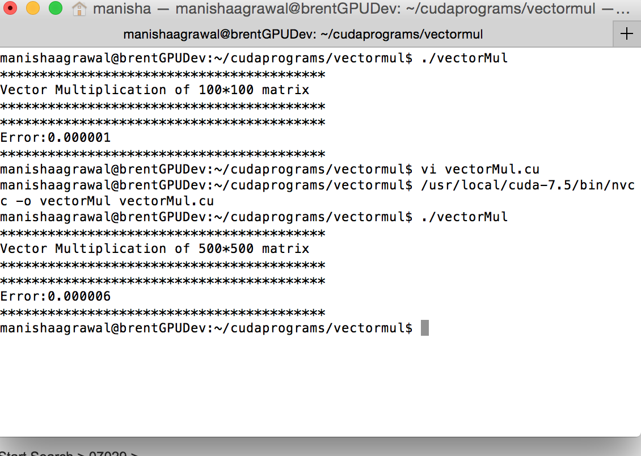

**3). A Cuda program to implement a dot product using shared memory and __syncthreads. Two 1-D arrays are taken as input where random floating point values were stored. . A dot product of the input matrices was also calculated using a serial method to test against the parallel output.**

#include <stdio.h>

#include <cuda_runtime.h>

#include <stdlib.h>

const int numElements = 1024;

const int threadsPerBlock = 256;

const int blocksPerGrid = (numElements+threadsPerBlock - 1) / threadsPerBlock;

__global__ void cuda_dot_kernel(float *a, float *b, float *c)

{

int id = (blockIdx.x * blockDim.x) + threadIdx.x;

int nextid = gridDim.x * blockDim.x;

__shared__ float shared_cache [threadsPerBlock];

int cacheIndex = threadIdx.x;

float temp = 0;

while(id < numElements)

{

temp+= a[id]*b[id];

id += nextid;

}

shared_cache[cacheIndex] = temp;

__syncthreads();

//for reduction thread block must be power of 2

for(blockDim.x/2; i!=0; i /= 2)

{

if(cacheIndex < i)

shared_cache[cacheIndex] += shared_cache[cacheIndex+i];

__syncthreads();

}

if ( cacheIndex == 0)

{

c[blockIdx.x] = shared_cache[0];

}

}

// Host main routine

int main(void)

{

int i;

cudaError_t err = cudaSuccess; // Error code to check return values for CUDA calls

size_t size = numElements * sizeof(float);

// Allocate the host input vector A,B,C

float *h_A = (float *)malloc(size);

float *h_B = (float *)malloc(size);

float *h_C = (float *)malloc(blocksPerGrid*sizeof(float));

// Verify that allocations succeeded

if (h_A == NULL || h_B == NULL || h_C == NULL)

{

fprintf(stderr, "Failed to allocate host vectors!\n");

exit(EXIT_FAILURE);

}

// Initialize the host input vectors

for (i = 0; i < numElements; ++i)

{

h_A[i] = rand()/(float)RAND_MAX;

h_B[i] = rand()/(float)RAND_MAX;

serial_product += h_A[i]*h_B[i];

}

//Allocate the device input vector A

float *d_A = NULL;

cudaMalloc((void**)&d_A, size);

// Allocate the device input vector B

float *d_B = NULL;

cudaMalloc((void**)&d_B,size);

// Allocate the device output vector C

float *d_C = NULL ;

cudaMalloc( (void**)&d_C, blocksPerGrid*sizeof(float) );

// Copy the host input vectors A and B to the device input vectors

err = cudaMemcpy(d_A, h_A, size, cudaMemcpyHostToDevice);

if (err != cudaSuccess)

{

fprintf(stderr, "Failed to copy vector A from host to device (error code %s)!\n", cudaGetErrorString(err));

exit(EXIT_FAILURE);

}

err = cudaMemcpy(d_B, h_B, size, cudaMemcpyHostToDevice);

if (err != cudaSuccess)

{

fprintf(stderr, "Failed to copy vector B from host to device (error code %s)!\n", cudaGetErrorString(err));

exit(EXIT_FAILURE);

}

// Launch the Dot Vector CUDA Kernel

cuda_dot_kernel<<<blocksPerGrid, threadsPerBlock>>>(d_A, d_B, d_C);

// Copy device result to the host result

err = cudaMemcpy(h_C, d_C, blocksPerGrid*sizeof(float), cudaMemcpyDeviceToHost);

if (err != cudaSuccess)

{

fprintf(stderr, "Failed to copy result from device to host (error code %s)!\n", cudaGetErrorString(err));

exit(EXIT_FAILURE);

}

// Free device global memory

cudaFree(d_C);

cudaFree(d_B);

cudaFree(d_C);

float result = 0;

for(int k=0; k<blocksPerGrid; k++)

{

result += h_C[k];

}

printf("Cuda Dot Product=%f\n", result);

printf("Serial product =%f\n", serial_product);

// Free host memory

free(h_A);

free(h_B);

free(h_C);

return 0;

}

**Output**

