**pyforest auto-imports**

***Step 1***

Go to Terminal in Jupyter Notebook

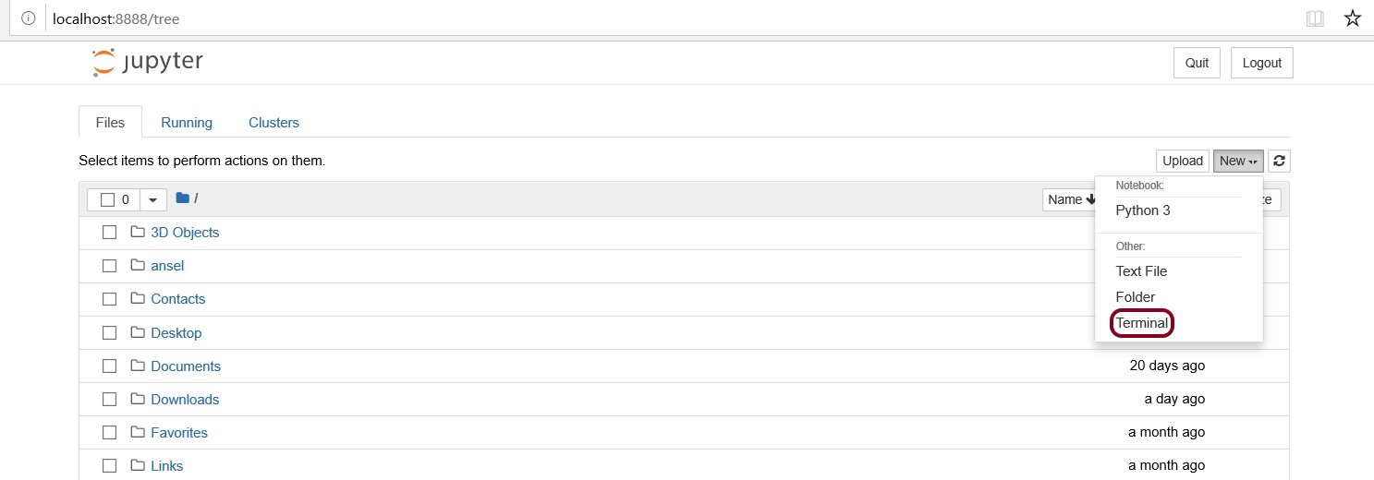

***Step 2***

pip install --upgrade pyforest

***Step 3***

python -m pyforest install_extensions

if error occurs as follows,

**ValueError: Please install nodejs 5+ and npm before continuing installation. nodejs may be installed using conda or directly from the nodejs website**

then try

conda install nodejs

successful completion, then do

python -m pyforest install_extensions (step 3)

Try refresh the jupyter notebook, and try. That’s it !!!