

**LA GRANDEE INTERNATIONAL COLLEGE**

**Simalchaur, Pokhara Nepal**

A Final Report

On

**“Car Rental System”**

**Submitted to:**

Bachelor of Computer Application (BCA) Program

In partial fulfilment of the requirements for the degree of BCA under

Pokhara University

**Submitted by:**

|  |  |  |  |
| --- | --- | --- | --- |
| **Name:** | **Course** | **Semester** | **P.U. Registration Number** |
| Priyanka Ghimire | BCA | 4th | 2021-1-53-0360 |
| Manisha Sharna | BCA | 4th | 2021-1-53-0354 |
| Diptan Gurung | BCA | 4th | 2021-1-53-0350 |
|  |  |  |  |

**Date:2080-11-09**

**Acknowledgement**

We have presented this report focusing on the topic “Car Rental System”. This report has been prepared for partial fulfilment of the requirement for the degree of BCA and to have practical experience.

We are heartily thankful to the faculty of IT, LA Grandee international college and our supervisor **Mr. Rishi Khanal** and **BCA Co-ordinator Mr. Ramesh Chalise** for their role to motivate and lead for this report. We obliged towards their constant guidance, supervision and feedbacks which enabled us to prepare a well-executed report.

Further, we express our gratitude to LA Grandee family, classmates, seniors and teachers who have directly and indirectly supported us during our project.

Sincerely,

Priyanka Ghimire

Manisha Sharma

Diptan Gurung

**Declaration for**

**“Car Rental System”**

**Student’s Declaration**

We hereby declare that the work reported in this project work on **“Car Rental System”** Submitted to LA Grandee International College, Pokhara University is our original work done in the form of partial requirement for the degree of Bachelor’s in Computer Application (BCA) under the supervision of **Mr. Rishi Saran Khanal**, Head of department , LA Grandee International College. The material contained in the report has not been submitted to any University of Institution for the award of any degree.

**Name of the student:** Priyanka Ghimire

**Class Roll No:** 16

**Exam Roll No:** 21535161

**Semester:** 4th

**Signature:**

**Name of the student:** Manisha Sharma

**Class Roll No:** 10

**Exam Roll No:** 21535155

**Semester:** 4th

**Signature:**

**Name of the student:** Diptan Gurung

**Class Roll No:** 6

**Exam Roll No:** 21535151

**Semester:** 4th

**Signature:**

**Supervisor’s Declaration**

I hereby recommended that this project entitled “**Car Rental System**” is done under my supervision by **Priyanka Ghimire, Manisha Sharma, Diptan Gurung** during their 4th semester in partial fulfilment of the requirements for the degree of **Bachelors in Computer Application (BCA)** under **Pokhara University** is completed to my satisfaction and be processed for final evaluation.

____________________________

**Er. Rishi Saran Khanal**

**Date: 2080-11-01**

**Letter of Approval**

We certify that we have examined this report entitled “**Car Rental System**” and are satisfied with the project defence. It is satisfactory in the scope and qualify as project in partial fulfilment of the requirements for the degree of **Bachelor in Computer Application** **(BCA)** under **Pokhara University.**

|  |  |  |
| --- | --- | --- |
| _________________  **Supervisor**  **Er. Rishi saran Khanal** | _______________  **External Examiner**  Mr.  **Date:** 2080-11-09 | ____________________  **Program Coordinator**  **Mr. Ramesh Chalise** |

# Abstract

A car rental system is a desktop application that enables users to add, edit, remove, and book cars. A car rental system is designed to manage the rental of vehicles to customers. The purpose of developing a desktop car rental system in VB.NET is to create a software application that helps car rental companies efficiently manage their operations, provide better customer service, and streamline their business processes.

**Table of content**

Abstract vi

List of Figure viii

Abbreviations ix

1. Introduction 1

2. Problem Statement 2

3. Objectives 3

4. Background Study 4

5. Requirement Document 5

5.1 Functional Requirements 5

5.2 Non-Functional Requirements 5

6. System Design 7

6.1 Dataflow Diagram 7

6.2 Er Diagram 10

6.3 Database Diagram 11

7. Development 12

7.1 Development methodology 12

7.2 Tools/system/language used. 14

7.3 Work Assigned 15

7.4 Project Gantt Chart 16

8. Project Results 17

9. Future Enhancements 18

10. Conclusion 19

# List of Figure

Figure 6.1.1 Level-0-DFD 7

Figure 6.1.2 Level-1-DFD 7

Figure 6.1.3 Level-2-DFD Admin login 8

Figure 6.1.3 level-2- DFD User Login 8

Figure 6.1.4 Level-2-DFD User Registration 9

Figure 6.2.1 ER Diagram 10

Figure 6.3.1 Database diagram 11

Figure 6.3‑1 Flowchart 11

Figure 7.1.1 Iterative model 12

Figure 7.4.1 Gantt Chart 16

# Abbreviations

|  |  |
| --- | --- |
| CRM | Car rental management |
| DFD | Data Flow Diagram |
| SDLC | Software Development Life Cycle |
| Ms | Microsoft |
| Gps | Global Positioning system |

# Introduction

A car rental management system is a crucial software solution designed to streamline and automate the operations of car rental businesses. This system facilitates the efficient management of vehicle fleets, reservations, customer information and overall business process is as the car rental industry continues to grow an evolve, the need for a robust and user-friendly software solution become increasingly evident. Car rental services have become an essential component of modern transportation solutions, serving various purposes from personal trips to business travel. This project aims to offer a comprehensive, user-friendly, and efficient solution for both customers and rental agencies. The CRM project is built using VB.NET and starts with a login system to provide access. Users can then add, view, edit, remove, and book cars. When adding cars, users must input details like the license plate number, car ID, car name, colour, and daily rental price. Additionally, users can add customer and admin profiles. All bookings and booking details can be efficiently managed through this system, saving time and effort.

# Problem Statement

Car rental businesses face a myriad of challenges in their day-to-day operations. These challenges include:

* Inefficient manual processes
* Fleet management
* Reservation conflicts
* Customer management
* Security Concerns

# Objectives

* To create an intuitive and user-friendly booking interface for customers, ensuring swift and hassle-free rental vehicle reservations.
* To establish a comprehensive database for storing car details, ensuring accessibility at any given time.
* To maintain a user database with information from registration, streamlining the process of vehicle rental and reservations, eliminating the need for time-consuming phone calls and waiting for available vehicles.

# Background Study

With the rise of technology, everything happens with just a click. Every business from different sectors is changing to a digital platform or doing things in digital format. Everything is upgrading with time. This system is also an upgrade to the manual Car Rental System and to be up to date with the current digital environment in business.

We propose to build a software project that can efficiently handle and manage various activities of renting. This system will eliminate the error caused by human employees and do things in computerized system. With the help of a human to machine communication, this system will make easier and effective way to store the information related to the car rental system.

# Requirement Document

The purpose of this document is to outline the functional and non-functional requirements for a car rental system developed in vb.net. This document will be used as a guide for the development team during the design and implementation phases of the project.

## Functional Requirements

The description of the services that the system should provide to the user. Some functional requirements are:

**• Users Login**

For log in people must have verified account.

**• Add Car**

The user can enter new car information in the add new car section.

**• Edit Car Details**

The user can edit/update the car information in the edit section.

**• Delete Car Details**

The user can delete their car information using the delete car option.

**• Admin Login**

Admin can enter the username and password to get access of the application.

## Non-Functional Requirements

Non-Functional requirements are set of specifications that describe the system’s operation capabilities and constraints and attempt to improve its functionality.

Some non-functional requirements are:

• **Usability**

The system should provide easy access to the users without any barriers and should be able to support multiple languages.

**• Portability**

The system should be able use on different platforms without change in its behaviour or performance.

• **Security**

The system should be secured, and it should not show customer’s name, password, and their other date to any other users.

# System Design

Dataflow, Algorithm and Flowchart are used for understanding the system's design and its functionalities, and both are important for creating proper documentation.

## Dataflow Diagram

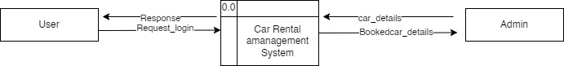

Figure 6.1.1 Level-0-DFD

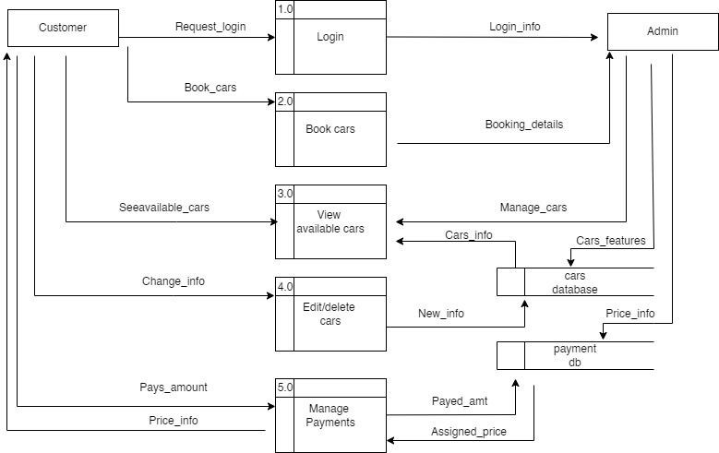

Figure 6.1.2 Level-1-DFD

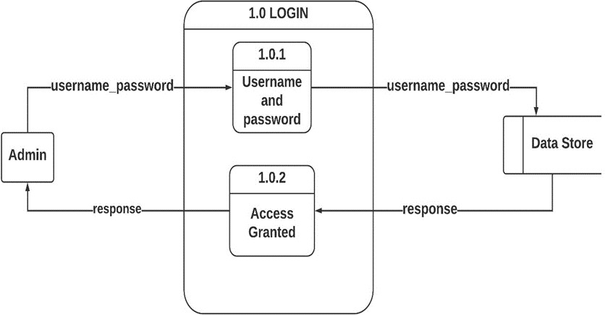

Figure 6.1.3 Level-2-DFD Admin login

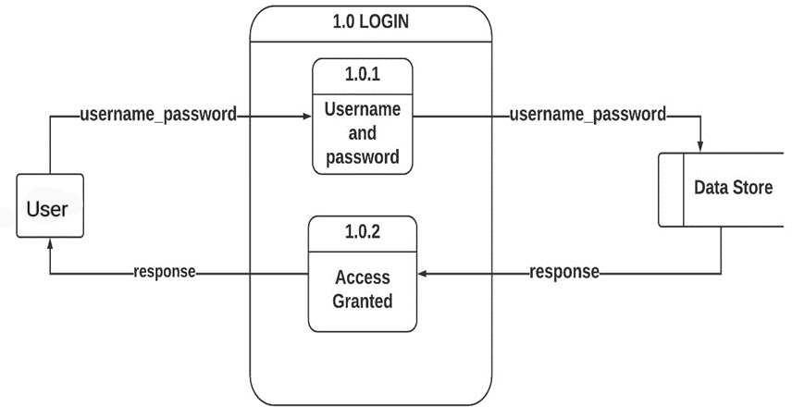

Figure 6.1.3 level-2- DFD User Login

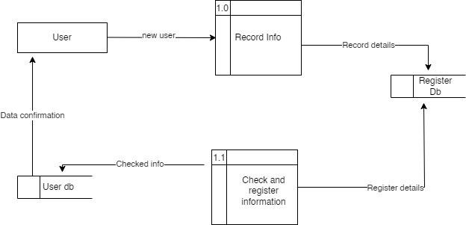

Figure 6.1.4 Level-2-DFD User Registration

## Er Diagram

An Entity Relationship Diagram is a diagram that represents relationships among entities in a database. It is commonly known as an ER Diagram.

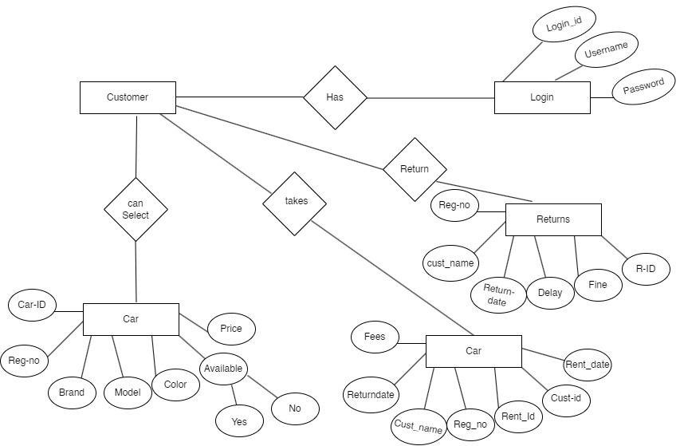

Figure 6.2.1 ER Diagram

## Database Diagram

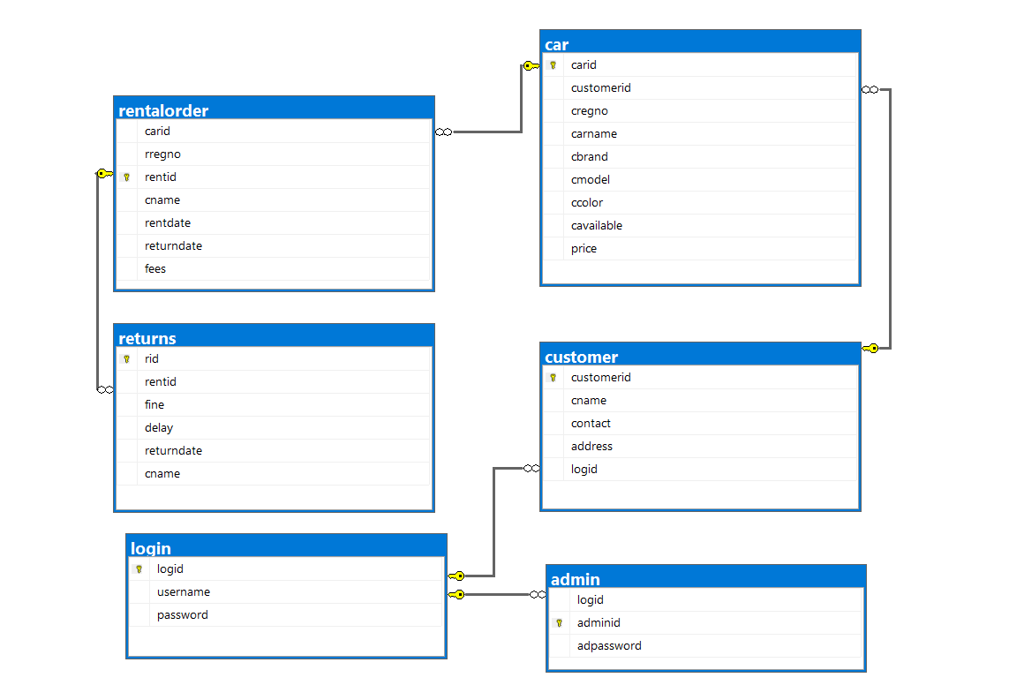

Figure 6.3.1 Database diagram

Figure 6.3‑1 Flowchart

# Development

For the development of this “Car rental system” program, we used the iterative module of the development. Similarly, different tools are also used for the development of the program which are clearly explained below and the division of the work and work done is also mentioned.

## Development methodology

A system development methodology in software engineering is the main guidance for constructing planning and controlling the process of developing an information system. Here, we are going to the design car rental management system using iterative method. An iterative method in software development is an approach that involves breaking the project into smaller, manageable iterations or cycles. Each iteration involves the process of planning, designing, implementing, testing, and delivering a functional part of the software. Iterative development allows for continuous improvement and adaptability throughout the project. The following illustration represents different phases of iterative method:

Figure 7.1.1 Iterative model

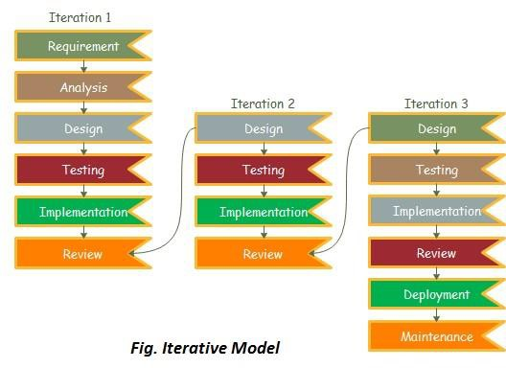

**i. Requirement and planning stage**

During this phase, the business requirements are collected, and an analyst determines whether they will be met within the allocated budget. It is used to layout the business needs in detail and the System information (hardware or software) are gathered and evaluated for feasibility.

**ii. Design**

In this phase, the project team gets the complete set of requirements to begin their work in a particular direction. They use different figures like a data flow diagram, class diagram, activity diagram, state transition diagram, etc to get a clear understanding of the software design and help them proceed with the development.

**iii. Coding**

The actual construction of the system begins at this point in the project. This stage will be guided by the analysis and design resulted from the Design Stage. All the requirements, planning, and design plans are executed and coded. The developer will implement the chosen design using predetermined coding and metrics standards.

**iv. Testing**

This step involves testing the current build iteration to a set of standards and norms to see if it meets them. Performance testing, stress testing, security testing, requirements testing, usability testing, multi-site testing, disaster recovery testing, and so on are all examples of this type of testing.

**v. Evaluation**

This is the last stage of the iterative model. After all the processes are complete, the system constructed up to this point is thoroughly evaluated. The system is examined by the development team, stakeholders, and other teams responsible for developing the project to see if the outcomes satisfy their expectations.

## Tools/system/language used.

**Ms- Word**

Ms-Word is a word processing software developed by Microsoft Corporation. It is one of the mostly used software for preparing the documents. Report preparation is easier as there are many features in Ms- Word.

**Ms- Powerpoint**

Ms- Powerpoint is a presentation software also developed by Microsoft Corporation. This software is used to create presentation using different tools available in it.

**Ms-Excel**

Ms- Excel is a spreadsheet software used for calculation, making pivot tables, graphics tools,etc. We have used Ms-Excel to make Gantt chart.

**Draw.io**

Draw.io is a free, online diagramming tool that allows us to create flowcharts, diagrams, mind maps, organisation charts, and much more. We have used draw.io to make the DFD’s and flowchart.

**Visual Studio**

Visual Studio is an **Integrated Development Environment (IDE)**developed by Microsoft to develop Desktop applications, GUI (Graphical User Interface), console, web applications, mobile applications, cloud, and web services, etc.

**Microsoft SQL Server**

Microsoft SQL Server is a relational database management system (RDBMS) developed by Microsoft. It is a powerful and widely used database server that is used for storing and retrieving data as requested by other software applications, either running on the same computer or on another computer across a network (including the internet).

## Work Assigned

The following table shows the work division between the members:

|  |  |  |
| --- | --- | --- |
| S.N | Name of the member | Work assigned |
| 1. | Priyanka Ghimire | * Requirement document * Problem identification * Proposal planning * System design * System coding * Documentation |
| 2 | Manisha Sharma | * Requirement document * Documentation * Proposal Planning * Support in System Design * Problem identification |
| 3 | Diptan Gurung | * Requirement document * Support in System Design * Documentation * Proposal Planning |

## Project Gantt Chart

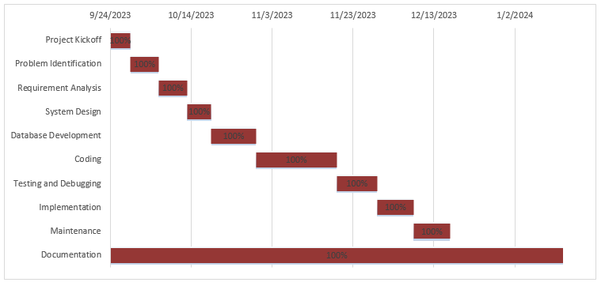

Figure 7.4.1 Gantt Chart

# Project Results

The result of the work that has been done on the project that means summary of the work done. This is the list of the tasks and results of each individual step and conducting about of a survey of the participants.

We have developed a project using vb.net. The project can complete different functions like adding, editing, updating and deleting the information related to car rental process. Through this project different problems have been solved. In our old days we used to write and record our car rental information in different diaries but through this it will be easy preventing lost and stolen of data. Users can keep it private through user login system. User can store the information and their data more securely. The different thoughts and goals have been developed after the completion of the project. Thoughts like, now it’s time to identify more about this system and what type of goals will be the most important to the project, and to develop the specific actions to achieve those goals.

# Future Enhancements

As the project progresses, there may be opportunities to enhance the functionality and user experience of the car rental system. The following are potential future enhancements that can be considered to improve the overall utility of the application.

* In future we could add Gps tracking feature.
* In future we will develop a mobile app to allow customers to easily browse and reserve vehicles on the go.
* We will add more features on payment.

# Conclusion

In conclusion, the development and deployment of our car rental system desktop application using VB.NET mark a significant achievement in modernizing and optimizing the car rental process. This project has been a collaborative effort, and we are proud to present a robust and user-friendly solution that addresses the needs of both our customers and administrators. The reservation process has been streamlined, reducing complexities and providing a more enjoyable experience. Furthermore, the system's architecture is scalable, allowing for future expansion and the integration of additional features.