

**LA GRANDEE INTERNATIONAL COLLEGE**

**Simalchaur Pokhara, Nepal**

A Mid Term Progress Report

on

**Movie Ticket Booking System**

**Submitted to**

La Grandee International College

Bachelor of Computer Application (BCA) Program

In partial fulfilment of the requirements for the degree of Bachelor of Computer Application (BCA) under Pokhara University

**Submitted by**

|  |  |  |  |
| --- | --- | --- | --- |
| Name | Program | Semester | P.U Registration No. |
| Priyanka Ghimire | BCA | 6th | 2021-1-53-0360 |
| Manisha Sharma | BCA | 6th | 2021-1-53-0354 |
| Diptan Gurung | BCA | 6th | 2021-1-53-0350 |

Date: 2024-12-08

**Table of contents**

1. Introduction 1

2. Problem Statement 2

3. Objectives 3

4. Background Study 4

5. Requirement document 5

5.1 Functional Requirements: 5

5.2 Non-Fnctional requirements 7

6. System Design 8

6.1 Data Flow Diagram 8

6.2 Entity Relationship Diagram(ER-Diagram) 10

5. Methodology 11

7. Project Gantt Chart 13

7. Deliverables 14

8. Conclusion 16

9. References 17

**Table of figures**

Figure 6.1 Level-0-DFD 8

Figure 6.2 Level-1-DFD 8

Figure 6.3 Level-2-DFD Admin Login 9

Figure 6.4 Level-2 DFD User Login 9

Figure 6.5ER Diagram 10

Figure 6.6 Use case diagram 11

Figure 7.7.1 Agile Methodology 13

# Introduction

In today's digital era, online ticket booking has become an essential part of the entertainment industry, especially for cinemas. Traditional methods of ticket booking, such as visiting theaters or using phone calls, are being replaced by efficient and user-friendly digital solutions. This project focuses on the development of a **Movie Ticket Booking System** using a combination of web technologies such as HTML, CSS, JavaScript, and PHP. The system allows users to explore available movies, select showtimes, choose their preferred seats, and purchase tickets all through an easy-to-navigate web interface.

The system enable users to browse available movies, select showtimes, choose seats, and securely purchase tickets via a web-based interface. By leveraging modern web technologies, the system aims to provide an intuitive and responsive user experience. HTML and CSS will be used to build a well-structured and aesthetically pleasing frontend, ensuring accessibility across different devices. JavaScript will handle the interactive elements, such as real-time seat selection and availability status updates. PHP, combined with a MySQL database, will manage the backend functionality, including user authentication, movie data management, and payment processing.

The primary objective of this project is to streamline the movie ticket booking process, making it more convenient for users and manageable for theater operators. The system will provide real-time information about movie schedules, seat availability, and booking status, reducing the possibility of overbooking and ensuring a smooth booking process.

This system is designed to cater to the needs of both users and theater operators, ensuring convenience, reliability, and scalability. The implementation of this project up to the mid-term phase includes the successful integration of core functionalities such as login,registration, seat selection, and showtime management, with further development planned for payment processing and enhanced user experience.

This progress report outlines the current status of the project, detailing the completed features, challenges encountered, and next steps for the final implementation.

# Problem Statement

* Complex payment integration
* Poor user interface and user experience

# Objectives

* To improve user experience and accessibility.
* To make a seamless payment integration

# Background Study

In today’s digital era, online systems have significantly transformed how businesses operate, including the entertainment industry. The **Movie Ticket Booking System** is one such innovation that has revolutionized how users purchase movie tickets. The system allows users to browse through available movies, select a showtime, choose seats, and pay for tickets online, all from the comfort of their home or mobile devices.

The old manual system was suffering from a series of drawbacks. Since whole of the system was to be maintained with hands the process of keeping, maintaining and retrieving the information was very tedious and lengthy. The records were never used to be in a systematic order, there used to be lots of difficulties in associating any particular transaction with a particular context. If any information was to be found it was required to go through the different registers, documents there would never exist anything like report generation. There would always be unnecessary consumption of time while entering records and retrieving records. One more problem was that it was very difficult to find errors while entering the records. Once the records were entered it was very difficult to update these records.

Historically, moviegoers had to visit theaters to purchase tickets, often facing long queues and the inconvenience of sold-out shows upon arrival. With the advent of internet technology, these challenges have been addressed by introducing online booking systems. Over the past decade, online platforms have become the preferred choice for booking movie tickets due to their convenience and efficiency.

With the increasing use of smartphones, high-speed internet, and digital wallets, there is a growing demand for **convenient and secure online services**. Users prefer the flexibility of booking tickets at any time and from any location, without needing to visit the cinema in person. Moreover, the rise of digital payments has further facilitated this transition, enabling users to complete transactions quickly and securely.

The Movie Ticket Booking System represents a crucial innovation in the entertainment industry, meeting the growing demand for convenience, real-time access, and efficient service. It benefits both cinemas by increasing revenue and efficiency and users by offering a hassle-free booking experience.

# Requirement document

The purpose of this document is to outline the functional and non-functional requirements for a Movie Ticket Booking System. This document will be used as a guide for the development team during the design and implementation phases of the project.

## 5.1 Functional Requirements:

**User Registration and Login**:

* Users must be able to register by providing a valid email, password, and confirmation of their password.
* Users should log in using their login credentials (email and password).

**Browse Movies and Showtimes**:

* Users can view a list of available movies, along with details such as title, genre, description, runtime, and showtimes.

**View Seat Availability**:

* Users can view the available seats for a selected movie and showtime in real-time.

**Book Tickets**:

* Users must be able to select seats for a chosen movie and showtime.
* A ticket must be generated containing details like ticket ID, seat number, movie name, and showtime.

**Payment Processing**:

* Users must be able to make payments for their booked tickets.
* The system should record the payment details, including payment ID, amount paid, and payment date.

**Edit or Cancel Bookings**:

* Users must have the option to edit or cancel their bookings before a specified deadline.

**Admin Management** :

* Admins should have access to manage user accounts, verify login details, and modify movie and showtime information.
* Admins can monitor seat availability and booking records.

**Sales Reports**:

* The system should generate reports for theater operators, including ticket sales and payment summaries.

**Error Handling and Validation**:

* Provide error messages for invalid login attempts or booking conflicts (e.g., selecting already-booked seats).
* Validate user inputs, such as email format and password strength.

**Data Management**:

* Maintain a database to store user registration details, movie information, seat availability, booking records, and payment history.

## Non-Fnctional requirements

Non-Functional requirements are set of specifications that describe the system’s operation capabilities and constraints and attempt to improve its functionality.

Some non-functional requirements are:

**Security**:

* User passwords must be stored securely using encryption.
* The system must ensure secure payment processing by integrating with a reliable payment gateway.
* Implement user authentication to prevent unauthorized access.

**Usability**:

* The interface should be intuitive and easy to use for customers with basic computer or smartphone skills.
* The system should provide clear error messages and guidance for users when issues occur (e.g., invalid login credentials or unavailable seats).

**Reliability**:

* The system should be available **99.9% of the time**, ensuring minimal downtime.
* Backup mechanisms must be implemented to recover data in case of a system failure.

**Maintainability**:

* The system should be modular, making it easy to update or add new features (e.g., additional payment methods or seat layouts).
* Bugs and issues should be easy to identify and resolve without impacting ongoing bookings.

These non-functional requirements ensure that the system meets the expectations of performance, reliability, security, and usability, contributing to a smooth experience for both users and theater operators.

# System Design

Dataflow, Entity-relationship diagram are used for understanding the system's design and its functionalities, and both are important for creating proper documentation.

## 6.1 Data Flow Diagram

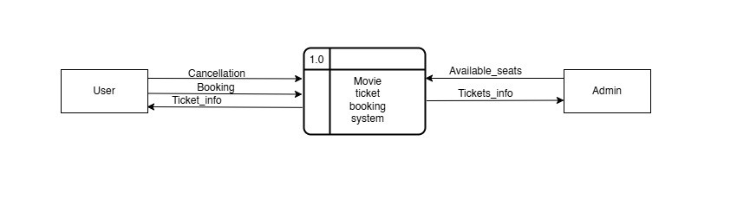

Figure 6.1 Level-0-DFD

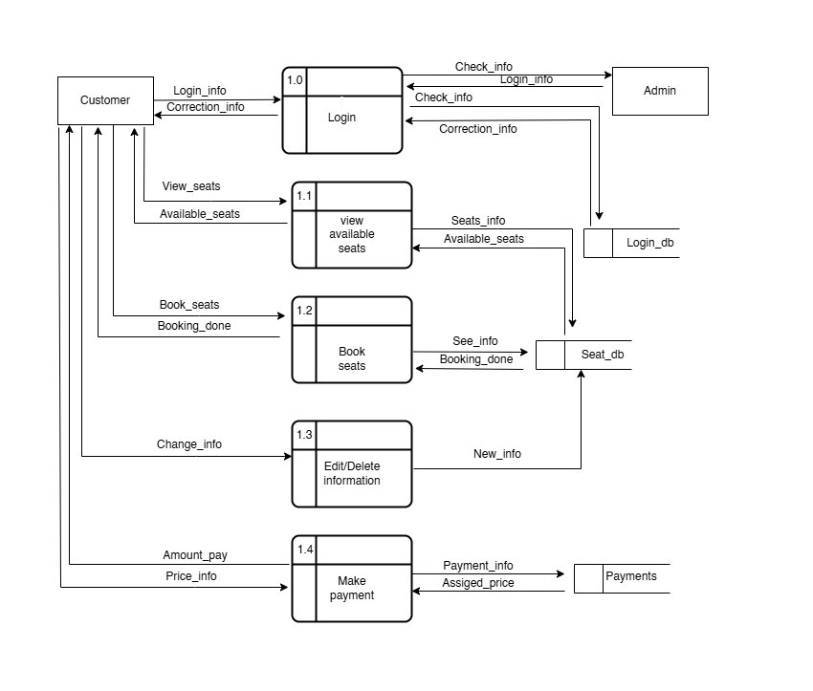

Figure 6.2 Level-1-DFD

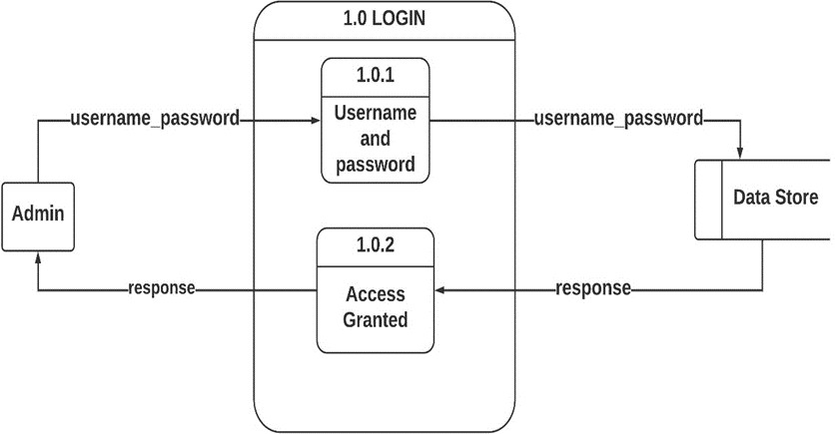

Figure 6.3 Level-2-DFD Admin Login

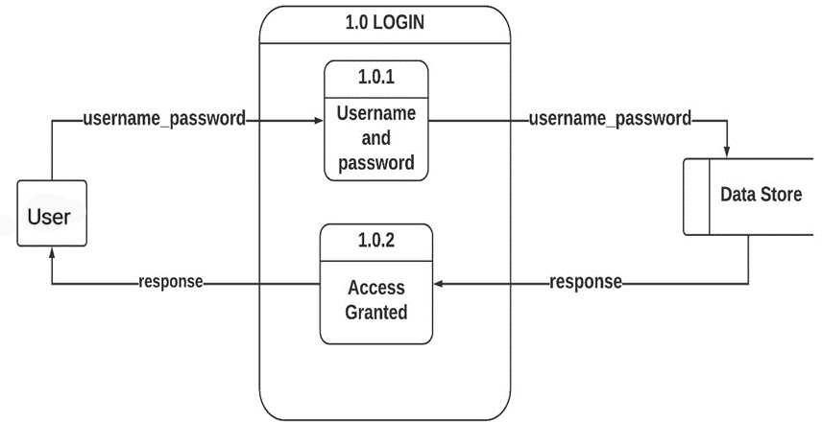

Figure 6.4 Level-2 DFD User Login

## Entity Relationship Diagram(ER-Diagram)

An Entity Relationship Diagram is a diagram that represents relationships among entities in a database. It is commonly known as an ER Diagram.

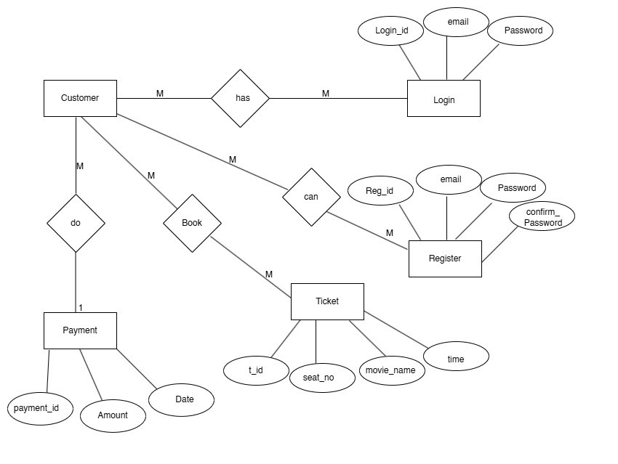

Figure 6.5 ER Diagram

## 6.3 Use Case Diagram

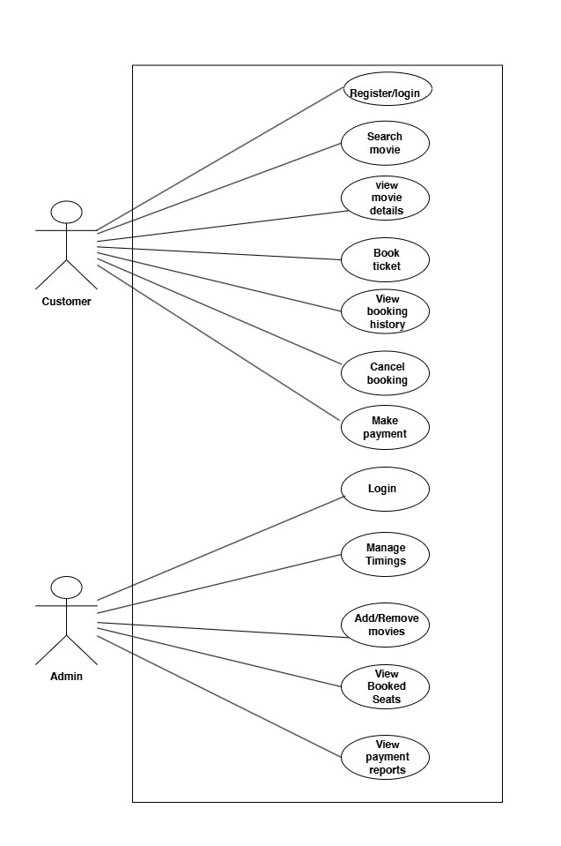

Figure 6.6 Use case diagram

# Methodology

We are employing Agile Methodology as our chosen approach for project development. This model follows an iterative process that emphasizes flexibility, collaboration and continuous improvement. It follows the iterative as well as incremental approach that emphasizes the importance of delivering of working product very quickly. Agile methodology is a project management framework that breaks projects down into several dynamic phases, commonly known as sprints. The Agile framework is an iterative methodology. After every sprint, teams reflect and look back to see if there was anything that could be improved so they can adjust their strategy for the next sprint.

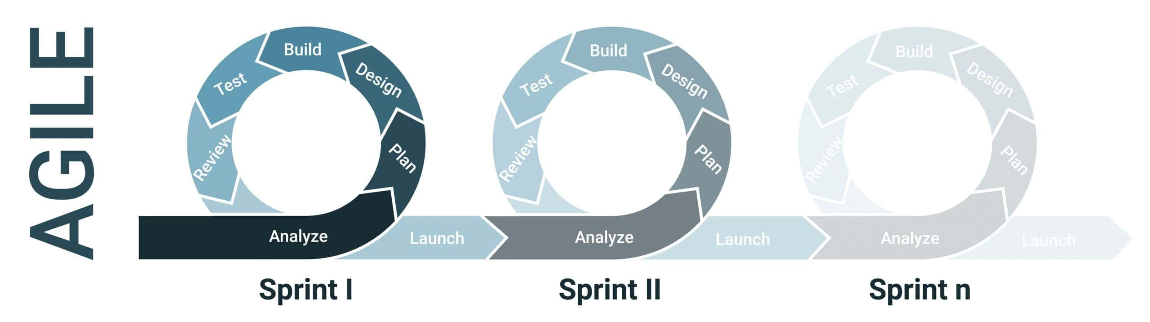

Figure 7.7.1 Agile Methodology

(Paliwa, 2024)

How it can be implemented in our system

1. **Planning Phase**

Define User Stories:

Identify features such as user registration, movie listings, seat selection, payment processing, and booking management. Each feature can be broken down into user stories that describe the desired functionality from an end-user perspective.

2. **Sprint Planning**

Sprints Sprint Planning:

Organize work into sprints (typically 1-4 weeks). For example:

Sprint 1: User registration and authentication

Sprint 2: Movie listings and search functionality

Sprint 3: Seat selection interface

Sprint 4: Payment gateway integration

3. **Development Phase**

Daily Stand-ups: Conduct brief daily meetings to discuss progress, blockers, and plans for the day.

Version Control: Use Git for version control to manage changes in code collaboratively.

4. **Testing Phase**

Continuous Testing: Implement automated tests for critical functionalities (e.g., seat availability checks) to ensure reliability after each sprint.

User Acceptance Testing (UAT): Involve users in testing the system after each major increment to gather feedback.

5.**Deployment**

Incremental Releases: Deploy the application incrementally after each sprint to gather real user feedback and make improvements based on actual usage.

# 8. Project Gantt Chart

# 9.Deliverables

The deliverables for the project include:

1. **Fully Functional Movie Ticket Booking System**:
   * Includes user interfaces for customers and an admin interface for theater management.
2. **User Interface (UI)**:

* Responsive front-end built with HTML, CSS, and JavaScript.
* User-friendly navigation for searching movies, selecting showtimes, and booking tickets.

1. **Admin Panel**:

* Dashboard for adding, editing, or deleting movie listings and showtimes.
* Functionality for managing seating arrangements and ticket availability.

1. **Backend System**:

* PHP-based server-side logic to handle requests from the user and admin interfaces.
* MySQL database for storing user information, movie data, booking details, and payment records.

1. **Database Design**:

A well-structured MySQL database schema to handle all necessary data, including:

* Movie details (title, genre, description, runtime, etc.)
* Showtimes and available seats.
* User and booking details.

1. **Testing & Validation**:

* Test cases for user interface interactions, seat reservations, and booking confirmation processes.

1. **Documentation**:

* Full technical documentation covering the design, development, and setup process.

# 10. Conclusion

The development of the **Movie Ticket Booking System** is progressing steadily toward its goal of providing a modern, efficient, and user-friendly solution for small and local theaters. By digitizing the ticketing process, the system aims to simplify movie browsing, showtime selection, and seat booking for customers, while offering theater management an organized and automated platform to handle operations.

At this stage of the project, key features such as login, registration, showtime selection, and seat availability management have been implemented successfully. Ongoing efforts are focused on integrating secure payment processing and generating detailed sales reports.

This system, once completed, will reduce manual tasks, minimize errors, and improve the overall experience for both users and theater operators. The progress so far demonstrates the feasibility and potential of the system to meet its objectives, with further refinements planned in the upcoming phases.

# 11. References

Paliwa, P. (2024, september 23). *What is Agile Methodology?* Retrieved from GeeksforGeeks: https://www.geeksforgeeks.org

researchgate.net. (January 2024). *A_CASE_STUDY_ON_ONLINE_TICKET_BOOKING_SYSTEM_PROJECT.* SSRN Electronic Journal..

Scribd.com. (Oct 29,2018). *PHP and MYSQL project report on movie ticket booking system.* FreeProjectz.com.