- Practical5b.c
Develop a program that executes the equivalent of the shell command: ls -l | grep ".c" using fork(), pipe(), dup2(), and exec() system calls.

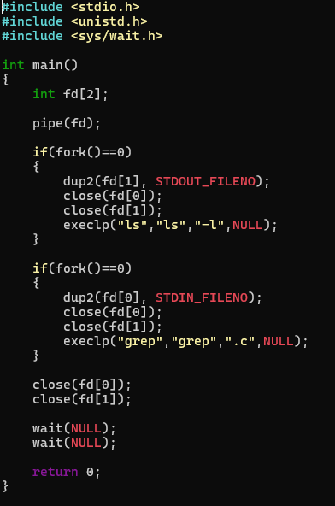
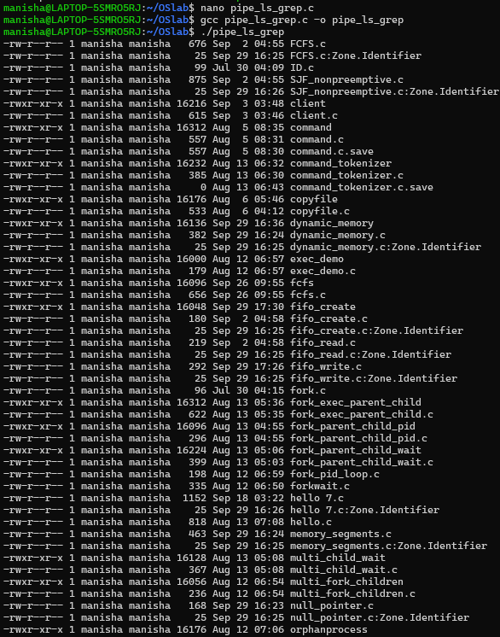
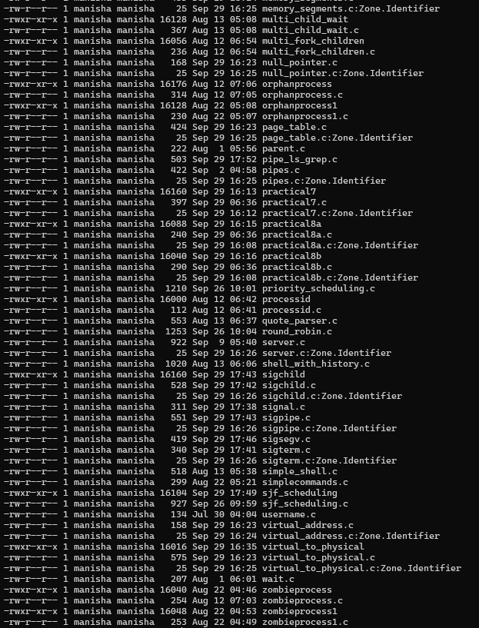

- Create a POSIX signal handling program that captures SIGINT, SIGTERM, and SIGUSR1. Demonstrate asynchronous event handling and explain the role of signal handlers.
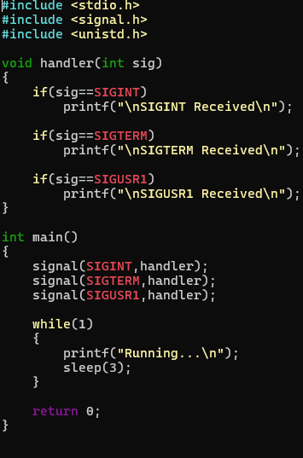
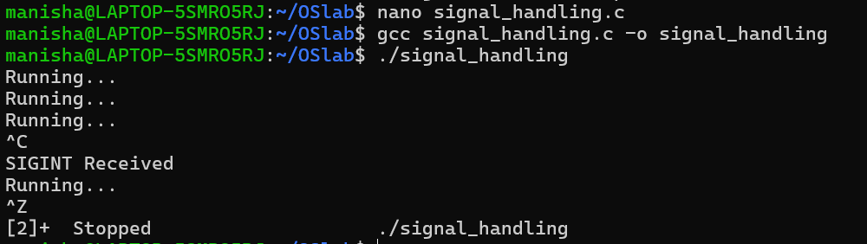

Ex; kill -SIGUSR1 PID
Ex: kill -SIGTERM PID

