03-09-26
unix_socket_server.c
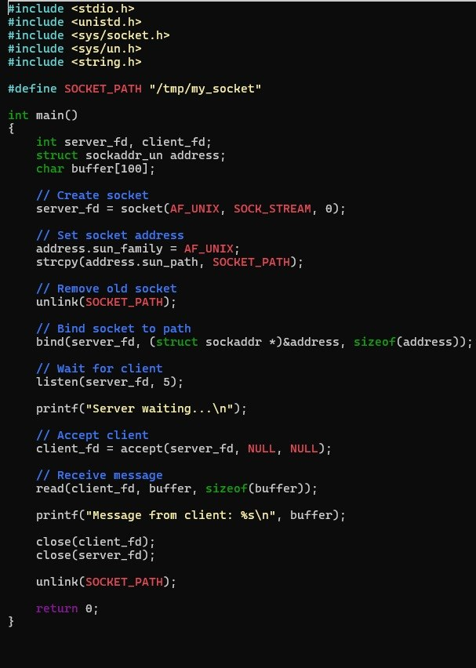

Output:
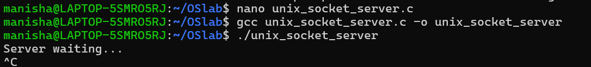
2. unix_socket_client.c

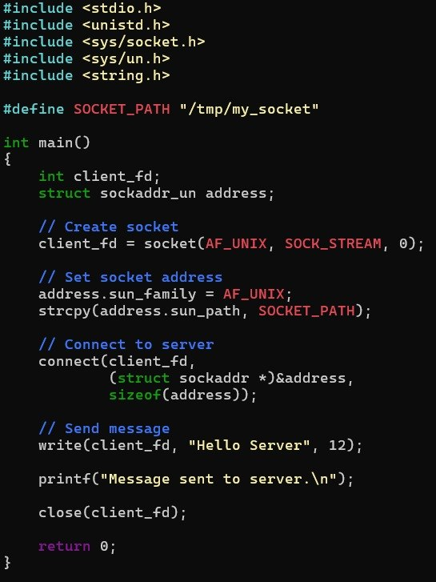
Output:
