- 24. To Organize Source Code, Improve Build Scripts, Add README, Verify Repository Structure, Tag Releases, Validate Deliverables.
To Create Demo Scenarios, Validate Features, Rehearse Presentation, Demonstrate Pipelines, Demonstrate Signals, Final Project Review.
INPUT:
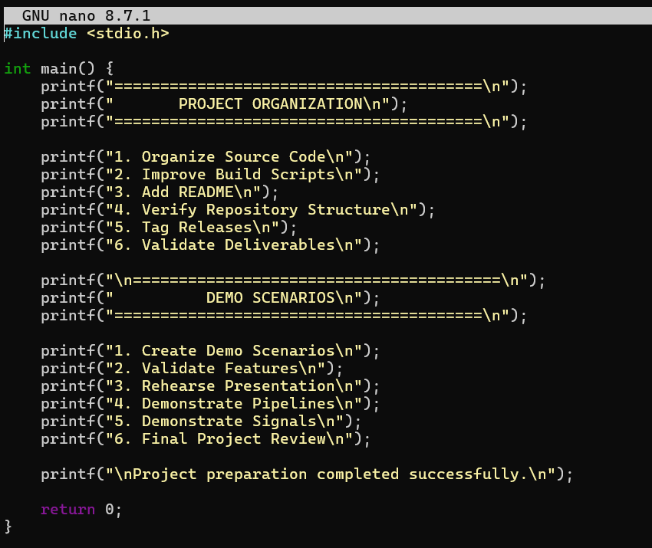
OUTPUT:

