Feasibility Report
Modulation and demodulation kernels for low-power radio: OQPSK, GFSK and QAM

Item | Detail
Project | Final-year project (PFE) at Acute Design, ACU IP family
Author | Manisha Rani
Version / date | Draft v0.1, 12 October 2026
Status | OQPSK analysed and prototyped in Python. GFSK and QAM: not yet analysed
Evidence labels used | Verified = run and measured in this work. Estimate = counted or derived by hand, not measured. Assumption = taken as given, to be confirmed. Hypothesis = expectation to be tested.

1. Summary
The project brief asks for a study of modulation and demodulation for three proposed radio schemes (OQPSK, GFSK, QAM), a feasibility report, and, if feasible, Python and then C implementations of OQPSK, with GFSK and QAM added if time allows.
Where the work stands. OQPSK, in its IEEE 802.15.4 2.4 GHz form, has been implemented end to end in floating-point Python: transmitter, channel model, and a streaming receiver with frame detection, carrier-frequency-offset (CFO) estimation, timing and phase tracking, and CRC checking. It decodes frames at CFO from −150 kHz to +95 kHz and at ±80 ppm sample-clock offset, and its output is identical for any input block size from 1 to 13,573 samples (all verified).
Preliminary OQPSK verdict: functionally feasible, cost feasibility open. The algorithms work and map onto a per-sample, minimal-block streaming model. Whether the cost fits the ACU depends on throughput, power and memory figures that are not yet known (Section 8). The current receiver costs roughly 20 multiplications and 24 additions per input sample while tracking (estimate), with clear reduction options identified but not yet tried.
Still to do for this report: the GFSK and QAM analyses, the agreed pass/fail thresholds, and the ACU hardware limits. They are marked in yellow where they appear.

2. Scope and feasibility criteria
The brief gives no numeric targets (data rate, sensitivity, power). The criteria below are therefore derived from the brief's own framing: ACU processes signals as a stream, per sample for temporal computation or per minimal block for block processing, and the goal is low-power kernels. Assumption: these criteria are acceptable to Acute Design; thresholds are open.
# | Criterion | How it is assessed | Threshold
C1 | Streaming fit | Can every stage run per sample or per minimal block with explicit state and no whole-buffer operations? | Yes / no per stage
C2 | Computational cost | Real multiplications and additions per sample and per second, counted per stage | To agree with ACU team
C3 | Memory / state | Words of state per stage, including history buffers | To agree with ACU team
C4 | Link performance | BER and PER versus Eb/N0 in AWGN, compared with an ideal receiver | Target sensitivity needed
C5 | Impairment robustness | PER under CFO, timing offset, sample-clock offset, random phase | Tolerances needed
C6 | Transmit-side efficiency | Envelope variation and peak-to-average ratio (power amplifier requirement) | Tx power budget needed
C7 | Spectrum | Occupied bandwidth and adjacent-channel leakage | Standard / mask needed
C8 | Portability to C | Fixed-point readiness, golden vectors, dependence on ACU SDK | Bit-exact vs Python

3. Method and test setup
- Python reference model (floating point, float64). All schemes are to be run through the same channel and test harness.
- Channel: complex AWGN with Eb/N0 defined per information bit. The noise scaling was cross-checked against an independent chip-level simulation at 2, 4 and 6 dB Eb/N0 and agreed within statistical error (verified).
- Impairments injected: carrier frequency offset, random carrier phase, fractional timing offset, sample-clock offset in ppm.
- Known simplifications: AWGN only (no multipath), unit input amplitude (no AGC), 4 samples per chip, anti-alias filtering omitted when resampling (assumptions).
- Note on the earlier model: the original noise function estimates signal power from the buffer, which is biased when idle padding is present. The new channel sets noise from unit signal power instead.

4. Scheme 1: OQPSK (IEEE 802.15.4, 2.4 GHz PHY)

4.1 Description
Four bits form a symbol; each of 16 symbols maps to a 32-chip spreading sequence at 2 Mchip/s (62.5 ksymbol/s, 250 kb/s). Even chips modulate the I arm and odd chips the Q arm, with Q delayed by one chip period and half-sine pulse shaping. This gives a constant-envelope waveform equivalent to MSK. Spreading provides roughly 9 dB of processing gain (8 chips per bit).
Assumption: the OQPSK scheme proposed in the brief is this 802.15.4 variant. The brief's own references (a Zigbee receiver and an advanced O-QPSK decoder) suggest so, but it has not been confirmed in writing.

4.2 Transmitter validation
- The chip table matches all 16 entries of two independent open-source decoders (verified).
- Arm assignment, one-chip Q delay, chip polarity and nibble order match the reference conventions. A waveform built the reference way decodes with our receiver, and our waveform decodes with the reference's sampling rule, with 0 errors in 800 bits each way (verified).
- Envelope is exactly 1.0 and phase steps are ±1 or 0 (in units of π/(2·sps)) at 2, 4, 8 and 16 samples per chip; the BER is the same at all four within statistical error (verified).
- The references are open-source decoders, not the standard text. A direct check against the standard remains to be done (open).

4.3 Receiver architecture
Stage | Function
Frame detector | Sliding autocorrelation at a one-symbol lag (the preamble repeats symbol 0 eight times), window of 6 symbols, normalised metric with hysteresis. Runs on every sample while searching.
Acquisition | One-shot on a short history after a trigger. The one-symbol-lag estimate is ambiguous beyond ±31.25 kHz, so five alias hypotheses (spacing 62.5 kHz) are tested and the one that best despreads the preamble wins. Symbol timing comes from a search over one symbol period. A weak result is rejected as a false alarm.
Tracking | One symbol per step (about 140 samples). Derotate, matched filter, despread against 16 sequences, then update a phase/frequency loop and an early/late timing loop. State is explicit.
Frame parsing | SFD (symbols 7, 10), PHR length, PSDU, CRC-16 check.

C1 (streaming fit): the detector and the tracker are already block functions with explicit state; block-size invariance was demonstrated. Acquisition still runs on a history buffer and needs a streaming rewrite for the ACU.

4.4 Results
Test | Result (verified)
CFO sweep at 30 dB: −150, −60, 0, +30, +95 kHz | All frames decoded, CRC correct; CFO estimate equal to the injected value
Block size 1 to 13,573 samples (9 dB, CFO 70 kHz) | Identical frame, CFO estimate and start index
127-octet frames, CFO 80 kHz, 9 dB, SCO −80 to +80 ppm | 8/8 frames decoded at every offset tested
Timing loop off versus on, +80 ppm, 127 octets | 8/10 versus 10/10 frames (small sample)
Noise only, 188 ms | 0 false frames; 69 rejected acquisition attempts

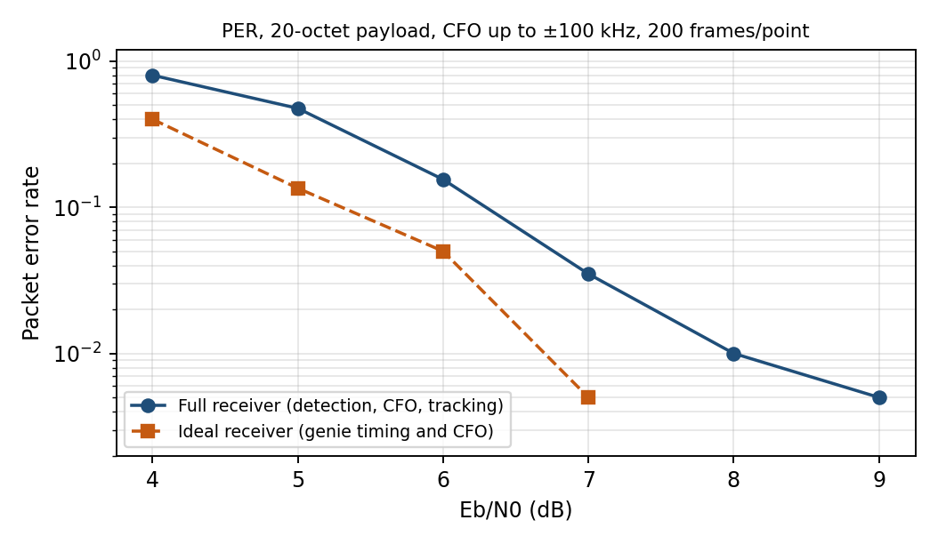
Figure 1. PER versus Eb/N0 (200 frames per point). The ideal receiver had no errors at 8 and 9 dB (not plotted on the log axis).
Eb/N0 | Receiver PER | Missed / CRC fail (of 200) | Ideal PER | Gap (approx.)
5 dB | 47.5% | 59 / 36 | 13.5% | about 1.2 dB
6 dB | 15.5% | 20 / 11 | 5.0% | about 1 dB
7 dB | 3.5% | 5 / 2 | 0.5% | about 1 dB
8 dB | 1.0% | 1 / 1 | 0% | not resolved
The "ideal" curve counts errors in the PHR and PSDU bits only, with genie timing and CFO. The dB gap is read by eye from these coarse points. Statistics: 200 trials cannot resolve an error floor near 1%.
Reading: most of the loss comes from missed detections, not from wrong decoding, so the detector, not the despreader, is the first thing to improve. Noise-only operation produced no false frames but many rejected acquisition attempts (one about every 2.7 ms at the noise level tested), which matters for cost, as shown next.

4.5 Computational cost and memory
Estimate: counted by hand from the algorithm in the code, assuming each sample is derotated once and real arithmetic only. These counts have not been measured on hardware.
Stage | Per sample or event | Per second | State (real words)
Detector (always on while searching) | 10 mult, 13 add per sample | 80 M mult/s, 104 M add/s at 8 MS/s | about 3,300 (Python model)
Tracker (while receiving a frame) | about 2,610 mult, 3,100 add per symbol, i.e. 20 mult and 24 add per sample | 163 M mult/s, 194 M add/s | about 300 plus loop scalars
Acquisition (per attempt) | about 80 k mult, 280 k add | depends on false-alarm rate | history of up to about 14 symbols (not minimised)

Tracker breakdown (per symbol): derotation with NCO 1,056 mult / 528 add; matched filter 528 / 528; early/late timing 1,024 / 1,024; despreading 0 / 1,024 (±1 coefficients need no multiplications).
Observation: the early/late timing check takes about 39% of tracker multiplications, and false acquisition attempts in noise at the measured rate would cost about as much as the tracker (about 130 M operations per second, estimate). Both are therefore the first places to reduce cost.
Candidate reductions (hypotheses, not yet implemented or measured): detect at a lower sample rate; run early/late only every few symbols, since drift at 80 ppm is about one sample per ~100 symbols; exploit the cyclic-shift structure of the chip table to cut despreading work; replace the NCO with a lookup or CORDIC; raise the acquisition threshold or add a cheaper pre-check.

4.6 Limitations and open issues
- Detection loses about 1 to 1.5 dB against the ideal receiver. Thresholds were set by hand and not optimised.
- No AGC: unit input amplitude is assumed. Required before any C port.
- Timing resolution is one sample (about ±0.125 chip at 4 samples per chip).
- AWGN only; no multipath, no phase noise, no interferers.
- Transmit-side spectrum and EVM have not been measured (C6, C7).
- Floating point only; no fixed-point study yet (C8).

4.7 Preliminary verdict
Feasible functionally and structurally for a streaming implementation (C1, C4, C5 demonstrated in Python). Undetermined for cost (C2, C3) until ACU limits are known. Not yet assessed: C6, C7, C8.

5. Scheme 2: GFSK
Not yet analysed. No code or measurements exist for GFSK. Parameters (data rate, modulation index, Gaussian BT, deviation) are not given in the brief and must be fixed with Acute Design before analysis.
Hypotheses to test (general engineering expectation, not results): constant envelope like OQPSK, so a non-linear power amplifier is acceptable; simple non-coherent discriminator receiver is possible, giving low complexity; sensitivity is typically a few dB worse than a coherent spread-spectrum receiver at the same data rate.
Plan: build a modulator, a discriminator receiver and a coherent option in the same harness; measure C1 to C5 and C8; reuse the channel model and the CFO and timing tests.

6. Scheme 3: QAM
Not yet analysed. The constellation order, symbol rate and pulse shaping are not given in the brief.
Hypotheses to test: the envelope varies, so the transmit chain needs a linear amplifier or back-off (C6); the receiver needs accurate gain, carrier and timing recovery, so it is likely the most complex of the three; spectral efficiency is the highest, which only pays off if data rate, not energy per bit, is the priority.
Plan: same harness and criteria as GFSK, starting with the lowest order the requirements allow.

7. Comparison matrix
Criterion | OQPSK | GFSK | QAM
C1 Streaming fit | Yes for detector and tracker; acquisition to rewrite | TBD | TBD
C2 Cost | About 20 mult + 24 add per sample (tracking), estimate | TBD | TBD
C3 Memory | About 3,600 real words (Python model), estimate | TBD | TBD
C4 Performance | About 1 dB from ideal at 7 dB Eb/N0 | TBD | TBD
C5 Robustness | CFO to ±150 kHz, SCO ±80 ppm | TBD | TBD
C6 Tx envelope | Constant (verified) | TBD (hypothesis: constant) | TBD (hypothesis: varying)
C7 Spectrum | Not measured | TBD | TBD
C8 C portability | Python done; fixed-point and AGC to do | TBD | TBD

8. Open items for Acute Design
- ACU hardware and SDK limits: clock, memory, word length, multiplier availability, power per operation.
- Target link requirements: data rate, receiver sensitivity, power budget.
- Pass/fail thresholds for C2 to C7.
- Confirmation that OQPSK means the 802.15.4 2.4 GHz PHY, and the intended parameters for GFSK and QAM.
- Whether the study must recommend one scheme or document all three.

9. Next steps
- Reduce OQPSK cost: cheaper detector, lower false-alarm rate, lighter timing loop; re-measure.
- Improve detection (the main source of the 1 to 1.5 dB loss) and rerun PER with thousands of frames per point.
- Analyse GFSK and QAM in the same harness; fill Sections 5 to 7.
- Fixed-point and AGC study, golden vectors, then the C port once the ACU SDK is available.

Appendix A. Correction to the earlier design note
The earlier note "OQPSK Modulator: Design and Verification" states that any two chip sequences differ in at least 16 of 32 positions, so five or six chips can be wrong. Computed from the table, the minimum Hamming distance is 12 (maximum 20), which guarantees correction of up to 5 chip errors. Cross-correlations between different sequences take the values −8, −4, 0, 4 and 8 against an autocorrelation of 32. The code is unaffected.
The same note describes the loopback test as proving the bits survive the chain. It proves only that transmitter and receiver agree with each other: permuting the chip table or reversing the bit order in both still passed. The comparison against the independent references (Section 4.2) addresses this.

Appendix B. Files
- oqpsk.py: transmitter and ideal receiver (from the earlier work).
- oqpsk_rx.py: streaming receiver, frame builder and test channel.
- test_rx.py, per_curve.py, validate_vs_references.py: tests, PER run and the reference comparison.

